|  |
| --- |
| utah serviceberry |
| *Amelanchier utahensis* Koehne |
| Plant Symbol = AMUT |

Contributed by: Upper Colorado Environmental Plant Center, Meeker, Colorado

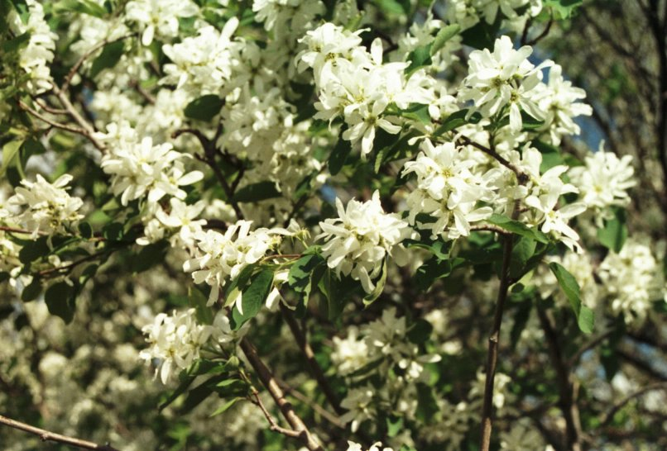

Steve Parr, Upper Colorado Environmental Plant Center

Alternate Names

Serviceberry, Juneberry, shadbush, and sarvis.

Uses

Utah serviceberry can be used for food and cover to improve wildlife habitat. Leaves and small branches are used by big game and livestock and berries are consumed by birds and small animals. It also provides nesting and cover for birds. Utah serviceberry can be used for reseeding big sagebrush and pinyon-juniper sites and is also beneficial for conservation plantings on rangelands and mined land. The plant can be used for landscaping and as a component of windbreaks and shelterbelts. It also can be used for roadside beautification. Native Americans used the berries as a source of food that was prepared in several ways (Dunmire and Tierney, 1997). Berries persist longer on the bush than on Saskatoon serviceberry and provide a food source over a longer period of time, especially when the ground may be covered with snow.

Status

Please consult the PLANTS Web site and your State Department of Natural Resources for this plant’s current status (e.g. threatened or endangered species, state noxious status, and wetland indicat values).

Description

*General*: Considerable variation occurs in the native shrubs or small trees that are generally 2 to 4 meters tall. Deciduous leaves are simple, alternate generally serrate-dentate from the middle to the tip. Flowers form clusters in early May with five showy white petals and the ovary is 2 to 5 celled. The persistent purplish – black pome can remain dry and pulpy. Considerable variation occurs when it is found on sites with Saskatoon serviceberry where natural hybrids are sometimes found. It generally occupies drier sites than Saskatoon serviceberry.

*Distribution*: Utah serviceberry is generally found at elevations of 5000 to 9000 feet from Montana to Oregon, south to New Mexico, and California (Harrington, 1954).

*Habitat*: The plant is found on dry ridges and slopes in big sagebrush, pinyon-juniper, and aspen communities. It is abundant in the southern portion of the Great Basin (Wasser, 1982).

Adaptation

The plant is found on rocky slopes, canyons and stream banks with 12 to 20 inches of annual precipitation. It has a deep spreading root system and occupies soils that are coarse to medium textured and well drained. It is not tolerant of high water tables or saline soils. It is adapted to drier sites than Saskatoon serviceberry. Utah serviceberry grows with a variety of other plants but grows slowly and seedlings can be suppressed by dense stands of grasses and forbs.

Establishment

Utah serviceberry can be established with seed planted about ¼ of an inch deep in fall months or container grown plants set in the ground in early spring when soil moisture is present. Sprouting does occur but is not as common as the occurrence in the more northern ecotypes of Saskatoon serviceberry. Establishment can be slow, especially if soil moisture is low, but the plant can survive on drier sites than Saskatoon serviceberry. New plantings can require several years (8 to 10) for flowering and seed production. Protection from browsing and plant competition along with the use of mulch will reduce the time required for establishment. Shade also will be beneficial for establishing live plants.

Management

After seeding or planting live plants, controlled browsing will be important for maintaining vigorous growth. Reducing plant competition is also necessary for rapid plant growth. Controlled browsing will be important for berry production. After the plant is established, it can withstand moderate to heavy browsing in years with average to above average precipitation. Browsing should not exceed more than 50 percent of the current season’s growth to maintain good plant vigor and growth.

Pests and Potential Problems

The plant is host of Apple-cedar rust when growing in close proximity to Junipers. The rust affects leaves and berries. No other serious diseases or pests are known (Wasser, 1982).

Environmental Concerns

The plant is not known to be aggressive, invasive, or difficult to control when used in areas where adapted.

Seeds and Plant Production

Utah serviceberry has about 25,800 seeds per pound.

In years with good moisture, large quantities of berries are produced and can be hand harvested. Controlled browsing is also important for berry production. Seedlings can exhibit good vigor but slow growth. Fresh seed may require cold stratification.

Cultivars, Improved, and Selected Materials (and area of origin)

Long Ridge Germplasm Utah serviceberry is the only release of the species. Seed and plants of Long Ridge Germplasm are available form Upper Colorado Environmental Plant Center (UCEPC) Meeker, Colorado.

Contact your local Natural Resources Conservation Service (formerly Soil Conservation Service) office for more information. Look in the phone book under ”United States Government.” The Natural Resources Conservation Service will be listed under the subheading “Department of Agriculture.”

References

Baldridge, D.E. and R. G. Lohmiller Editors 1990. *Montana interagency plant materials handbook for forage production, conservation, reclamation and wildlife*. Montana State University, EB 69, June 1990. 337 p.

Dunmire, W. W. and G. D. Tierney. 1997. *Wild plants and native peoples of the Four Corners*. Museum of New Mexico Press, Santa Fe, New Mexico. 313 p.

Harrington, H. D. 1954. *Manual of plants of Colorado*. 2nd Edition. Sage Books, Swallow Press Incorporated. 666 p.

Horton, H. 1989. Editor and compiler. *Interagency forage and conservation planting guide for Utah*. Utah State University, EC 433, August 1989. 67 p.

Plummer, A. Perry, D.R. Christensen, and S. B. Monsen. 1968. *Restoring big-game range in Utah*. Utah Div of Fish and Game, Pub. No. 68-3. 183 p.

Soil Conservation Service, Plant Materials Centers. 1988. *Plant Materials Handbook*. (For Arizona, Colorado, Montana, New Mexico, North and South Dakota, Utah and Wyoming) US Dept. of The Interior, Office of Surface Mining-Reclamation and Enforcement. May 1988.

Thornberg, Ashley A. 1982. *Plant Materials for use on surface mined lands in arid and semiarid regions*. USDA Soil Conservation Service, SCS-TP-157.

EPA-600/7-79-134. 88 p.

Wasser, C.H. 1982. *Ecology and culture of selected species useful in revegetating disturbed lands in the west*. US Fish and Wildlife Service, FWS/OBS-82/56, Sept. 1982. 347 p.

Prepared By

*Gary L. Noller*, Upper Colorado EnvironmentalPlant Center, Meeker, Colorado

Species Coordinator

*Gary L. Noller*, Upper Colorado EnvironmentalPlant Center, Meeker, Colorado

Edited: 080826 jsp

For more information about this and other plants, please contact your local NRCS field office or Conservation District, and visit the PLANTS Web site<<http://plants.usda.gov>> or the Plant Materials Program Web site <<http://Plant-Materials.nrcs.usda.gov>>

*The U.S. Department of Agriculture (USDA) prohibits discrimination in all its programs and activities on the basis of race, color, national origin, age, disability, and where applicable, sex, marital status, familial status, parental status, religion, sexual orientation, genetic information, political beliefs, reprisal, or because all or a part of an individual's income is derived from any public assistance program. (Not all prohibited bases apply to all programs.) Persons with disabilities who require alternative means for communication of program information (Braille, large print, audiotape, etc.) should contact USDA's TARGET Center at (202) 720-2600 (voice and TDD).*

*To file a complaint of discrimination write to USDA, Director, Office of Civil Rights, 1400 Independence Avenue, S.W., Washington, D.C. 20250-9410 or call (800) 795-3272 (voice) or (202) 720-6382 (TDD). USDA is an equal opportunity provider and employer."*

*Read about* [*Civil Rights at the Natural Resources Conservation Service*](http://www.nrcs.usda.gov/about/civilrights/)*.*