|  |
| --- |
| chalky bluestem |
| *Andropogon capillipes* Nash |
| Plant Symbol = ANCA4 |

*Contributed By: USDA NRCS National Plant Data*

*Center*

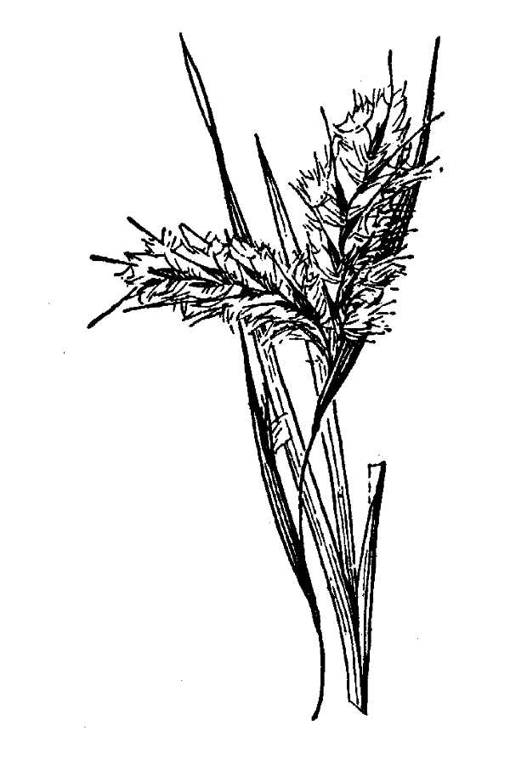

*Line drawing reprinted from* Hitchcock, A.S. 1950. *Manual of the grasses of the United States*. USDA Misc. Pub. No. 200, U.S. Gov. Printing Office, Washington, D.C.

## Uses

Chalky bluestem is a palatable grass. It furnishes excellent spring grazing and produces high‑quality winter forage. This grass establishes naturally on muckland soils that have been idle for 1 to 2 years, making it a valuable grass for protecting these soils against erosion. It is an indicator of past grazing use.

## Status

Please consult the PLANTS Web site and your State Department of Natural Resources for this plant’s current status, such as, state noxious status, and wetland indicator values.

## Description

Chalky bluestem is a warm‑season, perennial bunch grass. The height is between 3 and 5 feet. The leaf blade is folded tightly; keeled at base but flattened toward tip; lower blade is 20 to 25 inches long and 1/2 inch wide. The leaf sheath is keeled, overlapping and crowded at base. The ligule has a membrane 1/16-inch long. The seedhead is raceme partly enclosed in purplish‑brown spathe about 1 inch long.

## Management

Since this grass seldom contributes more than 10 to 15 percent of total herbage on any site, it is seldom selected as a key management species. It maintains itself in the plant composition of grazable woodlands if grazing is deferred every summer and proper grazing is practiced during winter. Under good management, it is one of the first grasses to become established on a range that has been overgrazed. Annual burning reduces stand.

## Establishment

Growth starts in mid‑January in southern Florida and 30to 45 days later in northern part of range. Vigorous plants produce leaves 8 to 10 inches long in 30 days. Stems, blades, and sheaths are covered with a white chalky coating that rubs off easily. Seedheads appear in September and early October. Seed ripen in October and November. Chalky bluestem is a good seed producer. Basal leaves stay green during winter unless temperature falls below 20' F. Particularly well adapted to wet acid or neutral sandy soils. Makes maximum growth on seepy slopes.

## Cultivars, Improved and Selected Materials (and area of origin)

Please contact your local NRCS Field Office.

## References

Frandsen, W. 1960. *Grass makes its own food*. United States Department of Agriculture Information Bulletin. 223 pp.

Gates, F. 1937. *Grasses in Kansas*. Kansas State Bd. Agriculture Report. 220‑A. 55: Pp. 349.

Gay, C. & D. Dwyer 1965. *New Mexico grasses*. New Mexico State University. Circ. 374. 85 pp.

Hitchcock, A. 1950. *Manual of the grasses of the United States*. 2nd Ed. Revised by Agnes Chase. United States Department of Agriculture Misc. Pub. 200. 1051 pp.

Hoffman, G. & B. Ragsdale [n.d.]. *Know your grasses*. Texas A & M University Agriculture Extension Service Bulletin. 182 (Rev.). 48 pp.

Judd, I. 1962. *Principal forage plants of southwestern ranges*. United States Department of Agriculture Forest Service.

Leithead, H.L, L.L. Yarlett, & T.N. Shiflet. February 1971*. 100 native forage grasses in 11 southern states*. USDA SCS Agriculture Handbook No. 389, Washington, D.C. 216p.

Rechenthin, C. A. 1956. *Elementary morphology of grass growth and how it affects utilization*. J. Range Mgmt. 9(4): Pp. 167‑170.

Shiflet, T. 1963. *Major ecological factors controlling plant communities in Louisiana marshes*. J. Range Mgmt. 16(5): Pp. 231‑235.

Silveus, W. 1933. *Texas grasses*. W. A. Silveus. San Antonio, Texas. 782 pp.

Silveus, W. 1942. *Grasses classification and description of species of Paspalum and Panicum in the United States*. W. A. Silveus. San Antonio, Texas. 526 pp.

USDA, NRCS 2003. *The PLANTS database*. Version: 000321. <http://plants.usda.gov>. National Plant Data Center, Baton Rouge, Louisiana.

## Prepared By & Species Coordinator:

*Percy Magee* , USDA NRCS National Plant Data Center, Baton Rouge, Louisiana

Edited: 19june02 ahv; jul03 ahv; 10aug03jsp; 24may06jsp

For more information about this and other plants, please contact your local NRCS field office or Conservation District, and visit the PLANTS Web site<<http://plants.usda.gov>> or the Plant Materials Program Web site <<http://Plant-Materials.nrcs.usda.gov>>

*The U.S. Department of Agriculture (USDA) prohibits discrimination in all its programs and activities on the basis of race, color, national origin, sex, religion, age, disability, political beliefs, sexual orientation, and marital or family status. (Not all prohibited bases apply to all programs.) Persons with disabilities who require alternative means for communication of program information (Braille, large print, audiotape, etc.) should contact USDA's* [*TARGET Center*](http://www.usda.gov/oo/target.htm) *at 202-720-2600 (voice and TDD).*

*To file a complaint of discrimination write USDA, Director, Office of Civil Rights, Room 326-W, Whitten Building, 14th and Independence Avenue, SW, Washington, DC 20250-9410 or call 202-720-5964 (voice or TDD). USDA is an equal opportunity provider and employer.*

*Read about* [*Civil Rights at the Natural Resources Convervation Service*](http://www.nrcs.usda.gov/about/civilrights/)*.*