|  |
| --- |
| elliott’s bluestem |
| *Andropogon gyrans* Ashe var. *gyrans* |
| Plant Symbol = ANGYG |

*Contributed By: USDA NRCS National Plant Data*

*Center*

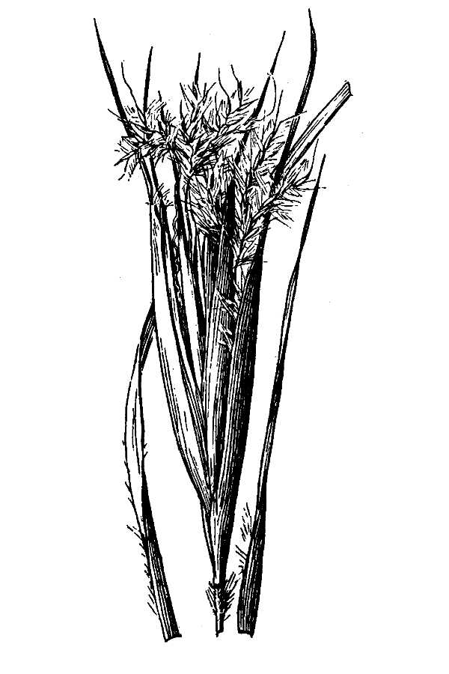

*Line drawing reprinted from* Hitchcock, A.S. 1950. *Manual of the grasses of the United States*. USDA Misc. Pub. No. 200, U.S. Gov. Printing Office, Washington, D.C.

# Alternate Names

*Andropogon campyloracheus, Andropogon elliottii, Andropogon elliottii* var. *gracilior, Andropogon elliottii* var. *projectus, Andropogon subtenuis*.

## Uses

Elliott’s bluestem is grazed readily by cattle during spring and early summer. Forage quality is relatively high when green. Protein concentrate should be provided when grazed during dormant season.

## Status

Please consult the PLANTS Web site and your State Department of Natural Resources for this plant’s current status, such as, state noxious status and wetland indicator values.

## Description

Elliott’s bluestem is a warm‑season, perennial bunch grass. The height is usually 2‑1/2 to 3 feet. The leaf blade is 6 to 15 inches long, smooth except for cluster of hair just above ligule. The leaf sheath is a basal sheath that is keeled, overlapping, relatively narrow; and has rounded upper sheaths. The stem is erect; 1 to 6 per plant, branching near top. The seedhead is a raceme, partially enclosed in conspicuous enlarged spathe, which turns a rusty color when plant matures.

## Management

Although of fair grazing value, this grass is seldom, if ever, abundant enough to be a key management species. It usually makes up no more than 3 to 5 percent of the plant composition. Proper grazing of more plentiful associated grasses maintains proper percentage of this grass in the plant community.

## Establishment

New growth starts in early spring but most of growth is made during spring and summer. Seedheads develop during fall, and seedstalks remain for several months. Distinctive seedhead clusters make plants conspicuous after maturity. Grows best in open areas but tolerates some shade. Adapts primarily to well‑drained soils on uplands and does not tolerate wet sites.

## Cultivars, Improved and Selected Materials (and area of origin)

Please contact your local NRCS Field Office.

## References

Frandsen, W. 1960. *Grass makes its own food*. United States Department of Agriculture Information Bulletin. 223 pp.

Gates, F. 1937. *Grasses in Kansas*. Kansas State Bd. Agriculture Report. 220‑A. 55: Pp. 349.

Gay, C. & D. Dwyer 1965. *New Mexico grasses*. New Mexico State University. Circ. 374. 85 pp.

Hitchcock, A. 1950. *Manual of the grasses of the United States*. 2nd Ed. Revised by Agnes Chase. United States Department of Agriculture Misc. Pub. 200. 1051 pp.

Hoffman, G. & B. Ragsdale [n.d.]. *Know your grasses*. Texas A & M University Agriculture Extension Service Bulletin. 182 (Rev.). 48 pp.

Judd, I. 1962. *Principal forage plants of southwestern ranges*. United States Department of Agriculture Forest Service.

Leithead, H.L, L.L. Yarlett, & T.N. Shiflet. February 1971*. 100 native forage grasses in 11 southern states*. USDA SCS Agriculture Handbook No. 389, Washington, D.C. 216p.

Rechenthin, C. A. 1956. *Elementary morphology of grass growth and how it affects utilization*. J. Range Mgmt. 9(4): Pp. 167‑170.

Shiflet, T. 1963. *Major ecological factors controlling plant communities in Louisiana marshes*. J. Range Mgmt. 16(5): Pp. 231‑235.

Silveus, W. 1933. *Texas grasses*. W. A. Silveus. San Antonio, Texas. 782 pp.

Silveus, W. 1942. *Grasses classification and description of species of Paspalum and Panicum in the United States*. W. A. Silveus. San Antonio, Texas. 526 pp.

USDA, NRCS 2000. *The PLANTS database*. Version: 000321. <http://plants.usda.gov>. National Plant Data Center, Baton Rouge, Louisiana.

## Prepared By & Species Coordinator:

*Percy Magee* , USDA, NRCS National Plant Data Center, Baton Rouge, Louisiana

Edited: 19june02 ahv; jul03 ahv; 10aug03jsp, 19Oct04rln; 24may06jsp

For more information about this and other plants, please contact your local NRCS field office or Conservation District, and visit the PLANTS Web site<<http://plants.usda.gov>> or the Plant Materials Program Web site <<http://Plant-Materials.nrcs.usda.gov>>

*The U.S. Department of Agriculture (USDA) prohibits discrimination in all its programs and activities on the basis of race, color, national origin, sex, religion, age, disability, political beliefs, sexual orientation, and marital or family status. (Not all prohibited bases apply to all programs.) Persons with disabilities who require alternative means for communication of program information (Braille, large print, audiotape, etc.) should contact USDA's* [*TARGET Center*](http://www.usda.gov/oo/target.htm) *at 202-720-2600 (voice and TDD).*

*To file a complaint of discrimination write USDA, Director, Office of Civil Rights, Room 326-W, Whitten Building, 14th and Independence Avenue, SW, Washington, DC 20250-9410 or call 202-720-5964 (voice or TDD). USDA is an equal opportunity provider and employer.*

*Read about* [*Civil Rights at the Natural Resources Convervation Service*](http://www.nrcs.usda.gov/about/civilrights/)*.*