|  |
| --- |
| broomsedge bluestem |
| *Andropogon virginicus* L. |
| Plant Symbol = ANVI2 |

*Contributed by: USDA NRCS Louisiana State Office, National Plant Data Center, & the Grazing Land Conservation Initiative-South Central Region*

## Alternative Names

Broomsedge, popotillo, whiskey grass, and yellow bluestem. Some botanists consider *Andropogon glomeratus* and *Andropogon virginicus* as one species. However, the two grasses are distinct and consistent in appearance and are currently recognized as separate species.

## Uses

*Livestock:* Broomsedge bluestem is grazed readily by cattle in the spring and early summer shortly after growth starts. The nutrition value is low except in early stages of growth. It is unpalatable when mature.

*Ornamental Landscaping:* Broomsedge bluestem is used as an ornament in landscapes. The infloresence is orange in the fall and remains throughout the winter. It provides color to the landscape.

*Wildlife*:Broomsedge bluestem benefits wildlife. Several species of birds and mammals eat the seeds in the winter when the seeds of other plants are not available. Several animals use the plants for cover and nesting sites (especially quail).

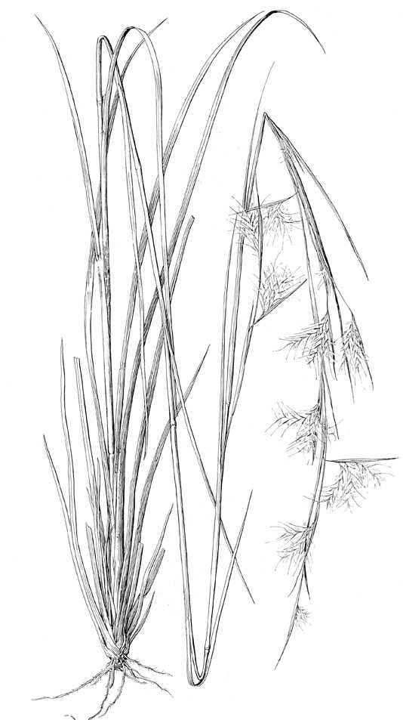

Grass Images

@ Texas A&M University

*Erosion Control*: Broomsedge bluestem is found on low fertile soils and prevents erosion when other plants can not be found.

*Conservation Practices*: Broomsedge bluestem, because of its growth habit, potentially has application when established with certain conservation practices; however, conservation practice standards vary by state. For localized information, consult your local NRCS Field Office.

## Status

Consult the PLANTS Web site and your State Department of Natural Resources for this plant’s current status, such as, state noxious status and wetland indicator values.

## Description

*General*: Grass Family (Poaceae). It is a native, warm-season, herbaceous, perennial bunch grass that begins its growth when the average daytime temperature is between 60° to 65° F. The slender, erect culms are up to 4 feet tall. The flattened sheaths are overlapping and with a few scattered hairs. The upper part of the plant is rounded and the lower part is slightly flattened and keeled. The blade is ⅛ to ¼ inch wide, 10 to 16 inches long and rough to the touch above. The ligule is small and membranous. The inflorescence has a panicle of two to four racemes about 1 inch long. The bases of the panicle branches are enclosed in an inflated, tawny spathe as long or longer than the spikelet. The upper lemma of the sessile spikelet has a straight awn that is ½ inch long. The pedicillate spikelet is absent. The seeds mature in 6 weeks to 2 months.

## Distribution

Broomsedge bluestem is found on the edges of forests and disturbed areas throughout the eastern United States. For current distribution, consult the Plant Profile page for this species on the PLANTS Web site.

## Establishment

*Adaptation*: Broomsedge bluestem is found in all of Louisiana’s Major Land Resource Areas (MLRA) except for the Gulf Coast Marsh (151). The USDA Hardiness Zones for broomsedge bluestem is 5 to 10. It grows on a wide variety of soils, especially in old fields and other disturbed sites. It is frequently found with *Andropogon glomeratus* but in higher, better-drained sites. However, broomsedge bluestem might have some allelopathic properties and may cause some other plants to not grow.

Broomsedge bluestem is propagated from seeds or by plant division. However, of the two propagation methods, it is best to plant broomsedge bluestem by seeds. The seeds are produced 6 to 8 weeks from when the culms were produced.

The seeds should be planted in late winter as a dormant seeding or when daily temperatures average in the low 60’s. The seed can be broadcast and culti-packed if the right field conditions exist. The seeding rate should be 10 to 12 pure live seed pounds/acre. The seeds should be planted to a depth of ¼ to ¾ inch. If the right field conditions do not exist or intensive seedbed preparation is undesirable, then disk the site and leave the surface as rough as possible. Do not attempt to create a smooth uniform appearance for the seedbed. Broadcast the seed and leave it undisturbed. When seeding under minimal seedbed preparation, increase the seeding rate by 50%.

It is not recommended to mix broomsedge bluestem seeds with cool season grass seeds. In parts of the United States where cool season grasses dominate, the warm season grasses can be taken over because they develop slower than the cool season grasses. It is also recommended that seed should not be moved more than 300 miles north, 100 miles east or west, or 200 miles south of its point of origin.

## Management

Broomsedge bluestem does not require fertilizers as the plants can grow in low fertility areas. Overgrazing and frequent haying of broomsedge bluestem results in an increase of this plant. However, if broomsedge bluestem becomes weedy, then burning, plowing, or mowing is recommended. Check with the local extension service for recommended herbicides. Broomsedge bluestem has no known pests or problems.

## Cultivars, Improved and Selected Materials (and area of origin)

Common seed is readily available from a number of growers, wholesalers, and retailers of native plants.

## References

Hitchcock, A.S. 1950. *Manual of the grasses of the United States*. USDA Miscellaneous Publication No 200. Agricultural Research Administration, Washington, D.C. Pp. 763-765.

Texas A&M University 1997. *Grass images: Andropogon virginicus*. <http://www.csdl.tamu.edu/FLORA/taesgrass/43753000t.jpg>. Bioinformatics Working Group, College Station, Texas.

USDA, NRCS 2000. *The PLANTS database*. <http://plants.usda.gov>. 001106. National Plant Data Center, Baton Rouge, Louisiana.

## Prepared By

# *Selena Dawn Newman*, USDA, NRCS, Louisiana Plant Materials Program

# *Maraya Gates*, USDA NRCS National Plant Data Center

## Species Coordinator

# *Mike Materne*, Louisiana State University, Baton Rouge, Louisiana

Edited 06dec00 jsp; 10feb03ahv; 24may06jsp

For more information about this and other plants, please contact your local NRCS field office or Conservation District, and visit the PLANTS Web site<<http://plants.usda.gov>> or the Plant Materials Program Web site <<http://Plant-Materials.nrcs.usda.gov>>

*The U.S. Department of Agriculture (USDA) prohibits discrimination in all its programs and activities on the basis of race, color, national origin, sex, religion, age, disability, political beliefs, sexual orientation, and marital or family status. (Not all prohibited bases apply to all programs.) Persons with disabilities who require alternative means for communication of program information (Braille, large print, audiotape, etc.) should contact USDA's* [*TARGET Center*](http://www.usda.gov/oo/target.htm) *at 202-720-2600 (voice and TDD).*

*To file a complaint of discrimination write USDA, Director, Office of Civil Rights, Room 326-W, Whitten Building, 14th and Independence Avenue, SW, Washington, DC 20250-9410 or call 202-720-5964 (voice or TDD). USDA is an equal opportunity provider and employer.*

*Read about* [*Civil Rights at the Natural Resources Convervation Service*](http://www.nrcs.usda.gov/about/civilrights/)*.*