

Plant Guide

# black sagebrush

## Artemisia nova A. Nelson

Plant Symbol = ARNO4

*Contributed by*: USDA NRCS Plant Materials Center, Aberdeen, Idaho

### Photo of Artemisia novaBlack sagebrush. Photo by Al Schneider @ USDA-NRCS PLANTS Database.

### Alternate Names

black sage

*A. arbuscula* ssp*. nova* (A. Nelson) G.H. Ward

*A. arbuscula* var*. nova* (A. Nelson) Cronquist

### Uses

*Wildlife/livestock.* Black sagebrush provides good forage to wildlife and livestock. Ogle and Brazee (2009) rate it as preferred forage for deer and antelope year round, and preferred for sheep during winter and fall and desirable in spring and summer. Palatability of black sagebrush varies from one population to the next. Preference test results between black sagebrush and big sagebrush subspecies are variable and largely inconclusive (McArthur and Stevens, 2004). Welsh et al. (1994) reported winter nutritive values of black sagebrush at 53.7 % in vitro digestibility, 9.9 % crude protein and 0.18 % phosphorus.

*Conservation*. Black sagebrush establishes readily and spreads naturally by seed. It is a good conservation species for dry sites with shallow soils (McArthur and Stevens, 2004).

### Status

Please consult the PLANTS Web site and your State Department of Natural Resources for this plant’s current status (e.g., threatened or endangered species, state noxious status, and wetland indicator values).

### Description

*General*: Sunflower family (Asteraceae).Black sagebrush is a low growing evergreen shrub with a flat topped crown. Mature plants range from 10 to 30 cm (4 to 12 in) tall. The leaves are dark green, sometimes grayish, triangular in outline with 3 rounded lobes. The leaf surface is often covered with hair, a feature which distinguishes this species from big sagebrush species (*A. tridentata*) (McArthur and Stevens, 2004). These hairs give the leaves a darker appearance. The slender floral stems stand 4 to 10 cm (1.6 to 4 in) above the vegetative crown. The flower heads typically contain 3 or 4 perfect disk flowers. The fruit is an achene, 0.8 to 1.5 mm (0.03 to 0.06 in) in length with no pappus.

This species resembles low sagebrush (*A. arbuscula*), but can be separated by its having entire leaves on the flowering stems and stalked flower heads. Big sagebrush differs from black sagebrush in having green and hairy involucral bracts or phyllaries around the flower heads; those of black sagebrush are straw colored and glabrous (Shultz, 2009).

There are two varieties of black sagebrush, the common variety *nova* and variety *duchensicola*. Variety *duchensicola* has whitish leaves, pubescent phyllaries, and larger flower heads with 5 flowers per head (Welsh et al, 2003). This variety occurs sporadically in Utah, Nevada and California (Shultz, 2009).

Black sagebrush readily hybridizes with other members of section Tridentatae resulting in narrow bands of intermediate forms situated between populations (Welsh et al., 2003). However black sagebrush typically occupies sites unsuited to other sagebrush species and forms distinct plant communities.

*Distribution*: Black sagebrush is widely distributed in the western United States. It occurs in arid regions of western North America in Arizona, California, Colorado, Idaho, Montana, Nevada, New Mexico, Oregon, Utah and Wyoming (Shultz, 2009). For current distribution, please consult the Plant Profile page for this species on the PLANTS Web site.

*Habitat*: Black sagebrush is primarily found in low desert scrub communities in valley bottoms or on sparsely vegetated mountain slopes. It often occurs in solid stands as the dominant or co-dominant species. Black sagebrush is often found in association with horsebrush (*Tetradymia* sp.), shadscale (*Atriplex* *confertifolia*), and winterfat (*Krascheninikovia lanata*). It is also found as a lesser component with big sagebrush, pinyon-juniper and mountain brush communities. Black sagebrush dominated communities typically have an abundance of bare ground between plants with few forbs.

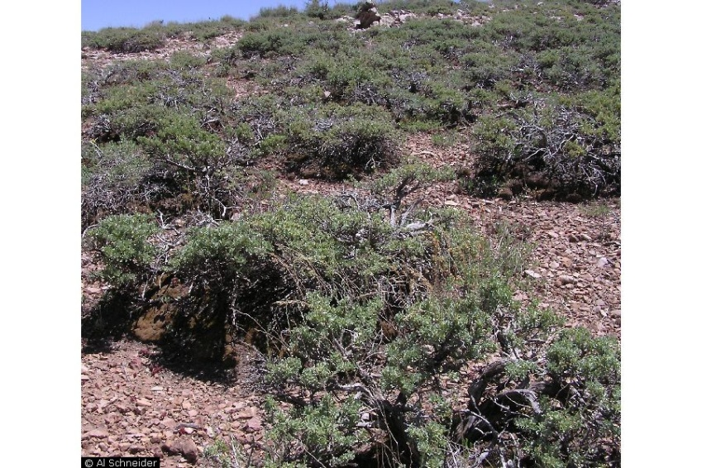

**Black sagebrush plant community. Photo by Al Schneider @ USDA-NRCS PLANTS Database.**

**Adaptation**

Black sagebrush is adapted to well drained medium textured soils from 1,200 to 2,400 m (4,000 to 8,000 ft) in elevation (USDA-NRCS, 2012). It is adapted to soils with a pH range of 7.0 to 8.5 (USDA-NRCS, 2012) and is frequently found in calcareous soils (McArthur and Stevens, 2004). Black sagebrush is adapted to areas receiving 15 to 50 cm (6 to 20 in) mean annual precipitation (Francis, 2004; USDA-NRCS, 2012) and a 90 day frost free period (USDA-NRCS, 2012).

Black sagebrush occupies drier sites with shallower, coarser soils than big sagebrush or low sagebrush (McArthur and Stevens, 2004). Black sagebrush is often an indicator of a root restricting layer at 28 to 69 cm (11 to 27 in) (Zamora and Tueller, 1973).

Black sagebrush is intolerant of fire; however, fires are infrequent in black sagebrush sites due to the open plant communities with sparse vegetation (Wasser, 1982).

### Establishment

Black sagebrush establishes well from direct seeding (McArthur and Stevens, 2004). It has better seedling vigor than big sagebrush seed due to the somewhat larger seed, and tolerates shallow drilling better than big sagebrush (McArthur and Stevens, 2004). However, black sagebrush should be seeded in alternate rows from grasses which are more vigorous and can impede shrub establishment (Richardson et al., 1986). Black sagebrush should be broadcast on the soil surface or drilled to 6 mm (0.25 in) deep in late fall or winter (Wasser, 1982). The full stand seed rate is 0.5 to 1lb PLS/ft² (Wasser, 1982). When seeded in a mixture, the seeding rate should be the appropriate percentage of the full stand seeding rate. Ogle et al (2011b) recommend a rate of 0.025 lb PLS/ac for rangeland seed to achieve a target establishment of 400 plants/ac. The seeding rate should be doubled for broadcasting or for critical area plantings (Ogle et al., 2011b).

Transplants and bareroot stock can also be used to establish black sagebrush. These techniques should be considered for small critical area plantings and seed increase plots. Transplanting should occur in early spring when moisture levels are optimum using 5 to 8 inch tall stock that has been overwintered and hardened (Welch et al., 1994). A 0.5 to 1.0 ft² area should be cleared of competing vegetation at the planting site for best establishment.

### Management

Black sagebrush is slower to develop than big sagebrush (McArthur and Stevens, 2004). Grazing should be deferred for 2 to 5 years for establishment (Jacobs et al., 2011; Ogle et al., 2011a). When established in rocky soils black sagebrush will exclude annual weeds (McArthur and Stevens, 2004).

### Pests and Potential Problems

Black sagebrush plants have been defoliated and killed by sagebrush moth (*Aroga websteri*) (Wasser, 1982).

### Environmental Concerns

### Black sagebrush is native to western North America. It will spread under favorable conditions but does not pose any environmental concern to native plant communities.

### Seed and Plant Production

### Large Photo of Artemisia nova seed

**Black sagebrush seed (achenes). Photo by Steve Hurst @ USDA-NRCS PLANTS Database**

Flowering occurs in late summer with the seed maturing in September and October (Francis, 2004). Seed is collected by shaking, beating or stripping the seed off the plants into containers. The raw materials can then be processed using a hammer mill or brush machine to dislodge the seeds from the flowering heads. Screen cleaners and air cleaners can then be used for final cleaning (Barner, 2009; Wasser, 1982). There are approximately 907,000 seeds/lb (Ogle et al., 2011).

Germination rates in lab tests are highly variable with some seed germinating within a few days and other seed not germinating for 90 or more days (Wasser, 1982). This is most likely a reflection of the conditions at the collection site. Stands in montane areas are more likely to have a longer stratification period than seeds collected from desert locations. A two week stratification period is recommended (Meyer et al., 1988).

Seeded stands flowered after 4 years in Utah (Wasser, 1982).

### Cultivars, Improved, and Selected Materials (and area of origin)

Pine Valley Ridge source is a selected germplasm of black sagebrush developed by the Intermountain Research Station in Ogden, Utah (Welch et al., 1994). It was shown to be preferred by wintering deer and was palatable to domestic livestock. It is adapted to sites with a minimum 18 cm (7 in) mean annual precipitation, well drained soils with pH from 6.6 to 8.8 and a growing season of 75 days or more (Welch et al., 1994).

In addition to the formal named release, there may also be unnamed selections/ecotypes of this species readily available from commercial sources.”

### References

Barner, Jim 2009. Propagation protocol for production of *Artemisia nova* A. Nelson seeds; USDA FS - R6 Bend Seed Extractory, Bend, Oregon. In: Native Plant Network. URL: http://www.nativeplantnetwork.org (accessed 25 January 2012). Moscow (ID): University of Idaho, College of Natural Resources, Forest Research Nursery.

Francis, John K. ed. 2004. Wildland shrubs of the United States and its Territories: thamnic descriptions: volume 1. Gen. Tech. Rep. IITF-GTR-26. San Juan, PR: USDA, Forest Service, International Institute of Tropical Forestry, and Fort Collins, CO: USDA, Forest Service, Rocky Mountain Research Station. 830 p.

Jacobs, J., Scianna, J.D. and S.R. Winslow. 2011. Big sagebrush establishment. USDA-NRCS Technical Note No. 68. Bozeman, MT. 9p.

McArthur and Stevens. 2009. Composite Shrubs. In: S.B. Monsen, R. Stevens, and N.L. Shaw [compilers]. Restoring western ranges and wildlands. Fort Collins, CO: USDA Forest Service, Rocky Mountain Research Station. General Technical Report RMRS-GTR-136-vol-2. p. 493-537.

Meyer, S.E., Kitchen, S.G., Wilson, G.R. and R. Stevens. 1988. Proposed rule for *Artemisia nova*. Association of Official Seed Analysts Newsletter 62(1): 16-17.

Ogle, D., and B. Brazee. 2009. Estimating initial stocking rates. USDA-NRCS Technical Note No. 3. Boise, Idaho. 39p.

Ogle, D., St. John, L., Stannard, M., Cornwell, J. and L. Holzworth. 2011a. Pasture and range seedings: planning-installation-evaluation-management. USDA-NRCS, Boise, ID-Salt Lake City, UT-Spokane, WA. ID-TN 10. 35p.

Ogle, D., St. John, L., Stannard, M., and L. Holzworth. 2011b. Technical Note 24: Conservation plant species for the Intermountain West. USDA-NRCS, Boise, ID-Salt Lake City, UT-Spokane, WA. ID-TN 24. 57p.

Richardson, B.Z., Monsen, S.B. and D.M. Bowers. 1986. Interseeding selected shrubs and herbs on mine disturbances in southeastern Idaho. In: McArthur, E.D., and B.L. Welch. Proceedings-symposium on the biology of Artemisia and Chrysothamnus; 1984 July 9-13; Provo, UT. Gen. Tech. Rep. INT-200. Ogden, UT: USDA, Forest Service, Intermountain Research Station: 134-139.

Shultz, L.M. 2009. Monograph of Artemisia subgenus Tridentatae (Asteraceae-Anthemideae). Systematic Botany Monographs vol. 89. The American Society of Plant Taxonomists. 131p.

[USDA NRCS] USDA Natural Resources Conservation Service. 2011. The PLANTS Database, version 3.5. URL: http://plants.usda.gov (accessed 29 Dec 2011). Baton Rouge (LA): National Plant Data Center.

Wasser, C.H. 1982. Ecology and culture of selected species useful in revegetating disturbed lands in the west. U.S. Dept. Int., Fish and Wildlife Service. FWS/OBS-82/56. 347p.

Welch, B.L., Briggs., S.F., and S.A. Young. 1994. Pine Valley Ridge Source-a superior selected germplasm of black sagebrush. Research Paper INT-RP-474. USDA Forest Service, Intermountain Research Station, Ogden, UT. 9p.

Zamora, B. and P.T. Tueller. 1973. *Artemisia arbuscula*, *A. longiloba*, and *A. nova* habitat types in northern Nevada. Great Basin Naturalist. 33: 225-242.

**Prepared By**:

Derek Tilley, USDA NRCS Plant Materials Center, Aberdeen, ID

Loren St. John, USDA NRCS Plant Materials Center, Aberdeen, ID

### Citation

TIlley, D. and L. St. John. 2012. Plant Guide for black sagebrush (*Artemisia nova)*. USDA-Natural Resources Conservation Service, Aberdeen Plant Materials Center. Aberdeen, Idaho 83210.

Published: February, 2012

Edited: 25Jan2012djt; 25Jan2012ls

For more information about this and other plants, please contact your local NRCS field office or Conservation District at <http://www.nrcs.usda.gov/> and visit the PLANTS Web site at <http://plants.usda.gov/> or the Plant Materials Program Web site <http://plant-materials.nrcs.usda.gov>.

PLANTS is not responsible for the content or availability of other Web sites.

**USDA IS AN EQUAL OPPORTUNITY PROVIDER AND EMPLOYER**