|  |
| --- |
| CICER MILKVETCH |
| *Astragalus cicer* L. |
| Plant Symbol = ASCI4 |

Contributed by: USDA NRCS, Boise, Idaho

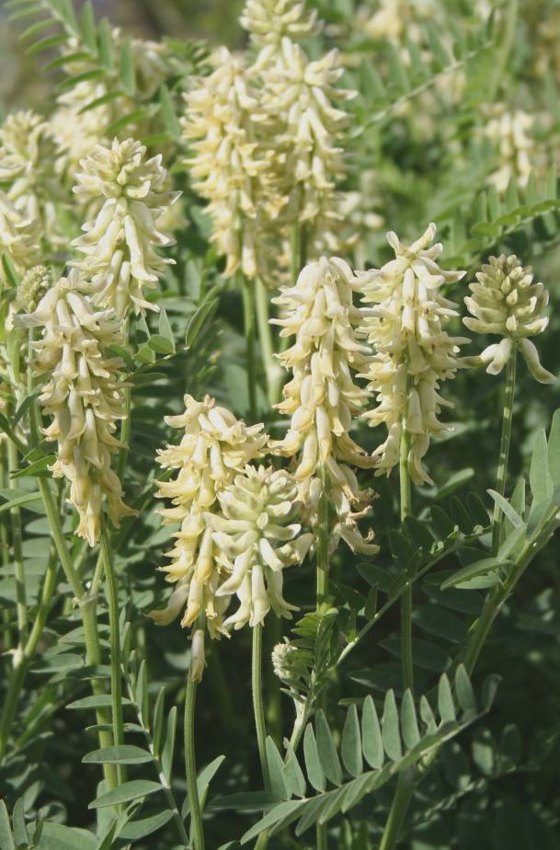Figure 1. Mature cicer milkvetch.

Derek J. Tilley, USDA NRCS Idaho PMC

Alternate Names

Chickpea milkvetch

Uses

*Hay/pasture*

Cicer milkvetch has many qualities that make it a viable choice as a non-bloat legume for hay or pasture. Yields of cicer milkvetch are generally comparable to those of alfalfa in areas with longer growing seasons (Baldridge and Lohmiller, 1990). Moisture content is 4 to 8% higher than that of alfalfa or sainfoin, and protein levels of 15 to 30% equal or exceed other legumes. The high protein content of cicer milkvetch is due, in part, to the high leaf to stem ratio (approximately 40% greater than alfalfa) and its ability to retain leaves during drying and baling (Baldridge and Lohmiller 1990). No bloating has been reported from grazing cicer milkvetch (Baldridge and Lohmiller 1990). Cicer milkvetch is not as palatable to grazing heifers as alfalfa, birdsfoot trefoil or sainfoin (Marten et al 1987). It is also less acceptable to sheep than alfalfa, birdsfoot trefoil and red clover (Marten et al 1990).

Stands of cicer milkvetch resist overgrazing because of its vigorous sod forming rhizomes. Recovery from grazing is rapid; however recovery after cutting for hay is relatively slow. Close grazing stimulates growth from the base of lower leaves, crowns and rhizome buds. This results in increased stand density following grazing. Forage yields under grazing average approximately 3 to 4 tons/ac. A study in Laramie, Wyoming showed more pounds of beef was produced on Lutana cicer milkvetch compared to Eski sainfoin, because the cicer milkvetch pasture improved each year over the four years of the study. Beef yield increases corresponded with the increase in forage.

*Wildlife*

Deer, elk and antelope have been documented eating cicer milkvetch year round, although it is less attractive than alfalfa and sainfoin. Seeds are eaten by small birds, deer, rabbit, sage grouse and pheasants (Stevens and Monsen, 2004).

*Stabilization of disturbed soils*

Cicer milkvetch has been successfully used in grass mixtures on streambanks, road cuts, mine spoils, and as a cover crop in orchards and windbreaks. Its extensive and prolific root system holds soil, and provides quick recovery and rapid growth in critical area plantings. Its nitrogen fixing ability also provides nitrogen to other species planted in reclamation mixtures. It is considered one of the better legumes for use in revegetating strip mines at higher elevations. It is better suited for wildlife due to its non-bloat nature as compared to alfalfa.

*Beautification*

Its abundant foliage and somewhat showy flowers makes cicer milkvetch an ideal vegetative cover for areas around summer homes and campgrounds (figure 1) (Stevens and Monsen 2004).

Status

Consult the PLANTS Web site and your State Department of Natural Resources for this plant’s current status (e.g. threatened or endangered species, state noxious status, and wetland indicator values).

Description

*General*: Legume family (*Fabaceae*). Cicer milkvetch is a long-lived, perennial, non-bloat legume with vigorous creeping roots or rhizomes. Stems are large and hollow, upright when young and becoming decumbent and trailing. Stems can reach 4 to 10 ft in length in one season. Young plants may reach heights of 3 ft, but older plants become more trailing in nature. Leaves are 4 to 8 in long with 10 to 13 pairs of leaflets, plus one terminal leaflet. Leaflets are ¾ to 2 ½ in long. Flowers are pale yellow to white with 15 to 60 flowers growing in a compact raceme. Pods are bladder-shaped and inflated turning black with maturity. Seeds detach within the pods and rattle. Pods do not shatter easily and may retain seeds through winter. Seeds are bright yellow or pale green, and are about twice as large as those of alfalfa (figure 2). The seeds have a very hard seed coat which requires chemical or mechanical scarification for adequate germination. There are approximately 130,000 seeds per pound and 65 pounds per bushel. Cicer milkvetch plants can live up to 35 yrs. 2n=2x=64 (Welsh et al 2003).

Cicer milkvetch is primarily pollinated by bumble bees, but may also be visited by other bee species including European honey bees and leaf cutter bees (Richards 1986). Plants are readily eaten by all classes of livestock as hay or pasture. The plants are also eaten by antelope, deer and elk. Cicer milkvetch plants contain no harmful alkaloids, nor do they accumulate toxic amounts of selenium.

*Nutrition*: Nutritional values for cicer milkvetch compare to other forage legumes such as alfalfa, birdsfoot trefoil and sainfoin. Cicer milkvetch has higher leaf:stem ratio and retains leaves longer in season than alfalfa, birdsfoot trefoil or sainfoin which equates to higher invitro dry matter digestibility (Loeppky et al 1996).

*Distribution*: For current distribution, consult the Plant Profile page for this species on the PLANTS Web site.

*Habitat*: Cicer milkvetch is native to moist places along streams and ditches of Europe from Finland and Sweden to Spain and east to Russia. The species is now established in pinyon-juniper, sagebrush, mountain shrub and aspen communities in the western United States (Welsh et al 2003).

Adaptation

Cicer milkvetch is best adapted to the Rocky Mountain region, but the species has a very wide range of adaptation (Baldridge and Lohmiller 1990). Trials including cicer milkvetch have shown that the species has good to excellent performance on coastal areas of Alaska south to Las Cruces, NM and also in the Central Plains west to the Cascade-Sierra ranges (Baldridge and Lohmiller, 1990).

Cicer milkvetch will grow in soils of all textures from clays to sands, but best performance comes from plants grown on moderately coarse textured soils. Plants are adapted to slightly acidic to slightly alkaline soils with pH levels of 6.0 to 8.1. The species is moderately salt tolerant. Production begins to be affected with EC >5ds/m and its upper limit is 10ds/m (Ogle et al 2004). These plants also do well on poor, disturbed soils making it useful for critical area plantings.

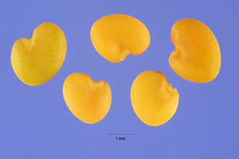

Figure 2. Cicer milkvetch seed. Photo by Steve Hurst, USDA NRCS PLANTS Database

Production fields of cicer milkvetch produce best on 18 to 35 inches of moisture annually, but the species also exhibits good drought tolerance and has been established on dryland sites in Idaho, Montana and Wyoming in areas receiving as little as 14 inches mean annual precipitation (Baldridge and Lohmiller 1990). It is recommended for use in regions receiving greater than 15 inches annual precipitation (Ogle et al 2008). Cicer milkvetch also does well on wet sites or on sub-irrigated sites where ground water is within 3 feet of the soil surface.

Hardy underground root crowns and prolific rhizomes prevent plants from being severely damaged by frost. The plants require only 30 days of frost free growth per season. This is fewer than that required by alfalfa. Cicer milkvetch has been grown in Idaho, Montana and Wyoming at elevations up to 7000 ft.

Establishment

Cicer milkvetch seed has an extremely hard seed coat which results in low germination of untreated seed. Seed coats respond well to mechanical or chemical scarification which facilitates air and water imbibition and allows germination. Moderate mechanical scarification works best. Too much mechanical scarring damages the embryos. Scarification is recommended immediately (within 1 week) prior to planting, because viability declines steadily after scarification. (Townsend and McGinnies 1972).

Establish cicer milkvetch in the same manner as alfalfa in a firm weed-free seed bed. If the soil is low in phosphorus, adding 200+ lb per acre incorporated into the soil during land preparation increases rate of growth and survival. Nitrogen should not be applied at time of establishment as it stimulates weed growth and competition.

Plant seed ½ to ¾ inches deep in April or May. However, if irrigation water is available, good stands can be achieved throughout the summer. Irrigate to prevent crusting and drying. Seed should be inoculated with *Astragalus* inoculum prior to planting. Do not plant with a nurse crop. Grasses planted with cicer milkvetch will out compete and shade out seedlings. When planted in a seed mix, plant cicer milkvetch and grasses in alternate rows.

Commercial seed should be at least 85 percent purity and 75 percent germination. Rates: 7 lb/ac for pure stands, 5 lb/ac for a mixture. For seed production fields use 24 inch rows with 4.2 lb/ac or 36 inch rows with 3.0 lb/ac.

Cicer milkvetch can be drill or broadcast seeded but drilling with a controlled depth followed by packer wheels provides best establishment.

Emergence occurs 10 to14 days after planting as compared to 7 to 10 days for alfalfa. Seedling vigor is good, and the growth rate of cicer milkvetch exceeds that of alfalfa as temperatures increase in summer.

Management

Cicer milkvetch is a long lived perennial, and stands normally improve with age due to the proliferation of plants via rhizomes. Leaves and stems stay green and succulent later into fall than alfalfa, but spring growth starts 14 to 28 days later than alfalfa. Growth rates increase with rising temperatures.

To control weeds during establishment mow weeds to an 8 inch height to keep weeds from overtopping cicer milkvetch seedlings and to reduce weed seed. Recovery after cutting for hay is typically slower than alfalfa.

In soils with low Phosphorus, application rates of 70+ lbs per acre Phosphorus annually are recommended. Stands with good Nitrogen fixing nodules should not require fertilization with Nitrogen unless there is a grass in the planting.

When harvested as hay in mountain areas, it is best if harvested in a two cutting regime because of slow spring growth and slow post cutting recovery. More frequent cutting decreases yield of cicer milkvetch hay. Yields and forage quality are also reduced if only cut once per season. First cutting should occur at 1/10th bloom stage (about 2 weeks later than 1/10th bloom of alfalfa). The second cutting should occur at the end of the growing season. Drying time is approximately 3 days longer than other legumes. Crimping the hay as it is cut or turning windrows reduces drying time by 30 to 50%.

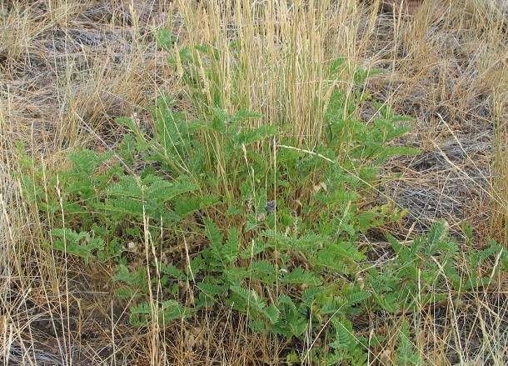

Figure 3. Cicer milkvetch grass- legume seeding mix.

Dan Ogle, USDA NRCS, Custer Co. Idaho.

*Grass/cicer milkvetch mixes*

Cicer milkvetch and grass mixtures can be successful when done correctly. Smooth brome and reed canarygrass suppress cicer milkvetch and should not be planted with it. Cicer milkvetch suppresses pubescent wheatgrass, western wheatgrass, Russian wildrye, switchgrass, timothy and Kentucky bluegrass and are also poor mixture choices. The most compatible grasses to plant with cicer milkvetch are creeping foxtail, meadow brome and orchardgrass in alternate row plantings. The use of alternate row plantings allows the establishment of cicer milkvetch. When planted in mixed rows with grasses, the grasses out-compete and over-shade the cicer milkvetch seedlings. Double seed rates for critical area reclamation plantings because of harsh site conditions (if broadcasting plant at least 2 times the drill seeding rate). Only use cicer milkvetch in critical area plantings in areas with greater than 15 inches mean annual precipitation.

Cicer milkvetch competes poorly with weeds during the establishment year and requires chemical or cultural weed control during stand establishment. Mature stands compete very well with weeds. Use trifluralin (pre-sowing); 2,4-DB (post emergence); trifluralin or 2,4-DB + bromoxynil on established stands (Moyer 1989). Read and follow all pesticide labels.

Pests and Potential Problems

Root, crown and stem rot (*Sclerotinia trifoliorum*) is a common problem for cicer milkvetch. It is indicated by wilting and death of aerial portions of the plant and by black sclerotial bodies on or inside stems.

Recovery of plants from this disease is commonly due to prolific rhizome activity. Recovered plants may not be affected in subsequent years. Infestations occur in hot humid weather and usually affect <10 percent of the field.

Aphids, thrips, seed chalced and grasshoppers have all been identified on cicer milkvetch. Grasshoppers eat the flowers as well as seed pods. Approximately 30 grasshoppers/yard² reduces seed yields by 80%. Chemical control of insect pests can be detrimental to bumblebee pollinators. If grasshoppers approach 30/yd2, cicer should be cut for hay or the field used for grazing. Hewitt et al (1982) however showed that grasshoppers preferred sainfoin, sweetclover, hairy vetch and crown vetch over cicer milkvetch, alfalfa and birdsfoot trefoil and recommended using cicer milkvetch for range plantings for this reason.

In trials conducted in north-central U.S. heifers and sheep grazed on pure stands of cicer milkvetch developed a photosensitization response. This affect has not been documented in other locations. The photosensitization is presumed to be related to high levels of phyllocrythrin in the blood, a normal by-product of chlorophyll breakdown (Marten et al 1987; Marten et al 1990).

Environmental Concerns

This species is native to Europe and was introduced into the US in the 1920s for testing by agricultural scientists for use as a forage legume. It has since been widely used throughout the west and has become naturalized in many localities. It is not considered weedy or invasive, but may spread under ideal conditions via seed or rhizomes.

**Seeds and Plant Production**

Average seed yields range from 400-600 lb/ac in Montana and Wyoming. Yields as high as 1000 lb/ac have been recorded. Dryland yields average between 100 and 200 lb/ac.

Cicer milkvetch requires 30 to 50 frost-free days. Plant at 20 to 36 inch row spacing to allow between-row cultivation and hand rouging. Wide rows also provide better moisture use in dryland settings. Establish seed production fields as described in establishment section. Bumble bees are the primary pollinator and are necessary for good seed production. Locate fields within ¼ mile of native bumblebee habitat for pollination.

Water should be controlled to 16 to 20 inches. Apply sparingly during bloom, but do not allow plants to wilt.

Harvest seed about the first week in September for low elevations (later at higher elevations). Seed shatter is typically not a concern. Windrow and allow seed to dry at least one week before combining. Light due or high humidity can cause the pods to become leathery and difficult to thrash. Delay combining until pods are brittle. Combine with cylinder speeds of 6000 to 6500 feet per minute (160 rpm for 15 inch cylinder). Rethreshing tailings can increase seed yield by 20%.

Seed fields can be kept in production up to 5 years. Declines in production over time occur due to weed invasion and reduced vigor and stand under seed production management.

Cultivars, Improved, and Selected Materials (and area of origin)

‘HiPal’ is a 16-clone synthetic released by the Minnesota Agricultural Experiment Station in 2001. It is known for being extremely winter hardy as well as being bloat-safe and high grazing tolerance. It may however have poor palatability when compared to alfalfa or birdsfoot trefoil. This release has not been tested in the western U.S.

‘Lutana’ was developed from 127 plants selected for early spring growth, rapid recovery after cutting, rapid rhizome spread, and uniformity of seed maturation. The cultivar was released in 1970 cooperatively by the Bridger, Montana Plant Materials Center, the Montana Agricultural Experiment Station and the Wyoming Agricultural Experiment Station. Forage production of Lutana is slightly less than adapted varieties of alfalfa, except in areas where alfalfa would be affected by frost or excessive moisture (Stroh et al, 1972). Foundation seed is maintained by the Bridger, MT PMC.

‘Monarch’ was developed as a 40-clone synthetic cultivar with improved seedling emergence over Lutana. Polycross progenies had 125 to 200% better seedling emergence than Lutana and forage yields were similar to those of Lutana. Parental clones and breeder seed are maintained by the Crops Research Laboratory, AR-SEA-USDA, Colorado State University, Fort Collins, CO.

‘Windsor’ is a 15 clone-synthetic released by the USDA-ARS, the Colorado Agricultural Experiment Station and the Wyoming Agricultural Experiment Station in 1993. The plants involved in development were selected for excellent regrowth following an early August harvest. Clones and breeder seed are maintained by the USDA-ARS, Fort Collins, CO. Windsor was exclusively released to Peterson Seed Co., Inc, Savage, MN.

‘AC Oxley II’ is a synthetic cultivar developed by the Agriculture and Agri-Food Canada Research Centre released in 2001. Oxley II was developed for improved seedling vigor and forage yield. Oxley II also yields approximately 10% more seed than Oxley under irrigation. Breeder seed is maintained by Agriculture and Agri-food Canada Research Centre, Lethbridge, AB. Seed distribution rights are granted to Prairie Seeds Inc and Newfield Seeds Co. Ltd.

References

Baldridge, D.E. and R.G. Lohmiller, eds. 1990. Montana interagency plant materials handbook. Montana State University, Bozeman, MT. 337p.

Hewitt, G.B., Wilton, A.C. and R.J. Lorenz. 1982. The suitability of legumes for rangeland interseeding and as grasshopper food plants. Journal of Range Management. 35: 653-656.

Loeppky, H.A., Bittman, S., Hiltz, M.R. and B. Frick. 1996. Seasonal changes in yield and nutritional quality of cicer milkvetch and alfalfa in northeastern Saskatchewan. Canadian Journal of Plant Science. 76: 441-446.

Marten, G.C., Ehle, F.R. and E.A. Ristau. 1987. Performance and photosensitization of cattle related to forage quality of four legumes. Crop Science. 27: 138-145.

Marten, G.C., Jordan, R.M. and E.A. Ristau. 1990. Performance and adverse response of sheep during grazing of four legumes. Crop Science. 30: 860-866.

Moyer, J.R. 1989. Weed control during cicer milkvetch establishment and yields in subsequent years. Canadian Journal of Plant Science. 69: 213-222.

Ogle, D., Majerus, M., and L. St. John. 2004. Plants for saline to sodic soil conditions. Natural Resources Conservation Service. Boise, Idaho. Idaho Technical Note No. 9. 12p.

Ogle, D., L. St. John, M. Stannard, L. Holzworth. 2008. Grass, Grass-Like, Forb, Legume and Woody Species for the Intermountain West. Natural Resources Conservation Service. Boise, Idaho. Idaho Technical Note No. 24. 43p.

Richards, K.W. 1986. Pollination requirements for cicer milkvetch. Journal Range Management 39: 457-459.

Stevens, R. and S.B. Monsen. 2004. Forbs for seeding range and wildlife habitats. In: S.B. Monsen, R. Stevens, and N.L. Shaw [compilers]. Restoring western ranges and wildlands. Fort Collins, CO: USDA Forest Service, Rocky Mountain Research Station. General Technical Report RMRS-GTR-136-vol-2. p. 425-466.

Stroh, J., A. Carleton, and W. Seamands. 1972. management of Lutana cicer milkvetch for hay, pasture, seed and conservation uses. Research Journal, Agricultural Experiment Station, University of Wyoming. Laramie, WY. No. 66, 17 pp.

Townsend, C.E., and W.J. McGinnies. 1972. Establishment of nine forage legumes in the central Great Plains. Agronomy Journal. 64: 699-702.

Townsend, C.E. 1993. Breeding, physiology, culture and utilization of cicer milkvetch (Astragalus cicer L) Advances in Agronomy. 49: 253-308.

Welsh, S. L., N. D. Atwood, S. Goodrich and L. C. Higgins. 2003. *A Utah Flora*. Brigham Young University Press. Provo, Utah. 912 p.

Prepared By

*Derek Tilley*, Range Conservationist (Plants), USDA NRCS Plant Materials Center, Aberdeen, Idaho

*Dan Ogle*, Plant Materials Specialist, USDA NRCS Idaho State Office, Boise, Idaho

*Loren St. John*, Manager, USDA NRCS Plant Materials Center, Aberdeen, Idaho

Species Coordinator

*Dan Ogle*, Plant Materials Specialist, USDA NRCS Idaho State Office, Boise, Idaho

Edited: 31jan08 djt; 31jan08 dgo; 31jan08 lsj; 081008 jsp

For more information about this and other plants, please contact your local NRCS field office or Conservation District, and visit the PLANTS Web site<<http://plants.usda.gov>> or the Plant Materials Program Web site <<http://Plant-Materials.nrcs.usda.gov>>

*The U.S. Department of Agriculture (USDA) prohibits discrimination in all its programs and activities on the basis of race, color, national origin, sex, religion, age, disability, political beliefs, sexual orientation, and marital or family status. (Not all prohibited bases apply to all programs.) Persons with disabilities who require alternative means for communication of program information (Braille, large print, audiotape, etc.) should contact USDA's* [*TARGET Center*](http://www.usda.gov/oo/target.htm) *at 202-720-2600 (voice and TDD).*

*To file a complaint of discrimination write USDA, Director, Office of Civil Rights, Room 326-W, Whitten Building, 14th and Independence Avenue, SW, Washington, DC 20250-9410 or call 202-720-5964 (voice or TDD). USDA is an equal opportunity provider and employer.*

*Read about* [*Civil Rights at the Natural Resources Convervation Service*](http://www.nrcs.usda.gov/about/civilrights/)*.*