

Plant Guide

# heliotrope milkvetch

## Astragalus limnocharis Barneby var. montii (S.L. Welsh) Isely

Plant Symbol = ASLIM

*Contributed by*: USDA NRCS Idaho and Utah Plant Materials Program

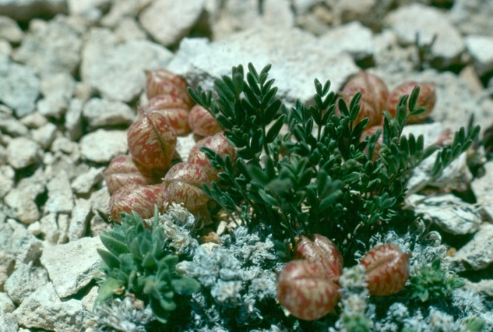**Heliotrope milkvetch (Astragalus limnocharis var. montii). Photo by Duane Atwood**

### Uses

There are no known human uses of heliotrope milkvetch. Sheep are known to graze the leaves and stems.

### Status

Heliotrope milkvetch was listed as a threatened species with critical habitat in 1987 (USDI-FWS, 1987). It is considered a species with a low degree of threat and a low recovery potential.

Consult the PLANTS Web site and your State Department of Natural Resources for this plant’s current status (e.g., threatened or endangered species, state noxious status, and wetland indicator values).

### Description

*General*: Legume family (Fabaceae). Heliotrope milkvetch is a low growing perennial forb. The leaves are pinnately compound with 5 to 13 leaflets; each 2 to 8 mm (0.08 to 0.3 in) long and 1 to 2 mm (0.04 to 0.08 in) wide. The stems and leaves have basally fixed hairs; the leaves are glabrous above and hairy on the underside. Two to 8 flowers are born in a loose raceme. The flowers are pinkish purple with

white tips on the wing petals. The fruit is an oval shaped, inflated pod, 11 to 18 mm (0.4 to 0.7 in) long and 8 to 12 mm (0.to 0.5 in) wide, mottled with pinkish brown freckles (Welsh et al., 2003).

*Distribution*:

Heliotrope milkvetch is known from three populations in Sanpete and Sevier Counties, Utah. All populations are located within the boundaries of the Manti-Lasal National Forest. Two populations occur on Heliotrope Mountain and the third is located on White Mountain. In total, the three populations cover an estimated 390 acres and comprise approximately 200,000 individuals (USDI-FWS, 1995).

For current distribution, consult the Plant Profile page for this species on the PLANTS Web site.

*Habitat*:

Heliotrope milkvetch grows in the subalpine zone from 3,200 to 3,350 m. (10,500 to 11,000 ft) in shale barrens of the Flagstaff Limestone formation. It can be found at timberline on plateaus and openings in spruce-fir forests growing with other alpine, mat-forming species.

**Adaptation**

This species is adapted to windswept plateaus at timberline in the Flagstaff Limestone formation. Average precipitation on the plateaus ranges from 76 to 90 cm (30 to 35 in).

### Management

The primary threat to heliotrope milkvetch comes from oil and gas exploration and development. The species occurs in an area with potential for oil and gas development. Any habitat disturbance from oil and gas exploration could have a significant negative impact on the survival of the species.

Limited sheep grazing occurs in heliotrope milkvetch habitat; however negative impacts to the populations from the current grazing levels have not been observed (USDI-FWS, 1995).

### Pests and Potential Problems

There are no known pests or potential problems regarding heliotrope milkvetch*.*

### Environmental Concerns

There are no known environmental concerns regarding heliotrope milkvetch*.*

### Seeds and Plant Production

Plants flower immediately after winter snow melt in mid-June. The species can self pollinate, but is primarily an outcrosser. The flowers are pollinated by multiple species of mason bees (*Osmia* spp.) (Greer et al., 1995).

### References

Greer, S.M., Tepedino, V.J., Griswold, T.L. and W.R. Bowlin. 1995. Pollinator sharing by three sympatric milkvetches, including the endangered species *Astragalus montii*. Great Basin Naturalist. 55(1): 19-28.

USDI-FWS. 1987. Endangered and threatened wildlife and plants; final rule to determine *Astragalus montii* (Heliotrope milkvetch) to be threatened species, with designation of critical habitat). In: Federal Register. 52(215): 42652-42657.

USDI-FWS. 1995. Heliotrope milkvetch (*Astragalus montii*) recovery plan. U.S. Fish and Wildlife Service. Denver, Colorado. 11pp.

Welsh, S.L., N.D. Atwood, S. Goodrich, and L.C. Higgins. 2003. A Utah Flora. Third Edition, revised. Brigham Young University, Provo, UT.

**Prepared By**:

*Derek Tilley*; USDA NRCS Plant Materials Center, Aberdeen, Idaho.

*Loren St. John*, USDA NRCS Plant Materials Center, Aberdeen, Idaho.

*Dan Ogle*, USDA NRCS, Boise, Idaho.

### Citation

Tilley, D., L. St. John and D. Ogle. 2010. Plant guide for heliotrope milkvetch (*Astragalus limnocharis* var*. montii*). USDA-Natural Resources Conservation Service, Idaho Plant Materials Center. Aberdeen, ID.

Published Jan 2010

Edited: 03Jan2011 djt, 03Jan2011dgo, 03Jan2011lsj

For more information about this and other plants, please contact your local NRCS field office or Conservation District at http://www.nrcs.usda.gov/ and visit the PLANTS Web site at http://plants.usda.gov/ or the Plant Materials Program Web site http://plant-materials.nrcs.usda.gov.

PLANTS is not responsible for the content or availability of other Web sites.

**USDA IS AN EQUAL OPPORTUNITY PROVIDER AND EMPLOYER**