|  |  |
| --- | --- |
| **Natural Resources Conservation Service** | Plant Guide |

## Mead’s Milkweed

## *Asclepias meadii* Torr. ex A. Gray Plant Symbol = ASME

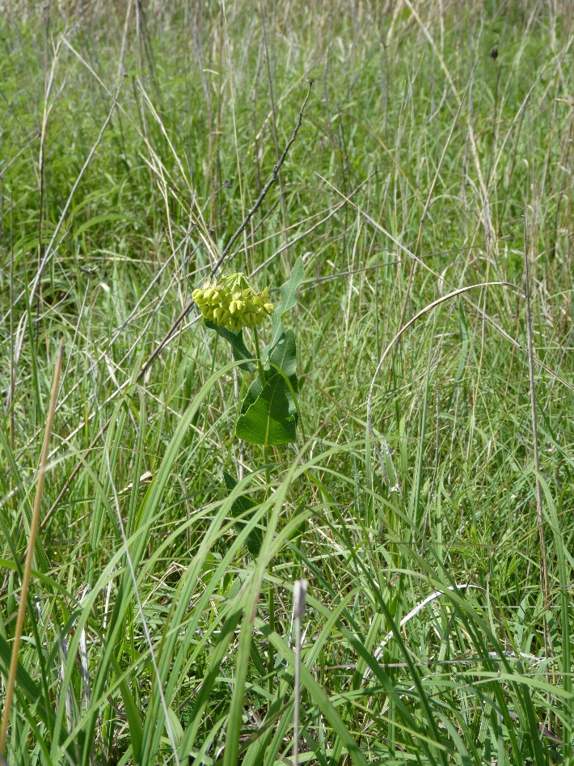

Mead's milkweed flowering on the Salac Prairie, John M. Row, NRCS, Manhattan, Kansas

### Alternate Names

### None

Warning: Mead’s milkweed is a protected species under the Endangered Species Act. Seed or plants may not be harvested from federal lands without a permit from the United States Fish and Wildlife Service (USFWS).

### Description

*General*: A rare, long-lived, herbaceous perennial of the ASCLEPIDACEAE, Mead's milkweed grows from a slender rhizome; the stems (ramets) usually solitary, grow to as much as 5 dm tall (Hartman 1986). Several ramets may arise from a genet (Kettle et al. 2000). The leaves opposite, sessile, glabrous except for the margins, lanceolate to broadly ovate, 4 to 8 cm long and 1 to 4.5 cm wide (Hartman 1986) on mature plants. Ramets produce solitary umbels on elongated peduncles. The characteristically hooked peduncles cause the umbels to nod, a characteristic unique among milkweeds (Betz 1989). Umbels produce 1 to 26 (12 on average) greenish-yellow flowers from late May to early June (Bare 1979; Betz 1989; Bowles et al. 1998). One, rarely two, erect, long, narrowly spindle-shaped pods 8 to 12 cm long and 1.3 cm in diameter are produced on deflexed pedicels (Betz 1989; Hartman 1986).

*Historical:*  With the advent of the plow, *Asclepias* *meadii* quickly disappeared from much of the landscape as native prairie was converted to cultivated land. Range-wide populations of the species occur mostly on privately owned, tallgrass prairie remnants, most of which are hayed annually. Populations also occur on tallgrass prairie preserves, remnant prairies along railroads, and land not suitable for cultivation in the eastern parts of the species range.

A physician-botanist named Dr. Samuel Barnum Mead first collected *A. meadii* in western Illinois in 1843. John Torrey identified the plant as a new species and named it for Dr. Mead (Betz 1989).

*Distribution*: In pre-settlement times, Mead’s milkweed probably was widely but sporadically distributed through the tallgrass prairie region of the central United States from east-central Kansas and southern Missouri, north to central Iowa and southwestern Wisconsin, and east to southern Illinois and northwestern Indiana (Betz 1989). Extant populations are known in eastern Kansas, Missouri, south-central Iowa, and southern Illinois (USFWS 2003). For current distribution, please consult the Plant Profile page for this species on the PLANTS Web site.

*Habitat*: Mead’s milkweed is found in unplowed tallgrass prairie on mesic to dry mesic upland sites (Betz and Lamp 1992). On deep silt-loam soils, it can be found growing in association with grasses such as big bluestem (*Andropogon gerardii*), Indian grass (*Sorghastrum nutans*), and prairie dropseed (*Sporobolus* *heterolepis*), and with prairie forbs such as purple prairie-clover (*Dalea purpurea*), white prairie-clover (*D. candida*, compass plant (*Silphium* *laciniatum*), and prairie gentian (*Gentiana puberulenta*) (Betz 1989).

**Conservation**

Mead’s milkweed occurs on some state, federal, and private prairies where restoration efforts are underway to augment existing populations to improve genetic diversity of the species. Due to scarce resources, progress will be slow.

Status

Mead’s milkweed is federally listed by the USFWS as a threatened species across its range (USFWS 1988).

*State Listings:* Endangered—Illinois, Iowa, and Missouri; Reintroduced—Indiana

Please consult the PLANTS Web site (<http://plants.usda.gov/>) and your state’s Department of Natural Resources for this plant’s current status (e.g., threatened or endangered species, and wetland indicator values).

**Plant Collection**

Check state and local laws regarding the status of Mead’s milkweed before collecting any part of this plant. For example, in Iowa, it is prohibited to take, possess, import, export, transport, process, sell, or buy Mead’s milkweed or any other state or federally listed plant (USFWS 2003).

If collection is permitted in your state and once permission has been obtained from the landowner, collect only a limited number of pods from any one area.

### Planting Guidelines

Mead’s milkweed is self-incompatible (Betz, 1989) so several sources of genetic material should be included in a planting. Seedlings may be set out in the spring. However, success in establishment may be limited (Row and Wynia 2001). Water in seedlings, and if conditions are dry, water a larger surrounding area to reduce the chance of rodent damage. Protect the seedlings from rodents until established. Set the young plants out in a random fashion in open areas of the prairie avoiding areas disturbed by rodent activity. Seedling cohort survivorship was low for Bowles et al. (1998), at about 10%, while survivorship of planted rhizomes was 50% for two or three growing seasons.

### Management

Mead’s milkweed responds well to an annual spring burn that removes the previous year’s growth of dead vegetation. Exclude areas containing Mead’s milkweed from mowing until after the seeds have disbursed in the fall.

### Pests and Potential Problems

Sucking insects, such as thrips, are a problem in greenhouse culture. They cause spotting of the leaves by destroying chlorophyll-bearing cells. Aphids are a common pest of milkweeds causing distortion of terminal buds and leaves. The milkweed bug and lesser milkweed bug are known to feed on pods but appear to cause little harm. Monarch butterfly caterpillars have also been known to feed on leaves. Cerambycid milkweed beetles cause damage to flowers, and their larvae bore into stems and roots (Betz 1989).

### Pollinators

### The uncommon to rare mining bee (Anthophora abrupta) was thought to be the principle pollinator of Mead’s milkweed flowers. Honeybees, bumblebees, and prairie bumblebees have also been suggested as pollinators (Betz et al. 1994).

### Environmental Concerns

None

### Seeds and Plant Production

Flowers pollinated by the first week of June develop ripe follicles by the second week of September (Betz 1989). Seeds per pod range from 30 to 120 (average is 67). There are approximately 5973 seeds per ounce of seed. The majority of the seeds placed in a growth chamber set at 20°/24°C alternating temperature, germinated within 3 days following a period of cold, moist stratification at 3°C to 4°C (Row 2016). Betz (1989) reported germination results from seeds planted in soil in a greenhouse to be 47.6%, which he considered low. Row (2016) found similar germination test results at 46.3%, not excluding abnormal seedlings. Stratified seed may be planted in a soil-less mix or in a well-drained soil consisting of 1/3 sand and 2/3 loam. The long petioles of the cotyledons usually emerge within 2 weeks in a greenhouse culture (Betz 1989). Seed may also be direct seeded in the fall.

**Literature Cited**

Bare, J. E. 1979. ASCLEPIADACEAE. Wildflowers and Weeds of Kansas. The Regents Press of Kansas, Lawrence. p. 279-289.

Betz, R. F. 1989. Ecology of Mead’s Milkweed (*Asclepias meadii* Torrey), p. 187-191 *in* T. B. Bragg and J. Stubbendieck (eds.) Proc. Eleventh North American Prairie Conference. Univ. of Nebraska, Lincoln.

Betz, R. F. and H. F. Lamp. 1992. Flower, pod, and seed production in eighteen species of milkweeds (*Asclepias*) *In*: D. D. Smith and C. A. Jacobs (eds.) Pro­c. of the Twelfth North American Prairie Conference, edited by, 25–30. University of Northern Iowa, Cedar Falls.

Betz, R. F., R. D. Struven, J. E. Wall, and F. B. Heitler. 1994. Insect pollinators of 12 milkweed (*Asclepias*) species. P. 45-60 *in* T. B. Bragg and J. Stubbendieck (eds.) Proc. of the Thirteenth North American Prairie Conference. Univ. of Nebraska, Lincoln.

Bowles, M. L., J. L. McBride, and R. F. Betz. 1998. Management and Restoration Ecology of the Federal Threatened Mead’s Milkweed, *Asclepias meadii* (ASCLEPIADACEAE). Ann. Missouri Bot. Gard. 85: 110-125

Hartman, R. L. 1986. ASCLEPIADACEAE. p. 614-635 *in* T. M. Barkley (ed.) Flora of the Great Plains. Great Plains Flora Association, Univ. Press of Kansas. Lawrence.

Kettle, W. D., H. M. Alexander, and G. L. Pittman. 2000. An 11-year Ecological Study of a Rare Prairie Perennial (*Asclepias meadii*): Implications for Monitoring and Management. Am. Midl. Nat. 144: 66-77.

Row, J. M. and R. L. Wynia. 2001. Mead’s milkweed – Easy to germinate, more difficult to establish. Ecological Restoration 19:1 49-50.

Row, J. M. 2016. Propagation and establishment of Mead’s Milkweed final study report. 40 p. http://www.nrcs.usda.gov/Internet/FSE_PLANTMATERIALS/publications/kspmcsr12823.pdf

U.S. Fish and Wildlife Service. 1988. Endangered and threatened wildlife and plants; determination of threatened status for *Asclepias meadii* (Mead’s milkweed). *Federal Register*, 53: 33992-33995.

U.S. Fish and Wildlife Service. 2003. Mead’s milkweed (*Asclepias meadii* Torr.) Recovery Plan. U.S. Fish & Wildlife Service, Fort Snelling, MN. 120 pp.

### 

### Citation

Row, J. M. 2015. Plant Guide for Mead’s milkweed (*Asclepias meadii*). USDA-Natural Resources Conservation Service. Manhattan, Kansas 66502.

Published: September 2015

Edited: 19Aug15 ccf; 13Apr16 jmr

For more information about this and other plants, please contact your local NRCS field office or Conservation District at <http://www.nrcs.usda.gov/> and visit the PLANTS Web site at <http://plants.usda.gov/> or the   
Plant Materials Program Web site:

<http://plant-materials.nrcs.usda.gov>.

PLANTS is not responsible for the content or availability of other Web sites.

***Helping People Help the Land***

**USDA IS AN EQUAL OPPORTUNITY PROVIDER AND EMPLOYER**