|  |  |
| --- | --- |
| **Natural Resources Conservation Service** | Plant Guide |

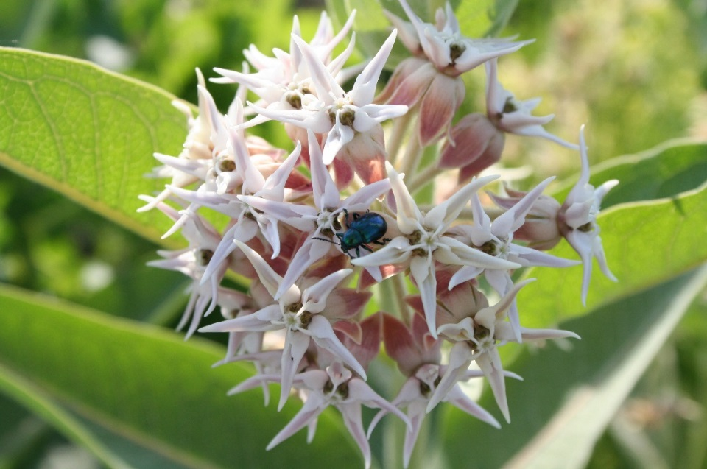**SHOWY MILKWEED**

**Asclepais speciosa Torr.**

Plant Symbol = ASSP

### Description

*General*: Milkweed Family (Asclepiadaceae). Showy milkweed is a native herbaceous perennial from widespread rhizomes, which produce stems that grow to 1½ to 5 ft tall in summer. The gray-green leaves are opposite, 4 to 7 inches long, oval, and covered in velvety hairs. Stems and foliage exude milky latex sap when cut. Flowers are in loose clusters at the top of the stems and are rose-purple, aging to yellow. Individual *Asclepias* flowers look like crowns, with the corolla (petals) reflexed, and hoods above the corolla. Plants flower from May to September. Thick seed pods 3 to 5 inches long split down one side in fall to release reddish-brown, flat seeds. Each seed has a tuft of white, silky hairs that allows them to be dispersed by wind. Leaves of first year plants are much narrower, about 0.5 inches wide, causing the plant to often be mistaken for other narrow-leaved species of milkweed.

*Distribution*:

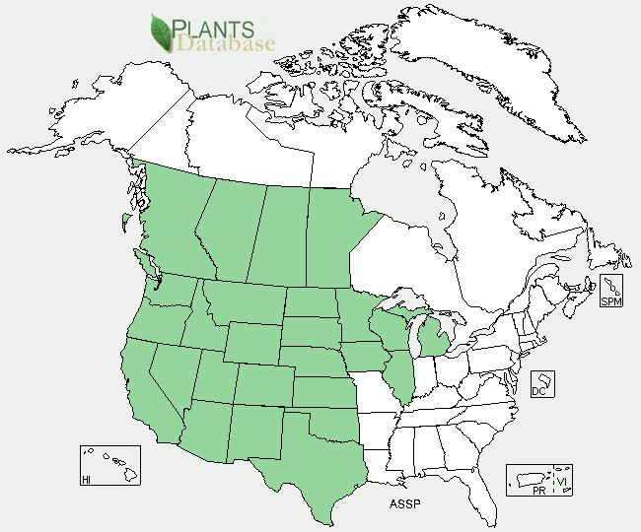For current distribution, please consult the Plant Profile page for this species on the PLANTS Web site. The plant occurs in California to British Colombia and Central Canada south to Texas.

*Habitat*: Showy milkweed is adapted to a broad range of moisture conditions. It is very commonly found along canal banks and riparian sites and in sub-irrigated or occasionally flooded wetlands with sedges and rushes. Populations can also be found however in very dry sites receiving less than 9 inches annual precipitation, though these populations are likely to be located in depressions where water accumulates.

***Adaptation***

This species typically grows in sites receiving 16 to 30 inches annual precipitation, but can be found in drier sites. It is adapted to a range of soil types, but prefers well-drained soils with a pH range of 5.0 to 7.0 (USDA NRCS 2016).

### Uses

*Insectary*: Milkweed species are attractive to butterflies, bees, and other insects. Accordingly, this is a good horticultural plant for floral landscaping to attract butterflies (particularly Monarchs) and other insects. Monarch butterflies are specific to milkweed plants. This is the only type of plant on which the eggs are laid and the larvae will feed and mature into a chrysalis. It is important to have large clumps of milkweeds for the young caterpillars; their response to predation is to drop to the ground and "play possum." They cannot find their way back to the milkweed stems, which they need to survive, unless they are fairly densely spaced.

Monarch, Queen and Viceroy butterflies are Müllerian mimics; all are toxic, and have co-evolved similar warning patterns to avoid predation. Other insects, which utilize milkweed, include the large milkweed bug, common milkweed bug, red milkweed beetle, blue milkweed beetle, and bees.

Milkweed sap contains a lethal brew of cardenolides (heart poison), which produces vomiting in low doses and death in higher doses. Chemicals from the milkweed plant make the monarch caterpillar's flesh distasteful to most animals.

### Ethnobotany

### People have used milkweed for fiber, food, and medicine all over the United States and southern Canada. Fibers from the stems of milkweed have been identified in prehistoric textiles in the Pueblo region. Tewa-speaking people of the Rio Grande still make string and rope from these fibers. At Zuni, the silky seed fibers are spun on a hand-held wooden spindle and made into yarn and woven into fabric, especially for dancers. Pueblo people ate green milkweed pods and uncooked roots from one of the species that forms fleshy tubers underground.

Milkweeds (especially *Asclepias speciosa*) supply tough fibers for making cords and ropes, and for weaving a coarse cloth. Milkweed stems were collected after the stalks dried in late fall early winter. The dried stalks were split open to release the fibers; milkweed fibers were sometimes mixed with fibers of Indian-hemp (*Apocynum cannabinum*). The bark is removed and the fibers released by first rubbing between the hands and then drawing the fibers over a hard surface. Twisting the fiber opposite each other and twining them together formed the cord; often this was accomplished by rolling the fibers on the thigh while twisting them together.

Vast quantities of fiber plants are required for the making of nets, regalia, and cordage by California Indians. Blackburn and Anderson (1993) quote Craig Bates of the Yosemite Museum that it takes approximately five stalks of milkweed or Indian hemp to manufacture one foot of cordage. A Sierra Miwok feather skirt or cape contain about 100 feet of cordage made from approximately 500 plant stalks, while a deer net 40 feet in length contained some 7,000 feet of cordage, which would have required the harvesting of a staggering 35,000 plant stalks, (Barrett and Gifford 1933).

Milkweed has also been used as a food source by Native Americans. The young shoots, stems, flower buds, immature fruits, and roots of showy milkweed were boiled and eaten as a vegetable by various indigenous groups of eastern and mid-western America. In some areas the young leaves and stems were used as greens. The flowers were also eaten raw or boiled, and the buds were boiled for soup or with meat. The most common use for these plants, recorded among almost all the tribes throughout California, was to obtain a kind of chewing gum from the sap of showy milkweed. The sticky white sap was heated slightly until it became solid, then added to salmon fat or deer grease.

The sap of showy milkweed was used as a cleansing and healing agent by some of the desert tribes for sores, cuts, and as a cure for warts and ringworm. The silky hairs were burned off the ripe seeds, which were then ground and made into a salve for sores. Seeds were boiled in a small amount of water and the liquid used to soak rattlesnake bites to draw out the poison. A hot tea made from the roots was given to bring out the rash in measles or as a cure for coughs. It was also employed as a wash to cure rheumatism. The mashed root, moistened with water, was used as a poultice to reduce swellings.

### Status

*[Threatened or Endangered](#status1" \o "Yes or no answer and/or state information)*[:](#status1" \o "Yes or no answer and/or state information)  This plant is listed as threatened in Iowa (USDA NRCS 2016).

*[Wetland Indicator:](#status2" \o "Use indicator code, e.g. facultative (FAC) )* FAC

*[Weedy or Invasive:](#status3" \o "Include statement, if necessary, shown below.  Also include states where the species is listed, if applicable.)* Showy milkweed may become weedy or invasive in some regions or habitats and may displace desirable vegetation if not properly managed (Whitson 1996). The light wind-dispersed seed allows it to invade agricultural fields. It also increases and spreads under grazing as most animals will avoid it while targeting preferred forage. Please consult with your local NRCS Field Office, Cooperative Extension Service office, state natural resource, or state agriculture department regarding its status and use.

Please consult the PLANTS Web site (<http://plants.usda.gov/>) and your state’s Department of Natural Resources for this plant’s current status (e.g., threatened or endangered species, state noxious status, and wetland indicator values).

### Planting Guidelines

Showy milkweed can also be direct seeded in late fall to allow for natural stratification during winter. The full stand seeding rate to apply 25 to 30 seeds/ft is 8 lbs/ac. The seeding rate should be adjusted to reflect the desired percentage in a seed mixture. Seed should be planted shallow, no more than 0.25 inches.

### Management

Milkweed thrives in disturbed sites where competition from other species is reduced. Grazing or burning in the fall or spring can open niches, reduce competition and increase sunlight for milkweed plants to establish and spread. Both milkweed and dogbane were burned in the fall by California Indian tribes to eliminate dead stalks and stimulate new growth. Burning causes new growth to have taller, straighter stems with longer fibers. It also stimulates flower and seed production.

**Pests and Potential Problems**

Insects besides butterflies that tolerate milkweed toxins include the large milkweed bug (*Oncopeltus fasciatus*), common milkweed bug (*Lygaeus kalmii*), red milkweed beetle (*Tetraopes tetrophthalmus*), blue milkweed beetle (*Chrysochus cobaltinus*), and some aphids (*Aphis* spp.). These insects can occasionally cause feeding damage.

**Environmental Concerns**

Showy milkweed is native to North America and is a natural component of many ecosystems; however, it can become problematic in agricultural settings.

Several species of milkweed are highly toxic and have caused poisonings in a wide range of livestock including chickens, rabbits, horses, cattle, sheep and goats (Panter et al., 2014). However, showy milkweed is considered to pose considerably less of poisoning than other species (Burrows and Tyrl 2001). Showy milkweed is much less likely to be accidentally grazed in high quantities because it is distinctly different in appearance from neighboring grasses, while other milkweeds with fine, narrow leaves are prone to accidental ingestion in large quantities.

Although showy milkweed is bitter and typically avoided by cattle, cows will graze it when other forage is unavailable. Cows were observed grazing showy milkweed leaves and shoots to the ground in southeast Idaho after forage grasses had become coarse.

### Control

Please contact your local agricultural extension specialist or county weed specialist to learn what works best in your area and how to use it safely. Always read label and safety instructions for each control method. Trade names and control measures appear in this document only to provide specific information. USDA NRCS does not guarantee or warranty the products and control methods named, and other products may be equally effective.

### Seeds and Plant Production

Pods ripen indeterminately on the plant. Some after-ripening can be expected, but it is best to collect seed when pods are ready to split and seed is brown. Aberdeen PMC places pods on bed frames lined with ¼ inch hardware cloth. As the pods mature and are stirred the seed falls through mesh while the pod halves and the coma hair remains above. The hair can be easily vacuumed off with a shop vac. Corvallis PMC shovels dried pods into a combine and allows the combine to separate seed from the fluff.

Counts done at the Aberdeen, Idaho Plant Materials Center indicate there are approximately 240 seeds in each pod and 70,000-80,000 seeds/lb, so approximately 300 pods are needed to collect one pound of cleaned seed.

Showy milkweed seed is often dormant and requires a cold stratification treatment for germination; however seed collections in southeast Idaho and central California germinated at IDPMC did not require any stratification for full germination. Landis and Dumroese (2015) recommend cleaning the seed in a running water rinse prior to stratification.

Aberdeen PMC grows showy milkweed in 10 ci conetainers, by sowing approximately 5 seeds/cone covered lightly with gravel. Stratification has not been necessary for adequate germination. Soil is kept moist via overhead misting during the germination period. As plants develop the watering duration is increased to encourage root growth. Some thinning may be required but the PMC typically lets the plants stay thick because the taproot doesn’t fill the cone well. Transplant success has been good as long as the soil is kept moist. Another option is to use Jiffy Peat Pots or other media that retains its shape and structure during planting (Landis and Dumroese 2015).

Propagation by rhizome cuttings is easy and reliable. The cuttings should be dug when the plant is dormant (generally from October through February or April depending on temperatures). Each piece of rhizome should have at least one bud. Plant the rhizomes 4 to 6 inches deep. Irrigation the first year will improve survival. Both seedlings and cuttings will usually bloom in the second year, although cuttings will occasionally bloom their first year (Young-Mathews and Eldredge 2012).

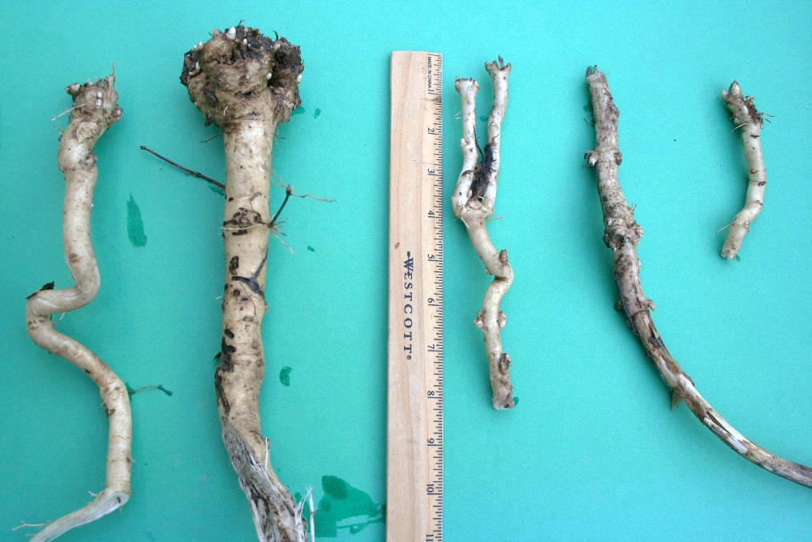*Whole Plant Collections*: For milkweed species with rhizomes, propagation by cuttings of the tuberous rhizome is also easy and reliable. The cuttings should be made when the plant is dormant. Each piece of the rhizome should have at least one bud (they are about two inches apart). Timing of propagation is important. Harvest or divide plants and move them in October at the beginning of the rainy season. Place the plants in the ground by late fall so they can develop enough root growth to survive the winter. Irrigation the first year will improve survival, and by the second year the root system should be well enough established so plants will survive on their own. Both seedlings and cuttings will usually bloom in their second year, although cuttings will occasionally bloom during their first year (Kindscher 1992).

### Cultivars, Improved, and Selected Materials (and area of origin)

There are currently no released selections or cultivars of showy milkweed; however, seed from wildland collected material is readily available commercially. Plant materials should be selected based on the local climate, resistance to local pests, and intended use. Consult with your local land grant university, local extension or local USDA NRCS office for recommendations for use in your area**.**

**Literature Cited**

Balls, E.K. 1962. *Early uses of California plants*. University of California Press. 102 pp.

Blackburn, T.C. & K. Anderson 1993. *Before the wilderness. Environmental management by native Californians*. A Ballena Press Publication. 476 pp.

Bouton, D.W. 1995. *The Monarch butterfly. A fragile tissue in the wind*. Continuum Publishers, Harpersville, New York, New York.

Bunting, P. *Pers comm 2-8-1999*. Forester and member of the Sierra Native American Tribal Council.

Burrows, G.E. and R.J. Tyrl. 2001. *Toxic Plants of North America*. Iowa State Press. Ames IA. 1342p.

Cooke, S.S. 1997. *A field guide to the common wetland plants of Western Washington and Northwestern Oregon.* Seattle Audubon Society and Washington Native Plant Society. 414 pp.

Dunmire, W.W. & G.D. Tierney 1995. *Wild plants of the Pueblo Province. Exploring Ancient and Enduring Uses*. Museum of Mexico Press, Santa Fe, New Mexico. 289 pp.

Dunmire, W.W. & G.D. Tierney 1997. *Wild plants and native peoples of the Four Corners*. Museum of New Mexico Press. 312 pp.

Gilmore, M.R. 1977. *Uses of plants by the Indians of the Missouri River region*. University of Nebraska Press. 125 pp.

Grace, E.S. 1997. *The world of the Monarch butterfly*. Sierra Club Books. San Francisco, California. 114 pp.

Gunther, E. 1945 rev. 1973. *Ethnobotany of western Washington*. University of Washington Publications in Anthropology, 10(1). University of Washington Press, Seattle, Washington.

Hedrick, U.P. 1972. *Sturtevant's edible plants of the world*. Dover Publications, Inc., New York, New York. 686 pp.

Hickman, J.C. 1993. *The Jepson manual. Higher plants of California*. University of California Press. 1399 pp.

Kindscher, K. 1992. *Medicinal wild plants of the prairie. An ethnobotanical guide*. University Press of Kansas. 340 pp.

Kuhnlein, H.V. & N.J. Turner 1991. *Traditional plant foods of Canadian indigenous peoples. Nutrition, botany and use*. Gordon and Breach Science Publishers. 633 pp.

Landis T.D. and R.K. Dumroese. 2015. Propagating native milkweeds for restoring monarch butterfly habitat. The International Plant Propagators’ Society, Combined Proceedings, Vol. 64 (2014): 299-307.

Martin, A.C., H.S. Zim, & A.L. Nelson 1951. *American wildlife and plants: A guide to wildlife food habits*. Dover Publications, Inc., New York, New York. 500 pp.

Mason, H.L. 1957. *A flora of the marshes of California*. University of California Press, Berkeley and Los Angeles. 878 pp.

Moser, C.L. 1993. *Native American basketry of southern California*. Riverside Museum Press. 155 pp.

Panter, K.E., Ralphs, M.H., Pfister, J.A., Gardner, D.R., Stegelmeier, B.L., Lee, S.T., Welch, K.D., Green, B.T., Davis, T.Z. and D. Cook. 2014. Plants Poisonous to Livestock in the Western States. USDA-ARS. Agriculture Information Bulletin Number 415.

Powell, J.A. & C.L. Hogue 1979. *California insects*. University of California Press. 388 pp.

Schmidt, M.G. 1980. *Growing California native plants*. University of California Press. 366 pp.

Stewart, B. 1997. *Common butterflies of California*. West Coast Lady Press. 255 pp.

USDA, NRCS 1999. *The PLANTS database*. National Plant Data Center, Baton Rouge, Louisiana. <http://plants.usda.gov> Version: 05APR1999.

Whitson, T.D. (ed.) et al.. 1996. Weeds of the West. Western Society of Weed Science in cooperation with Cooperative Extension Services, University of Wyoming. Laramie, Wyoming.

Young-Mathews, A., and E. Eldredge. 2012. Plant fact sheet for showy milkweed (*Asclepias speciosa)*. USDA-Natural Resources Conservation Service, Corvallis Plant Materials Center, OR and Great Basin Plant Materials Center, Fallon, NV.

### Citation

Stevens, M. 2000. Plant Guide for showy milkweed (*Asclepias speciosa)*. USDA-Natural Resources Conservation Service, National Plant Data Center.

Published 2000

[Edited:](#edited" \o "[e.g., 08Sep2009 rg, 08Sep2009 jfh; 17Sep2009 mws]  NOTE:  Please remove the brackets if no editing data exists (new document).1) The author is the person(s) who did the majority of the work and should not exceed 2 people. Names should not be added to updated PGs unless significant rewrites are done. If a substantial rewrite is done the citation should be adjusted as follows:Original authors name, title, [add ed. (rev) Editor name. new pub date], remainder of citation remains the same.Example:  Pavek, P.L.S. 2012. Plant guide for pea (Pisum sativum L.). ed. (rev) E.R. Garner. 2014. USDA-Natural Resources Conservation Service, Pullman, WA.2) If minor updates or revisions are made it is only in the edited by section. Retain the most recent 5-10 edits.3) Names should not be removed regardless of death or retirement.) 05dec00jsp; 17mar03ahy; 30may06jsp; 20dec16djt

For more information about this and other plants, please contact your local NRCS field office or Conservation District at <http://www.nrcs.usda.gov/> and visit the PLANTS Web site at <http://plants.usda.gov/> or the   
Plant Materials Program Web site:

<http://plant-materials.nrcs.usda.gov>.

PLANTS is not responsible for the content or availability of other Web sites.

The U.S. Department of Agriculture (USDA) prohibits discrimination against its customers, employees, and applicants for employment on the bases of race, color, national origin, age, disability, sex, gender identity, religion, reprisal, and where applicable, political beliefs, marital status, familial or parental status, sexual orientation, or all or part of an individual's income is derived from any public assistance program, or protected genetic information in employment or in any program or activity conducted or funded by the Department. (Not all prohibited bases will apply to all programs and/or employment activities.)

If you wish to file an employment complaint, you must contact your agency's [EEO Counselor](http://www.ascr.usda.gov/doc/EEO_Counselor_List.pdf) (PDF) within 45 days of the date of the alleged discriminatory act, event, or in the case of a personnel action. Additional information can be found online at <http://www.ascr.usda.gov/complaint_filing_file.html>.

If you wish to file a Civil Rights program complaint of discrimination, complete the [USDA Program Discrimination Complaint Form](http://www.ocio.usda.gov/sites/default/files/docs/2012/Complain_combined_6_8_12.pdf) (PDF), found online at <http://www.ascr.usda.gov/complaint_filing_cust.html>, or at any USDA office, or call (866) 632-9992 to request the form. You may also write a letter containing all of the information requested in the form. Send your completed complaint form or letter to us by mail at U.S. Department of Agriculture, Director, Office of Adjudication, 1400 Independence Avenue, S.W., Washington, D.C. 20250-9410, by fax (202) 690-7442 or email at [program.intake@usda.gov](mailto:program.intake@usda.gov).

Individuals who are deaf, hard of hearing or have speech disabilities and you wish to file either an EEO or program complaint please contact USDA through the Federal Relay Service at (800) 877-8339 or (800) 845-6136 (in Spanish).

Persons with disabilities who wish to file a program complaint, please see information above on how to contact us by mail directly or by email. If you require alternative means of communication for program information (e.g., Braille, large print, audiotape, etc.) please contact USDA's TARGET Center at (202) 720-2600 (voice and TDD).

For any other information dealing with Supplemental Nutrition Assistance Program (SNAP) issues, persons should either contact the USDA SNAP Hotline Number at (800) 221-5689, which is also in Spanish or call the [State Information/Hotline Numbers](http://www.fns.usda.gov/snap/contact_info/hotlines.htm).

For any other information not pertaining to civil rights, please refer to the listing of the [USDA Agencies and Offices](http://www.usda.gov/wps/portal/usda/usdahome?navtype=MA&navid=AGENCIES_OFFICES_C) for specific agency information.

***Helping People Help the Land***

**USDA IS AN EQUAL OPPORTUNITY PROVIDER AND EMPLOYER**