

Plant Guide

# Fourwing saltbush

## Atriplex canescens (Pursh) Nutt.

Plant Symbol = ATCA2

*Contributed by*: USDA NRCS Idaho Plant Materials Program

### Large Photo of Atriplex canescensFourwing saltbush. Photo by Steven Perkins @ USDA-NRCS PLANTS Database

**Alternate Names**

*Common Alternate Names:*

Chamise, chamize, chamiso, white greasewood, saltsage, fourwing shadscale, bushy atriplex

### Uses

*Rangeland/Grazing:* Fourwing saltbush is highly palatable browse for most livestock and big game (Peterson et al., 1987). Protein, fat and carbohydrate levels of fourwing saltbush have been compared to those of alfalfa (Catlin, 1925). It is utilized primarily in the winter at which time it is high in carotene and digestible protein averages near 8 percent (Otsyina et al., 1982).

*Wildlife:* fourwing saltbush provides excellent season long browse for deer (Ogle and Brazee, 2009). It is a good browse plant for bighorn sheep, antelope, and elk in fall and winter. It is also a food source and excellent cover for sharptail grouse, gray partridge (Huns), sage grouse, and other upland birds, rabbits, songbirds, and small mammals (Howard, 2003).

*Erosion Control:* fourwing saltbush makes excellent screens, hedges, and barriers. It is especially useful on saline-sodic soils (Ogle and St. John, 2008). It has excellent drought tolerance and has been planted in highway medians and on road shoulders, slopes, and other disturbed areas near roadways. Because it is a good wildlife browse species, caution is recommended in using fourwing saltbush in plantings along roadways. Its extensive root system provides excellent erosion control.

*Reclamation:* fourwing saltbush is used extensively for reclamation of disturbed sites (mine lands, drill pads, exploration holes, etc,). It provides excellent species diversity for mine land reclamation projects.

### Status

Please consult the PLANTS Web site and your State Department of Natural Resources for this plant’s current status (e.g., threatened or endangered species, state noxious status, and wetland indicator values).

### Description

Fourwing saltbush is a polymorphic species varying from deciduous to evergreen, depending on climate. Its much-branched stems are stout with whitish bark. Mature plants range from 0.3 to 2.4 m (1 to 8 ft) in height, depending on ecotype and the soil and climate. Its leaves are simple, alternate, entire, linear-spatulate to narrowly oblong, canescent (covered with fine whitish hairs) and ½ to 2 inches long. Its root system is branched and commonly very deep reaching depths of up to 6 m (20 ft) when soil depth allows (Kearney et al., 1960).

Fourwing saltbush is mostly dioecious, with male and female flowers on separate plants (Welsh et al., 2003); however, some monoecious plants may be found within a population. At higher ploidy levels fourwing saltbush can exhibit trioecy (three sexual states), with plants able to switch from female to male under environmental stress (McArthur and Monsen, 2004). Fourwing saltbush plants can also exhibit hermaphroditic characteristics (male and female parts in one flower). Male flowers are red to yellow and form dense spikes at the ends of the branches. The female flowers are axillary and nondescript. The seed is contained in a winged utricle that turns a dull yellow when ripe and may remain attached to the plant throughout winter.

Fourwing saltbush is a highly variable species. Introgression and changes in ploidy are common. There are six currently accepted varieties of fourwing saltbush: *A. c.* *angustifolia* (Torr.) S. Watson, *A. c.* *canescens*, *A. c.* *gigantean* S.L. Welsh & Stutz, *A. c.* *laciniata* Parish, *A. c.* *linearis* (S. Watson) Munz, and *A. c. macilenta* Jeps. Hybridization is also common among *Atriplex* species including between woody and herbaceous species (Stutz, 1984). Several hybrid forms involving fourwing saltbush have been documented including hybrids with *A. nuttallii, A. polycarpa, A. gardneri, A. obovata* and *A. falcata* (Stutz, 1984).

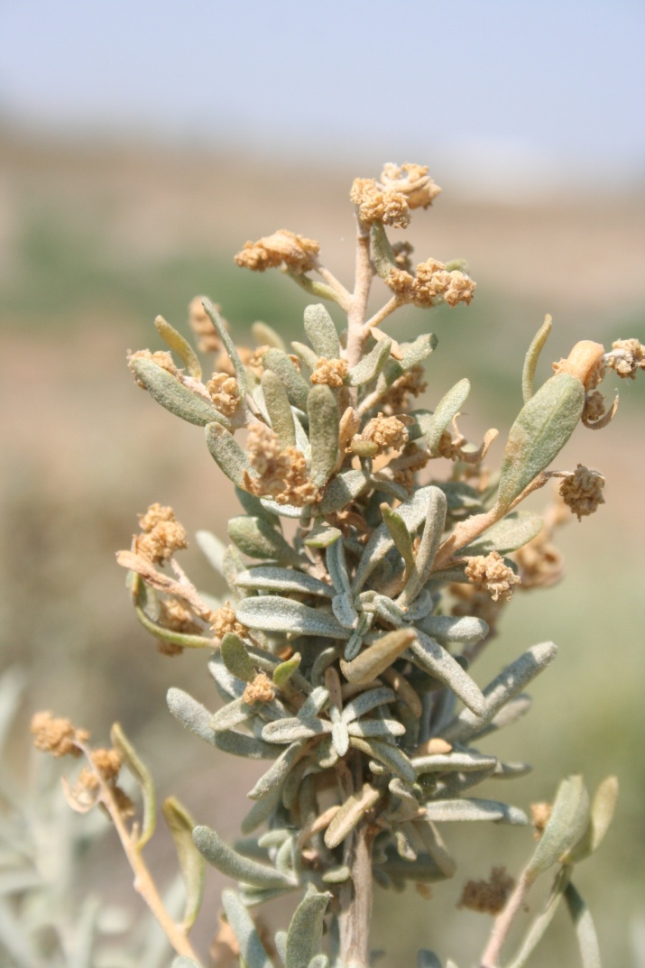

**Male fourwing saltbush flowers. Photo by Derek Tilley, USDA-NRCS**.

**Ethnobotany**

American Indians boiled fresh roots with a little salt and drank half-cupful doses for stomach pain and as a laxative. Roots were also ground and applied as a toothache remedy. Leaf or root tea was taken as an emetic for stomach pain and bad coughs (Felger and Moser, 1974). Soapy lather from leaves was used for itching and rashes from chickenpox or measles. Fresh leaf or a poultice of fresh or dried flowers was applied to ant bites. Leaves were used as a snuff for nasal problems. Smoke from burning leaves was used to revive someone who was injured, weak, or feeling faint.

*Distribution*:

Fourwing saltbush is one of the most widely distributed and important native shrubs on rangelands in the western United States including the Intermountain, Great Basin, and Great Plains regions. It can be found from the Pacific Coast to the Missouri River, and from Mexico to southern Alberta (Welsh et al., 2003). For current distribution, consult the Plant Profile page for this species on the PLANTS Web site.

*Habitat*.

Fourwing saltbush occurs most commonly in salt-desert scrub communities in the Great Basin, Mojave and Sonora Desert areas of western North America (Kearney et al., 1960; Welsh et al., 2003). In the Great Basin region it is often associated with black greasewood (*Sarcobatus vermiculatus*), black brush (*Coleogyne ramosissima*), big sagebrush (*Artemisia* *tridentata*), creosote bush (*Larrea* *tridentata*), rabbitbrush (*Chrysothamnus* spp.) and shadscale (*Atriplex confertifolia*) (Welsh et al., 2003). In the Mojave and Sonoran deserts it is found in alkali bottoms with iodinebush (*Allenrolfea occidentalis*) and shadscale. It can also be found in association with sand dune communities as well as Joshua tree (*Yucca brevifolia*) and pinyon-juniper (*Pinus-Juniperus* spp.) communities (Kearney et al., 1960). In the Great Plains it can be found with blue grama (*Bouteloua* *gracilis*), prickly-pear cactus (*Opuntia polyacantha*) and galleta (*Pleuraphis jamesii*).

**Adaptation**

Fourwing saltbush is adapted to most soils but is best suited to deep, well drained; loamy to sandy to gravely soils. It is sometimes found growing in dense clay soils. It is very tolerant of saline soil conditions and somewhat tolerant of sodic soil conditions (Ogle and St. John, 2010). Under saline conditions plants take up salts and accumulate it in the plant’s scurfy leaf coverings.

Fourwing saltbush has high tolerance to boron. It does not tolerate high water tables or late winter inundation. It is extremely drought tolerant and has fair shade tolerance. It is not especially tolerant of fire, but may resprout to some degree if fire intensity is not too severe. Its ability to tolerate extreme cold conditions varies with ecotype.

Fourwing saltbush most commonly grows in areas that receive 200 to 360 mm (8 to 14 in) of annual precipitation (Ogle et al., 2012). It can be found from sea level in Texas to over 2,400 m (8,000 ft) in Wyoming (Mozingo, 1987; Powell, 1988).

### Establishment

*Planting:* Fourwing saltbush begins growth in mid to late spring. Seed matures 3 to 4 months after flowering. It typically spreads via seed distribution, but may also root sprout following wildfire or layer if covered with sand. Stands typically take three to four years to establish, but once established the plants are fairly competitive with other species. Fourwing saltbush can be established by transplanting in early spring, direct seeding in late fall, early winter or very early spring.

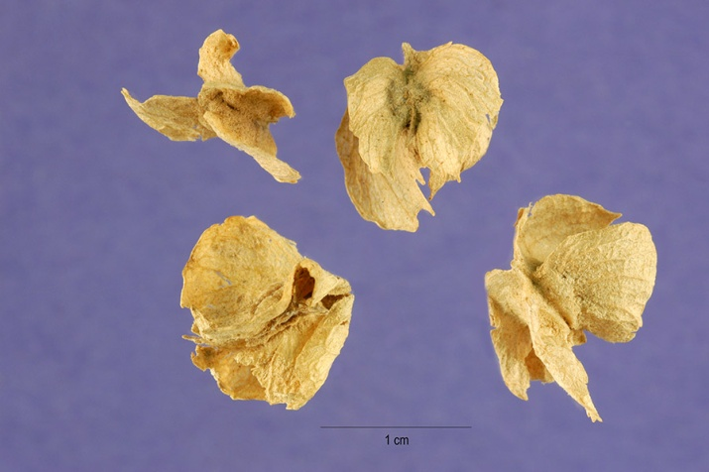

**Unprocessed seed with wings intact. Photo by Steve Hurst @ USDA-NRCS PLANTS Database.**

An adapted cultivar/release or local seed source should be used to ensure the ecotype is compatible with the site. Seed should be after-ripened for ten months and dewinged prior to planting. On moist fine soils, seed should be planted ½ inch deep. On sandy to coarse gravely soils, plant up to ¾ inch deep. Seeding rates of 0.25 to 0.50 PLS (pure live seed) pounds per acre is recommended for rangeland seeding mixtures (3 to 7 percent of the seeding mix) to provide approximately 400 plants per acre (Ogle et al., 2011). Dewinged seed is preferred because seed flow through a drill and planting depth can be controlled more easily. There is no prechilling requirement for fourwing saltbush seed. See Seed Production section for additional planting recommendations

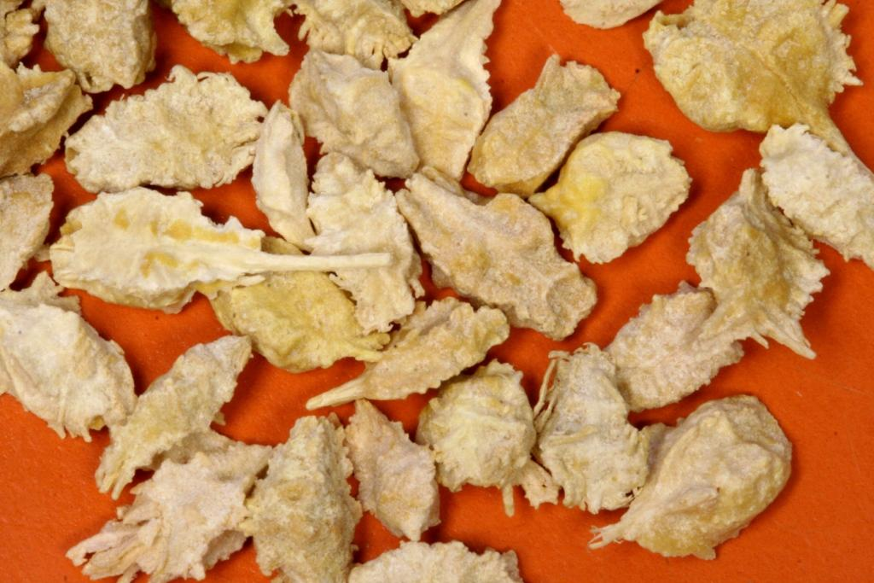

**Fourwing saltbush seed that has been processed to remove the wings to facilitate flow through seeding equipment. Photo by Derek Tilley**.

Seedling vigor is generally outstanding and depending on ecotype, young plants may reach heights of 46 cm (18 in) by the end of the first growing season.

### Management

Fourwing saltbush is palatable to cattle, sheep and deer season long. It provides nutritious winter browse on many areas and is a good fall and winter browse plant for bighorn sheep, antelope, and elk.

In new plantings, utilizing good seedbed and weed control techniques should enhance establishment and reduce competition with other plants. In interseedings, plant competition should be reduced by chemical, scalping, furrowing or other techniques that help control existing vegetation and weeds. Animals utilizing the area should be removed from new plantings for at least two growing seasons or until plants are well established and reproducing. Irrigation may be needed for transplants on harsh sites to ensure establishment. Young seedings are not tolerant of excessive insect, rabbit, and rodent damage and plantings may require control measures if severe damage appears.

In established plantings, deferred rotation grazing systems are recommended for fourwing saltbush management. Plants can be grazed from late spring through winter, but plant health is best maintained if used primarily as a winter browse. Fourwing saltbush tolerates browsing very well, but will decrease in abundance under continuous close browsing. Proper use of fourwing saltbush as browse is approximately 40 to 50 percent of the current year’s growth.

Excessive use results in damage or loss of plants from breakage of brittle branches. During dry periods, branches and stems may be brittle and trampling by livestock may damage plants. Damaged plants generally recover if rested, but production will be reduced until fully recovered. No injury to livestock results from grazing this plant. However, it can cause bloat and scours in spring if it is the primary dietary source. Rabbits, rodents, and grasshoppers utilize fourwing saltbush and may damage stands under severe conditions requiring pest control measures.

### Pests and Potential Problems

The Atriplex case-bearing moth (*Coleophora* *atriplicivora*) can damage leaves and reduce seed production on fourwing saltbush (Moore and Stevens, 1984).

### Environmental Concerns

Fourwing saltbush is native, long-lived, and spreads primarily by seed distribution. It is not considered "weedy", but could slowly spread into adjoining vegetative communities under ideal climatic and environmental conditions. This species is well documented as having beneficial qualities and no negative impacts on wild or domestic animals.

### Seeds and Plant Production

Establishing plants in a greenhouse and transplanting to the field will result in the most satisfactory stands for seed production.

Plant spacing should be 1.8 to 2.4 m (6 to 8 ft) within row and 2.4 to 3.0 m (8 to 10 ft) between rows. Planting one male plant for every 5 female plants is recommended. Fourwing saltbush is wind pollinated and seed production stands should be designed with the majority of the male plants on the windward side of the field. Transplanting into weed barrier fabric can also improve plant establishment, seed production, weed control, and moisture conservation. Transplanting is recommended in the spring prior to summer heat. Full seed production is usually reached the third year following transplanting.

Plantings can also be established with seed. A minimum of 15 to 20 Pure Live seeds per linear foot of drill row should be planted. Hand seeding in late fall or very early spring may also be an option. Plant 5 to 10 seeds in a close group at desired spacing. The plants should be thinned to the desired spacing and ratio of male to female plants when fruiting starts (about 3 years). Full seed production may be reached the fourth year following direct seeding.

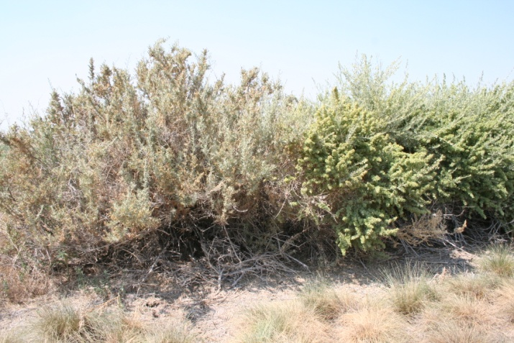

**Male plant left, female plant right. Photo by Derek Tilley, USDA-NRCS.**

Fourwing saltbush requires an equivalent of 10 to 14 inches annual precipitation for seed production. Irrigation may only be needed for establishment and during drought years to ensure a seed crop. If irrigation is available, irrigate to promote vegetative growth. Make sure soil moisture is adequate at early flowering, during seed set and early maturation. Irrigate to field capacity prior to fall freeze-up. Expected seed yields may range from 200 to 400 pounds per acre. Fertilization is not generally recommended unless soil tests indicate severe nutrient deficiencies. Rabbits and rodents can damage stands and may destroy plants. Insects such as grasshoppers and Mormon crickets infrequently damage stands beyond recovery.

Seed generally ripens in late August and September and can be harvested from mid September through December. Harvesting seed is best accomplished for woody ecotypes by hand stripping or vacuuming the seed from the plant. Mechanized harvesting has been used on ‘Wytana’, but seed requires additional conditioning to properly dry and clean out excessive trash (leaves, stems, and other inert matter).Seed is grown from second year or older wood and cutting will remove the following years’ crop. Harvested seed is usually threshed (dewinged) by processing seed through a hammermill (1500 rpm) equipped with a ¼ inch screen and then running seed through a fanmill to the desired grade.

Dewinging may hasten after-ripening of seed resulting in shorter viability of seed. Seed can be stored and remain viable for 6 to 10 years. The dewinging process greatly enhances the ability of the seed to flow through planting equipment. Removing the hull that surrounds the embryo can injure the seed resulting in reduced viability, seedling vigor, and stand establishment. One must be extremely careful when threshing to limit the amount of mechanical action on the seed to minimize damage while also removing empty seed.

Fourwing saltbush seed requires about 10 month's after-ripening following harvest before accurate percent germination can be determined. Seeds per pound will vary by accession or ecotype. Seed weights conducted by the authors averaged 38,000 seeds per pound winged and 78,000 seeds per pound dewinged.

### Cultivars, Improved, and Selected Materials (and area of origin)

Foundation and registered seed is available through the appropriate state Crop Improvement Association or commercial sources to grow certified seed. Common wildland collected seed is also available from commercial sources.

**'Marana'** fourwing saltbush was released in 1979 by the NRCS Plant Materials Center in Lockeford, California. It originated from plants near El Cajon, California and was selected for ease of establishment and drought resistance. It is best adapted to areas in the southwest including southern New Mexico, southern Arizona and southern to central California.

**‘Rincon’** fourwing saltbush was selected by the Forest Service, Shrub Science Laboratory in Provo, Utah and cooperatively released with the NRCS Plant Materials Center, Meeker, Colorado in 1983. The original seed was collected at Rincon Blanco near Canjilon, Rio Arriba County, New Mexico at 7,800 feet elevation. Rincon is an erect, leafy form with early season green-up. It is best adapted to the southwest areas of central Utah, central Nevada, western Colorado, to central New Mexico and central Arizona.

**‘Santa Rita’** fourwing saltbush was cooperatively released by the NRCS Plant Materials Center, Tucson, Arizona, ARS, and University of Arizona in 1987. It is best adapted to areas in the southwest including southern New Mexico, southern Arizona and southern to central California.

**‘Wytana’** fourwing saltbush was released by the NRCS Plant Materials Center, Bridger, Montana in 1976. Wytana is a natural cross between fourwing saltbush and Gardner or Nuttall saltbush (*Atriplex x aptera*). It is a short, herbaceous type that is best adapted to the Great Plains and mountain foothills of Idaho, Montana and Wyoming.

### References

Catlin, C.N. 1925. Composition of Arizona forages, with comparative data. Bull. 113. Tucson, AZ: University of Arizona, Agricultural Experiment Station: 155-171.

Fegler, R.S. and M.B. Moser. 1974. Seri Indian pharmacopoeia. Economic Botany. 28: 414-436.

Howard, J. 2003. *Atriplex canescens*. In: Fire Effects Information System, [Online]. USDA-Forest Service, Rocky Mountain Research Station, Fire Sciences laboratory. Available: http:www.fs.fed.us/database;feis/ (accessed 28Aug2012).

Kearney, T.H., Peebles, R.H., Howell, J.T and E. McClintock. 1960. Arizona flora. 2nd ed. University of California Press. Berkeley, CA. 1085p.

McArthur, E.D. and S.B. Monsen. 2004. Chenopod Shrubs. In: S.B. Monsen, R. Stevens, and N.L. Shaw [compilers]. Restoring western ranges and wildlands. Fort Collins, CO: USDA Forest Service, Rocky Mountain Research Station. General Technical Report RMRS-GTR-136-vol-2. p. 467-491.

Moore, T. Blaine; Stevens, Richard. 1984. Distribution and importance of the Atriplex case-bearing moth, *Coleophora atriplicivora* cockerel, on some chenopod shrubs, especially *Atriplex canescens*. In: Tiedemann, Arthur R.; McArthur, E. Durant; Stutz, Howard C.; [and others], compilers. Proceedings--symposium on the biology of Atriplex and related chenopods; 1983 May 2-6; Provo, UT. Gen. Tech. Rep. INT-172. Ogden, UT: U.S. Department of Agriculture, Forest Service, Intermountain Forest and Range Experiment Station: 220-225. [8024]

Mozingo, H.N. 1987. Shrubs of the Great Basin: A natural history. Reno, NV: University of Nevada Press. 342p.

Ogle, D. and B. Brazee. 2009. Estimating initial stocking rates. Range Technical Note No. 3. USDA-NRCS. Boise, Idaho. 39p.

Ogle, D. and L. St. John. 2008. Plants for saline to sodic soil conditions. Plant Materials Technical Note No. 9. USDA-NRCS. Boise, Idaho. 12p.

Ogle, D.G., St. John, L., Stannard, M. and L. Holzworth. 2011. Conservation plant species for the Intermountain West. Plant Materials Technical Note No. 24. USDA-NRCS. Boise, Idaho. 57p.

Otsyina, R., McKell, C.M and G. Van Epps. 1982. Use of range shrubs to meet nutrient requirements of sheep grazing on crested wheatgrass during fall and early winter. Journal of Range Management. 35(6): 751-753.

Peterson, J.L., Ueckert, D.N., Potter, R.L. and J.E. Huston. 1987. Ecotypic variation in selected fourwing saltbush populations in western Texas. Journal of Range Management. 40: 361-366.

Powell, A.M. 1988. Trees and Shrubs of Trans-Pecos Texas including Big Bend and Guadalupe Mountains National Parks. Big Bend National Park, TX: Big Bend Natural History Association. 536p.

Stutz, Howard C. 1984. Atriplex hybridization in western North America. In: Tiedemann, Arthur R.; McArthur, E. Durant; Stutz, Howard C.; [and others], compilers. Proceedings--symposium on the biology of Atriplex and related chenopods; 1983 May 2-6; Provo, UT. Gen. Tech. Rep. INT-172. Ogden, UT: U.S. Department of Agriculture, Forest Service, Intermountain Forest and Range Experiment Station: 25-27. [2284]

Welsh, S.L., Atwood, N.D., Goodrich, S. and L.C. Higgins. 2003. A Utah Flora. Brigham Young University. Provo, UT. 912p.

**Prepared By**:

Daniel G. Ogle, USDA NRCS Idaho State Office, Boise, Idaho

Loren St. John, USDA NRCS Plant Materials Center, Aberdeen, ID

Derek Tilley, USDA NRCS Plant Materials Center, Aberdeen, ID

### Citation

Ogle, D.G., St. John, L., and D. Tilley. 2012. Plant Guide for fourwing saltbush (*Atriplex canescens*). USDA-Natural Resources Conservation Service, Aberdeen, ID Plant Materials Center. 83210-0296.

Published October, 2012

Edited: 05dec00jsp; 23sept02lsj; 20sept02dgo; 13feb03jsp; 14Mar05rln; 28Aug2012djt; 28Aug2012ls;16Sep2012gm

For more information about this and other plants, please contact your local NRCS field office or Conservation District at <http://www.nrcs.usda.gov/> and visit the PLANTS Web site at <http://plants.usda.gov/> or the Plant Materials Program Web site <http://plant-materials.nrcs.usda.gov>.

PLANTS is not responsible for the content or availability of other Web sites.

**USDA IS AN EQUAL OPPORTUNITY PROVIDER AND EMPLOYER**