

Plant Guide

# Pigeonpea

## Cajanus cajan (L.) Millsp.

Plant Symbol = CACA27

*Contributed by*: USDA NRCS Cape May Plant Materials Center, Cape May, NJ

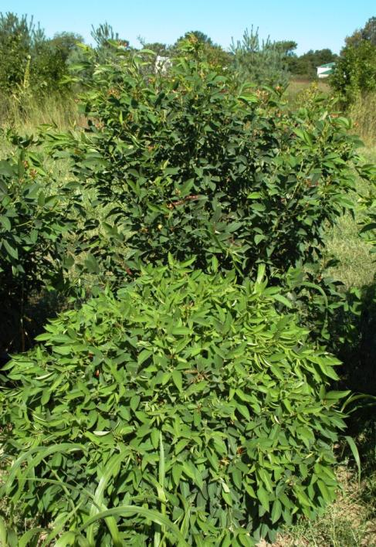

Pigeonpea (Cajanus cajan) variety ‘2 B Bushy’ (background) and ‘ICPL 92016’ (foreground). Photo by Christopher Sheahan, USDA-NRCS, Cape May Plant Materials Center, 2012.

### Alternate Names

*Alternate Common Names:* pigeon pea, Angola pea, Congo pea, dhal, no-eye pea, gungo pea, and red gram

*Alternate Scientific Names:*

*Cajanus indicus* Spreng.,

*Cajanus flavus* DC.,

*Cytisus cajanus* L.

### Uses

*Commercial crop: Cajanus cajan* is grown as a pulse crop (crop harvested for dry seed) or eaten green as a vegetable. The grain is popularly consumed in India, Asia, and Africa. India is the largest importer and producer, where seed is sold as dhal (dry split pea). Unprocessed seed should not be consumed by humans or livestock. The seed contains tannin and trypsin inhibitors (trypsin inhibitors are removed through cooking).

The protein content in split seeds is similar to soybean and ranges from 21–28% (Phatak et al., 1993). It is also widely used as a good source of dietary vitamins and minerals.

*Forage:* *C. cajan* makes an excellent, high-protein forage for livestock. Crude protein ranges from 28–36% (Phatak et al., 1993). In Florida, plants yielded 3.1 short tons/acre of biomass (Duke, 1983). Livestock may browse foliage, but damage to the branches may result, so continuous grazing should be avoided. Palatability has been reported to increase with age of the plant (Cook et al., 2005).

*C. cajan* can be grown as a forage intercropped with sorghum and/or millet. The deep taproot of *C. cajan* draws water from deeper soil depths than most legumes, so will not interfere with the water uptake of other crops and grasses. It is not generally seeded as forage with other legumes like cowpea (*Vigna unguiculata*), but mainly with grasses (Cook et al., 2005).

A nutritious feed for sheep can be made from the seedpod hulls and threshed waste of harvested plants.

*Cover crop/green manure:* *C. cajan* competes poorly with weeds and can be slow to establish if soils are not at least 64°F (Mullen et al., 2003). As a green manure it can fix about 62 lb N/acre up to the time when pods are produced (Phatak et al., 1993).

*Wildlife:* *C. cajan* has been used as a trap crop for *Heliothis* spp. (moth pests), in affected cotton (Mullen et al., 2003). A trap crop is a form of companion planting used to attract pests away from nearby crops. Plantingsare also used as live fences and windbreaks in many regions.

### Ethnobotany

Woody stems have been used for thatched roofs, baskets, and charcoal (Allen and Allen, 1981). Decoctions of leaf and stem have been used as a diuretic, laxative, and to treat sore throat (Allen and Allen, 1981). Several cultures have used decoctions for skin irritations and sores. Floral decoctions have been used to treat bronchitis, coughs, and pneumonia. Some Chinese use the dried roots to evacuate intestinal worms, as an expectorant, sedative, and a remedy for wounds (Duke, 1983).

### Status

C. cajan is an introduced species in the United States. Please consult the PLANTS Web site and your State Department of Natural Resources for this plant’s current status (e.g., threatened or endangered species, state noxious status, and wetland indicator values).

### Description

*General*: *C. cajan* is an erect perennial, warm-season crop that is widely grown in the tropics and subtropics. It is a shrub that can grow to 12 ft tall, but usually only reaches 3 to 6 ft.

The ribbed stem grows upright and is covered in short, soft hairs (pubescent) and is woody at the base. Its deep tap root is fast-growing. The pubescent, stalked leaflets are 2 to 4 inches long (5–10 cm) and ¾ to 1½ inches wide (2–4 cm), with minute resinous glands underneath.

The bi-laterally symmetrical, bell-shaped blooms are yellow or yellow and red, may be in pairs, and grow in the angle between stem and leaf on an unbranched inflorescence. The upper two lobes are united and two-toothed, and the lower lip is smaller and three-toothed. The lower bracts fall off early.

The two-valve, pointed seedpods are produced in clusters, and mottled red. They are 2 to 3.5 inches (5–9 cm) long, ½ inch (12 mm) wide, flat, covered with soft hairs, and taper to a sharp point. The round or oval seeds may be light beige to dark brown. The 2 to 9-seeded pods do not shatter in the field.

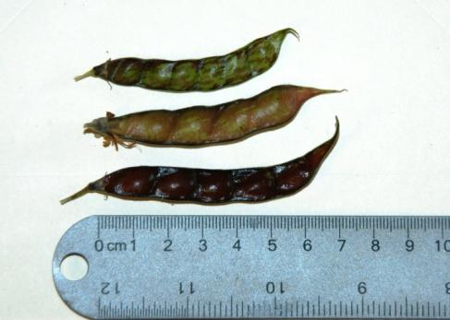

Seedpods of pigeonpea (Cajanus cajan). (Photo by Christopher Sheahan, USDA-NRCS, Cape May Plant Materials Center,2012)

*C. cajan* has a deep taproot system that grows large, cylindrical nodules. This nodulation can be initiated by a variety of rhizobial strains (Allen and Allen, 1981).

*Distribution*: *C. cajan* is an old world food crop that grows best in the tropics and subtropics, but has also been successfully grown in the Southern United States, Hawaii, and Puerto Rico. It is uncertain whether *C. cajan* is native to Africa (Allen and Allen, 1981) or India (Duke, 1983). Nevertheless, the plant has been in cultivation in parts of Africa and India for thousands of years. For current distribution, please consult the Plant Profile page for this species on the PLANTS Web site.

*Habitat*: *C. cajan* grows in forests in its native range. It can be found in warmer, dryer regions of the tropics and subtropics as well as more temperate regions.

**Adaptation**

*C. cajan* is adapted to a wide range of soil types. It grows best in well-drained soils and will not survive waterlogged conditions. It can be grown in a pH range of 4.5–8.4 (Cook et al., 2005). *C. cajan* grows best under hot conditions (65–86°F), and can grow in temperatures greater than 95°F (Cook et al., 2005).

Mullen et al. (2003) found that a soil temperature of 64°F or greater is required at time of planting, as lower temperatures will lengthen the period of establishment. Nevertheless, it is a hardy plant that can grow at temperatures as low as 41°F (Phatak et al., 1993), and has been successfully grown in warmer temperate regions such as North Carolina (Duke, 1983). Frost will defoliate the plant.

*C. cajan* is drought resistant and can survive under very dry conditions because of its deep root system. It has been found to grow throughout a six month dry season (Cook et al., 2005); however, flowering will be delayed and seed yields will decrease under long periods of drought (Mullen et al., 2003). It is less adapted to humid, wet conditions.

### Establishment

Sow seeds 1.5 inches deep on 1 to 3 foot rows at 8 to 10 lb per acre. Drill the seed in a weed-free seedbed or transplant seedlings on 6 foot rows if grown as intercrop. Seedlings will emerge within 3 weeks, but will grow slowly, so it is important to closely manage weeds for the first 6 weeks after seedling emergence (Cook et al., 2005).

Cowpea type inoculants can be used prior to planting but are not necessary, as naturally available *Rhizobium* species are present in most soils where legumes have been grown in the last three years (Phatak et al., 1993).

For successful pod development, it is important to grow the plant under full sunlight and never under waterlogged conditions. Fertilization is not recommended as the plant can grow well in soils with low phosphorus levels (Phatak et al., 1993) and has shown little response to fertilizers (Duke, 1983).

### Management

*C. cajanus* can be managed as an annual shrub or a perennial plant. As a perennial plant it has been successfully used in alley cropping systems with cereals and legumes. Under good management, the plant can live up to five years. As the plant ages, the stem will become woodier, and leaf regeneration will decline.

Harvesting should be done after first frost, as leaf drop will make harvesting easier. Harvesting methods are similar to those for soybean and can be done with a combine.

The plant will not survive heavy, continuous grazing or heavy cutting, but may be pruned. Weeds can be cultivated in the inter-rows. It cannot survive fire.

Pigeon pea can be used in rotation with cowpea and it is resistant to root lesion nematodes (*Pratylenchus* spp.) that affect cowpea (Mullen et al., 2003).

### Pests and Potential Problems

The plant attracts *Heliothis* spp. which can significantly decrease yields. Other pests include: cutworms (Noctudidae), thrips (Thysanoptera), mirids (Miridae), and green stink bugs (*Nezara viridula*). The seedpods are eaten by *Heliothis* spp., pod borers (*Lycaena boetica*), and other caterpillars in the field and by bean weevils during storage (Cook et al., 2005). *C. cajan* can develop *Fusarium* wilt, a common fungal disease.

### Environmental Concerns

None.

### Seeds and Plant Production

The time required to reach maturity can vary greatly due to seed variety, temperature, and photoperiod. *C. cajan* is a short-day plant, requiring a daylight length of 12.5 hours to initiate flowering and seed production (Cook et al., 2005). *C. cajan* requires 65-80 days to flower and 50-75 additional days to create mature seeds (Mullen et al., 2003), however many varieties have been developed to flower earlier. Itis 60% self-pollinated (Cook et al., 2005), but varieties grown within 2–3 miles may cross (Mullen et al., 2003).

The plant is a prolific seed producer. A single Hawaiian hybrid plant was shown to yield 6,460 seeds, weighing 2.5 lb (1.15 kg) (Allen and Allen, 1981). Yields of mature seedpods can be from 0.25 to 1 ton/acre (Mullen et al., 2003). In Australia and India, short-duration varieties (less than 100 days) have yielded 2.23 tons/acre (Phatak et al., 1993). There are roughly 7,000 to 8,000 seeds per pound (Cook et al., 2005; USDA-NRCS, 2012).

The seedpods can withstand weather damage (Mullen et al., 2003). After the first year of growth, seed production declines in subsequent years (Duke, 1983).

### Cultivars, Improved, and Selected Materials (and area of origin)

### There are many cultivars of pigeonpea from Africa and India.

### The variety ‘Flavus’ is yellow-flowered and early maturing. The variety ‘Bicolor’ may be red, purple, or streaked, perennial, and late-maturing. Both varieties may cross. There is a day-neutral cultivar from Florida called ‘Amarillo’ that can be sown and harvested throughout the year (Duke, 1983). Other varieties include ‘Hunt’, ‘Quantum’, and ‘Quest’ (Mullen et al., 2003).

### References

Allen, O.N and E.K. Allen. 1981. The Leguminosae: a source book of characteristics, uses, and nodulation. The Univ. of Wisconsin Press, Madison.

Cook, B.G., B.C. Pengelly, S.D. Brown, J.L. Donnelly,

D.A. Eagles, M.A. Franco, J. Hanson, B.F. Mullen, I.J. Partridge, M. Peters, and R. Schultze-Kraft. 2005. Tropical forages: an interactive selection tool. *Cajanus cajun*. CSIRO, DPI&F(Qld), CIAT, and ILRI, Brisbane, Australia.

http://www.tropicalforages.info/key/Forages/Media/Html/Cajanus_cajan.htm (accessed 24 July 2012).

Duke, J.A. 1983. Handbook of energy crops. NewCROP (New Crops Resource Online Program), Purdue Univ. Center for New Crops and Plant Products. http://www.hort.purdue.edu/newcrop/duke_energy/Cajanus_cajun.html (accessed 24 July 2012).

FAO. 2012. Grassland species index. *Cajanus cajan*. http://www.fao.org/ag/AGP/AGPC/doc/Gbase/DATA/PF000150.HTM (accessed 6 June 2012).

Mullen, C.L., J.F. Holland, and L. Heuke. 2003. Cowpea, lablab, and pigeon pea. Agfact P4.2.21. NSW Agriculture, Orange, New South Wales. http://www.dpi.nsw.gov.au/__data/assets/pdf_file/0006/157488/cowpea-lablab-pigeon-pea.pdf (accessed 24 July 2012).

Phatak, S.C., R.G. Nadimpalli, S.C. Tiwari, and H.L. Bhardwaj. 1993. Pigeonpeas: potential new crop for the southeastern United States. In: J. Janick and J.E. Simon, editors, New Crops. Wiley, New York. p. 597–599. http://www.hort.purdue.edu/newcrop/proceedings1993/v2-597.html (accessed 24 July 2012).

Stevens, J.M. 2012. Pea, pigeon— *Cajanus cajan*. Institute of Food and Agricultural Sciences (IFAS), Univ. of FL. Extension. Publication #HS641. http://edis.ifas.ufl.edu/mv108# (accessed 24 July 2012).

Thorp, S., M. Davison, O. Frost, and M. Pickstock. (ed.) 2012. New agriculturist: the potential of pigeonpea. Wren Media Ltd., Suffolk, UK. http://www.new-ag.info/99-5/focuson/focuson3.html (accessed 6 June 2012).

USDA NRCS. 2012. The PLANTS database. National Plant Data Team, Greensboro, NC. http://plants.usda.gov (accessed 10 July 2012).

### Prepared By: *Christopher M. Sheahan*; USDA-NRCS, Cape May Plant Materials Center, Cape May, New Jersey

### Citation

Sheahan, C.M. 2012. Plant guide for pigeonpea (*Cajanus cajan)*. USDA-Natural Resources Conservation Service, Cape May Plant Materials Center. Cape May, NJ. 08210.

Published August 2012

Edited: 31Aug2012 aym; 7Sept2012 ac

For more information about this and other plants, please contact your local NRCS field office or Conservation District at <http://www.nrcs.usda.gov/> and visit the PLANTS Web site at <http://plants.usda.gov/> or the Plant Materials Program Web site <http://plant-materials.nrcs.usda.gov>.

PLANTS is not responsible for the content or availability of other Web sites.

**USDA IS AN EQUAL OPPORTUNITY PROVIDER AND EMPLOYER**