

Plant Guide

**CHRIST’S INDIAN PAINTBRUSH**

***Castilleja christii* N.H. Holmgren**

Plant Symbol = CACH19

Contributed by: USDA, NRCS Idaho Plant Materials Program

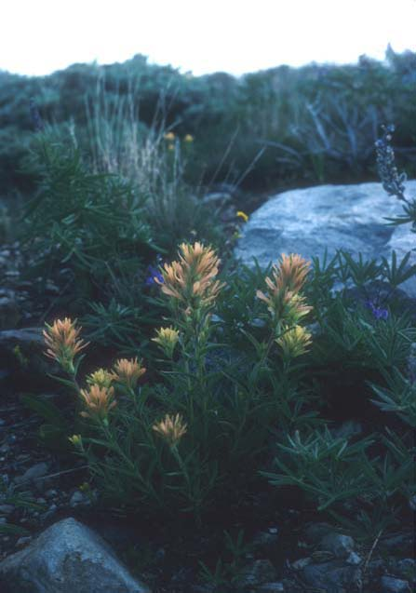

**Figure 1 Carol Dawson, Center of Plant Conservation**

**Alternate Names**

None known.

**Uses**

Christ’s Indian paintbrush is one of Idaho’s rarest plants. A single population occurs in the Albion Mountains of Cassia County, Idaho. It was named after John H. Christ, the first botanist to collect the species (Center for Plant Conservation 2006). This species has no known agricultural, economic, or other human uses at this time. This species may have scientific significance due to its evolutionary isolation which is an important subject in conservation biology research.

**Status**

Christ’s Indian paintbrush is currently a Candidate for listing under the Endangered Species Act and is on the US Fish and Wildlife Service Notice of Review list. It is also a Sensitive plant species on the Regional Foresters Sensitive List for the Intermountain Region of the USDA Forest Service.

Consult the PLANTS Web site and your State Department of Natural Resources for this plant’s current status (e.g. threatened or endangered species, state noxious status, and wetland indicator values).

**Description**

*General*: Perennial herb, 5 to 15 inches tall; stems erect to ascending, usually unbranched, several to a cluster; herbage glabrous to hispid with some hairs gland-tipped near the inflorescence. The leaves are 2-5 inches long, narrowly to broadly lanceolate, with 1 or maybe 2 pairs of lateral lobes, although sometimes all entire. The inflorescence is glandular, yellow to yellow orange, the bracts lanceolate to ovate, with 1 or 2 pairs of narrow lateral lobes; the calyx is 0.5 to 1 inch long, the primary lobes more deeply cleft in front than behind; the corolla is approximately 1 to 1.5 inches long, the galea about 0.5 inch and the lower lip much reduced with incurved teeth, the tube 0.5 to 0.75 inch long (Mosley 1993). This and other paintbrush species are often believed to be purely parasitic, meaning that they survive by using resources produced in another plant host. However, Christ’s Indian paintbrush is actually hemi-parasitic in that it is capable of independent production of nutrients but gains additional nutrients through root attachment with surrounding plants (Center for Plant Conservation 2006).

*Distribution*: Known from one population on Mount Harrison, Cassia County, Idaho. For current distribution, consult the Plant Profile page for this species on the PLANTS Web site.

*Habitat*: Christ’s Indian paintbrush is found in grassy upper sub-alpine meadows along the crest and slope of Mount Harrison in loamy gravel and occurs most often in areas where snowdrifts remain into early summer. It is found among stands of Sandberg bluegrass (*Poa secunda*), Idaho fescue (*Festuca idahoensis*), alpine goldenrod (*Solidago multiraciata*), western yarrow (*Achillea millefolium*) and coiled-beak lousewort *(Pedicularis contorta*) (Center for Plant Conservation 2006).

**Adaptation**

Christ’s Indian paintbrush occurs almost exclusively on gentle, northerly facing slopes (9,100 feet elevation) of Mount Harrison, Cassia County, Idaho. It only rarely occurs in deep soils on south and west facing slopes. The soils are deep and gravelly appearing to have been derived from the underlying quartzite bedrock (Mosley 1993).

**Establishment**

Christ’s Indian paintbrush reproduces by seed. Little is known about seed dispersal or viability and no pollinators have been observed. Growth begins slightly before or soon after the snow melts in late June to early July. Peak flowering occurs from mid-July to mid-August depending on the year. Fruits begin to mature soon after flowering and probably dehisce by mid-September (Mosley 1993). Seeds have been collected by Denver Botanic Gardens and are currently stored at the National Seed Storage Laboratory in Fort Collins, Colorado. Seed germination studies by Denver Botanic Gardens suggest that this species has strong seed dormancy since they may require three months or more of cool, moist conditions to germinate. This dormancy mechanism is likely due to the habitat where the plant is found (Center for Plant Conservation 2006).

**Management**

A Candidate Conservation Agreement outlining 10 years of conservation actions for this rare species was signed by the US Fish and Wildlife Service and USDA Forest Service in 2005 (USDA-FS 2009).

**Pests and Potential Problems**

Considerable pocket gopher digging takes place on sites occupied by Christ’s Indian paintbrush. The species is threatened primarily by smooth brome (*Bromus inermus*), an aggressive introduced grass that is found within the population.

**Environmental Concerns**

The greatest threats to this species is habitat loss and degradation, due mainly to road construction and recreational activities. Although the site where the population occurs is closed to livestock grazing, trespass occasionally occurs (Center for Plant Conservation 2006). The long term effect of global climate change on this population may require extraordinary conservation measures such as ex situ conservation of the plant and its seeds to ensure its continued existence (USDA-FS 2009)

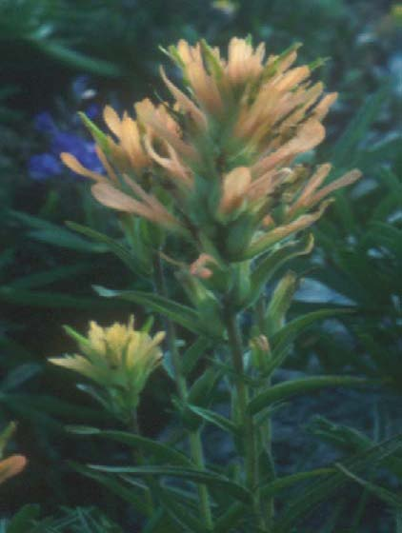 **Figure 2 Carol Dawson, Center for Plant Conservation**

**Seeds and Plant Production**

No commercial or restoration propagation known.

**Cultivars, Improved, and Selected Materials (and area of origin)**

None.

**References**

Center for Plant Conservation 2006. *Castilleja christii*. [Online]. Available at http:www.centerforplantconservation.org/ASP/CPC_ ViewProfile.asp?CPCNum=804/ (accessed 11 September 2009).

Moseley 1993. The Status and distribution of Christ’s Indian Paintbrush (*Castilleja christii*) and Davis’Wavewing (*Cymopterus davisii*) in the Albion Mountains, Sawtooth National Forest and City of Rocks National Reserve. Idaho Department of Fish and Game. 17 p.

USDA Forest Service 2009. Plant of the Week. Christ’s Indian Paintbrush. [Online]. Available at http://www.fs.fed.us/wildflowers/plant-of-the- week/castilleja_christii.shtml/ (accessed 11 September 2009).

USDA PLANTS Database. PLANTS Profile for Castilleja christii (Christ’s Indian paintbrush). [Online]. Available at http://plants.usda.gov/java/nameSearch?keywordquery =Castilleja+christii&mode=sciname/ (accessed 30 September 2009)

**Prepared By**

Loren St. John, USDA NRCS Plant Materials Center, Aberdeen, Idaho

Dan Ogle, USDA NRCS Idaho State Office, Boise, Idaho

**Citation**

St. John, L. and D.G. Ogle. Plant Guide for Christ’s Indian paintbrush (*Castilleja christii*). USDA Natural Resources Conservation Service, Plant Materials Center, Aberdeen, ID.

Published December, 2010

Edited: 02Nov09ls; 05Nov09dgo; 19 Nov09 jb;19Nov09mws; 24Nov09ls

For more information about this and other plants, please contact your local NRCS field office or Conservation District at <http://www.nrcs.usda.gov/> and visit the PLANTS Web site at <http://plants.usda.gov/> or the Plant Materials Program Web site <http://plant-materials.nrcs.usda.gov>.

PLANTS is not responsible for the content or availability of other Web sites.

**USDA IS AN EQUAL OPPORTUNITY PROVIDER AND EMPLOYER**