|  |
| --- |
| flexible ceanothus |
| *Ceanothus x flexilis* Greene ex. McMinn |
| Plant Symbol = CEFL4 |

*Contributed By: USDA NRCS California State Office & Lockeford Plant Materials Center, California*

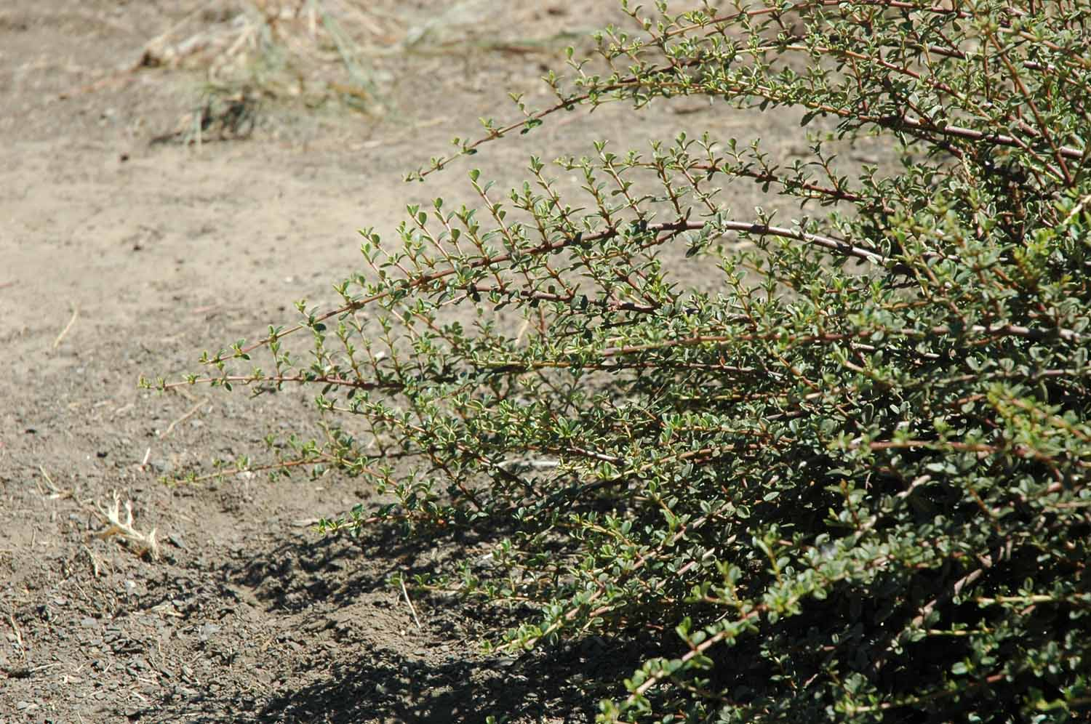

USDA NRCS Lockeford PMC

# Uses

*Ceanothus x flexilis* is used as a ground cover that provides erosion control and is used for restoration projects due to its low and wide growth pattern. Its maintenance is low and it is used for ornamental value on road slopes revegetation and landscaping slopes around rural and mountain homes.

# Status

Consult the PLANTS Web site and your State Department of Natural Resources for this plant’s current status, such as state noxious status and wetland indicator values.

# Description

Buckthorn Family (Rhamnaceae). *Ceanothus x flexilis* is a native, evergreen, semi-erect shrub that grows 0.6 to 1.2m (2 to 4 feet) high and spreads to 0.6 to 2.4m (2 to 8 feet) wide. It is a naturally occurring hybrid between buckbrush (*Ceanothus cuneatus*) and squawcarpet (*Ceanothus prostrates*). The leaves are opposite and the flowering period is April and May. Flower clusters are small with white to bluish, umbellate flowers.

# Distribution

# *Ceanothus x flexilis* is native to California. For current distribution, please consult the Plant Profile page for this species on the PLANTS Web site.

# Adaptation

*Ceanothus x flexilis* is adapted to lower elevations that receive a coastal influence.

# Establishment and Management

After *Ceanothus x flexilis* has formed a third pair of leaves they can be transplanted individually to larger ½ to 1 gallon containers. The young plants will be ready for their permanent location in 11/2 to 2 years. New plants should be watered occasionally until they are well established; after which, deep watering every 1 to 1 ½ months will be adequate to maintain uniform growth.

Container plants may be available from local nurseries. Dig a hole two to three times the diameter of the root ball and at least six inches deeper. Backfill the hole with six inches of native soil. Make a few, 1/8 inch deep vertical cuts in the root ball, or carefully “tease” roots away from the root ball with your hands to encourage roots to grow into the new soil. Set the plant into the hole with 8 feet spacing between each plant and fill in around roots, firming the soil with your hands as you fill until the hole is half full. Fill the hole with water and allow to settle. This will settle the silt and eliminate air pockets around the roots. Backfill with enough planting mix so the plant will set at the same level it was growing in the container. Water to allow soil to settle, then add more soil if necessary. Build a berm of soil to form a watering basin around the outer edge of the hole. Break the basin down after two or three years. Provide the plant with weed control measures during the first year.

# Seed Production

*Ceanothus x flexilis* is a hybrid cross and does not produce seed.

# Cultivars, Improved and Selected Materials (and area of origin’

‘Cuesta’ Cultivar- Collected from a native stand near the Grass Valley airport, Nevada County, California in 1974. Stem cuttings were collected from mature plants on this site and used to grow container plants for experimental plantings in the Sierra Nevada foothills. It was initially selected for its possible use on CALTRANS revegetation projects and compared to about 60 different species of shrubs in the Sierra Nevada foothills. It showed superior performance in establishment, maintenance and ornamental value.

Contact your local Natural Resources Conservation Service (formerly Soil Conservation Service) office for more information. Look in the phone book under ”United States Government.” The Natural Resources Conservation Service will be listed under the subheading “Department of Agriculture.”

**References**

USDA NRCS. 1991. *Notice of Release of ‘Cuesta’ Ceanothus x flexilis*. Ecological Sciences Division, Washington D.C. and California Agricultural Experiment Station, University of California, Davis, CA.

# Prepared By

# Dave Dyer, USDA NRCS Plant Materials Center, Lockeford, and Reina O’Beck, California State Office, Davis, California.

# Species Coordinator

Dave Dyer, USDA NRCS Lockeford Plant Materials Center, California.

Edited: 8Sep2005 rb; 23sep05 jsp; 05jun06 jsp

For more information about this and other plants, please contact your local NRCS field office or Conservation District, and visit the PLANTS Web site<<http://plants.usda.gov>> or the Plant Materials Program Web site <<http://Plant-Materials.nrcs.usda.gov>>

*The U.S. Department of Agriculture (USDA) prohibits discrimination in all its programs and activities on the basis of race, color, national origin, sex, religion, age, disability, political beliefs, sexual orientation, and marital or family status. (Not all prohibited bases apply to all programs.) Persons with disabilities who require alternative means for communication of program information (Braille, large print, audiotape, etc.) should contact USDA's* [*TARGET Center*](http://www.usda.gov/oo/target.htm) *at 202-720-2600 (voice and TDD).*

*To file a complaint of discrimination write USDA, Director, Office of Civil Rights, Room 326-W, Whitten Building, 14th and Independence Avenue, SW, Washington, DC 20250-9410 or call 202-720-5964 (voice or TDD). USDA is an equal opportunity provider and employer.*

*Read about* [*Civil Rights at the Natural Resources Convervation Service*](http://www.nrcs.usda.gov/about/civilrights/)*.*