

Plant Guide

# YELLOW STAR-THISTLE

## Centaurea solstitialis L.

Plant Symbol = CESO3

*Contributed by:* USDA NRCS Montana/Wyoming Plant Materials Program

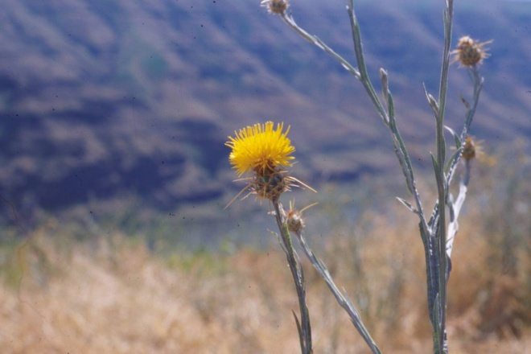

Figure 1. Yellow star-thistle flower heads. Photo by Mark Stannard, USDA-NRCS Pullman Plant Materials Center, Pullman, Washington.

### Alternate Names

Yellow starthistle

### Uses

Flowers provide nectar for honey bees.

### Status

Yellow star-thistle is a listed noxious weed and is invasive in many western states. Consult the PLANTS Web site and your State Department of Natural Resources for this plant’s current status (e.g., threatened or endangered species, state noxious status, and wetland indicator values).

### Weediness

Yellow star-thistle is one of the more invasive weeds of the Intermountain West and Pacific Northwest. A report from 2003 estimated that yellow star-thistle has infested nearly 15 million acres in 17 western states. This plant is weedy and invasive in some regions or habitats and often displaces desirable vegetation if not properly managed. Consult with your local NRCS Field Office, Cooperative Extension Service office, state natural resource, or state agriculture department regarding its status and use. Weed information is also available from the PLANTS Web site at <http://plants.usda.gov/>. Also consult related web sites listed in PLANTS for this species for further information.

### Description

*General:* The rosette of yellow star-thistle lies close to the ground (see Figure 2) and produces six to 28 deeply lobed leaves that range from one to eight inches (2.5 to 20 centimeters) long and are generally less than two inches (5 centimeters) wide. The rigidly branched, winged flowering stems (see Figure 2) average about two feet (60 centimeters) tall, but range from four inches (10 centimeters) to five feet (1.5 meters), depending on environmental conditions. The stem leaves are entire without lobes, linear in shape, and are vested with woolly hairs that persist through the growing season. Flower heads are solitary on the ends of short stems and have many bright yellow flowers (see Figure1). The bracts of the flower heads are armed with stout, straw-colored spines one to two inches (2.5 to 5 centimeters) long that radiate from the flower head in a star shape.

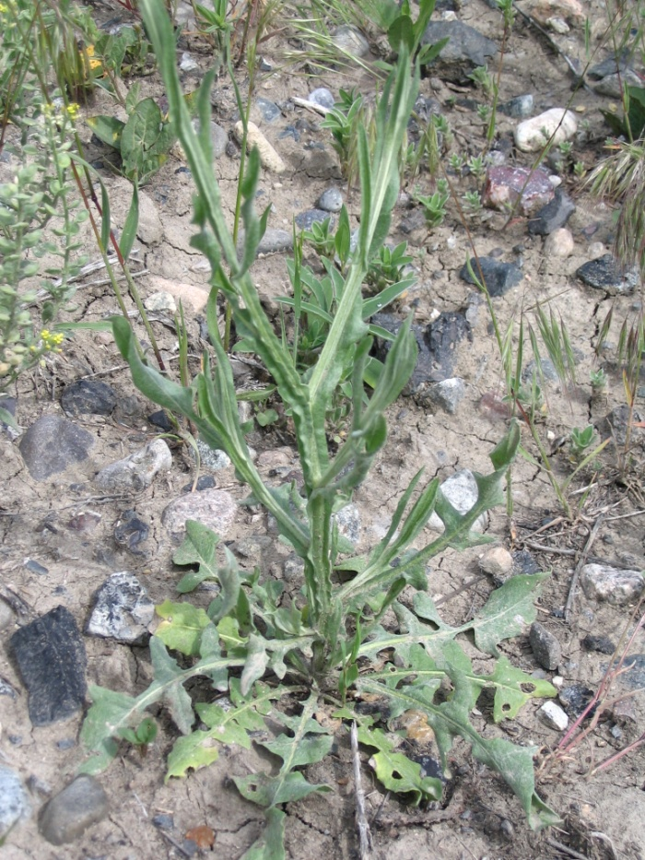

Figure 2. A yellow star-thistle rosette and flowering stem showing leaf shapes and the winged stem. Photo by Jane Mangold, Montana State University, Bozeman, Montana.

*Distribution:* Yellow star-thistle is native to the Mediterranean region. It has been reported in most states in the United States and in four Canadian Provinces. For current distribution, consult the Plant Profile page for this species on the PLANTS Web site.

*Habitat:* Yellow star-thistle prefers deep loamy soils with south facing slopes and 12 to 25 inches or more of annual rainfall with a bimodal distribution in the fall and spring. It favors perennial bunchgrass communities dominated by bluebunch wheatgrass, Idaho fescue, and Sandberg’s bluegrass. Although it does not compete well with sagebrush, it readily invades sagebrush communities after disturbance. It is most common in disturbed areas in full sun, such as rangelands, along highways or roads, railroad tracks and other transportation or communication lines. In Montana small patches have occurred along road sides, in new alfalfa seedings (from contaminated seed) and other disturbed areas such as construction lots. Because patches were controlled before they could establish and spread, it is unknown if certain regions or plant community types in Montana are more vulnerable. In Idaho large areas of canyon grasslands, rangelands, pasture, roadsides and other disturbed areas primarily in western to northern regions are infest with yellow star-thistle. Research in west central Idaho found rangelands with south to southwest aspects and 20-30% plus slopes were most vulnerable to yellow star-thistle invasion. In eastern Oregon it is common in grassland foothills. In Washington it is common on south-facing grassland slopes, primarily in the south eastern part of the state. In California it is prevalent in the Central Valley and surrounding foothills and continues into mountainous regions below 7,000 feet (2,100 meters).

**Adaptation**

In its native range, yellow star-thistle evolved under Mediterranean climatic conditions characterized by precipitation in the fall and spring, and dry conditions in the winter and summer.

### Establishment

Yellow star-thistle is a winter annual dependent on seed production for population growth and spread. Plants normally produce 20 to 120 seeds each, but under ideal conditions production may exceed 100,000 seeds per plant. Up to 90 percent of the seeds have a short plume (pappus). These seeds disperse at maturity and readily germinate when moisture is available in the fall. The other 10 percent lack a plume, disperse over winter, and may remain dormant in the soil for two to three years. One-quarter to one-half inch (0.6 to 1.3 centimeters) of rain in the fall is sufficient to stimulate germination and seedling emergence. Seedling densities in have been reported as high as 2,500 per square foot. Populations overwinter as seedlings or rosettes. Seed can also germinate in the spring.

Beginning in March and continuing through May, seedlings transition into rosettes. Normally, between 60 and 75 percent of the rosettes die from self-thinning and moisture stress. Surviving rosettes produce a tap root capable of penetrating deeply into the soil to access deep soil moisture. A flower stalk grows from surviving rosettes and blooms in mid-summer. Flowers are primarily pollinated by honeybees (*Apis* spp.) and bumblebees (*Bombus* spp.), and germinable seed is produced eight days after flower initiation. Spring emerging seedlings are capable of blooming in the year of emergence or overwintering to bloom in the following year.

### Management

See Control below

### Pests and Potential Problems

See the biological control section under Control below.

### Environmental Concerns

Yellow star-thistle is problematic on canyon lands, rangelands, pastures, roadsides, and disturbed areas. Its rapid growth rate and aggressive resource acquisition make it competitive in native plant communities where it forms dense stands displacing native species and reducing diversity. Loss of native bunchgrasses reduces available forage for livestock and wildlife, and the long, stout spines on the flowers deter grazing. Consumption of yellow star-thistle by horses causes chewing disease, a fatal nervous disorder. Rosettes can be grazed by cattle and sheep before the spiny flower heads form.

### Control

Contact your local agricultural Extension specialist or county weed specialist to learn what works best in your area and how to use it safely. Always read label and safety instructions for each control method. Trade names and control measures appear in this document only to provide specific information. USDA NRCS does not guarantee or warranty the products and control methods named, and other products may be equally effective.

*Herbicide:* There are many herbicides effective for controlling yellow star-thistle including glyphosate, 2,4-D, picloram, dicamba, clopyralid and others. For optimal population regulation, herbicide should be applied at the transitional stage from rosettes to flowers and before the population has advanced beyond the 2% flower initiation stage.

*Biological:* Five insect species have been released in the western United States for the management and control of yellow star-thistle. They feed on the flower buds and seedheads and can reduce seed production from 45 to 100 percent. There is also a rust fungus that reduces the vigor of yellow star-thistle plants.

*Burning:* Prescribed fire has been effective in reducing populations. Burns conducted for three consecutive years in late June and early July after the dispersal of desirable grass seed but before yellow star-thistle seed production, reduced the yellow star-thistle seed bank, seedling density, and summer vegetative cover each by over 90 percent.

*Hand pulling:* Hand pulling that removes the root crown is effective for new, small introductions of yellow star-thistle. To prevent seed dispersal, flowering plants should be destroyed in a hot fire or bagged and disposed of in an appropriate landfill. Repeated monitoring should be planned for every two to four weeks during the growing season.

*Mowing:* Where the plant is dense and widespread, timely mowing over a three-year period has reduced plant density. Mowing may reduce seed production, but it does not eliminate it, and may serve to spread seed. When mowing is followed by rain, seed production may increase. Always clean mowing machinery before moving to weed-free areas.

*Tillage:* Tillage will control yellow star-thistle in annual cropping systems. On disturbed sites vulnerable to weed invasion, tillage should be considered as a seedbed preparation prior to revegetation. Quickly establishing competitive, desired vegetation following disturbance may decrease the chance for invasive weeds like yellow star-thistle to become established.

**Seed and Plant Production** *Not applicable*

**Cultivars, Improved, and Selected Materials (and area of origin)** *Not applicable*

### References

Benwefield, C.B., J.M. DiTomaso, and G.B. Kyser. 2001. Reproductive biology of yellow star-thistle: maximizing late-season control. Weed Science 49:83-90.

DiTomaso, J.M. 2005. Yellow star-thistle (*Centaurea solstitialis* L.). In: C.L. Duncan and J.K. Clark (eds), Invasive plants of range and wildlands and their environmental, economic, and societal impacts. Weed Science Society of America, Lawrence, KS. Pages 36-50.

DiTomaso, J.M., M.S. Hastings, and G.B. Kyser. 1999. Prescribed burning for control of yellow star-thistle (*Centaurea solstitialis*) and enhanced native plant diversity. Weed Science 47:233-242.

Pitcairn, M.J., G.L. Piper, and E.M. Coombs. 2004. Yellow Star-thistle. In: Coombs, E.M., Coombs, J.K. Clark, G.L. Piper, and A.F. Cofrancesco, Jr. (eds), Biological control of invasive plants in the United States. Oregon State University Press, Corvallis, OR. Pages 233-262.

Sheley, R.L. and L.L. Larson. 1997. Cheatgrass and yellow star-thistle growth at 3 soil depths. Journal of Range Management 50: 146-150.

Sheley, R.L., L.L. Larson, and J.S. Jacobs. 1999. Yellow Star-thistle. In: Sheley, R.L. and J.K. Petroff (eds), Biology and Management of Noxious Rangeland Weeds. Oregon State Press, Corvallis, OR. Pages 408-416.

**Prepared By:** *Jim Jacobs,* Plant Materials Specialist, USDA NRCS Montana State Office, Bozeman, Montana

*Jane Mangold,* Extension Invasive Plant Specialist, Montana State University, Bozeman, Montana

*Hilary Parkinson,* Research Associate, Montana State University, Bozeman, Montana

*Melissa Medley,* Extension Weeds Integrated Pest Management Specialist, Montana State University, Bozeman, Montana

*Dan Ogle,* Plant Materials Specialist, USDA NRCS, Boise, Idaho

### Citation

Jacobs, J., J. Mangold, H. Parkinson, and M. Graves. 2011. Plant Guide for Yellow Star-thistle (*Centaurea solstitialis)*. USDA-Natural Resources Conservation Service, Montana State Office. Mozeman, Montana 59715.

Published September, 2011

Edited: 18July2011 jsj; 1Aug2011 mm, 3Aug2011 jm; 8Aug2011 hp; 25Aug2011 dgo

For more information about this and other plants, please contact your local NRCS field office or Conservation District at <http://www.nrcs.usda.gov/> and visit the PLANTS Web site at <http://plants.usda.gov/> or the Plant Materials Program Web site <http://plant-materials.nrcs.usda.gov>.

PLANTS is not responsible for the content or availability of other Web sites.

**USDA IS AN EQUAL OPPORTUNITY PROVIDER AND EMPLOYER**