

Plant Guide

# Douglas’ dustymaiden

## Chaenactis douglasii (Hook.) Hook. & Arn.

### Plant Symbol = CHDO

#### Contributed by: USDA NRCS Idaho Plant Materials Program

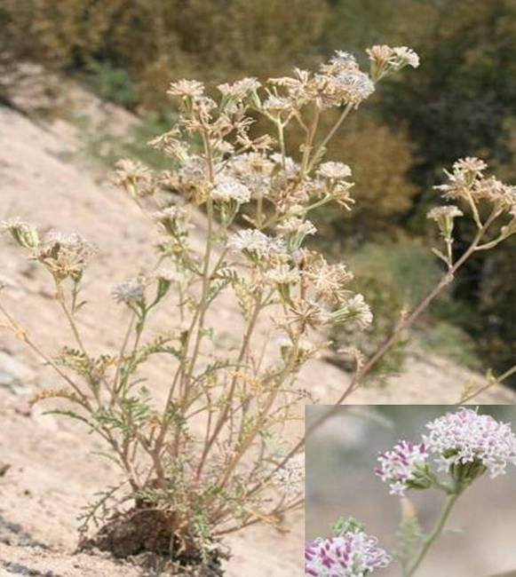

Figure . Douglas’ dustymaiden plant and flower (inset). Photo by Derek Tilley.

#### **Alternate Names**

Duskymaiden, Chaenactis, False yarrow, Morning brides, Pincushion, *C. angustifolia* Greene, *C. pedicularia* Greene, *C. pumila* Greene, *C. ramosa* Stockwell

#### **Uses**

*Restoration/reclamation*:

Douglas’ dustymaiden is an early colonizer of disturbed sites. It is commonly found on roadsides and gravel pits competing against invasive species such as cheatgrass and knapweed species.

It has also been found to be among the most successful native pioneer forb species on a broad variety of mining waste rock surfaces (Borden and Black, 2005).

*Wildlife*:

Douglas’ dustymaiden can be used as part of a native forb component in wildland seedings to increase biodiversity, improve wildlife habitat, and provide food for numerous birds and mammals. Douglas’ dustymaiden is readily visited by pollinators and other insect species. It is considered an important species for sage grouse during brood rearing because of its insect associations.

*Ethnobotanic*:

Douglas’ dustymaiden was commonly used by Native Americans to treat a variety of health problems. A poultice of Douglas’ dustymaiden was used by Native Americans to treat swelling, sores and aches (Foster and Hobbs, 2002; Moerman, 1998). A tea made from the plant was used to slow heart rates in children (Foster and Hobbs, 2002; Moerman, 1998) and for indigestion and headaches.

#### **Status**

Consult the PLANTS Web site and your State Department of Natural Resources for this plant’s current status (e.g., threatened or endangered species, state noxious status, and wetland indicator values).

#### **Description**

*General*: Sunflower family (Asteraceae). Douglas’ dustymaiden is a biennial or short-lived perennial forb developing from a basal rosette of grayish multi-lobed to lacey leaves. Flowering stems generally reach 30 to 60 cm tall (12 to 24 in) and are topped with white to pinkish composite flowers (figure 1). The fruit is a golden to black achene, approximately 8 mm (0.3 in) long with 10 to 16 membranous pappus scales (Welsh et al. 2003). There are approximately 342,500 seeds/lb (USDA NRCS PLANTS Database, 2010.).

Cytogeographic studies have revealed multiple ploidy levels present in the *Chaenactis douglasii* complex (Mooring, 1980). Mooring reported chromosome counts of 2n=12, 13, 14, 15, 18, 24, 25, 26, 27, 28, 37 and ca 38. Mooring also noted that diploid populations primarily occur in the mountains of the Pacific and Rocky Mountain Regions, while polyploids inhabit the intervening plateaus. Mooring also found ploidy level to be correlated with the age of geologic substrate.

This species is morphologically diverse and has been treated by taxonomists as a single species or as up to ten different species with six varieties. The PLANTS Database currently recognizes one species with two varieties, *douglasii* and *alpina* (USDA, 2010).

Variety *douglasii* are larger statured biennials or perennials, typically from 10 to 50 cm (4 to 20 in) tall, while variety *alpina* are shorter perennials (5 to 10 cm tall) (2 to 4 in) and are typically caespitose or mat forming (Moorefield, 2006).

*Distribution*:

Dustymaiden occurs throughout western North America at elevations from 1,000- 3,000 m (3,000- 10,000 ft) from British Columbia to Arizona, ranging as far east as South Dakota. Variety *douglasii* is known in and east of the Sierra and Cascade ranges extending to the western edge of northern Great Plains. For current distribution, consult the Plant Profile page for this species on the PLANTS Web site.

*Habitat*:

The species can be found in a variety of plant communities including shadscale, sagebrush steppe, pinyon-juniper, mountain brush and pine-fir forests in areas receiving 10 to 60 inches annual precipitation (USDA-NRCS, 2009).

#### **Adaptation**

Douglas’ dustymaiden is adapted to a wide range of soil conditions ranging from acidic to moderately basic. The species is found growing in medium to coarse textured well drained soils with a pH of 4.2 to 7.9 and electrical conductivity of 0.06 to 2.5 dS/m (Borden and Black, 2005). Douglas’ dustymaiden requires full exposure to sunlight and a minimum 10 inch rooting depth (USDA-NRCS, 2009).

#### **Establishment**

Seed can be surface sown in greenhouse containers in spring and transplanted when plants are large enough to disturb (Coffey, 1993). Parkinson and DeBolt (2005) reported 12% germination from 30 day cold moist stratification at 4° C (39° F); however no tetrazolium tests were conducted to determine seed viability prior to the experiment. A common garden study comparing 15 populations of Douglas’ dustymaiden from Idaho, Utah and Nevada had establishment percentages ranging from 66 to 98% (Tilley and St. John, 2010) from seed that was field-planted in November and allowed to undergo natural stratification.

Seed should be drilled or broadcast seeded in late fall into a firm, weed-free seed bed at a depth of 0 to 6 mm (0 to 0.25 in). For a pure stand, target delivery of 20 to 30 pure live seeds (PLS) per square foot, seed at a rate of 3.5 lb (1.6 kg) PLS per acre. If seeding as part of a mix, adjust seeding rate to the desired percentage of the mixture. Broadcast seedings should be followed with a cultipacker to ensure good seed to soil contact.

Seed should be mixed with a dilutent such as rice hulls to assist seed flow through seeding equipment. When calculating rice hull amounts based on seed bushel weights, it is important to determine the condition of the seed. Douglas’ dustymaiden seed which has not had the pappus removed has a bushel weight of approximately 3 lb/bu, while seed which has had the pappus removed by milling or brushing can have bushel weights of up to 15 lb/bu.

#### **Management**

When planted in a native reclamation mix, it will be a minor component of the establishing plant community; therefore management should be based on other key species in the mixture.

#### **Pests and Potential Problems**

There are no known pests or problems associated with Douglas’ dustymaiden.

#### **Environmental Concerns**

There are no known environmental concerns associated with Douglas’ dustymaiden.

#### **Seed and Plant Production**

Seed production fields of Douglas’ dustymaiden can be planted into weed barrier fabric at 23 to 30 cm (9 to 12to 18 in) spacing. Seed should be planted in late fall into slightly roughened soil and then lightly packed. Plants grown in weed barrier fabric at Aberdeen, Idaho (an 8- 12 inch mean annual rainfall zone) required no supplemental irrigation (Tilley and St. John, 2010). Effects of irrigation on plant growth and seed production have not been evaluated. Flowering begins in early summer and continues for several weeks. Seed can be harvested by hand, flailvac or direct combined. Harvested seed should be dried to 12% moisture and stored in a freezer for at least 48 hrs to remove pests (Parkinson and DeBolt, 2005).

Weed control efforts should begin prior to planting. Planting into a weed-free seed bed, or using weed barrier fabric greatly reduces management inputs. Weeds can be controlled using pre-emergent herbicides and by hand rouging. Weedy grasses can be controlled with selective herbicides.

Always read and follow label and safety instructions for each control method. USDA-NRCS does not guarantee or warranty any products or control methods named, and other products may be equally effective.

Douglas’ dustymaiden plants provide pollen and nectar to a variety of insect visitors. Insect surveys at the Aberdeen Plant Materials Center showed visitation by: sweat bees (*Halictus ligatus*), green sweat bees (*Agapostemon* sp.), Hunt’s bumblebees(*Bombus huntii*)*,* and mason bees (*Osmia* sp.), and *Micranthophora flexipes* as well as European honey bees (*Apis mellifera*). Managing seed production fields for native bee habitat may improve seed yield.

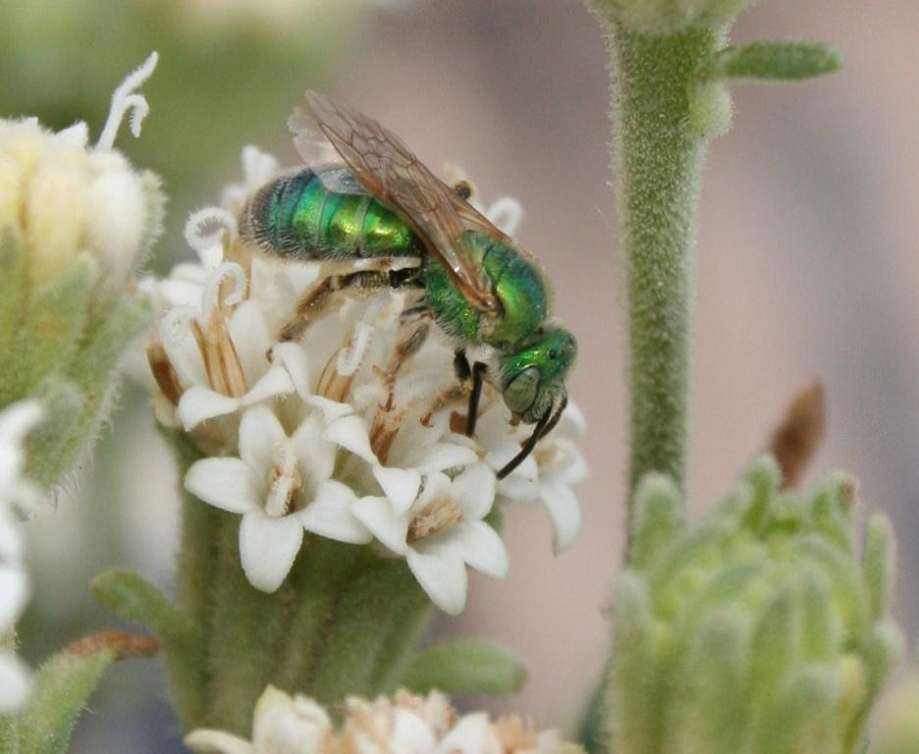

Figure 2. A green sweat bee (*Agapostemon* sp.) visiting Douglas' dustymaiden. Photo by Derek Tilley

It is difficult to remove the membranous pappus from the achene for seed processing, and complete removal may not be possible (figures 2 and 3). This may become problematic when attempting to seed through a grain or range drill or other seeding equipment, especially without the aid of a dilutant such as rice hulls. Good results in removing the pappus can be obtained from hammer-milling the seed with a sizeable amount of plant material. The inert matter helps in rubbing the pappus from the achenes. Using the hammer-mill or debearder without inert material does not provide enough weight or friction for successful achene removal. Some damage occurs to seed during milling, but germination rates of milled seed do not appear to differ significantly from un-milled seed (Tilley and St. John, 2010).

An alternate method used by USDA Forest Service at the Bend, OR Seed Extractory is to use a Westrup Model LA-H laboratory brush machine with a #40 mantel at a speed of 3 to dislodge seed from the flower heads and remove the pappus. The gate is left completely open to allow the seed to move quickly through the machine and avoid damaging the achenes. This is followed by air-screening (Barner 2009).

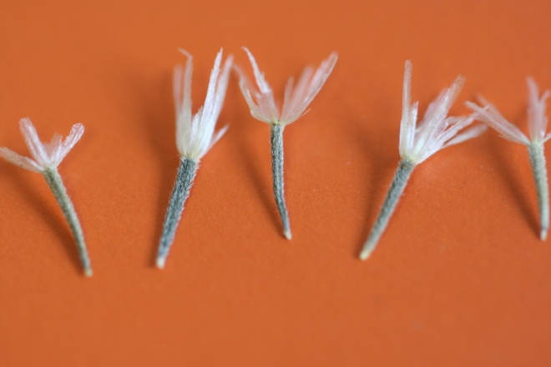

Figure . Unprocessed Douglas' dustymaiden seed. Photo by Derek Tilley.

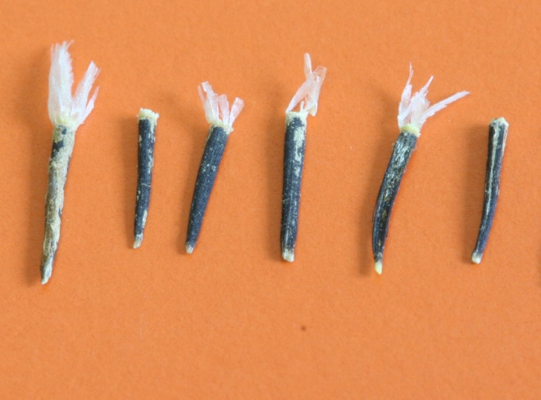

Figure . Seed after processing. Photo by Derek Tilley.

#### **Cultivars, Improved, and Selected Materials (and area of origin)**

Currently there are no releases of this species.

Aberdeen Plant Materials Center assembled collections of Douglas’ dustymaiden in 2007 and began evaluating populations in a common garden study in 2008. The goal is to develop one or more selected class germplasm releases for use in the Intermountain West.

#### **References**

Barner, J. 2009. Propagation protocol for production of *Chaenactis douglasii* (Hook.) Hook. & Arn. Seeds; USDA FS-R6 Bend Seed Extractory, Bend, OR. In: Native Plant Network. URL: http://www.nativeplant network.org (accessed 26 July 2010). Moscow (ID): University of Idaho, College of Natural Resources, Forest Research Nursery.

Borden, R.K. and R. Black. 2005. Volunteer revegetation of waste rock surfaces at the Bingham Canyon Mine, Utah. Journal of Environmental Quality 34:2234-2242.

Coffey, T. 1993. The History and Folklore of North American Wildflowers. Houghton Mifflin Co. Boston, MA.

Foster. S., and C. Hobbs. 2002. A Field Guide to Western Medicinal Plants and Herbs. Houghton Mifflin Harcourt. 442p.

Morefield. J.D. Mooring, J.S. 1980.  2006.  *Chaenactis*.  In: Flora of North America Editorial Committee, Eds.  1993+.  Flora of North America North of Mexico.  12+  vols.  New York and Oxford.  Vol. 21, pp. 400-414.

Mooring, J.S. 1980. A Cytogeographic Study of *Chaenactis douglasii*. American journal of Botany 67 (9) pp. 1304-1319.

Parkinson, H., and A. DeBolt. 2005. Propagation protocol for production of container *Chaenactis douglasii* (Hook.) H. & A. plants; USDA Forest Service, RMRS, Boise, ID. In: Native Plant Network. URL: http://www.nativeplantnetwork.org (accessed 9 Feb 2007). Moscow (ID): University of Idaho, College of Natural Resources, Forest Research Nursery.

Tilley, D. and L. St. John. 2010. Douglas’ dustymaiden initial evaluation planting: progress report 2010. USDA-NRCS. Aberdeen, ID.

USDA-NRCS. 2009. The PLANTS Database [Online]. Available at http://plants.usda.gov (accessed 10 December 2009). USDA-NPDC, Baton Rouge, LA.

Welsh, S.L., N.D. Atwood, S. Goodrich, and L.C. Higgins. 2003. A Utah Flora. Third Edition, revised. Brigham Young University, Provo, UT.

#### **Prepared By**

*Derek Tilley*; Range Scientist, USDA NRCS Plant Materials Center, Aberdeen, Idaho.

*Dan Ogle;* Plant Materials Specialist, USDA NRCS, Boise, Idaho.

*Loren St. John*; Team Leader, USDA NRCS Plant Materials Center, Aberdeen, Idaho.

#### **Citation**

Tilley, D., D. Ogle, and L. St. John. 2010. Plant guide for Doulas’ dusty maiden (*Chaenactis douglasii*). USDA-Natural Resources Conservation Service, Idaho Plant Materials Center. Aberdeen, ID. 83210.

Published: November 2010

Edited: 10Sep2010djt; 10Sep2010LS; 10Sep2010jab; 21Sept2010dgo

**USDA IS AN EQUAL OPPORTUNITY PROVIDER AND EMPLOYER**