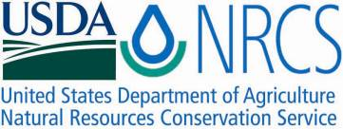

Plant Guide

## WESTERN PRAIRIE CLOVER

|  |
| --- |
| *Dalea ornata* (Douglas) Eaton & Wright |
| Plant Symbol = DAOR2 |

Contributed by: USDA NRCS Plant Materials Center, Pullman, Washington

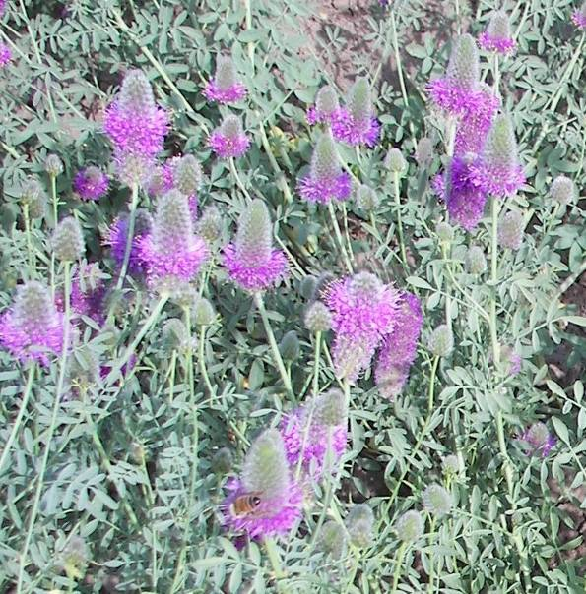

Kishor Bhattarai, Utah State University

### Alternate Names

Blue Mountain prairie clover, showy prairie clover, ornate dalea, Petalostemon ornatus Douglas ex. Hook, Petalostemon ornatum Douglas, Kuhnistera ornata (Douglas) Kuntze, Petalostemon lagopus Rydb., Petalostemon ornatum fo. pallidus H. St. John

### Uses

Rangeland revegetation: Western prairie clover can be used in seeding mixes for diversification and revegetation of rangelands.

Forage: Western prairie clover is a non-toxic legume and has the potential for increasing forage production and quality (Bhattarai et al. 2009).

Pollinator habitat: Dalea ornata attracts native bee fauna as well as managed agricultural pollinators. A similar species native to the Great Plains (D.

purpurea) yields more than 20,000 seeds per plant when pollinated by agricultural pollinators Apis mellifera and Megachile rotundata (Cane 2006).

*Beautification*: This plant is an excellent choice for beautification of roadsides, rest areas and parks.

### Status

Please consult the PLANTS Web site and your State Department of Natural Resources for this plant’s current status (e.g., threatened or endangered species, state noxious status, and wetland indicator values).

### Description

*General*: Legume family (Fabaceae). Western prairie clover is a perennial, herbaceous North American legume that grows to 12 – 24 inches in height. It has a cluster of stems that arise from a taproot. Dried stems are also usually present from previous years. Leaves are 1.6 to 2 inches long, alternate and odd-pinnate, comprised of 5 – 7 oval shaped leaflets, each 0.4 – 0.8 inch long. Leaves and stems are dotted with tiny glands. The plant is hairless except for long silky hairs on the calyces. Flowers occur in dense, cylinder-shaped spikes which are 0.8 – 2.4 inches long. The flowers are light pink to purple in color and have 5 petals. One petal is broad-clawed and attached to the calyx. The other 4 petals are narrow-clawed, attached to the staminal tube and alternate with the 5 stamens. The flowers bloom upward along the spike May – July. Seedpods are enclosed by the calyces and contain 1 or 2 seeds. The plant is primarily insect-pollinated and has a variable degree of self-incompatibility.

*Distribution*: Western prairie clover is native to southeastern Washington, western Idaho, eastern Oregon, northern California and northwestern Nevada. It is relatively uncommon. For a current distribution map, please consult the Plant Profile page for this species on the PLANTS Web site.

*Habitat*: Western prairie clover is found in sagebrush-steppe habitats in the southern Columbia Plateau, the Blue Mountains and the northern Great Basin.

**Adaptation**

Western prairie clover is adapted to low to moderate elevations and is characteristic of soft clay and sandy soils derived from weathering of basalt and volcanic ash (Barneby 1977).

### Establishment

This species can be established by seed; however availability of seed for this species is extremely limited. With releases planned in the near future by the ARS Forage and Range Research Laboratory in Logan, UT, and the Pullman Plant Materials Center in Pullman, WA, more seed may become available.

To establish a planting, the seed must first be scarified using sandpaper or a laboratory scarifying device. Seed also can be scarified by soaking in 98% sulfuric acid, rinsed with water and air-dried. The seed should be planted with a drill into a prepared, firm, weed-free seed bed at a depth of ¼ - ½ inch and at a rate of 4 – 5 pounds Pure Live Seed (PLS) per acre. If the seed is planted in a mix, the seeding rate should be adjusted according to the proportion of the mix. If the seed is broadcast, the seeding rate should be doubled. To improve the plant's ability to establish and fix nitrogen, the seed should be inoculated with the proper *Rhizobium* bacteria strain prior to planting.

### Management

In all native forb plantings, weeds must be managed for several years to ensure successful establishment. One of the most common options for weed management is application of herbicide. In Nebraska, Masters et al. (1996) found stands of purple prairie clover (*D. purpurea*) had greater foliar cover when treated with imidazolinonone herbicides (imazapyr and imazethapyr) compared to untreated stands. Numerous pre- and post-emergent herbicides are labeled for rangeland use and can be applied to cover an entire area or spot-sprayed. Another management option that can be used alone or in combination with herbicide application is mowing. The mower should be set at a height that does not negatively affect the seedlings of desired species.

### Pests and Potential Problems

Seedlings of *Dalea ornata* may be damaged by rodents and insects.

### Environmental Concerns

This plant does not appear to spread aggressively by seed or vegetative means.

### Seeds and Plant Production

When growing western prairie clover for seed production, the seed should be planted at a rate of 25 – 30 PLS per lineal foot (Cornforth, et al 2009). The Forage and Range Research Laboratory in Logan, UT, has determined *Dalea ornata* has 283 – 340 seeds per gram (128,367 – 154,227 seeds per pound) depending on environmental factors and genotype. The plants continue to flower while seed produced earlier in the season matures, complicating the harvest process.

### Cultivars, Improved, and Selected Materials (and area of origin)

None

### References

Barneby, R.C. 1977. Daleae imagines. Memoirs of the New York Botanical Garden 27:1-892.

Bhattarai, K., B.S. Bushman, D.A. Johnson and J.G. Carman. 2009. Characterization of the population structures in the wildland collections of *Dalea ornata* and *D. searlsiae* from the western U.S. Society for Range Management 62nd Annual Meeting, Alberquerque, NM, 2009. Paper No. 1000-6. [Online]. Available at

<http://www.srmmeetings.org/pdf_Abstracts/pstrA1000_Ecology/1000_6.pdf> (Accessed 29 October 2009). USDA-ARS, Logan, UT.

**Burke Museum of Natural History and Culture. [Online]. Available at** <http://biology.burke.washington.edu/herbarium/imagecollection.php?Genus=Dalea&Species=ornata>**. (Accessed 29 Oct 2009). University of Washington, Seattle, WA.**

Cane, J. 2006. An evaluation of pollination mechanisms for purple prairie clover, *Dalea purpurea* (Fabaceae: Amorpheae). Am. Midl. Nat. 156:193-197.

Cornforth, B., L. St. John and D. Ogle. 2001. Seed Production Standards for Conservation Plants in the Intermountain West. USDA-NRCS Plant Materials Technical Note No. 14. Boise, ID.

Davis, R.J. 1952. Flora of Idaho. W.M.C. Brown Company, Dubuque, IA.

Hitchcock, C.L. and A. Cronquist. 1973. Flora of the Pacific Northwest. University of Washington Press, Seattle, WA.

Masters, R.A., S.J. Nissen, R.D. Gaussoin, D.D. Beran and R.N. Stougaard. 1996. Imidazolinone herbicides improve restoration of Great Plains grasslands. Weed Technology. 10:392-403.

USDA-ARS. 2009. Improved Plant Genetic Resources for Pastures and Rangelands in the Temperate Semiarid Regions of the Western U.S. 2009 Annual Report. [Online]. Available at <http://afrsweb.usda.gov/research/projects/projects.htm?ACCN_NO=412652> (Accessed 29 Oct 2009). USDA-ARS, Logan, UT.

**Prepared By**

*Pamela Scheinost*, USDA NRCS Plant Materials Center, Pullman, Washington

*Douglas A. Johnson*, USDA ARS Forage and Range Research Laboratory, Logan, Utah

*James H. Cane*, USDA ARS Pollinating Insects Research Unit, Logan, Utah

### Citation

Scheinost, P., D.A. Johnson and J.H. Cane. 2009. Plant guide for western prairie clover (*Dalea ornata*). USDA-Natural Resources Conservation Service, Pullman Plant Materials Center. Pullman, WA.

Published November 2009

Edited: 13nov2009 jhc; 13nov2009 daj; 17 nov2009 ps; 20Nov2009 jb; 3Dec2009 ps

For more information about this and other plants, please contact your local NRCS field office or Conservation District at <http://www.nrcs.usda.gov/> and visit the PLANTS Web site at <http://plants.usda.gov/> or the Plant Materials Program Web site <http://plant-materials.nrcs.usda.gov>.

PLANTS is not responsible for the content or availability of other Web sites.

**USDA IS AN EQUAL OPPORTUNITY PROVIDER AND EMPLOYER**