

Plant Guide

# showy ticktrefoil

*Desmodium canadense* (L.) DC.

Plant Symbol = DECA7

Contributed by: USDA NRCS East Texas Plant Materials Center

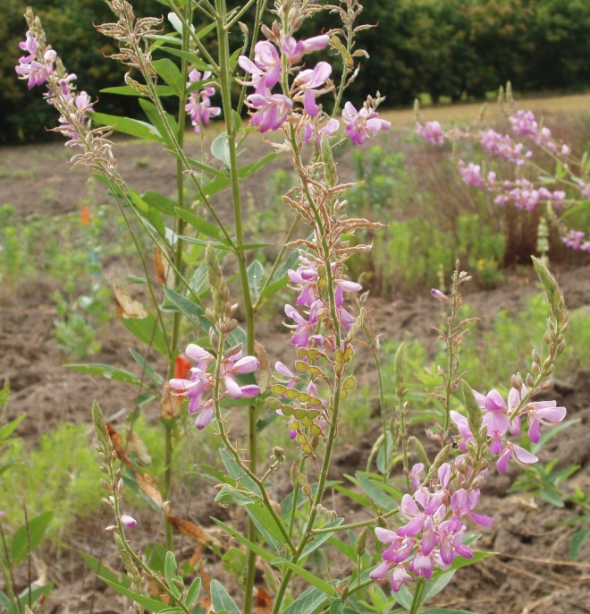

R. Alan Shadow

USDA NRCS East Texas Plant Materials Center

Alternate Names

beggar’s lice, stick tights, showy trefoil

Uses

*Wildlife and Conservation*

Desmodium species are considered valuable wildlife plants, and showy ticktrefoil is no exception. It ranks as one of the most important species in the diet of Northern Bobwhite, is used heavily by Ruffed Grouse and Wild Turkey, and is preferred browse for White-tailed Deer (Miller and Miller, 1999). Showy ticktrefoil is an important pollinator habitat plant. Humming birds frequent the brightly colored blooms, along with a host of insects. Long-tongue bees, bumblebees, miner bees, leaf-cutting bees, and some short-tongued bees can be found working blooms of showy ticktrefoil (Hilty, 2002-2009).

Status

Please consult the PLANTS Web site and your State Department of Natural Resources for this plant’s current status (e.g. threatened or endangered species, state noxious status, and wetland indicator values).

Description

*General*:

Showy ticktrefoil is a native, warm-season, perennial legume that typically grows 3-4 feet in height (USDA-NRCS, 2009. It is capable of obtaining up to 6 feet in height under optimum conditions and when in competition with tall grasses (Grow Native, 2009). Its growth form is erect, though it may occasionally sprawl. The central stem is green in color with fine, white hairs. The leaves are compound, trifoliate, and have an alternate arrangement on the stem. The leaflets are 2 - 3.5 inches in length, and less than a half inch across, giving them a lanceolate shape. The leaves are rounded at the tips and have fine, hook like, hairs on their underside (Hilty 2002-2009).

Flowering occurs on the upper half of the plant on an elongated raceme during mid-summer, July – August, and lasts about 3 weeks. The pea-like flowers are approximately a half inch in size with no scent, and consist of an upper and lower petal. They are open pollinated (USDA-NRCS, 1997), and may be sparsely spaced or densely packed along the raceme. The later giving the plant a nodding appearance when in full bloom. The blossoms are pink to purple in color with a patch of darker pink and yellow near their center. Each flower is born on a hairy, red pedicel, and has a hairy, greenish-red calyx. They are keel shaped near the point of attachment, and open wide starting with the upper petal (Hilty, 2002-2009).

Flowers desiccate and drop after pollination, forming seed pods, loments. The loments generally have 3 to 5 segments and are about 2.5 inches in length. They are flattened and covered in fine, hooked hairs that readily adhere to clothing and passing animals (Hilty 2002-2009). Showy ticktrefoil produces approximately 80,000 seeds per pound (Rotar and Urata, 1966)

*Distribution*:

Showy ticktrefoil is commonly found throughout the central United States from Texas, northward into Canada. It is found as far west as the Dakotas, but is absent in the southeastern United States. North of Virginia, its range extends eastward to the Atlantic coast all the way to Maine.

For current distribution, please consult the Plant Profile page for this species on the PLANTS Web site.

*Habitat*:

Showy ticktrefoil is commonly associated with the tall grass prairie region. It is a facultative plant, meaning it can be found in both upland and lowland sites. It typically favors moist soils such as those found along river banks, lake edges, and wet meadows (Hitly, 2002-2009). It can also be found in open woods, rocky and sandy prairies, roadsides and disturbed areas (Native Plants information Network, 2009).

Adaptation

Showy ticktrefoil prefers full sun, and is indifferent to soil acidity (NPIN, 2009). It is highly adaptable and will grow on a wide range of soil textures from coarse sands to fine clays, preferring loamy soil, as long as adequate moisture is present (Evergreen, 2009). It is very competitive and is capable of competing with the tall grasses it is associated with in open prairies. It is fire tolerant, and burning will increase stand vigor (USDA-NRCS, 1997).

**Establishment**

To help reduce weed pressure, prepare a clean, firm seed bed by disking, harrowing, and firming the seed bed with a cultipacker or roller prior to establishment. Rain or irrigation may also be used to settle and firm the seed bed. If possible, allow an initial flush of weeds to germinate before planting. Treat with a broad spectrum herbicide such as glycosphate while the weeds are young, 2-4 leaf stage. This process may be repeated multiple times if severe weed pressure is anticipated. Avoid soil disturbances such as disking or tillage after the initial flush of weeds have been treated as this brings new weed seed to the surface for germination.

For optimum results, seed should be scarified, treated with “EL” culture inoculants, and planted ¼ inch deep or less. Planting may be done in spring, after the threat of frost has passed, or fall. For fall plantings, the seed should be planted late enough that it over winters in the soil, and germinates the following spring. A Brillion seeder or grain drill can be used to plant the seed.

For conservation plantings, showy ticktrefoil usually comprises less than 10% of a seeding mixture. The rate can vary from .5 to 1 pound of pure live seed per acre. The seeding rate should be increased to 10 pounds of pure live seed per acre for monotypic stands or wildlife plots. For seed production, 3.3 pounds per acre on 36 inch rows should be used. This equates to 20 pure live seed per linear foot of row (USDA-NRCS, 1997). Plantings should coincide with rain events to ensure adequate moisture is available for germination and subsequent seedling growth for optimum stand establishment. Irrigation is helpful for seed production, but it is not necessary for conservation plantings.

Management

Fertilization is not recommended during the first year of establishment as it will increase weed competition in the new planting. Fertilizer application should only be made to new plantings if soil tests indicate severe potassium or phosphorous deficiencies. Being a legume, showy ticktrefoil does not require nitrogen inputs. Nitrogen application will encourage weeds and make them more competitive. A complete fertilizer; low in nitrogen, may be used in established stands. Use soil tests to determine the proper amount of P and K to apply.

Weeds may be controlled with selective herbicides, mowing, and cultivation. Grass selective herbicides may be extremely useful in limiting grass competition in plantings (USDA-NRCS 1997).

Timely mowing of weeds will inhibit them from developing seed, or destroy the seed before it is mature. Mowing also reduces weed competitiveness by reducing leaf area, and allows more light to reach the showy ticktrefoil seedlings. Be certain to mow above the plants to reduce injury and increase its competitiveness. Cultivation may also be used to control weeds between rows in seed production fields. One disadvantage of cultivation is the potential for increased weed competition as tillage can bring new weed seed to the surface for germination.

For tall weeds, a wick applicator filled with a 50% glyphosate mixture is effective. Attach the wick applicator to an ATV or tractor and drive slowly through the planting with the wick positioned above the height of the ticktrefoil plants, and at a height to maximize control of the target weeds.

Once established, a pre-emergent herbicide may be used to limit weed pressure throughout the growing season. It should be noted that pre-emergent herbicides also have activity on desirable seeds that germinate in wildlife or restoration planting. Its use may only be applicable in a seed production situation.

Please contact your local agricultural extension specialist or county weed specialist to learn what works best in your area and how to use it safely. Always read label and safety instructions for each control method. Trade names and control measures appear in this document only to provide specific information. USDA NRCS does not guarantee or warranty the products and control methods named, and other products may be equally effective.

Pests and Potential Problems

Skipper butterfly larva feed on the foliage of the plant. The stems are a preferred food source for the Japanese beetle, *Papilio japonica* (Hilty, 2002-2009). Plants in a study at Michigan State University were reportedly decimated by Japanese beetles during both years of the study, and also attracted aphids, thrips, lygus bugs, leafhoppers, and leaf beetles (Landis et al, 2006.).

As mentioned, the seed of showy ticktrefoil are incased in a pod that is covered in tiny, hooked hairs that act as a natural Velcro. The seed will readily cling to clothing or animal fur and are distributed in this fashion. This can lead to distribution into unwanted areas. The pods can also cause some difficulty during harvest and seed cleaning.

Environmental Concerns

There are no known negative environmental concerns with this species.

Cultivars, Improved, and Selected Materials (and area of origin)

Alexander Germplasm showy ticktrefoil is a source-identified release from the Elsberry, Missouri Plant Materials Center. It was collected from a native stand in Alexander County in southern Illinois.

Contact your local Natural Resources Conservation Service (formerly Soil Conservation Service) office for more information. Look in the phone book under United States Government. The Natural Resources Conservation Service will be listed under the

subheading “Department of Agriculture.”

**References**

Miller, J.H., and Miller, K.V. 1999. Forest Plants of the Southeast and Their Wildlife Uses. Craftmaster Printers, Incorporated, Auburn, Alabama.

Hilty, J. 2002-2009. Illinois Wildflowers. http://www.illinoiswildflowers.info/prairie/plant x/shw_trefoilx.htm. May 21, 2009. Dr. John Hilty, Illinois.

USDA, NRCS. 2009. The PLANTS Database (http://plants.usda.gov, 21 May 2009). National Plant Data Center, Baton Rouge, LA 70874-4490 USA.

Grow Native. 2009. (http://www.grownative.org//plants/details.asp?i d=7. May 21, 2009) Missouri Department of Conservation and Missouri Department of Agriculture, Missouri. 2009.

Rotar, P.P. Urata, U. 1966. Technical Progress Report No. 147: Some Agronomic Observations in Desmodium Speices: Seed Weights. Hawaii Agricultural Experiment Station, University of Hawaii.

USDA, NRCS Plant Material Program 1997. Alexander Germplasm Showy Ticktrefoil *Desmodium canadense* L. (http://plant- materials.nrcs.usda.gov/mopmc/pubs/MOPMCB R08AlexanderTickTrefoil.pdf. 21 May 2009) Elsberry Plant Materials Center, Elsberry, MO. 63343 USA.

Lady Bird Johnson Wildflower Center The University of Texas at Austin. 2009. Native Plant Information Network (http://www.wildflower.org/plants/result.php?id_ plant=deca7 21 May 2009) Ausitn, TX. 78739 USA.

Evergreen. 2009. The Native Plants Database (http://www.evergreen.ca/nativeplants/search/vie w-plant.php?ID=00254, 21 May 2009) Canada, 2002-2009.

Landis, D., Fieldler, A., Issacs, R. Tuell, J. Michigan State University Department of Entomology. 2006. (http://nativeplants.msu.edu/descan.htm 21 May 2009) Michigan State University. East Lansing, MI 48824 USA.

Prepared By

R. Alan Shadow, USDA NRCS East Texas Plant Materials Center

Species Coordinator

Published October, 2009

Edited:

For more information about this and other plants, please contact your local NRCS field office or Conservation District at <http://www.nrcs.usda.gov/> and visit the PLANTS Web site at <http://plants.usda.gov/> or the Plant Materials Program Web site <http://plant-materials.nrcs.usda.gov>.

PLANTS is not responsible for the content or availability of other Web sites.

**USDA IS AN EQUAL OPPORTUNITY PROVIDER AND EMPLOYER**