

Plant Guide

# SNAKE RIVER WHEATGRASS

*Elymus wawawaiensis*

**J. Carlson & M. Barkworth**

Plant Symbol = ELWA2

Contributed by: USDA NRCS Idaho State Office

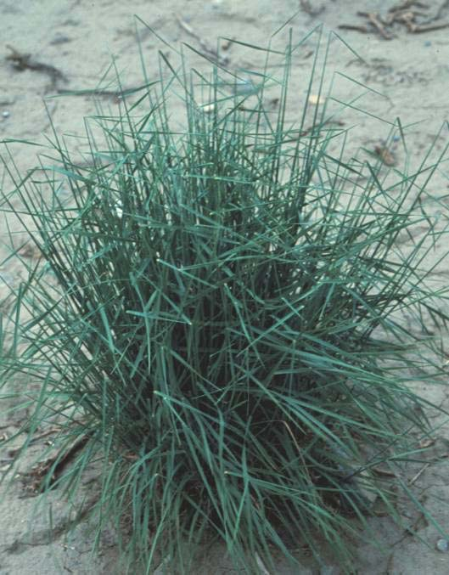 *Snake River Wheatgrass. Dr. Tom Jones, USDA, ARS, Logan, UT*

Alternate Names

Formerly referred to as bluebunch wheatgrass before the description of Snake River wheatgrass as a new species.

Uses

*Grazing/rangeland/wildlife*: Snake River wheatgrass is palatable to all classes of livestock and wildlife. It is a preferred feed for cattle, horses, sheep, elk, deer and antelope in spring when protein levels can be as high as 20 percent. Protein levels decrease to about 4 percent as the grass matures and cures by early to mid summer. Digestible carbohydrates remain about 45 percent throughout the active growth period.

*Erosion control/reclamation*: Snake River wheatgrass is very drought tolerant, stands are persistent once established, and it is adapted to stabilization of disturbed soils. It is very compatible with slower developing natives such as streambank wheatgrass, thickspike wheatgrass, basin wildrye, western wheatgrass, bluegrass species, and needlegrass species. It does not compete well with aggressive introduced grasses. Its drought tolerance, combined with an extensive root system and fair to good seedling vigor, make this species ideal for reclamation in areas receiving 10 to 20 inches annual precipitation. The cultivars ‘Discovery’ and 'Secar' compete well in areas as low as 8 inches annual rainfall. This grass can be used in urban areas where irrigation water is limited to stabilize ditch banks, dikes, and roadsides as a component of a native mix.

### Description

*General*: The natural distribution of Snake River wheatgrass is limited to eastern Oregon, eastern Washington, and west central to northern Idaho, but it is widely used as a surrogate for bluebunch wheatgrass for restoration, reclamation, and rehabilitation of rangelands in the Columbia Plateau, Northern Basin and Range, Central Basin and Range, and Snake River Plain, which encompass large portions of eastern Washington, eastern Oregon, southern Idaho, Nevada, and western Utah.

Snake River wheatgrass is a long-lived, perennial, cool-season native bunchgrass with an extensive root system with strong tillers. Snake River wheatgrass spreads by seed.

Snake River wheatgrass can be morphologically distinguished from bluebunch wheatgrass by characters such as the ratio of spikelet length to internode length, glume shape, seedling pubescence, and seedling leaf marginal barbs (Jones et al., 1991).

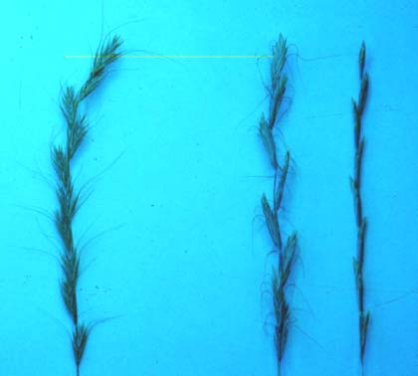

*Snake River (left) vs. awned (center) and awnless( right) bluebunch wheatgrasses*

Snake River wheatgrass has a seed of considerably smaller mass than bluebunch wheatgrass. Snake River wheatgrass is always awned, while bluebunch wheatgrass may be awned or awnless. Snake River wheatgrass is always allotetraploid (2*n*=28) while bluebunch wheatgrass may be diploid (2*n*=14) or autotetraploid (2*n*=28) (Carlson and Barkworth, 1997).

##### Adaptation and Distribution

Snake River wheatgrass does best on medium to coarse-textured soils, but can be found on heavy to medium to coarse-textured soils over 10 inches deep, including fairly sandy sites. It can be seeded on clayey sites. It may be found on thin, rocky sites and on very steep slopes. It tolerates weakly saline conditions. It does not grow on acidic sites. It is cold tolerant, moderately shade tolerant, and very tolerant of fire. It is intolerant of high water tables, poor drainage, and periods of extended inundation.

On native sites Snake River wheatgrass is most abundant in the 8 to 20 inch annual precipitation zones. When seeded, it does best with 10 to 20 inches of precipitation (‘Discovery’ and 'Secar' have established with as little as 7 inches) and it will tolerate up to 35 inches on very well-drained soils. The elevation range is from 500 feet above sea level to 10,000 feet. It is a major component of native plant communities where it is found and generally occupies 20 to 60 percent of the overall composition by weight of the plant community.

For a current distribution map, consult the Plant Profile page for this species on the PLANTS Website.

Status

Consult the PLANTS Website and your State Department of Natural Resources for this plant’s current status (e.g. threatened or endangered species, state noxious status, and wetland indicator values).

Establishment

This species should be seeded with a drill at a depth of 1/2 inch or less on medium-textured soils, 1/4 inch on fine-textured soils and 3/4 inch or less on coarse-textured soils. The single species seeding rate recommended for this grass is 8 pounds Pure Live Seed (PLS) or about 24 PLS per square foot. If used as a component of a mix, adjust to percent of mix desired. For broadcast plantings, mined lands, and other harsh critical areas, the seeding rate should be increased to 40 to 50 PLS per square foot. Seedlings are significantly weaker than crested wheatgrass and a clean firm weed free seedbed is required for establishment (cheatgrass and other weed competition can cause stand failure).

Seed in very early spring on heavy to medium- textured soils and in late fall on medium to light- textured soils. Late summer (August to mid- September) seeding is not recommended unless irrigation is available. Dormant fall seedings will pre-chill seed and improve germination.

Snake River wheatgrass establishes fairly quickly for a native grass and stands should be given up to 3 years to ensure establishment. It is compatible with other native species and should be used in seeding mixtures. It should not be seeded with strongly competitive introduced species.

Stands may require weed-control measures during establishment. Application of 2,4-D should not be made until plants have reached the four to six-leaf stage. Mow weeds at or prior to their bloom stage. New stands may be damaged by grasshoppers and other insects and pesticides may be needed.

Management

Stands of Snake River wheatgrass should not be grazed until they have firmly established (usually two to three growing seasons) and started to flower.

Six inches of new growth should be attained in spring before grazing is allowed in established stands. The growing point of Snake River wheatgrass is fairly high and stands can be easily overgrazed. Spring grazing should occur no more than one out of three years and no more than 40 percent utilization should occur during rapid growth. Heavy early-spring grazing is especially damaging, and grazing should be delayed until flowers are halfway emerging from the protecting leaf. No more than 60 percent utilization should occur after seed ripens.

Snake River wheatgrass is not suited to hay production and is best suited to rangeland, critical area stabilization, and cropland retirement type uses.

Environmental Concerns

Snake River wheatgrass is long lived and spreads primarily via seed distribution. It is not considered a "weedy" or invasive species, but can spread into adjoining vegetative communities under ideal climatic and environmental conditions. Most seedings do not spread from original plantings.

It is a cross-pollinating species and is known to cross with bluebunch wheatgrass, thickspike wheatgrass, quackgrass, and bottlebrush squirreltail. These interspecific hybrids generally exhibit low fertility and do not dominate a site or crowd out non-hybrid plants.

Seed Production

Seed production of Snake River wheatgrass has been very successful under cultivated conditions. Row spacing of 24 to 36 inches are recommended under irrigation and 36 inches under dryland conditions. Seeding rates of 3 to 4 PLS per acre are recommended. Cultivation and/or judicious use of appropriate herbicides will be needed to maintain rows and weed-free conditions.

Seed fields are productive for three to four years. Average production of 75 to 100 pounds per acre can be expected under dryland conditions. Average production of 250-500 pounds per acre can be expected under irrigated conditions.

A  Snake River wheatgrass seed production field 
 Dr. Tom Jones, USDA, ARS, Logan, UT 


*A Snake River wheatgrass seed production field*

*Dr. Tom Jones, USDA, ARS, Logan, UT*

Harvesting is best completed by swathing, followed by combining of the cured rows. The seed heads readily shatter and require close scrutiny of maturing stands. If direct combined, harvest at 30 percent moisture and dry seed down to 12 percent moisture (if stored in bins) or 15 percent moisture (if stored in sacks).

Debearding will be required during processing. Seed is generally harvested from mid-July to mid-August.

Cultivars, Improved, and Selected Materials (and area of origin)

**‘Discovery’**, the second Snake River wheatgrass (*Elymus wawawaiensis*) plant material, was released in 2008 (Jones, 2008). It was developed from four accessions that were found to have improved vigor in comparison to Secar. These accessions were crossed and seed was harvested in bulk to generate Discovery.

Discovery was compared to Secar in seeded trials at two sites in the Intermountain Region and four sites in the Great Plains (Jones, 2008). Stand frequency of Discovery in the Intermountain locations for year 2 was 49.3% compared to 27.4% for Secar. Forage yield of Discovery for years 2 to 4 was 108.0% greater than Secar. No significant differences were observed at the Great Plains locations. Discovery was also compared to Secar in a transplanted trial at Millville, Utah where it produced 18% greater straw weight across two densities the summer after establishment.

The populations used to generate Discovery trace to materials collected in Whitman and Asotin counties in southeastern Washington and Idaho County in central Idaho.

Breeder seed is maintained by the USDA-ARS Forage and Range Research Laboratory, Logan, UT, and will be made available to commercial growers through the Utah Crop Improvement Association for production of Foundation, Registered, and Certified generations.

**'Secar'** is the original cultivar release of Snake River wheatgrass (*Elymus wawawaiensis*). It was originally released as a bluebunch wheatgrass, but cytological examination later determined it to be Snake River wheatgrass. The original collection site for Secar is along the Snake River Gorge near Lewiston, Idaho. The Idaho- Oregon- Montana-Wyoming AES, Washington Agriculture Research Center, and Pullman Plant Materials Center released Secar in 1980.

It is one of the most drought-tolerant native perennial grasses available and can survive down to 8 inches rainfall. It is a bunchgrass with fair to good seedling vigor and establishes well under droughty conditions. While Secar is considered to be highly drought tolerant as a mature plant, drought often reduces the stand during the establishment year. 'Secar' is intended for use on rangeland for re-establishment of native-plant communities and for cropland retirement type plantings. Certified seed is available and Breeder seed is maintained by Pullman PMC. Foundation seed is available through the Washington State Crop Improvement Association.

References

Alderson, J. & W.C. Sharp 1994. *Grass varieties in the United States*. Agriculture Handbook No. 170. USDA, SCS, Washington, D.C.

Carlson, J.R. & M.E. Barkworth 1997. *Elymus wawawaiensis: a species hitherto confused with Pseudoroegneria spicata (Triticeae, Poaceae)*. Phytologia 83:312-330.

Cronquist, A., A.H. Holmgren, N.H. Holmgren, J.L. Reveal, & P. K. Holmgren 1977. *Intermountain Flora*. Vol. 6. The New York Botanical Garden. Columbia University Press, New York, New York.

Hitchcock, A. S. 1950. *Manual of the grasses of the United States*. USDA, Washington, DC.

Jones, T.A. 2008. *Notice of release of ‘Discovery’ Snake River wheatgrass.* Native Plants J. 9:99-102.

Jones, T.A., D.C. Nielson, and J.R. Carlson. 1991. *Developing a grazing-tolerant native grass for bluebunch wheatgrass sites.* Rangelands 13:147-150.

Miller, R.P., J.M. Seufert, and M.R. Haferkamp. 1987. *The ecology and management of bluebunch wheatgrass (*Agropyron spicatum*): A review.* Oregon Agric. Exp. Sta. Bull. No. 669.

Morrison, K.J., and C.A. Kelley. 1981. *Secar bluebunch wheatgrass.* EB 0991. Cooperative Extension, Washington State University, Pullman.

USDA, Forest Service 1996. *Fire effects information system*. Version: 000413. Rocky Mountain Research Station, Fire Sciences Laboratory, Missoula, MT. http://www.fs.fed.us/database/feis/

USDA, NRCS 2000. *The PLANTS database*. http://plants.usda.gov National Plant Data Center, Baton Rouge, Louisiana.

Prepared By

*Daniel G. Ogle*

USDA, NRCS, Idaho State Office, Boise, Idaho

*Mark Stannard*

USDA, NRCS, Plant Materials Center, Pullman, Washington

*Dr. Thomas A. Jones*

USDA, ARS, Forage and Range Laboratory, Logan, Utah

Species Coordinator

*Daniel G. Ogle*

USDA, NRCS, Idaho State Office, Boise, Idaho

Published September 2008

Edited: 091608dgo; 091508ms; 071108taj

For more information about this and other plants, please contact your local NRCS field office or Conservation District at <http://www.nrcs.usda.gov/> and visit the PLANTS Web site at <http://plants.usda.gov/> or the Plant Materials Program Web site <http://plant-materials.nrcs.usda.gov>.

PLANTS is not responsible for the content or availability of other Web sites.

**USDA IS AN EQUAL OPPORTUNITY PROVIDER AND EMPLOYER**