

Plant Guide

Engelmann’s Daisy

*Engelmannia peristenia* (Raf.) Goodman & C.A. Lawson

Plant Symbol = ENPE4

Contributed by: USDA NRCS James E. “Bud” Smith Plant Materials Center, Knox City, Texas

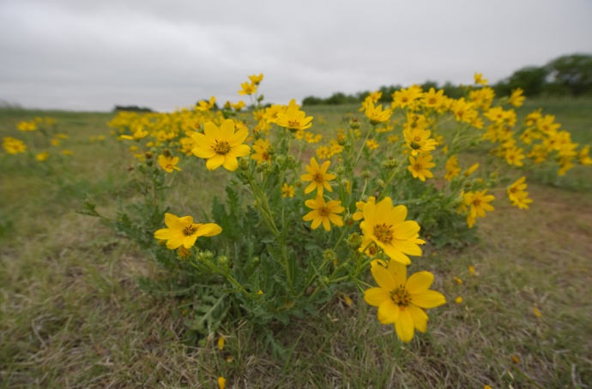 USDA NRCS 2009

Alternate Names

Cutleaf daisy

Uses

*Livestock:* Engelmann’s daisy is rarely found on overgrazed pastures due to its palatability by livestock (Lady Bird Johnson Wildflower Center, 2010). Cattle, sheep, and goats can all benefit from the high protein and digestibility obtained from this species. Crude protein can reach as high as twenty-five percent in early spring (TPWD, 2009). Engelmann’s daisy is an important food plot during the winter and early spring, before other native plants have begun to initiate growth (USDA SCS, 1970).

*Wildlife:* Deer and rabbits will browse on the foliage of Engelmann’s daisy (Agrilife, 2009). Like livestock, wildlife can use the high protein earlier in the year before the warm season grasses initiate growth. Engelmann’s daisy has a wildlife index value of 3.59. This gives it a “fair” rating for wildlife use (TPWD, 2009). Dense foliage will also provide cover for small mammals and birds. Engelmann’s daisy flowers provide nectar to a wide variety of pollinators including bees, butterflies, and hummingbirds (Lady Bird Johnson Wildflower Center, 2010).

*Erosion Control:* Engelmann’s daisy is used on slopes, such as roadsides and embankments, to help reduce soil erosion. The Texas Parks and Wildlife Department has given Engelmann’s daisy a “good” rating due to an erosion index of 5.24 (TPWD, 2009).

Status

Please consult the PLANTS Web site and your State Department of Natural Resources for this plant’s current status (e.g., threatened or endangered species, state noxious status, and wetland indicator values).

Weediness

This plant may become weedy or invasive in some regions or habitats and may displace desirable vegetation if not properly managed. Please consult with your local NRCS Field Office, Cooperative Extension Service office, state natural resource, or state agriculture department regarding its status and use. Weed information is also available from the PLANTS Web site at <plants.usda.gov>. Please consult the Related Web Sites on the Plant Profile for this species for further information.

Description

*General*: Engelmann’s daisy is a native, cool-season perennial which can grow up to three feet tall. The plant produces a basal rosette of leaves that can grow eight inches long. Leaves are very deeply cleft or almost divided. Coarse hair can be found on both the leaves and stems of the plant. The vegetation remains green throughout the year with new growth beginning in the spring (Hatch, 1993). The flower head elongates during the spring months. Engelmann’s daisy flower heads are made up of eight yellow rays, each ray about 1 cm long (Correll, 1970). They measure one to two inches in diameter. Flowering occurs from April to November (Rickett, 1969). During extreme heat, the petals of the plant fold downward. Engelmann’s daisy reproduces from seed which is distributed by wind and birds (TPWD, 2009). Volunteer plants can also be found in areas where plants were previously grown and the soil has been disturbed (USDA SCS, 1970).

*Distribution*: Engelmann’s daisy is most commonly found throughout north central Texas and the Edward’s Plateau. It is also found as far north as South Dakota, as far west as Arizona, and as far east as Louisiana (USDA NRCS, 2009).

For current distribution, please consult the Plant Profile page for this species on the PLANTS Web site.

*Habitat*: Engelmann’s daisy can be seen growing throughout much of Texas with the exception of the piney woods area. Its main habitat is areas such as prairies, upland sites, and open roadways (Hatch, 1993).

Adaptation

Engelmann’s daisy is adapted to a wide range of soil types and climate conditions, but is found most frequently throughout central and west Texas (USDA SCS, 1970). Ideal soil types range from sandy loams to clay loams. Engelmann’s daisy does not tolerate heavy clay soils, salinity, or deep sands. The plant has a deep tap root which makes it a hardy, drought tolerate species (TPWD, 2009).

Establishment

Planting should be done in the fall for areas south of Dallas and Fort Worth. In areas north, planting in later winter or early spring is the best time (USDA SCS, 1970). Sow seed ¼ to ¾ of an inch deep in a well prepared, firm seedbed. The full seeding rate for Engelmann’s daisy is 15 lb pure live seed (pls) per acre. When planting this as a component of a seed mixture, the seeding rate should be adjusted to the desired percent of the mix. Ideal plant spacing would be two to three plants per square yard. Fertilizer applications will vary depending on individual soil conditions. Soil samples should be taken to determine adequate application rates. Nutrient levels should be at a medium range for optimal productivity. For range seedings, fertilizer is not normally recommended (USDA SCS, 1979)

Management

Engelmann’s daisy is rarely planted as a monoculture planting, but is commonly found as a component of a range seeding mixture. Twelve months of grazing deferment should be planned and applied to allow plant establishment. Areas with heavy wildlife populations should also consider the impact and added maintenance associated with attempting to establish Engelmann’s daisy.

Proper management of Engelmann’s daisy is required to ensure the plant is not overgrazed or over utilized by livestock and wildlife. Consult your local NRCS Field Office for assistance with planning and applying prescribed grazing.

Pests and Potential Problems

None known

Environmental Concerns

None known

Control

Please contact your local agricultural extension specialist or county weed specialist to learn what works best in your area and how to use it safely. Always read label and safety instructions for each control method. Trade names and control measures appear in this document only to provide specific information. USDA NRCS does not guarantee or warranty the products and control methods named, and other products may be equally effective.

Seeds and Plant Production

Seed can be harvested by several different methods. One is to use a flail-vac or seed stripper to brush seed into a hopper. The other is by cutting plants down to about six inches and allowing them to dry. Then use a combine with a pickup header attachment to harvest and thresh seed.

Cultivars, Improved, and Selected Materials (and area of origin)

‘Eldorado’ Engelmann’s daisy was released from the James E. “Bud” Smith Plant Materials Center, Knox City, TX in 1985. It originated from a native collection in Schleicher County, TX, and was released to provide an adapted forb for inclusion in range mixes for wildlife and livestock.

References

Correll, Donovan S. and Marshall C. Johnston. Manual of the Vascular Plants of Texas. Texas Research Foundation, Renner, TX, 1970. p. 1625.

Hatch, Stephan L. and Jennifer Pluhar. Texas Range Plants. Texas A&M University Press, College Station, TX. 1993. p. 241.

Lady Bird Johnson Wildflower Center. The University of Texas at Austin. 2010. Native Plant Information Network. Available at http://www.wildflower.org/plants/result.php?id_plant =ENPE4 Austin, TX, 78739, USA. Accessed 2 Feb. 2010.

Research and Extension Center Virtual Herbarium. Texas AgriLife Research and Extension at Uvalde. 2009. Texas A&M University. Available at http://uvalde.tamu.edu/herbarium/enpe.htm 19 June 2009. College Station, TX. Accessed 19 June 2009.

Rickett, Harold W. Wild Flowers of the United States. Volume 3 Part Two of Two Parts. McGraw-Hill Book Company. New York, New York. 1969. p. 455.

Texas Parks and Wildlife: Texas Plant Information Database. 2009. Texas Parks and Wildlife. Available at http://tpid.tpwd.state.tx.us/species_report.asp?species =190 19 June 2009.) Austin, TX, 78744, USA. Accessed 19 June 2009

USDA NRCS. 2009. The PLANTS Database (http://plants.usda.gov 20 June 2009.) National Plant Data Center, Baton Rouge, LA, 70874-4490, USA.

USDA SCS. 1979. Planting Guide for Engelmann’s daisy (Engelmannia pinnatifida). June 1979.

USDA SCS. 1970. Technical Notes: Engelmann’s daisy (Engelmannia pinnatifida). May 1970. Fort Worth, Texas.

Prepared By

Brandon Carr, USDA NRCS James E. “Bud” Smith Plant Materials Center, Knox City, Texas

Citation

Carr, C. 2010. Plant guide for Engelmann’s Daisy (*Engelmannia peristenia)*. USDA-Natural Resources Conservation Service, James E. “Bud” Smith Plant Materials Center. Knox City, TX 79529.

Published September, 2010

Edited: 21Jul2010bc

For more information about this and other plants, please contact your local NRCS field office or Conservation District at <http://www.nrcs.usda.gov/> and visit the PLANTS Web site at <http://plants.usda.gov/> or the Plant Materials Program Web site <http://plant-materials.nrcs.usda.gov>.

PLANTS is not responsible for the content or availability of other Web sites.

**USDA IS AN EQUAL OPPORTUNITY PROVIDER AND EMPLOYER**