|  |
| --- |
| WYETH buckwheat |
| *Eriogonum heracleoides* Nutt. |
| Plant Symbol = ERHE2 |

Contributed by: USDA NRCS, Boise, Idaho

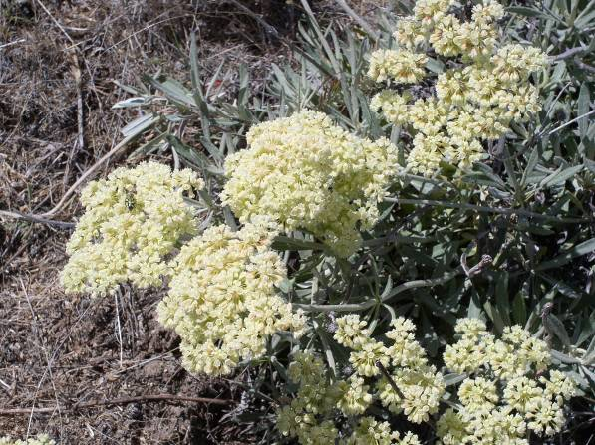

Parsnipflower buckwheat.

Derek J. Tilley, USDA NRCS Idaho PMC

Alternate Names

Whorled buckwheat, Parsnipflower buckwheat

Uses

*Restoration/low water use landscaping:* Wyeth buckwheat produces large splays of small, cream to yellow colored flowers and has tremendous potential for use in native landscaping and drought tolerant plantings in the semi-arid regions of western North America (Young 1989). Wyeth buckwheat can be used in seeding mixtures to increase the forb- sub-shrub component in native species diversification and site restoration planting projects in the sagebrush steppe and mountain foothills of the Intermountain West. Flowers of buckwheat species are known to attract insects which are an important part of the diets of insect loving species such as sage grouse (*Centrocercus urophasianus*). Wyeth buckwheat has little or no forage value for livestock (USDA, 1937).

*Ethnobotanical*: A decoction of roots and stems are said to have been used to treat colds and tuberculosis and to treat cuts and sores (Turner and others 1980). Root decoctions have also been reported to have been used for diarrhea, stomachaches and other ailments (Steedman 1930).

Status

Consult the PLANTS Web site and your State Department of Natural Resources for this plant’s current status (e.g. threatened or endangered species, state noxious status, and wetland indicator values).

Description

*General*: Buckwheat family (Polygonaceae). Wyeth buckwheat is a perennial forb to sub-shrub with a branching woody stem. Leaves are covered with dense white hairs making the herbage appear a light green to blue-grayish color. The flowers are a creamy-yellow color and have six petals which are borne in simple or compound umbels. Plants of Wyeth buckwheat can be distinguished from other closely related members of the genus by having a whorl of 5 to 10 leaves at midpoint of flowering stem; however in some subspecies this is not apparent (Freeman and Reveal 2005). The seeds, or achenes, are light to dark brown from 3 to 5 mm long. There are approximately 374,000 seeds/kg (170,000 seeds/lb).

*Distribution*: The species range includes the Rocky Mountain and Intermountain western states from British Columbia and Alberta south to Utah and Nevada. For current distribution, please consult the Plant Profile page for this species on the PLANTS Web site.

*Habitat*: Plants of Wyeth buckwheat can be found growing in rocky soils, often on slopes and dry canyons. This species is frequently found growing in association with mountain big sagebrush (*Artemisia* *tridentata* ssp. *vaseyana*) and antelope bitterbrush (*Purshia tridentata*).

Adaptation

Plants are found growing naturally in areas receiving 12 inches to about 25 inches annual precipitation. Wyeth buckwheat grows in mountain foothills at the upper end of the Wyoming big sagebrush zone and into the mountainous coniferous and deciduous forest regions. Wyeth buckwheat typically occupies sites at lower elevation and precipitation than sulphurflower buckwheat (*E. umbellatum*), but the ranges of the two species do overlap. Plants grow in course, rocky, well-drained soils.

Establishment

Recently harvested seed is typically dormant and responds best to a 16 to 24 week chilling period at 2º C (36 º F) (Meyer and Paulsen 2000). Seed should be planted at or just below the soil surface, to no more than 3mm (0.25 in) depth. The full seeding rate is 3.4 kg/ha PLS (4.0 lb/ac PLS), but this species should not be seeded in a pure stand. This species would normally be included in native seed mixtures at a rate of 0.3 to 0.6 kg/ha PLS (1/4 to 1/2 lb/ac PLS).

Management

When planted in a native reclamation seed mix, Wyeth buckwheat will be a minor component of the establishing plant community; therefore management should be based on other key species in the mixture. Any new planting should be deferred from livestock grazing until it is well established which may require 1 to 3 years.

Pests and Potential Problems

Seed collections often contain insect larvae in the seeds. Placing seeds in a freezer (0 to 10º F) for 7 to 10 days prior to long term storage effectively kills insect pathogens.

Environmental Concerns

Wyeth buckwheat is a species native to the Intermountain and Rocky Mountain West. The species is not considered weedy or invasive, but plants can spread to adjoining vegetative communities under ideal environmental conditions.

Seed and Plant Production

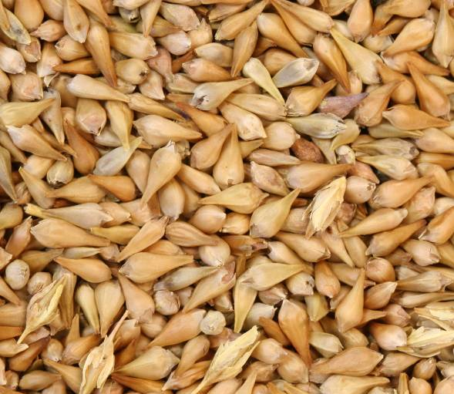

Parsnipflower buckwheat seed.

Derek J. Tilley, USDA NRCS Idaho PMC

Seed should be planted in late fall as a dormant planting to allow proper stratification of the seed over winter. For best results the seedbed should be weed free, moist and firmly packed. The use of weed barrier fabric is very effective at controlling weeds. Additionally, preliminary herbicide tolerance trials conducted at the University of Oregon, Malheur Experiment Station on sulphurflower buckwheat indicated Prowl® (pendimethalin) Treflan® (trifluralin) and Balan® (benefin) look promising for use in seed production fields (Shock and others 2006). J. Herbert Stone Nursery in Oregon recommends soil fumigation prior to planting forb seed production fields to eliminate soil borne pathogens and to reduce weed competition (Archibald 2006). Buckwheat seed should be planted to a depth of no more than 3 to 6 mm (0.125 to 0.25 in). When planting in weed barrier fabric, plant at 9 to 18 in spacing. When drill seeding, use a seeding rate of 20 to 30 pure live seeds (PLS) per linear foot (Ogle and others 2006).

Seed can be harvested by hand or direct combined in mid to late July. Due to the wide window of seed ripening it may be beneficial to harvest multiple times by hand to obtain the greatest amount of viable seed.

For seed cleaning, run harvested material through a hammermill followed by an air screen cleaner. Check cleaned seed for holes or other insect damage which may indicate the absence or damage of the seed within the achene. It may be necessary to reclean using the air screen cleaner with the blower on a higher setting to remove empty achenes.

Cultivars, Improved, and Selected Materials (and area of origin)

There are currently no commercial releases of Wyeth buckwheat; however wildland collected seed is available. The Aberdeen, Idaho Plant Materials Center is currently conducting a common garden study to evaluate accessions for potential release. Contact your local Natural Resources Conservation Service office for more information. Look in the phone book under “United States Government.” The Natural Resources Conservation Service will be listed under the subheading “Department of Agriculture.”

References

Archibald, C. 2006. Seed production protocols for *Anaphalis margaritaceae, Eriophyllum lanatum* and *Eriogonum umbellatum*. Native Plants Journal 7(1):47-51.

Freeman, C.C. and J.L. Reveal. 2005. Polygonaceae. In: *Flora of North America*. Volume 5: *Magnoliophyta: Caryophyllidae*, part 2. Oxford University Press. New York, New York. Pp. 216-601.

Meyer, S.E. and A. Paulsen. 2000. Chilling requirements for seed germination of 10 Utah species of perennial wild buckwheat. Native Plants Journal 1:18-24.

Ogle, D. G., L. St. John, M. Stannard & L. Holzworth. 2003. Technical Note 24: Grass, grass-like, forb, legume, and woody species for the intermountain west. USDA-NRCS, Boise, ID. ID-TN 24, Jan. 2003. 41p.

Shock, C.C., Ishida, J. and C. Ransom. 2006. Identification of herbicides for use in native forb seed production. In: Great Basin Native Plant Selection and Increase Project, FY05 Progress Report. pp. 32-35.

Steedman, E.V. 1930. Ethnobotany of the Thompson Indians of British Columbia, based on field notes by James A. Teit. Bulletin du Bureau d'Ethnologie 45: 441-522.

Turner, N.J., Bouchard, R., and D.I.D. Kennedy. 1980. Ethnobotany of the Okanagan-Coleville Indians of British Columbia and Washington. Victoria.

USDA. 1937. Range Plant Handbook. United States Government Printing Office, Washington DC.

Young, J.A. 1989. Germination of seeds of sulphur flower. Journal of Seed Technology 13:31-38.

Prepared By

Derek Tilley, Range Conservationist (Plants), USDA NRCS Plant Materials Center, Aberdeen, Idaho

Dan Ogle, Plant Materials Specialist, USDA NRCS Idaho State Office, Boise, Idaho

Loren St. John, Manager, USDA NRCS Plant Materials Center, Aberdeen, Idaho

Species Coordinator

Dan Ogle, Plant Materials Specialist, USDA NRCS Idaho State Office, Boise, Idaho

Edited: 012207 djt; 011907 dgo; 011907 lsj; 011907 jb; 081008 jsp

For more information about this and other plants, please contact your local NRCS field office or Conservation District, and visit the PLANTS Web site<<http://plants.usda.gov>> or the Plant Materials Program Web site <<http://Plant-Materials.nrcs.usda.gov>>

*The U.S. Department of Agriculture (USDA) prohibits discrimination in all its programs and activities on the basis of race, color, national origin, sex, religion, age, disability, political beliefs, sexual orientation, and marital or family status. (Not all prohibited bases apply to all programs.) Persons with disabilities who require alternative means for communication of program information (Braille, large print, audiotape, etc.) should contact USDA's* [*TARGET Center*](http://www.usda.gov/oo/target.htm) *at 202-720-2600 (voice and TDD).*

*To file a complaint of discrimination write USDA, Director, Office of Civil Rights, Room 326-W, Whitten Building, 14th and Independence Avenue, SW, Washington, DC 20250-9410 or call 202-720-5964 (voice or TDD). USDA is an equal opportunity provider and employer.*

*Read about* [*Civil Rights at the Natural Resources Convervation Service*](http://www.nrcs.usda.gov/about/civilrights/)*.*