

Plant Guide

# Plains Lovegrass

## *Eragrostis intermedia* A.S. Hitchc.

### Plant Symbol = ERIN

#### Contributed by: NRCS USDA Tucson Plant Materials Center

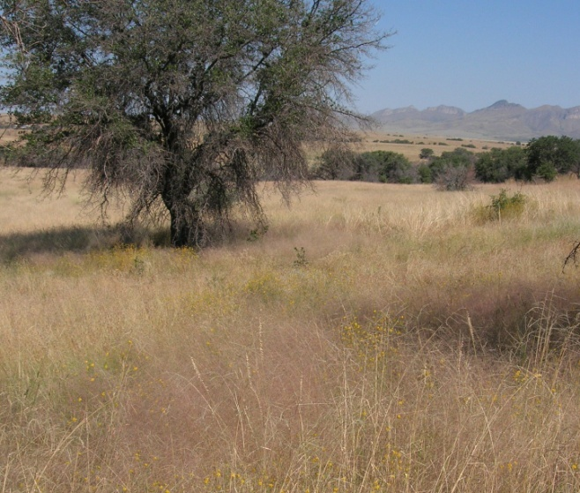 Plains Lovegrass reflects a pink hue in the mixed grasslands of Southeast Arizona.

#### **Alternate Names**

Plains Lovegrass

#### **Uses**

*Forage:* Important early spring forage grass for livestock and wildlife. Its seeds are eaten by upland game birds.

*Restoration:* Establishes well following fire (Bock et al 2009).

#### **Status**

Please consult the PLANTS Web site and your State Department of Natural Resources for this plant’s current status (e.g., threatened or endangered species, state noxious status, and wetland indicator values).

#### **Description**

*General*: Plains Lovegrass is a native, warm season perennial bunchgrass. Plains Lovegrass typically grows 2 to 3 ½ feet tall. The inflorescence is an erect, open, diffuse, pyramid-shaped panicle 8 to 16 inches long and 6-12 inches wide. The spikelets have 3 to 9 flowers (Hitchcock 1951). The fresh inflorescence is pinkish in color.

*Distribution*:

Plains Lovegrass occurs from eastern California to Florida, north into Missouri and south into scattered locations of Central America. For updated distribution, please consult the Plant Profile page for this species on the PLANTS Web site.

For current distribution, please consult the Plant Profile page for this species on the PLANTS Web site.

*Habitat*: Plains Lovegrass is common in the desert grasslands of southern Arizona, the interior chaparral of Arizona and mixed-grass and short grass prairie of the southwest USA. It often grows in areas where annual precipitation is bimodal, with wet seasons in both winter and summer. The bulk of the forage is produced in the summer months. In areas where plains Lovegrass grows productively, mean annual precipitation usually exceeds 15 inches.

#### **Adaptation**

Plains Lovegrass occurs on clay, sandy and rocky soils and often on disturbed sites, at 0 to 6069 feet elevation. In southern Arizona, it is most productive on sandy and sandy loam soils with poorly developed profiles, and least productive on shallow, rocky soils, at 3,800 to 6,000 feet elevation.

#### **Establishment**

Seed of Plains Lovegrass is reddish-brown, rectangular-prismatic in shape, and very small (3,386,000 per lb). Natural dispersal occurs when the fruiting stalks detach and tumble across the ground, releasing seed.

Recommended seeding rate is 0.3 pure live seed (PLS) lb per acre if planted with a drill, and approximately 0.6 PLS lb per acre if seed is broadcast. When used as part of a mix the seeding rate should be adjusted to the desired percentage of the mixture. Due to the small seed size use of a carrier, such as rice hulls, should be considered to obtain better control of the seeding rate. Seed should be planted onto a firm, weed-free seedbed. Broadcast seeding should be followed lightly with a cultipacker or harrow to provide seed with a shallow covering of soil.

#### **Management**

Due to its high seed stalk to leaf ratio, this species is only intermediate in forage preference to cattle. However, it is often heavily grazed because it is one of the first species to green up in the spring. Where grazing occurs, it often declines. Because of its importance as an early spring forage plant, ranges where this species is still present should be managed in order to preserve or increase it. These ranges should be deferred from grazing during July and August every third year, if possible (Ruyle and Young 1997).

#### **Pests and Potential Problems**

Plains Lovegrass is at risk of overgrazing, and should be managed where grazing occurs.

#### **Seeds and Plant Production**

Plains Lovegrass should be planted in early spring into a firm, weed-free seedbed at 24 to 40” spacing. Plants require 30 lb/acre available nitrogen during the establishment year and 45 lb/ac available nitrogen on established fields. Apply phosphorus according to soil test recommendations. For establishment, irrigate to maintain a moist soil surface and to avoid soil crusting. On established fields irrigate approximately every 4 weeks during the growing season.

Seed is produced from summer to fall. Seed harvest may be done by direct combining or using a Woodward Flail Vac Seed Stripper. Yields for irrigated production fields average 180 lb per acre, but may vary from year to year. Seed from Plains Lovegrass has very good viability.

Seed with attached rachillas may be put through a hammer mill to break up stems and remove seedheads from the rachillas. Seed may then be separated from the chaff using an office type Clipper cleaner with 11/32 top screen and 60x60 bottom screen. Little to no blower is needed.

#### **Cultivars, Improved, and Selected Materials (and area of origin)**

Bonita Germplasm (*Eragrostis intermedia*) Plains Lovegrass is a selected class release developed by the NRCS USDA Tucson Plant Materials Center for Southeast Arizona Major Land Resource Area (MLRA 41). MLRA 41 corresponds to Level 3 Ecoregion 79. It is a composite of 30 accessions collected from native plains Lovegrass stands in Southeast Arizona and Southwest New Mexico.

#### **References**

Bock, Carl, J. Bock, M. Grant, T. Seastedt. 2009. Effects of fire on abundance of *Eragrostis intermedia* in a semi-arid grassland in southwestern Arizona. Journal of Vegetation Science, 6(3):325-328.

Ruyle, G. and D. Young, Eds. 1997. Arizona range grasses: their description, forage value and grazing management. University of Arizona Cooperative Extension. College of Agriculture. Tucson, Arizona. 85716.

Gould, F.W. 1977. Grasses of Southwestern United States. University of Arizona Press, Tucson, Arizona. 85716.

Hitchcock, A.S. 1951. Manual of the Grasses of the United States. Misc. Publ. No. 200. Washington, DC; U.S. Department of Agriculture, Agricultural Research Administration.

Kearney, T.H., and R.H. Peebles. 1969. Arizona flora. University of California Press, Berkeley, California.

#### **Prepared By**

#### Mary Hershdorfer, NRCS USDA Tucson Plant Materials Center

#### **Citation**

Hershdorfer, M. 2009. Plant guide for plains lovegrass (Eragrostis intermedia A.S. Hitchc.). USDA Natural Resources Conservation Service, Tucson Plant Materials Center, Tucson, AZ 85705.

Published October, 2009

Edited:

For more information about this and other plants, please contact your local NRCS field office or Conservation District at <http://www.nrcs.usda.gov/> and visit the PLANTS Web site at <http://plants.usda.gov/> or the Plant Materials Program Web site <http://plant-materials.nrcs.usda.gov>.

PLANTS is not responsible for the content or availability of other Web sites.

**USDA IS AN EQUAL OPPORTUNITY PROVIDER AND EMPLOYER**