

Plant Guide

# Maguire daisy

## Erigeron maguirei Cronquist

Plant Symbol = ERMA8

*Contributed by*: USDA NRCS Idaho and Utah Plant Materials Program

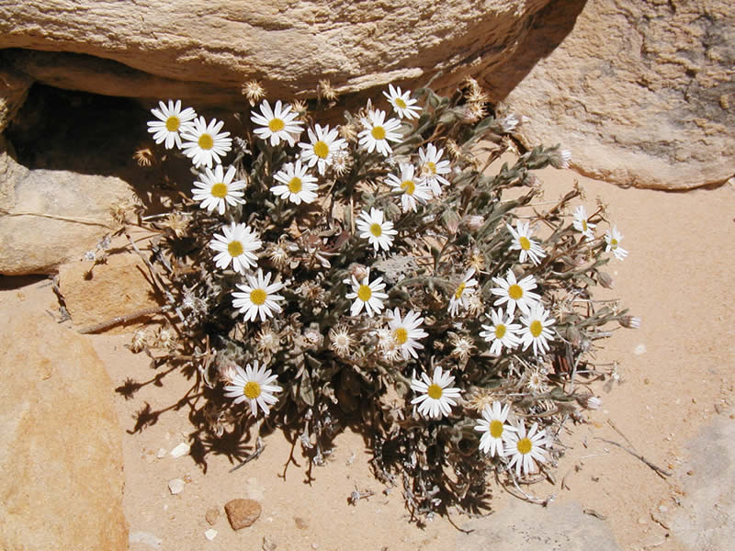**Maguire daisy (Erigeron maguirei). Photo from USDA-FS.**

### Uses

There are no known human uses of Maguire daisy.

### Status

Maguire daisy (*E.* *maguirei* var. *maguirei*) was listed as endangered in 1985 (USDI-FWS, 1985). However, in 1993, it was determined through DNA analysis that varieties *maguirei* and *harrisonii* did not merit recognition as distinct species (Van Buren, 1993). Following this discovery, the now broader *E. maguirei* was reclassified as threatened in 1996 (USDI-FWS, 1996). In 2008, USDI-FWS proposed delisting of the species, citing that populations were stable and the species is not currently, and is not likely to become an endangered species within the foreseeable future (USDI-FWS, 2008). It was officially removed from the List of Endangered and Threatened Plants, and announced the availability of the final post-delisting monitoring plan in 2011 (USDI-FWS, 2011).

Consult the PLANTS Web site and your State Department of Natural Resources for this plant’s current status (e.g., threatened or endangered species, state noxious status, and wetland indicator values).

### Description

*General*: Sunflower family (Asteraceae). Maguire daisy is a perennial, herbaceous forb with spreading to erect stems arising from a branching caudex. Mature plants reach up to 18 cm (7 in) in height. The lowest leaves are 2 to 5 cm (0.75 to 2 in) long and 3 to 8 mm (0.12 to 0.31 in) wide. The leaves become

reduced going up the stem. Leaves and stems are covered with spreading hairs. The stems bear 1 to 3 flowers with 12 to 20 white to pinkish rays. The flower centers are made of several yellow to orange disk flowers. The fruit is a 2 nerved, hairy achene with a pappus of 13 to 25 barbellate bristles (Welsh et al., 2003).

*Distribution*:

Maguire daisy populations have been identified in Emery, Wayne and Garfield Counties in southeastern Utah. The range of the species is currently estimated at 1,010 km² (390 mi²). (USDI-FWS, 2008).

For current distribution, consult the Plant Profile page for this species on the PLANTS Web site.

*Habitat*:

Maguire daisy occurs on mesa tops in dwarf mountain mahogany-slickrock plant communities in association with pinyon-juniper, ponderosa pine and slickrock pockets in mesic canyon bottoms, mountain shrub and intermittent riparian communities. All known populations exist between 1,500 and 2,600 m (4,900 to 8,500 ft) in elevation. The species occurs primarily on Navajo Sandstone formations but is also found on the Wingate and Chinle formations.

**Adaptation**

Maguire daisy is adapted to arid, sandy sites receiving 15 to 23 cm (6 to 9 in) of mean annual precipitation.

### Management

According to the USDI-FWS (2008) the known populations of Maguire daisy were stable, and threats had been addressed with adequate regulatory mechanisms in place.

### Pests and Potential Problems

There are no known pests or potential problems regarding Maguire daisy*.*

### Environmental Concerns

There are no known environmental concerns regarding Maguire daisy*.*

### Seeds and Plant Production

Maguire daisy appears to be an obligate outcrosser requiring a pollinator for successful fertilization. Monitored populations have been shown to produce seed and reestablish at rates suggesting stability. Seed germination studies at Flagstaff Arboretum showed 26, 30, and 24% germination with direct misting, or 1 or 2 months of stratification (CPC, 2010).

### References

CPC. 2010. Plant profile for Maguire daisy (Erigeron maguirei). Center for Plant Conservation. http://www.centerforplantconservation.org/welcome.asp. Accessed 28 December, 2010.

USDI- Fish and Wildlife Service. 1985. Endangered and threatened wildlife and plants; determination of endangered status for *Erigeron maguirei* var. *maguirei* (Maguire daisy). In: Federal Register. 61(119): 36089-36092.

USDI- Fish and Wildlife Service. 1996. Endangered and threatened wildlife and plants; reclassification of *Erigeron maguirei* (Maguire daisy) from endangered to threatened. In: Federal Register. 61(119): 31054-31058.

USDI- Fish and Wildlife Service. 2008. Endangered and threatened wildlife and plants; proposed removal of *Erigeron maguirei* from the federal list of endangered and threatened plants; availability of post-delisting monitoring plan. In: Federal Register. 73(96): 28410-28423.

USDI-Fish and Wildlife Service. 2011. Endangered and threatened wildlife and plants; removal of *Erigeron maguirei* (Maguire daisy) fromt eh federal list of endangered and threatened plants; availability of final post-delisting monitoring plan. In: Federal Register. 76(12): 3029-3044.

Welsh, S.L., N.D. Atwood, S. Goodrich, and L.C. Higgins. 2003. A Utah Flora. Third Edition, revised. Brigham Young University, Provo, UT.

**Prepared By**:

*Derek Tilley*; USDA NRCS Plant Materials Center, Aberdeen, Idaho.

*Loren St. John*, USDA NRCS Plant Materials Center, Aberdeen, Idaho.

*Dan Ogle*, USDA NRCS, Boise, Idaho.

### Citation

Tilley, D., L. St. John and D. Ogle. 2010. Plant guide for Maguire daisy (*Erigeron maguirei*). USDA-Natural Resources Conservation Service, Idaho Plant Materials Center. Aberdeen, ID.

Published Jan 2010

Edited: 03Jan2011djt, 03jan2011ls; 03jan2011dgo

For more information about this and other plants, please contact your local NRCS field office or Conservation District at http://www.nrcs.usda.gov/ and visit the PLANTS Web site at http://plants.usda.gov/ or the Plant Materials Program Web site http://plant-materials.nrcs.usda.gov.

PLANTS is not responsible for the content or availability of other Web sites.

**USDA IS AN EQUAL OPPORTUNITY PROVIDER AND EMPLOYER**