|  |
| --- |
| snow buckwheat |
| *Eriogonum niveum* Dougl. ex Benth. |
| Plant Symbol = ERNI2 |

## *Contributed By: USDA NRCS Pullman Plant Materials Center, Pullman, Washington*

# Alternate Names

canyon heather

# Uses

*Erosion control/reclamation/landscape:* Snow buckwheat is a very successful pioneer species (Tiedemann, et al 1997). It tolerates extremely droughty soils and is a common occupant of dry, rocky southern exposures. It is an excellent candidate for stabilizing skeletal soils exposed in road cuts, and mine spoils that lack soil development.

Snow buckwheat grows to 0.5 m (20 in.) in height in most areas but may be as much as 1m tall and 1m wide on better sites. The canopy, while quite short, can effectively protect the soil from erosive winds.

Snow buckwheat is a very useful xeriscaping plant, because it requires very little moisture and does not become weedy. It can be shaped by careful pruning to produce a more formal looking round-full plant. The bloom period is very long and the white flowers take on a pink blush in late fall.

*Grazing/rangeland/wildlife*: Snow buckwheat has limited domestic livestock grazing value. Sheep will utilize the tips of the flower heads and ignore the rest

of the plant. (USDA Forest Service Range Plant Handbook).

Mule deer in north-central Washington are reported to make heavy use of snow buckwheat in the winter and early spring months (Burrell 1982). Bighorn sheep also make heavy use of snow buckwheat, and it decreases in response to bighorn sheep grazing (Wikeem and Pitt 1991). Small birds and mammals use the canopy for cover.

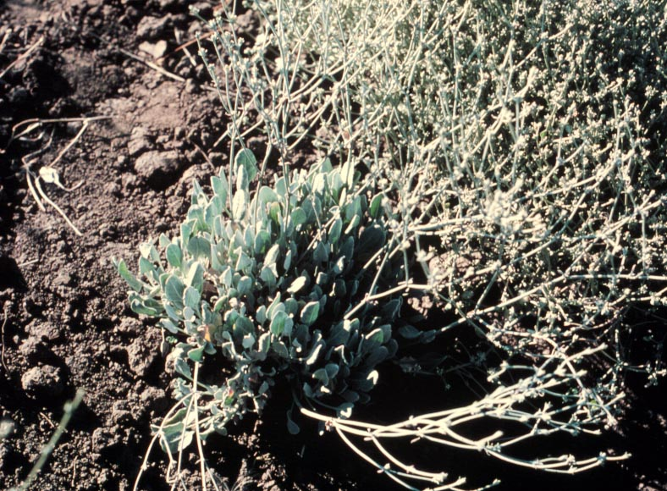

Clarence Kelley

USDA NRCS Pullman PMC

Several species of bees and butterfies utilize snow buckwheat as a foodstuff, including the endangered Mormon Metalmark butterfly (*Apodemia mormo*) (Royal British Columbia Museum 1995).

*Ethnobotany:* A tea brewed from the roots of snow buckwheat and a related species, Indian tobacco (*E. heracleoides*) were used by Native Americans as a diarrhea remedy. Boiled roots and stems were used to treat a variety of ailments including cuts, colds, and blood poisoning (Parish et al. 1996). It has been suggested that the Columbia Basin buckwheats were also used to develop dyes by the Native Americans (Sackschewsky and Downs 2001).

# Status

This is a native species. Consult the PLANTS Web site and your State Department of Natural Resources for this plant’s current status, such as state noxious status and wetland indicator values.

# Description

*General*: Buckwheat Family (Polygonaceae). Snow buckwheat is a deciduous, low growing, evergreen halfshrub.

The crown gives rise to numerous short-woody stems. Leaves attached to the main stems are short and generally oblong. The bottoms of the leaves are gray and very tomentose while the tops are only slightly hairy. The flowering stems are tomentose and as much as 200mm in length. Leaves on the flowering stems are short and narrow. The flower heads may be as long as 200mm and generally ascending. The flowers are white or light pink and turn brown at seed maturity in the fall. The seeds are small and shaped like urns. There are approximately 943,000 seeds/kg (427,000 seeds/pound).

# Distribution

Hitchcock et al. (1964) described the distribution of snow buckwheat as the east slope of the Cascade Mountains from British Columbia, south to central Oregon, east to west-central Idaho. For current distribution of this species and its relatives, consult the Plant Profile page for this species on the PLANTS Web site.

# Adaptation

Cold Hardiness Zone: 5a-7a.

Mean Annual Precipitation: 150-460mm (6-18 in.)

Elevation: 150-1500m (500-4900 ft.)

MLRA: 6, 8, 9, 10, 11, 23, 24, and 25

Soil: Well-drained sands to clays

Snow buckwheat is common in big sage (*Artemisia tridentata*), antelope bitterbrush (*Purshia tridentata*), and open Ponderosa pine (*Pinus ponderosa*) areas. It also occurs in the canyon grasslands of the Snake and Columbia River systems.

It is primarily found in full sun but will grow in partial shade such as open Ponderosa pine hillsides.

Snow buckwheat is common on steep slopes and rocky scabland soils that support little competing vegetation. Its taproot enables it to acquire moisture percolating through the rock cracks. It occurs much less frequently on deep, moist soils.

Species often associated with snow buckwheat include the following: big sagebrush (*Artemisia tridentata* - probably *wyomingensis, vasciana,* and *tridentata* subspecies), antelope bitterbrush (*Purshia tridentata*), Ponderosa pine (*Pinus ponderosa*), western juniper (*Juniperus occidentalis*), bluebunch wheatgrass (*Pseudoroegneria spicata*), sand dropseed (*Sporobolus airoides*), Snake River wheatgrass (*Elymus wawawaiensis*), Sandberg bluegrass (*Poa secunda*), Indian ricegrass (*Achnatherum hymenoides*), and needle-and-thread (*Nassella comata*).

# Establishment

*Seeding*: Snow buckwheat should be seeded in late fall (Tiedemann and Driver 1983). Standard reclamation drills and broadcast seeders are capable of handling snow buckwheat seed, however, ensure the seed is kept shallow (max. 6mm deep). Germination in the wild occurs during cool-wet conditions thus allowing the seedlings to develop while moisture is readily available and evaporative rates are low.

*Transplanting*: Rooted transplants are easily outplanted. The soil should be at least 75% of field capacity when planted. Once fully established, snow buckwheat is long-lived and very persistent.

# Management

Snow buckwheat is a low maintenance plant once established. Cheatgrass and other winter annuals should be controlled the first year to allow good establishment. Observations have shown that snow buckwheat withstands severe defoliation if the woody stems and crowns are not damaged.

Digging up plants is not advised because it is difficult to extract a large enough portion of the root to support the plant. Also, removing plants in the wild severely disturbs the site and leaves it especially prone to weed invasion.

Its tolerance to fire is unknown, however, most *Eriogonum* species which remain green year round are severely damaged by fire.

# Environmental Concerns

Snow buckwheat is long-lived, spreading via seed in the wild. It is not considered to be a "weedy" or invasive species, but can spread into adjoining vegetative communities under ideal climatic and environmental conditions.

# Propagation

Snow buckwheat seed should be grown in areas where it is native or areas that have long growing seasons. Weeds can be controlled by between-row cultivation. No herbicides are labeled for snow buckwheat seed fields.

Seed is fully ripe when the flowers turn brown. Shattering can be severe at full maturity. Mechanical harvest is possible providing that the cutting bar is set high enough to not damage the crown. Observations have indicated that cutting back the woody stems reduces plant life and reduces seed production the following year.

Seed shelf life can be as short at 12 months if not properly stored. Seed is best stored in cool-dry conditions.

Plants are easy to produce for out-planting. Seed should be planted in mid-winter and allow for at least 10 weeks growth before hardening. Avoid potting media that does not drain well, and do not over-water.

# Cultivars, Improved and Selected Materials (and area of origin)

'Umatilla' snow buckwheat was selected by the Pullman Plant Materials Center and released in 1991. It was developed from a native collection made in Umatilla County, Oregon. It is primarily recommended for use in rangeland restoration plantings, upland wildlife habitat improvement plantings in semi-arid environments, and soil stabilization plantings on sites that will not support dense populations of conventional conservation species. It has performed very well on mine spoils in central Washington (Zamora and Leier 1993). It is also well suited for xeriscape plantings, particularly where a native halfshrub is desired.

Limited quantities of Foundation seed are available to growers from the Pullman Plant Materials Center.

# References

Burrell, G.C. 1982. Winter diets of mule deer in relation to bitterbrush abundance. J. Range Manage. 36:508-510.

Hitchcock, C.L., A. Cronquist, M. Ownbey, and J.W. Thompson 1964. Vascular plants of the Pacific Northwest. University of Washington Press, Seattle, Washington.

Parish, R., Coupe, R. and D. Lloyd 1996. Plants of southern interior British Columbia. Lone Pine Press, Vancouver, B.C., Canada.

Royal British Columbia Museum 1995. ><http://rbcm1.rbcm.gov.bc.ca/end_species/species/mmetalm.html><

Sackschewsky, M.R. and J.L. Downs 2001. Vascular plants of the Handford site. U.S. Dept. of Energy, Pacific Northwest National Laboratory Rep. 13688. Richland, Washington.

Tiedemann, A.R. and C.H. Driver. 1983. Snow eriogonum; a native halfshrub to regetate winter game ranges. Reclam and Reveg Res. 2:31-39.

Tiedemann, A.R., S.M. Lambert, J.R. Carlson, C.J. Perry, N.L. Shaw, B.L. Welch, and C.H. Driver 1997. ‘Umatilla’ snow buckwheat for rangeland restoration in the interior Pacific Northwest. Rangelands. 19:22-25.

Wikeem, B.M. and M.D. Pitt 1991. Grazing effects and range trend assessment on California bighorn sheep range. J. Range Manage. 44:466-470.

USDA, Forest Service 1937. Range Plant Handbook.

USDA NRCS 2003. *The PLANTS database*. Version: 030106. <http://plants.usda.gov>. National Plant Data Center, Baton Rouge, Louisiana.

Zamora, B.A. and J.W. Leier 1993. The potential of snowy buckwheat (*Eriogonum niveum*) for revegetation of xeric mine spoil sites in the Pacific Northwest. *IN*: Abstracts 8th Wildland Shrub Symp. Arid Land Restoration, Las Vegas, Nevada.

# Prepared By

## Mark Stannard and Wayne Crowder

USDA, NRCS, Plant Materials Center, Pullman, Washington

# Species Coordinator

## Mark Stannard

USDA, NRCS, Plant Materials Center, Pullman, Washington

Edited 06jan03 dgo; 30jan03 jsp; 09jun03 ahv; 06jun06 jsp

For more information about this and other plants, please contact your local NRCS field office or Conservation District, and visit the PLANTS Web site<<http://plants.usda.gov>> or the Plant Materials Program Web site <<http://Plant-Materials.nrcs.usda.gov>>

*The U.S. Department of Agriculture (USDA) prohibits discrimination in all its programs and activities on the basis of race, color, national origin, sex, religion, age, disability, political beliefs, sexual orientation, and marital or family status. (Not all prohibited bases apply to all programs.) Persons with disabilities who require alternative means for communication of program information (Braille, large print, audiotape, etc.) should contact USDA's* [*TARGET Center*](http://www.usda.gov/oo/target.htm) *at 202-720-2600 (voice and TDD).*

*To file a complaint of discrimination write USDA, Director, Office of Civil Rights, Room 326-W, Whitten Building, 14th and Independence Avenue, SW, Washington, DC 20250-9410 or call 202-720-5964 (voice or TDD). USDA is an equal opportunity provider and employer.*

*Read about* [*Civil Rights at the Natural Resources Convervation Service*](http://www.nrcs.usda.gov/about/civilrights/)*.*