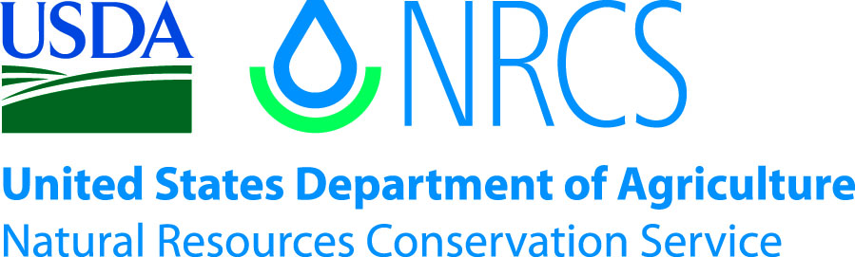

Plant Guide

# Naked Buckwheat

## Eriogonum nudum Dougl.

Plant Symbol =ERNU3

*Contributed by*: USDA NRCS Corvallis Plant Materials Center, Oregon

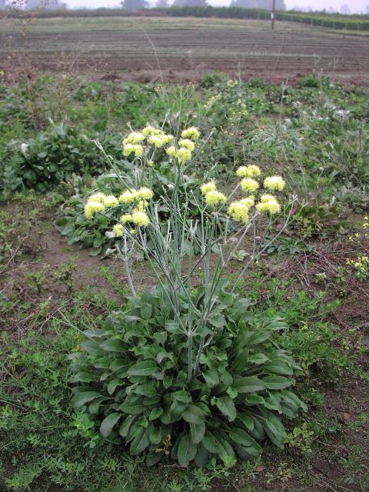

Naked buckwheat flowering at the NRCS Corvallis Plant Materials Center. Photo by Amy Bartow. NRCS.

### Alternate Names

*Alternate Common Names:* barestem buckwheat, naked wild buckwheat, naked stemmed eriogonum, nude buckwheat

*Alternate Scientific Name: Eriogonum latifolium* Smith ssp. *nudum* (Douglas ex Bentham) S. Stokes

### Uses

*Pollinator habitat:* Naked buckwheat is a great pollinator plant for various butterflies, including blues, hairstreaks, and metalmarks (Pavlick, 2007). It is also an important host plant for butterfly caterpillars and the flowers provide pollen to native and honey bees.

*Forage:* Forage use of this plant is limited largely to spring and fall. In the spring, the new succulent growth is attractive to livestock. In the fall, the flowers may get nibbled (Dayton, 1960).

*Ornamental:* This species can be great for xeriscaping.

*Restoration*: Naked buckwheat can be used with other native forbs or grasses for revegetation purposes.

**Ethnobotany**

Native Americans have used naked buckwheat as a part of their diet and tools. The University of Michigan-Dearborn’s Native American Ethnobotany website lists different tribal uses for naked buckwheat (Moerman, 2012). The Karok and Miwok tribes ate the young stems raw as greens. The Miwok tribe also used the twigs and leaves as a broom and the Karok tribe children used the stems for a game. The Kawaiisu tribe used hollow stems as pipes for smoking and for drinking tubes.

### Status

Please consult the PLANTS Web site and your State Department of Natural Resources for this plant’s current status (e.g., threatened or endangered species, state noxious status, and wetland indicator values).

### Description

*General:* Naked buckwheat is a common, native perennial forb in the buckwheat family (Polygonaceae). The smooth slender stems grow about three feet tall; the basal leaves arise from a short, woody crown. The leaves are slender stalked and the flowers are usually white, but often tinged with yellow or rose, and are clustered on a two- or three-forked inflorescence (Dayton, 1960). Naked buckwheatflowers July to August. The fruit is a hard, dry three-sided achene (Young and Young, 1992). There are 13 botanical varieties of *Eriogonum nudum*, but they can be difficult to distinguish and tend to intergrade across their range (Jepson Flora Project, 2012); a botanical key should be consulted for positive identification.

### *Distribution*: The native distribution of naked buckwheat is highly variable and extends from low to subalpine elevations (up to 12,400 ft) from southern Washington south to California and western Nevada, and into northwestern Mexico (Jepson Flora Project, 2012). For updated distribution, please consult the Plant Profile page for this species on the PLANTS Web site.

*Habitat*: Naked buckwheat grows in abundant stands in dry open meadows, on rocky outcrops, and along trails and roadsides (Dayton, 1960).

**Adaptation**

Naked buckwheat prefers sandy, well-drained soils, is drought tolerant, and usually is found in exposed, sunny sites (Jepson Flora Project, 2012).

### Establishment

For restoration purposes, weed control is essential for establishment. Seedlings grow slowly in cool spring temperatures and weeds can quickly overtake young plants in the first growing season. During warmer summer temperatures, this species grows vigorously, even when soil moisture is low.

Naked buckwheat can be established by direct seeding. Seeds of most populations have a high percentage of dormant seed that will not germinate until 90 days of cold/moist stratification. Therefore, sow seed in the fall at a rate of 5 pounds per acre (50 seeds per square foot) at a depth of 1/8 to1/4 inch for a solid stand. There are approximately 400,000 seeds in a pound. Sowing a pound of seed over and acre will result in a rate of about 10 seeds per foot.

Naked buckwheat seed increase field at the NRCS Corvallis Plant Materials Center. Photo by Amy Bartow. NRCS.

### Management

Naked buckwheat is a low maintenance plant once established. Weed control in the first year is of utmost important as seedlings grow slowly. Given the right environment, this species can live 3 to 5 years.

### Pests and Potential Problems

Plants can quickly wilt and rot if grown in waterlogged soils. Leaf rusts have been noticed on some naked buckwheats, but are rarely severe.

### Environmental Concerns

There are no known environmental concerns associated with naked buckwheat.

### Seeds and Plant Production

*Field Establishment:* Seed production for *Eriogonum nudum* requires a year for establishment. Sow seed in the fall at a rate of 5 lb/acre, drilled at a depth of 1/8 – 1/4 inch, with 10- to 14-inch row spacing, unless more space is needed for between row cultivation. This seeding rate will result in approximately 50 seeds per square foot. Seeds will stay dormant until spring and then grow slowly throughout the season. The plants will need one year to fully establish, with sparse flowering and little to no seed production the first year. Irrigation should not be required for fall sowing.

*Harvest:* Seeds are mature when the bracts are dry and papery, and usually change color, turning brown or rusty. Plants usually flower uniformly and seed retention is moderate. The window for harvesting is usually in mid-September in the Willamette Valley of Oregon. Highest yields have been achieved using a modified swather that both cuts and collects material. Harvested material should be dried on a tarp before cleaning.

*Seed Cleaning:* A thresher or stationary combine can be used to dehull seeds. Use a small air-screen machine to fine tune cleaning.

*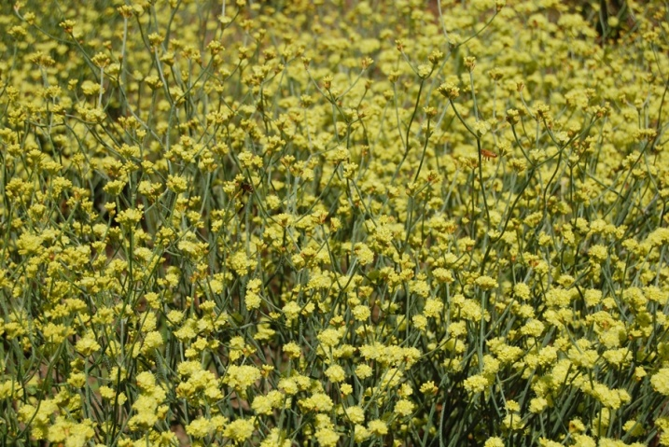Yields/Stand longevity:* The second through fourth years, yields will be high. At the Corvallis Plant Materials Center, yields are typically 50-100 pounds per acre. The species is short-lived when grown for seed in the Willamette Valley and will not last longer than four years.

### Cultivars, Improved, and Selected Materials (and area of origin)

There are no improved cultivars of naked buckwheat, but seed and plants are sometimes available from commercial sources in California (CNPLX, 2012) or by contract grow out.

### References

CNPLX (California Native Plant Link Exchange). 2012. Eriogonum nudum - Naked buckwheat. http://www.cnplx.info/nplx/ (accessed 21 Mar 2012). Calflora, Berkeley.

Dayton, W. 1960. Notes on western range forbs. USDA Forest Service, Washington, DC.

Freeman, C.C., and J.L. Reveal. 2005. Polygonaceae Jussieu. In: Flora of North America north of Mexico, vol. 5, Magnoliophyta: Caryophyllidae, part 2, eFloras, New York. http://www.efloras.org/ florataxon.aspx? flora_id=1&taxon_id=250060414 (accessed 21 Mar 2012).

Jepson Flora Project. 2012 (v. 1.0). Jepson eFlora, Eriogonum nudum, M. Costea and J.L. Reveal, http://ucjeps.berkeley.edu/cgi-bin/get_cpn.pl?ERNU3 (accessed 21 Mar 2012).

Moerman, D. 2012. *Eriogonum nudum*. In: Native American Ethnobotany Database [Online]. Univ. of Michigan, Dearborn. http://herb.umd.umich.edu/ (accessed 21 Mar 2012).

Young, J.A., and C.G. Young. 1992. Seeds of woody plants in North America. Dioscorides Press, Portland, OR.

**Prepared By**:

*Meghan Hemingway*, USDA NRCS Corvallis Plant Materials Center, Oregon

### Citation

Hemingway, M. 2012. Plant guide for naked buckwheat (*Eriogonum nudum)*. USDA-Natural Resources Conservation Service, Plant Materials Center, Corvallis, OR.

Published May 2012

Edited: 21Mar2012 aym ; 6Nov2012jab

For more information about this and other plants, please contact your local NRCS field office or Conservation District at <http://www.nrcs.usda.gov/> and visit the PLANTS Web site at <http://plants.usda.gov/> or the Plant Materials Program Web site <http://plant-materials.nrcs.usda.gov>.

PLANTS is not responsible for the content or availability of other Web sites.

**USDA IS AN EQUAL OPPORTUNITY PROVIDER AND EMPLOYER**