

Plant Guide

# sulphur-flower buckwheat

## Eriogonum umbellatum Torr.

Plant Symbol = ERUM

*Contributed by*: *USDA NRCS Lockeford Plant Materials Center, Lockeford, California*

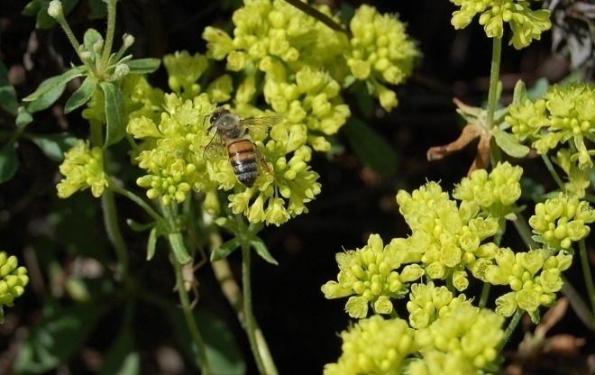

Honey bee visiting sulphur-flower buckwheat blooms. Photo Lockeford Plant Materials Center.

### Alternate Names

Sulphur flower, buckwheat bush, sulfur buckwheat, sulfur flower buckwheat, sulphur wildbuckwheat, slender buckwheat

### Uses

*Wildlife*: The seeds are an important food source for many species of birds and small mammals. Quail, sage-grouse, deer and mountain sheep eat the leaves, and insects found on the plants are an important food source for sage-grouse chicks. The plants are rated as having medium palatability for browse animals, but low palatability for grazing animals, with low protein content.

*Pollinators*: Sulphur-flower buckwheat attracts a wide variety of bees and other native pollinators. It is a larval host and nectar source for lupine blue butterfly (*Plebejus lupini)* (Opler et al., 2010). The cythera metalmark butterfly (*Apodemia mormo cythera*) and the Rocky Mountain dotted-blue (*Euphilotes ancilla*) are also found in association with a few varieties of sulphur-flower (Reveal, 2005; Pratt and Ballmer, 1991). Bees produce a strong, dark honey from sulphur-flower nectar.

*Landscaping*: Sulphur-flower buckwheat can be used for environmental enhancement, erosion control and foundation plantings around mountain homes. Plants withstand sun, heat, drought, and wind, making them ideal plants for dry sunny slopes. The showy flowers and seed heads, and compact growth habit make this plant a good choice for rock gardens.

*Ethnobotanic Uses*: Tribes throughout western North America traditionally used different parts of the sulphur-flower buckwheat plant to treat a variety of ailments. The Klamath used a poultice of the leaves on burns to soothe the pain (Spier, 1930). The Cheyenne made a tea from powdered stems and flowers that was used as a gynecological aid for lengthy menses (Hart, 1981). The Paiute and Shoshone made a poultice of mashed leaves, and sometimes roots, to treat lameness or rheumatism, and took a hot decoction of roots for colds or stomachaches (Train et al., 1941). The Kayenta Navajo used the plant as a fumigant or to induce vomiting for gastrointenstinal ailments (Wyman and Harris, 1951). The Kawaiisu used the mashed flowers as a salve for gonorrheal sores (Zigmond, 1981).

### Status

Please consult the PLANTS Web site and your State Department of Natural Resources for this plant’s current status (e.g., threatened or endangered species, state noxious status, and wetland indicator values).

### Description

*General*: Buckwheat Family (Polygonaceae). Sulphur-flower buckwheat is a native, low-growing, woody perennial commonly found on dry, sunny exposures on rocky slopes and ridges throughout the west. Taxonomic classification of this species is variable as many varieties intergrade, and it has been classified into 5, 25, 30 or 41 varieties, respectively (USDA-ARS, 2009; Costea and Reveal, 2011; USDA-NRCS, 2011; Reveal, 2005). The plant typically forms low, broad mats with individual clumps ranging from 4 inches to 2 ft (but up to 4 ft) tall and wide (Costea and Reveal, 2011). Leaves are basal, 1 inch long, and softly wooly or hairless. Flower stems 3 to 16 inches tall are topped by clusters of tiny sulfur yellow flower heads. Flowers range from yellow to orange or reddish, sometimes turning rusty orange-red with age. Flower displays can color entire slopes starting in June at lower elevations and continue into September or October at higher elevations.

*Distribution*: Sulphur-flower buckwheat is native to western mountainous regions of North America at elevations of 700 to 12,000 feet (Costea and Reveal, 2011). It is found from California to western Canada and into Colorado and New Mexico. For current distribution, please consult the Plant Profile page for this species on the PLANTS Web site.

*Habitat*: Sulphur-flower buckwheat is usually found in dry, open, rocky sites with shallow, sandy soils, especially on sunny slopes and ridges. It is a component of the following community types: sagebrush scrub, northern juniper woodland, yellow pine forest, subalpine forest, alpine fell-fields, pinyon-juniper woodland, lodgepole forest, red fir forest, and foothill woodland. In California, sulphur-flower buckwheat is often found growing with *Poa secunda*, *Elymus multisetus*, and *Achillea millefolium* (CNPLX, 2010). It typically grows in regions that receive from 8-18 inches annual precipitation, which may come in the form of winter rain/snow or summer monsoons.

**Adaptation**

Sulphur-flower buckwheat is adapted to well-drained, sandy or gravelly soils with low fertility, and will not tolerate saturated soils or shading. It has high drought, salinity and carbonate tolerance, and grows in soils ranging from a pH of 6.5 to 9.0 (USDA-NRCS, 2011).

### Establishment

Sulphur-flower buckwheat can be raised from seed or as container grown plants.

A direct seeding rate of 15 pounds per acre is recommended. Plant in fall and maintain good weed control, especially of annual grasses, during the first year of establishment.

Seeds exhibit physiological dormancy, and thus usually require 8 to 12 weeks (but as many as 24 weeks) cold, moist stratification in order to germinate, depending on the elevation and climate of the original collection (Meyer and Paulson, 2000). Cold stratify seeds by placing them in a fine mesh bag buried in moist peat moss or sand in a ventilated container under refrigeration at 34 to 37°F (Corey and Luna, 2008). Plant out in the early spring. Seeds are naturally cold stratified by fall sowing if locally-adapted germplasm is used. Select a hot, sunny, well-drained planting site and broadcast the seeds directly on the ground where they are to grow permanently.

Sulphur-flower buckwheat seedling survival will be enhanced if the seedbed has first been cleared of weeds and prepared to a depth of eight to ten inches. Scatter seeds evenly over the seedbed and rake and water lightly. Cover seeds with sand, sawdust or weed-free compost to a depth equal to one or two times the seed diameter (about 1/4 inch).

Keep the seedbed moist until seeds germinate, then continue to water once every two to three days (or as needed) for the next few weeks. Reduce watering to once a week for another month; continue to water a few times a month through the fall. Plants are drought tolerant when established and will need only occasional watering.

Sulphur-flower buckwheat has a long taproot and thus mature plants are difficult to transplant. When container-grown plants are ready to plant, dig a hole two to three times the diameter of the root ball and at least six inches deeper. Backfill the hole with six inches of native soil. Make a few one-eighth inch deep vertical cuts in the rootball, or carefully loosen roots away from the rootball with your hands to encourage roots to grow into the new soil. Set the plant into the hole and fill in around the roots with planting mix, firming the soil with your hands as you fill, until the hole is half full. Fill the hole with water and allow it to settle. This will settle the soil and eliminate air pockets around the roots. Backfill with enough soil so that the plant will sit at the same level at which it was growing in the container. Water it to allow the soil to settle, and then add more soil if necessary. Build a berm of soil to form a watering basin around the outer edge of the hole. Break the basin down after two or three years.

### Management

Control of weeds and irrigation is necessary in the first year of establishment.

### Pests and Potential Problems

Plants are relatively free from disease and pest problems, but are susceptible to root and crown rot if soil drainage is inadequate.

### Environmental Concerns

There are no known environmental concerns associated with sulphur-flower buckwheat.

### Seeds and Plant Production

Fields for seed production should be weed-free (fumigated if necessary to control soil-borne pathogens and weed seed bank) and prepared in the fall to create a smooth, firm, level seedbed for planting. Seed production fields in Oregon are direct-sown in the fall on 4-ft wide raised beds with 12-inch row spacing at a depth of ¾ inch and target density of 12 plants/ft2 of seedbed (Archibald, 2006), or a rate of 2.25 lbs/acre pure live seed (Parris et al., 2010). A layer of sawdust just thick enough to cover the seeds is then applied (1/4 to 1/3 inch), and constant moisture is maintained with sub-surface drip or sprinkler irrigation until fall rains begin. Weeds are controlled by mowing, cultivation, tillage and hand removal. Alternatively, production fields can be established in the fall to early spring with container stock transplanted into weed mat to reduce the need for weed management.

Plants usually produce few flowers the first year, but can remain productive for ten to twenty years. They can be pruned back after flowering to promote a denser, more compact plant. Because sulphur-flower buckwheat seed does not mature uniformly, seed is often first harvested by hand, and later by flail-vac harvester or small-plot combine when most seed heads have matured and perianth becomes papery (June to July in California). Seed does not shatter easily and holds on the plants.

Harvested seed is first processed with a hammermill or brush machine (Westrup Model LA-H laboratory brush machine, with a #20 mantel, at a speed of 3) to remove seed (achenes) from flower heads. For small seed lots, seed is then finished by air-screening using an office Clipper, with a top screen 7 to 1/12 round (size depends on lot) and a bottom screen 1/21 to 1/25 round (size depends on lot), medium speed, and medium to high air (Barner, 2009). For large seed lots, seeds are first air-screened using a Clipper Eclipse, Model 324, with a top screen 6 round, second screen 6 round, and a bottom screen 1/25 round, medium to high air (screen size and air can vary by lot). Seed lot is finished using an Oliver Model 30, Gravity Separator at a speed 20, air 50, and hopper speed 1.5 (speed, air, and hopper speed vary by lot) (Barner, 2009). Foundation seed production fields of ‘Sierra’ at the NRCS Plant Materials Center in Lockeford, CA yield an average of 150 lbs seed per acre. Germination and percent hard seed vary considerably by origin, seed lot, growing season, and age of the crop; seeds maintain viability five to seven years if stored at 37 to 41°F with low relative humidity. There are approximately 140,000 to 200,000 seeds per pound.

Plants are propagated by sowing stratified seed directly into 10-cubic inch conetainers in the greenhouse in a well-drained potting mix (eg. 4:4:1:1 sand, milled sphagnum peat, perlite, vermiculite with 5 oz dolomite) (CAPMC, unpublished data). Seedlings in the early stages of growth get leggy quickly and are somewhat susceptible to root-rot, crown-rot and damping-off, so should be removed from the greenhouse about 6 weeks after germination if danger of extreme cold has passed. A thin layer of sand mulch around seedlings can help reduce risk of damping-off. Seedlings are fertilized twice weekly with 20-10-20 liquid NPK at 100 ppm during the active growth phase, from about 6 to 18 weeks old, and with 10-20-20 liquid NPK at 200 ppm during the eight weeks of hardening off (Corey and Luna, 2008). Tightly rooted plants are ready for transplanting in six months.

### Cultivars, Improved, and Selected Materials (and area of origin)

Sulphur-flower buckwheat seeds and container plants are readily available from commercial sources.

‘Sierra’ was released in 1987 by the NRCS Plant Materials Center, Lockeford and the California Agricultural Experiment Station, Davis (USDA-SCS, 1987). The original collection was made in 1972 in South Lake Tahoe, El Dorado County, California at an elevation of 6,200 ft. This low-growing shrub was developed for critical area stabilization on dry, rocky slopes and droughty sites. It can be used for landscaping around mountain homes, and is an excellent dry flower for arrangements as it holds its color and structure for many months. This cultivar is adapted to the dry Sierra Nevada foothills and mountains where soils and slopes limit competition. Sierra is fairly free from diseases, but is susceptible to root and crown rot problems related to wet and poorly drained soils. It is recommended for use in Major Land Resource Areas (MLRAs) 14, 15, 18, 19, 20 and 22.

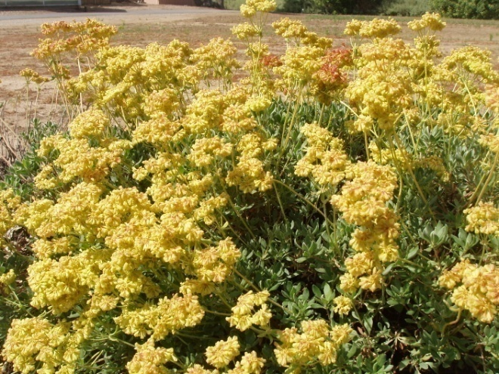

'Sierra' sulphur-flower buckwheat production field at the LockefordPlant Materials Center, 2008.

### References

Archibald, C. 2006. Seed production protocols for *Anaphalis margaritacea, Eriophyllum lanatum,* and *Eriogonum umbellatum.* Native Plants J. 7(1):47–51.

Barner, J. 2009. Propagation protocol for production of *Eriogonum umbellatum* Torr. seeds. USDA-FS-R6 Bend Seed Extractory, Bend, OR. *In*: Native Plant Network. Available at http://www.nativeplantnetwork.org (accessed 3 Jan. 2011). Univ. of Idaho, College of Natural Resources, Forest Research Nursery, Moscow.

CNPLX (California Native Plant Link Exchange). 2010. Available at http://www.cnplx.info/query.html (accessed 23 May 2011).

Corey, S., and T. Luna. 2008. Propagation protocol for production of container *Eriogonum umbellatum* Torr. plants (172 ml conetainers). USDI-NPS-Glacier National Park, West Glacier, MT. *In*: Native Plant Network. Available at http://www.nativeplantnetwork.org (accessed 3 Jan. 2011). Univ. of Idaho, College of Natural Resources, Forest Research Nursery, Moscow.

Costea, M., and J.L. Reveal. 2011 (in press). *Eriogonum*. In B.G. Baldwin et al. (eds.), The Jepson manual: vascular plants of California. Retrieved from http://ucjeps.berkeley.edu/ jepsonmanual/review/ (6 Jan. 2011). Univ. of California Press, Berkeley.

Hart, J.A. 1981. The ethnobotany of the northern Cheyenne Indians of Montana. J. Ethnopharm. 4:1-55.

Meyer, S.E., and A. Paulsen. 2000. Chilling requirements for seed germination of 10 Utah species of perennial wild buckwheat (*Eriogonum* Michx. [Polygonaceae]). Native Plants J. 1:18-24.

Opler, P.A., K. Lotts, and T. Naberhaus, coordinators. 2010. Attributes of *Plebejus lupini. In:* Butterflies and Moths of North America. Available at http://www.butterfliesandmoths.org/ (accessed 26 Jan. 2011). Big Sky Institute, Bozeman, MT.

Parris, C., C.C. Shock, E. Feibert, and N. Shaw. 2010. Sulphur-flower buckwheat–*Eriogonum umbellatum* (ERUM). Sustainable Agricultural Techniques: Native Plant Seed Production EM 9017. Available at http://ir.library.oregonstate.edu/xmlui/bitstream/handle/1957/19598/em9017.pdf (accessed 1 Feb. 2011). Oregon State University Extension Service, Corvallis.

Pratt, G.F., and G.R. Ballmer. 1991. Three biotypes of *Apodemia mormo* (Riodinidae) in the Mojave Desert. J. Lepid. Soc. 45(1):46-57.

Reveal, J.L. 2005. *Eriogonum umbellatum*. *In*: Flora of North America North of Mexico,Vol. 5. Available at http://www.efloras.org (accessed 26 Jan. 2011). eFloras, New York.

Spier, L. 1930. Klamath ethnography. Univ. of CA Publ. in Am. Archaeology and Ethnology 30:1-338.

Train, P., J.R. Henrichs, and W.A. Archer. 1941. Medicinal uses of plants by Indian tribes of Nevada. USDA, Washington, DC.

USDA-ARS, National Genetic Resources Program. 2009. *Eriogonum* *umbellatum* Torr. *In*: Germplasm Resources Information Network (GRIN) [Online Database]. Available at http://www.ars-grin.gov/cgi-bin/npgs/html/ taxon.pl?70267 (accessed 26 Jan. 2011). National Germplasm Resources Laboratory, Beltsville, MD.

USDA-NRCS. 2011. The PLANTS Database Available at http://plants.usda.gov (accessed 26 Jan. 2011). National Plant Data Center, Baton Rouge, LA.

USDA-SCS. 1987. Notice of the naming and release of ‘Sierra’ sulphur flower buckwheat for conservation and beautification use on critically eroded areas. USDA-SCS and California Agricultural Experiment Station, Davis.

Wyman, L.C., and S.K. Harris. 1951. The ethnobotany of the Kayenta Navaho. Univ. of New Mexico Press, Albuquerque.

Zigmond, M.L. 1981. Kawaiisu ethnobotany. Univ. of Utah Press, Salt Lake City.

**Prepared By**:

*Dave Dyer*, USDA NRCS Plant Materials Center, Lockeford, California

*Reina O’Beck*, California State Office, Davis, California

*Anna Young-Mathews*, USDA NRCS Plant Materials Center, Lockeford, California

### Citation

Dyer, D., R. O’Beck, and A. Young-Mathews. 2011. Plant guide for sulphur-flower buckwheat (*Eriogonum umbellatum)*. USDA-Natural Resources Conservation Service, California Plant Materials Center, Lockeford, CA.

Published *March, 2005*

#### Edited: 28Mar2005 ro; 23Sep2005 jsp; 1Feb2011 aym; 29Mar2012 jab

For more information about this and other plants, please contact your local NRCS field office or Conservation District at <http://www.nrcs.usda.gov/> and visit the PLANTS Web site at <http://plants.usda.gov/> or the Plant Materials Program Web site <http://plant-materials.nrcs.usda.gov>.

PLANTS is not responsible for the content or availability of other Web sites.

**USDA IS AN EQUAL OPPORTUNITY PROVIDER AND EMPLOYER**