|  |  |
| --- | --- |
| **Natural Resources Conservation Service** | Plant Guide |

# leafy spurge

## Euphorbia esula L.

Plant Symbol = EUES

*Contributed by*: USDA NRCS Aberdeen, Idaho Plant Materials Center

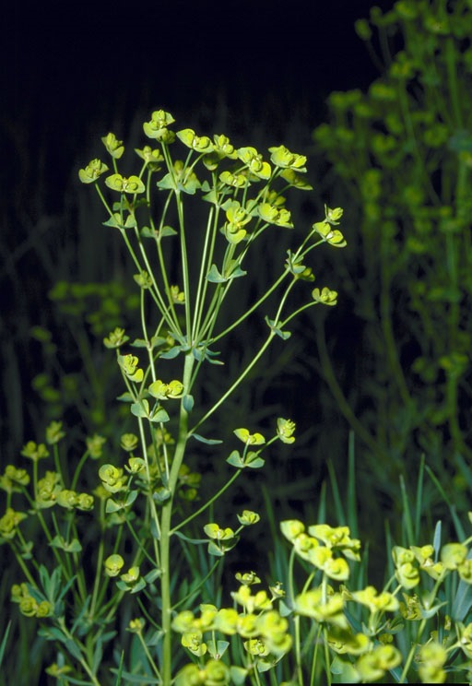

Leafy spurge. William M. Ciesla, Forest Health Management International, Bugwood.org.

### Alternate Names

*Common Names:* wolf’s milk, faitours-grass, tithymal

*Scientific Names:* Considerable taxonomic confusion surrounds leafy spurge varieties, subspecies and hybrids. The PLANTS Database recognizes 2 varieties *Euphorbia esula* var. *esula,* and *Euphorbia esula* var. *uralensis* (= Russian leafy spurge)

### Caution: This plant is highly invasive.

### Caution: This plant can be toxic.

### Uses

Leafy spurge is a noxious, introduced, aggressive invader plant that can overtake large areas, displace desirable plant communities, and reduce aesthetic and economic values and wildlife habitat. Cattle and horses avoid leafy spurge. The milky sap, which contains ingenol, a toxic compound, can cause severe diarrhea and weakness in cattle and horses forced to consume it. Leafy spurge can also cause blistering and hair loss around horses’ hooves and can be irritating to the skin, eyes and digestive tracts of humans and other animals. Sheep and goats tend to be less bothered by the toxic sap properties and are often used in concert with herbicides and other biological agents to manage heavy infestations of leafy spurge (Bourchier, et. al., 2006; Gucker, 2010).

Leafy spurge seed is consumed by mourning doves. The plant provides nesting habitat for western meadowlarks but are not utilized by other bird species (Gucker, 2010). Grasshopper sparrows and savannah sparrows have had their populations reduced in areas of heavy weed infestation. Leafy spurge reduces habitat for bison, deer, and elk and is a major threat to the endangered western prairie fringed orchid (*Platanthera praeclara*) because leafy spurge has established and spread into much of the only remaining suitable habitat of the orchid (Bourchier, et. al., 2006).

Although leafy spurge is an invasive plant and most efforts are to control or manage the plant, it has been evaluated for use as a biofuel, as an antiviral against herpes simplex and in China, as a dilution of boiled plant material to control maggots, mosquito larvae, rats, and some plant diseases (Gucker, 2010).

### Status

Leafy spurge is recognized as a noxious weed in Alaska, Arizona, California, Colorado, Connecticut, Hawaii, Idaho, Iowa, Kansas, Massachusetts, Minnesota, Montana, Nebraska, Nevada, New Mexico, North Dakota, Oregon, South Dakota, Utah, Washington, Wisconsin, and Wyoming.

Please consult the PLANTS Web site and your State Department of Natural Resources for this plant’s current status (e.g., threatened or endangered species, state noxious status, and wetland indicator values).

### Weediness

Leafy spurge produces a prolific, and often deep, massive root system. It can produce abundant seed in the second and subsequent growing seasons. Seed is forcibly ejected from the plant when ripe and all animals that come in contact with the plant can disperse seed. Vehicles and road maintenance equipment can also disperse seed. Seed can also be spread by ants and by water as the seed can float and survive underwater storage (Gucker, 2010).

This plant is weedy and invasive in many regions and habitats and will displace desirable vegetation if not properly managed. Please consult with your local NRCS Field Office, Cooperative Extension Service office, state natural resources department, or state agriculture department regarding its status and use. Weed information is also available from the PLANTS Web site at http://plants.usda.gov/. Please consult the Related Web Sites on the Plant Profile for this species for further information.

### Description

*General*: Leafy spurge is a member of the spurge (Euphorbiaceae) family. It is a strongly rooted (often growing in clumps), introduced broadleaf weed that grows 30-70 cm tall. The roots can extend to soil depths of up to 4.5 m. It does not have morphologically structured runners or rhizomes as some have reported but does exhibit shoot-bud production by roots (Gucker, 2010). The plants are glabrous and erect with numerous leaves and the stems ooze a milky sap when damaged. The principal leaves are alternate, broadly linear to narrowly oblong, 3-9 cm long and 3-8 mm wide and essentially 1-nerved. The leaves just below the flowers are heart-shaped. The inflorescence is an umbel with showy yellowish-green colored bracts that are flared horn-like on each side. Flowers are greatly reduced and lack both sepals and petals. A central female flower is surrounded by five groups of male flowers. The fruit is a small, 3-chambered capsule 3-3.5 mm long and the seed is ellipsoid, 2-2.5 mm long, and mostly smooth (Cronquist et. al., 1997; Gucker, 2010). When seed is ripe the capsules explode to eject seeds up to 15 feet from the plant. The seeds have elaisomes (fleshy structures attached to the seed) that aids in dispersal by some ants (Gucker, 2010).

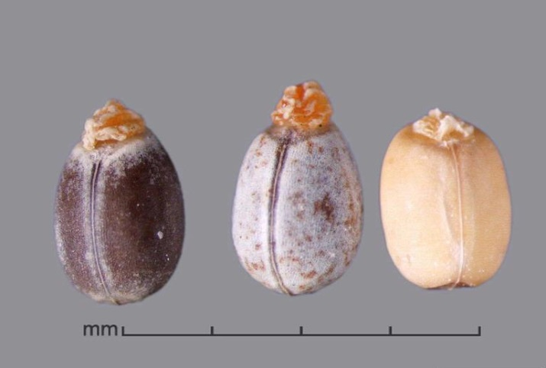

Leafy spurge seed with elaisomes attached on left 2 seeds. Julia Scher, USDA APHIS PPQ, Bugwood.org.

There is considerable taxonomic confusion with leafy spurge because multiple introductions into North America resulted in a complex of variable genotypes. The only species recognized to hybridize with leafy spurge is cypress spurge (*Euphorbia cyparissias*). The hybrid is known as *Euphorbia x pseudoesula* (Gucker, 2010).

*Distribution*: Leafy spurge is native to Europe and Asia and was first reported in Massachusetts in 1827, likely established from contaminated soil from ship ballasts. Contaminated crop seed including oats, smooth brome and alfalfa brought by European settlers accelerated the spread westward into North America. Leafy spurge is abundant in the northern Great Plains and prairie regions of Canada. It has been found in 35 states with the most extensive infestations in the mid-western and western states of Minnesota, North Dakota, South Dakota, Nebraska, Colorado, Idaho, Montana, and Wyoming as well as the southern portions of all six provinces in Canada (Bouchier, et, al., 2006). By 2005, leafy spurge had infested approximately 5 million acres in the United States (Gucker, 2010). For current distribution, please consult the Plant Profile page for this species on the PLANTS Web site.

*Habitat*: Leafy spurge is found in many different habitats from streambanks to dry, upland sites and invades disturbed and undisturbed areas including pastures, abandoned cropland, roadsides, woodlands, riparian communities, meadows and mountain ridges (USDA Forest Service 2012).

**Adaptation**

In Europe, leafy spurge is often found on sandy soils. In North America it is found on fine to coarse textured, and on moist to dry soils but is most aggressive under dry conditions where competition from desirable plants is reduced. Leafy spurge can tolerate temperatures from -50-100°+ F and annual precipitation ranging from 7-25 inches. Soil texture and fertility can affect growth and distribution of leafy spurge roots. In fine textured soils leafy spurge roots are thicker (greater branching) in the top 6 inches of soil and on coarse textured soils, roots are thicker with less branching at soil depths greater than 30 inches. High levels of soil nitrogen can reduce the biomass of leafy spurge roots with greater root concentrations closer to the soil surface (Gucker, 2010).

### Establishment

Leafy spurge reproduces by seed and from root sprouting. First-year plants do not produce seeds. Seed dormancy is controlled by the seed coat and is overcome by warm, moist conditions with temperature ranging from 79-82° F. Most seedlings emerge early in the spring often following heavy precipitation. Seeds planted to a depth of 0.5 and 2 inch depth achieved maximum germination and seeds typically germinate better in fine textured soils than coarse textured soils. Seedlings grow rapidly and are capable of vegetative regeneration within a week of emergence and able to resprout even after being severed 1 inch below the soil surface (Gucker, 2010).

Leafy spurge shoots emerge from established plants from mid-April to early May and flowering begins in late May to mid-June but can extend to later months depending on latitude and environment. In the northeastern states flowering may occur until October. Mature seeds develop about 30 days after pollination. Flowers are pollinated primarily by insects and high levels of seed can be produced (up to 3,400 pounds per acre in a Saskatchewan study). Ripe seed is forcibly ejected up to 15 feet from parent plants and seed may remain viable in the soil for up to five years (Gucker, 2010)

Leafy spurge can spread prolifically from the root crown, root buds and root pieces and can occupy a large area in a relatively short time (from 0.5-11 feet annually), and is considered to be more important to the persistence and spread of established stands than from seed production (Gucker, 2010).

Leafy spurge may also exhibit allelopathic properties to inhibit competition from other plants but field studies have not shown allelopathy to be a consistent property of the species (Gucker, 2010).

### Management

Leafy spurge stands that are established over large areas are extremely difficult and expensive to eradicate. Early detection and eradication of stands just beginning to occupy otherwise desirable plant communities should be given high priority for treatment. Manage for and maintain healthy plant communities; use of certified weed-free hay, straw, mulch and gravel; detect, map and eradicate new stands as soon as possible; implement monitoring and follow up treatment for missed plants and seedlings; and combine mechanical, cultural, biological, and chemical methods for effective control are all actions that should be considered when planning management of leafy spurge (USDA, Forest Service, 2012).

### Environmental Concerns

Leafy spurge is highly invasive, listed as a noxious weed in many states, is able to establish and persist in many different plant communities, and is difficult to control once it has established in an area.

### Control

*Physical:* Physical methods alone are mostly ineffective in controlling leafy spurge. Because of the expansive root system, hand pulling or grubbing are not effective. Hand cutting or mowing can reduce seed production and its competitive ability but will only suppress growth. Plants should be clipped within 4 inches from the ground just before seed set and then repeated throughout the growing season. Flowering parts that have been mowed must be removed and destroyed since seed will ripen if left in place (USDA, Forest Service, 2012).

Tillage can be effective but only when reseeding takes place. Areas that are suitable for tillage and seeding should be tilled at 3 week intervals to a depth of at least 4 inches beginning when leafy spurge begins growth in the spring. If using tillage in conjunction with herbicide application allow plants to grow 4-6 inches tall before spraying and wait at least 1 week after spraying before resuming tillage. Equipment must be cleaned after field operations to prevent movement of seeds or root parts to uninfested areas (USDA, Forest Service, 2012).

Prescribed fire is not recommended for control of leafy spurge because the plant rapidly regenerates new shoots from the root system. Fire may be used in conjunction with herbicide control or grazing to remove litter which could enhance reseeding efforts (USDA, Forest Service, 2012).

Land managers, road crews, and the public need to be educated to identify noxious species so they can help report suspected infestations and the importance of not travelling through infested sites. Vehicles, humans and livestock should be discouraged from moving through infested areas and to check and remove seeds prior to leaving an infested area to help stop the spread of leafy spurge. Weed screens on irrigation water from infested areas can help prevent seed transportation through irrigation canals (USDA, Forest Service, 2012).

*Chemical:* Long-term control of large, well established leafy spurge stands with herbicides alone usually has not been very successful and is very expensive. A waxy layer on the leaves and stems makes chemical control difficult without the use of surfactants and the roots are able to purge chemicals from the root system (Gucker, 2010).Herbicide application is most effective during the fall because chemicals are more easily transported to the root system after flowering. Picloram (Tordon 22K) has long been used on leafy spurge because of its selective control while allowing grasses to return naturally but is a restricted use herbicide. Aminocyclopyrachlor (Perspective or Streamline) is a newer herbicide that is showing effective control in laboratory testing. Imazapic (Plateau) is effective and especially useful on permeable soils, around trees, or near surface water. Dicamba (Clarity) is less expensive than Picloram products and is not a restricted use herbicide. Glyphosate (Roundup, Rodeo) is a non-selective herbicide that is recommended only in conjunction with grass seeding (USDA, Forest Service, 2012).

Please contact your local agricultural extension specialist or county weed specialist to learn what works best in your area and how to use it safely. Always read label and safety instructions for each control method. Trade names and control measures appear in this document only to provide specific information. USDA NRCS does not guarantee or warranty the products and control methods named, and other products may be equally effective.

*Biological:* Grazing of sheep or goats in combination with either herbicide application or use of insects can lower seed production of leafy spurge and decrease its spread. Sheep and goats (especially Angora goats) will readily graze young leafy plants and are not as susceptible to poisoning as other livestock. To maximize suppression of leafy spurge, sheep or goats should graze the plants at a moderate to severe rate of utilization. Studies have shown that stocking rates of 3-6 sheep per acre per month, 1-2 ewes with lambs per acre per month, or 12-16 Angora goats per acre per month are usually adequate. Grazing should begin in the spring when plants are 2-6 inches tall and continue until all of the yellow bracts on the stem have been consumed. If using grazing in combination with herbicide application, remove animals early in the fall and allow 3-4 inches of regrowth before application. Animals should be quarantined 5-6 days to prevent spreading seed to noninfested sites (USDA, Forest Service, 2012).

Using host-specific natural enemies of leafy spurge is referred to as “classical biological control”. Numerous biological agents for control of leafy spurge have been tried throughout the United States with varying degrees of success. Currently there are twelve leafy spurge biological control species permitted for release in the United States. Bourchier et. al. (2006) provides detailed information on the permitted insects for control of leafy spurge and guidelines to plan, implement, monitor and evaluate an effective leafy spurge biological control program. There are seven beetles (Coleoptera), two flies (Diptera), and three moths (Lepidoptera) permitted for release. Leafy spurge flea beetles (*Aphthona* spp*.*) appear to be the most successful control agents for leafy spurge in North America. Larvae are root and stem feeders which do the greatest damage by creating wounds on the roots that allow plant pathogens to enter and cause deterioration of the root system. Adults feed on leafy spurge leaves and flowers but have little or no impact on growth and development of leafy spurge. Different flea beetle species have different habitat preferences and for optimal biological control, a variety of flea beetle species should be released and the beetles will sort out their preferred habitats (Bourchier, et. al., 2006). If using grazing in combination with flea beetles, graze once in the spring and once in the fall to allow the beetle to complete its life cycle on the plant (USDA, Forest Service, 2012).

Any strategy adopted for managing leafy spurge must involve careful planning, maintaining repetitive treatment over multiple consecutive years, periodically monitoring treated areas and spot treatment, using sound grazing management practices and monitoring the return of desirable plant species (USDA, Forest Service, 2012).

### References

Bourchier, R. Hansen, R., Lym, R., Norton, A., Olson, D., Randall-Bell, C., Schwarzlander, M, Skinner, L. 2006. Biology and Biological Control of Leafy Spurge [Online]. U.S Department of Agriculture, Forest Service, Forest Health Technology Enterprise Team. http://www.fs.fed.us/foresthealth/technology/pdfs/LeafySpurgeBiocontrols.pdf (accessed 16 December, 2013)

Cronquist, A., Holmgren, N., Holmgren, P. 1997. Intermountain Flora. Volume Three, Part A. Subclass Rosidae (except Fabales). The New York Botanical Garden, Bronx, New York.

Gucker, C. 2010. Euphorbia esula. In: Fire Effects Information System [Online]. U.S. Department of Agriculture, Forest Service, Rocky Mountain Research Station, Fire Sciences Laboratory. http://www.fs.fed.us/database/feis (accessed 12 December, 2013)

USDA Forest Service, 2012. Field Guide for Managing Leafy Spurge in the Southwest. U.S. Department of Agriculture, Forest Service, Southwestern Region. TP-R3-16-2. 10 p.

**Prepared By**:

Loren St. John, USDA NRCS Plant Materials Center, Aberdeen, ID

Derek Tilley, USDA NRCS Plant Materials Center, Aberdeen, ID

### Citation

St. John, L., Tilley D. 2014. Plant Guide for Leafy spurge (*Euphorbia esula*). USDA-Natural Resources Conservation Service, Plant Materials Center. Aberdeen, Idaho 83210.

Published January, 2014

Edited: 19Dec2013ls; 2Jan2014djt; 08 Jan2014 jab

For more information about this and other plants, please contact your local NRCS field office or Conservation District at http://www.nrcs.usda.gov/ and visit the PLANTS Web site at http://plants.usda.gov/ or the Plant Materials Program Web site http://plant-materials.nrcs.usda.gov.

PLANTS is not responsible for the content or availability of other Web sites.

***Helping People Help the Land***

**USDA IS AN EQUAL OPPORTUNITY PROVIDER AND EMPLOYER**