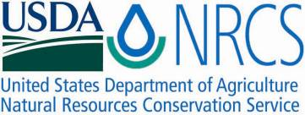

Plant Guide

# Penland's eutrema

## *Eutrema penlandii* Rollins

Plant Symbol = EUPE10

*Contributed by*: USDA NRCS Colorado Plant Materials Program

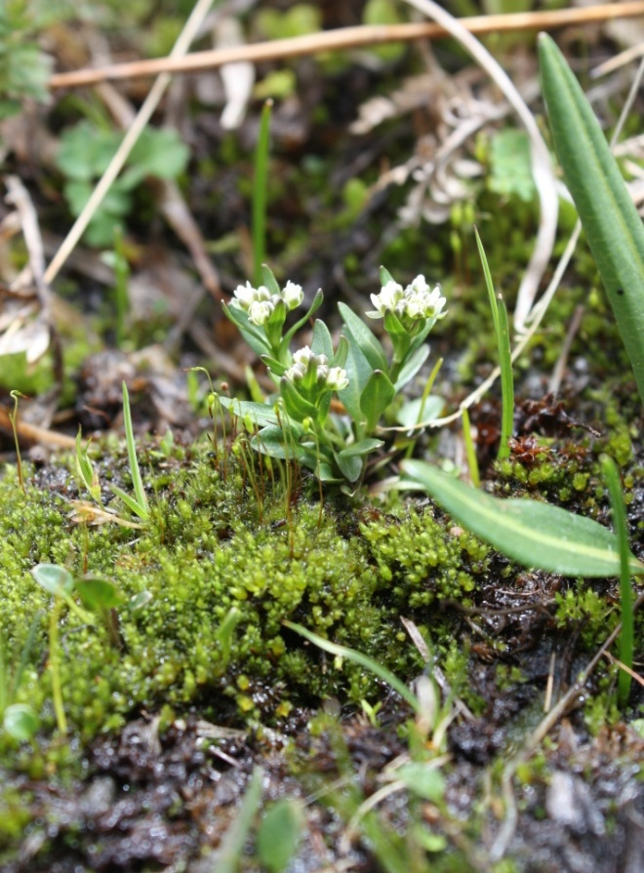

Figure1: Penland’s eutrema, *Eutrema penlandii*. Photo USFWS, Alicia Langton July 2010.

### Alternate Names

### *Eutrema edwardsii ssp. Penlandii*, Weber 1985)

### Penland Alpine Fen mustard

Mosquito Range mustard

### Uses

### Penland’s eutrema was first collected near Hoosier Pass, Colorado, by C. William T. Penland of Colorado College in 1935. Reed C. Rollins of the Gray Herbarium described the species as *Eutrema penlandii* in 1950 (Rollings, 1950). Many mustard family plant species have known food value (cabbage, broccoli, kohlrabi, kale, etc.), in fact, Wasabi, *Eutrema japonica,* is a commonly recognized member of the *Eutrema* genus in Asia. It is unknown at this time if the plant requires pollinators for reproduction. The plant is browsed by alpine wildlife. It has no known agricultural, economic, or other human uses at this time.

### Status

Penland’s eutrema was designated as endangered by the U.S. Fish and Wildlife Service (USFWS) in 1993, at which time it was known to occur at 14 sites with an estimated population of 16,400 individuals (USFWS, 1993). A habitat survey conducted in 2003 resulted in the discovery of two additional sites but this addition did not significantly change the known overall population or habitat extent (USFWS, 2011).The NatureServe conservation status rank, an international effort which ranks species on their “global” status, ranks Penland’s eutrema as G1/S1- critically imperiled globally and in Colorado, (Figure 2). Penland’s eutrema is only one of two species of *Eutrema* in North America and the only one in the lower 48 states (NatureServe 2011), (CPC, 2011).

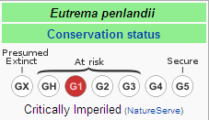

Figure 2. Penland's eutrema global "rarity" rank (NatureServe 2008).

### Description

*General*:

Mustard family (Brassicaceae). Penland’s eutrema is a diminutive herbaceous perennial plant that grows from a taproot (Figure 3). Plants grow up to 6 inches (15 cm) in height with one to several spreading erect stems (Figure 1). Basal leaves are heart-shaped with rounded tips. Several white, four-petalled flowers top each stem. The leaves and fruit are without hairs (glabrous) and stalked which distinguishes this species from many other small types of mustard that grow in the area such as *Draba* (whitlow-grass). Flowering occurs June to August and even into September, depending on the site and snow melt (USFWS, 2011). Fruits of Penland’s eutrema are the characteristic mustard family siliques; they are diamond-shaped in cross-section and turn purple-black when mature which also distinguishes the plant from other look-alikes (USFWS, 2011).

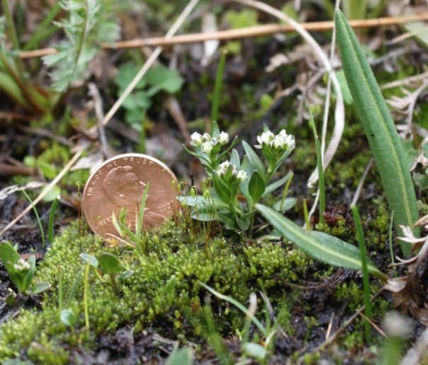

Figure 3: Penland’s eutrema posed with a penny for size perspective. USFWS Alicia Langton July 2010.

*Distribution*:

*Eutrema penlandii* is a narrow endemic known only to occur in the Mosquito mountain range of Colorado in Lake, Park, and Summit counties (US FWS, 1993). Range-wide distribution reaches 18 miles from north to south and approximately 10 miles east to west, encompassing roughly 200 acres of occupied habitat. This species is thought to be an ice-age relic with its closest relative, *E. edwardsii,* found in the Canadian Arctic Archipelago. (Roy et al. 1993). According to the FWS 2011, approximately 40% of the existing known populations and habitat for Penland’s Eutrema occurs on private land. Please consult the USFWS website at www.fws.gov for more information. For current distribution, please consult the Plant Profile page for this species on the PLANTS Web site.

*Habitat*:

Penland’s eutrema is an alpine tundra species that grows above treeline in association with many species of moss, forbs, and graminoids in alpine meadow habitat (Spackman, et al. 1997), (Chapman 2006). It occurs in wetlands with perennial water flow from snowmelt, at 11,800 -13,100 ft. in elevation (USFWS, 2011). Penland’s eutrema generally grows on the leeward, south and east-facing, flat to gently sloping benches with steep walls that provide some protection from snow-melting winds (USFWS, 2011). The annual precipitation is 30-40 inches (US Department of Agriculture, 2006). Penland’s eutrema is known to frequently occur in association with a variety of alpine tundra species including: white marsh marigold (*Caltha leptosepala*), water sedge (*Carex aquatilis*), mountain sedge (*Carex scopulorum),* Bering chickweed (*Cerastium beeringianum*), alpine spring beauty (*Claytonia megarhiza*), tufted hairgrass (*Deschampsia cespitosa*), Ross avens (*Geum rossii*), elephanthead (*Pedicularis groenlandica*), arctic bluegrass (*Poa arctica*), America bistort (*Polygonum bistortoides),* alpine bistort (*Polygonum viviparum*), King’s crown (*Rhodiola integrifolia*), Rose crown (*Rhodiola rhodantha*), diamondleaf saxifrage (*Saxifraga rhomboidea*), and alpine meadow rue (*Thalictrum alpinum*), (Figure 4), (USFWS, 2011), ( RMH, 2010). The Mosquito Range includes thirteen other rare plant species, of which, two are known only from the range (USFWS 2011).

**Adaptation**

Penland’s eutrema is adapted to grow in the Mosquito Range in central Colorado (Spackman 1997), where a unique set of habitat conditions exist. An arctic circumpolar species, Penland’s eutrema is separated from its closest relative *E. edwardsii*, which occurs in the Canadian Arctic Archipelago by over 1000 miles to the north (Roy et al. 1993).

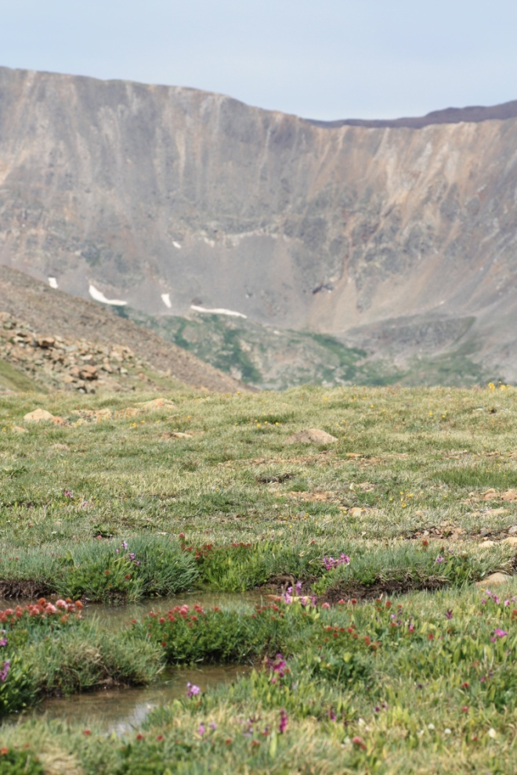

Figure 4: Penland’s eutrema habitat. Photo USFWS, Alicia Langton, July 2010.

**Management**

Primary threats to Penland’s eutremaappear to be from habitat loss through recreation (off-highway vehicle use, camping, and hiking), alterations to hydrology, mining impacts, and climate.

### Pests and Potential Problems

### Currently there are no known pests affecting the growth and vigor of Penland’s eutrema. Associated threats may include the introduction of non-native invasive plant species from hikers and campers as recreational use numbers continue to increase annually of this popular recreation area that constitutes the only habitat of Penland’s eutrema. Impacts of herbivory from pikas and rodents have been noted by researchers (USFWS 2011). However, Penland’s mustard has evolved some tolerance to grazing and wildlife usage. For instance, a taproot growth form enables re-sprouting after grazing. Interestingly, to date, the main non-native constituent in Penland’s mustard habitat is dandelion, *Taraxacon officinales*, another tap-rooted species.

### Concerns

### Hydrology is the most fragile aspect of the habitat affecting Penland’s eutrema. Any activity that directly or indirectly alters the surface or ground water supply and alters the wetland habitat required by this species could pose a significant threat. On a larger scale, climate change could potentially threaten this and other alpine species since there are no upward elevation to which the species may migrate.

### Seeds and Plant Production

### Depending on snow-melt, Penland’s eutrema produces mature fruits from late-July into August and into September (USFWS). Penland’s eutrema produces from seed with no means of vegetative reproduction. Little else is known about the reproduction, pollinators, or seed dispersal at this time.

### References

Chapman, S.S., G.E.Griffith, J.M. Omernik, A.B. Price, J. Freeouf , and D.L. Schrupp, 2006. Ecoregions of Colorado (color poster with map, descriptive text, summary tables, and photographs): Reston, Virginia, U.S. Geological Survey (map scale 1:1,200,000).

Center for Plant Conservation (CPC). http://www.centerforplantconservation.org/Collection/CPC_ProfileImage.asp?FN=1921b.

http://www.centerforplantconservation.org/. Accessed 2011.

NatureServe. 2008. NatureServe Explorer: An online encyclopedia of life [web application]. [Internet].Version 7.0. NatureServe, Arlington, Virginia. http://www.natureserve.org/explorer. Accessed: June 17, 2011.

O'Kane, Steve L. Jr. 1985. Endangered Species Information System, Species Biology Workbook for ERIOGONUM PELINOPHILUM. U.S. Fish and Wildlife Service.

Rocky Mountain Herbarium. www.rhm.uwyo.edu/

3/25/2010. Accessed *Eutrema penlandii*, accession records, September 2011.

Rollings, R.C. *Eutrema penlandii* Rollings, sp.nov. Contributions to the Gray Herbarium 171:51.

Rollins, R.C. 1993. The Cruciferae of continental North America: Systematics of the mustard family from the Arctic to Panama. Stanford Univ. Press, Stanford, California. 976 pp.

Roy, G., S. Kelso, and A. Tonnesen. 1993. Habitat characteristics of *Eutrema penlandii*

(Brassicaceae) in the Colorado Rockies: A study

of alpine endemism.

Spackman, S. et al. 1997. Colorado Rare Plant Field Guide. Prepared for the Bureau of Land Management, the U.S. Forest Service and the U.S. Fish and Wildlife Service by the Colorado Natural Heritage Program.

U.S. Fish and Wildlife Service. 1984. Final rule to determine *Eutrema penlandii* to be an endangered species. Federal Register 49(136): 28562-28565.

U.S. Fish and Wildlife Service (USFWS). 1988. *Eutrema penlandii* Recovery Plan. U.S. Fish and Wildlife Service, Denver, Colorado.

U.S. Fish and Wildlife Service. 2011. *Eutrema penlandii*, unpublished summary pages.

USDA, Natural Resources Conservation Service, PLANTS Database [USDA PLANTS]. http://plants.usda.gov/. Accessed 2011.

US Department of Agriculture, Natural Resources Conservation Service. 2006. Land Resource Regions and Major Land Resource Areas of the United States, the Caribbean, and the Pacific Basin. U.S. Department of Agriculture Handbook 296.

Weber, W.A. 1987. Colorado Flora: Western Slope. Colorado Associated University Press, Boulder, Colorado. 530 pp.

**Acknowledgements:**

Thank you for editorial contributions from:

Anderson, David, and the Botany Team, Colorado Natural Heritage Program, Colorado State University, Fort Collins, CO.

**Prepared By**:

Christine Taliga, USDA NRCS Colorado State Office, Denver, CO. and Gina Glenne, USDI Fish and Wildlife Service, Grand Junction, CO.

### Citation

Taliga, Christine E. and Gina Glenne, 2011. Plant Guide for Penland’s eutrema (*Eutrema penlandii)*. USDA-Natural Resources Conservation Service, Colorado State Office. Denver, 80225-0426.

Published *September, 2011*

**Edited:** 18Sep2011 cet; 22Sep2011 gg; 23Sept2011rm, 23Sep2011jab

For more information about this and other plants, please contact your local NRCS field office or Conservation District at <http://www.nrcs.usda.gov/> and visit the PLANTS Web site at <http://plants.usda.gov/> or the Plant Materials Program Web site <http://plant-materials.nrcs.usda.gov>. PLANTS is not responsible for the content or availability of other Web sites.

**USDA IS AN EQUAL OPPORTUNITY PROVIDER AND EMPLOYER**