|  |  |
| --- | --- |
| **Natural Resources Conservation Service** | Plant Guide |

# BUCKWHEAT

Fagopyrum esculentum Moench

Plant Symbol = FAES2

### Alternate Names

*Scientific Names:*

Polygonum fagopyrum L.

Fagopyrum fagopyrum (L.) Karst.

Fagopyrum vulgare Hill

Fagopyrum sagittatum Gilib.

### Description

*General*: Buckwheat family (Polygonaceae). Buckwheat is a warm-season, broadleaf annual with superficial surface roots, a weak tap root and erect, reddish stems. The plant produces multiple branches along the stems, heart-shaped leaves, and clusters of small white flowers at the end of the branches. The flowers have pink anthers.

*Distribution*: Buckwheat can be found in almost all U.S. states and Canadian provinces. For current distribution, please consult the Plant Profile page for this species on the PLANTS Web site.

**WARNING:** Buckwheat has the potential to contaminate commodity wheat crops when grown prior or adjacent to wheat in several Midwestern and western states, which causes major issues with wheat exports to Japan and other Asian countries. Please see the “Environmental Concerns” section of this document for more information.

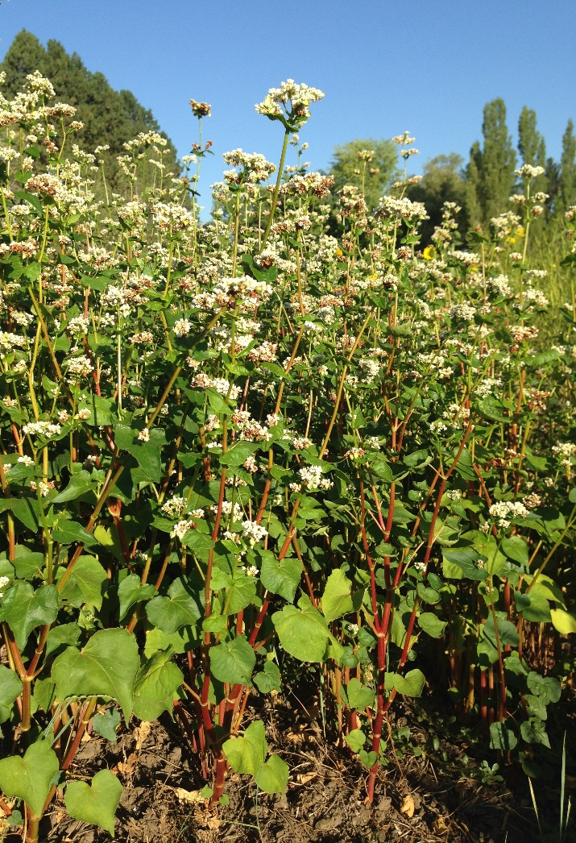

Buckwheat plants. Pamela Pavek, NRCS

***Adaptation***

Buckwheat grows best in soils with light to medium texture and good drainage (Clark, 2007) and will tolerate moderately acidic soils (to a pH of 5) (Myers and Meinke, 1994). It will not grow well in compacted, saturated, or coarse soils and is not tolerant of frost, flooding, soil crusting or extreme drought (Clark, 2007; Bjorkman and

Shail, 2010). Buckwheat is better adapted to low-fertile soils than most other crops (Clark, 2007) and often the residual nutrients from preceding crops are enough for adequate growth (Bjorkman et al., 2008).

### Uses

*Commercial crop:* Buckwheat is a pseudo-cereal processed into products such as breakfast foods, flour and noodles, and is used as stuffing in therapeutic pillows. In 2012, buckwheat was grown as a commercial crop on approximately 33,687 acres throughout the U.S. (National Agricultural Statistics Service, 2012). The majority of those acres (21,270) were in North Dakota. Other buckwheat-producing states include Washington (4,270 acres), Montana (2,816 acres), and New York (1,786 acres) (National Agricultural Statistics Service, 2012).

Buckwheat can provide agronomic benefits to a rotation by breaking up disease cycles, smothering weeds and conserving moisture. Buckwheat uses about half the moisture of soybeans (Myers and Meinke, 1994).

*Livestock forage and feed:* Buckwheat has historically been used as feed for cattle, pigs and chickens (Myers and Meinke, 1994). The grain is high in the amino acid lysine, which is deficient in other grains, but overall it has lower feed value than wheat, oats, barley, rye, or corn (Oplinger et al., 1989). It should be ground and mixed with other grains when fed to livestock, and comprise no more than one-third of the mixture (Morrison, 1936; Oplinger et al., 1989). Buckwheat hay is sometimes used as livestock feed, however it has low forage value (Morrison, 1936; O’Meara, 2011). Buckwheat grain can cause a skin rash in livestock if consumed frequently or in large quantities, (Oplinger et al., 1989) and buckwheat hay can cause intestinal disturbances (Morrison, 1936).

*Green manure and cover crop:*Buckwheat grows in the shortest time period of all cover crops (Bjorkman and Shail, 2010) flowering within 3 to 6 weeks and completely maturing within 11 to 12 weeks (Bjorkman et al., 2008). During its growth period, it reaches a height of 2 to 3 feet, forms a dense canopy, and produces about 2 to 3 tons of biomass per acre (Clark, 2007; Pavek, 2014).

### Because buckwheat grows quickly, it is an excellent suppressor of weeds, and it has been used for this purpose in North America for several centuries. Thomas Jefferson and George Washington corresponded with one another about how well buckwheat suppressed weed growth on their farms, and at that time, the practice had already been used by European settlers for over 150 years (Bjorkman et al., 2008).

### Buckwheat can also be grown as a cover crop to prevent erosion, improve soil aggregate stability, scavenge nutrients such as phosphorus and calcium, and mineralize rock phosphate (Clark, 2007; Bjorkman and Shail, 2010). When buckwheat residue is incorporated into the soil, it rapidly breaks down and releases nutrients for uptake by the subsequent crop (Oplinger et al., 1989). In addition, buckwheat has the potential to suppress root pathogens such as *Thielaviopsis* and *Rhizoctonia* species (Magdoff and van Es, 2009).

### *Pollinator and beneficial insect habitat:* Buckwheat is an excellent plant for bee pasture and insectary gardens (Mader et al., 2011; Lee-Mader et al., 2014). The plants produce numerous, shallow white flowers and abundant nectar, and bloom in the late summer when other plants are no longer blooming (Oplinger et al., 1989). About one acre of buckwheat can provide enough forage for a hive of honey bees, producing about 150 pounds of honey in one season (Oplinger et al., 1989; Myers and Meinke, 1994). The flowers also attract beneficial insects such as parasitic wasps, minute pirate bugs, insidious flower bugs, tachinid flies, ladybeetles and hoverflies, which may prey on insect pests of neighboring crops (Clark, 2007; Bjorkman and Shail, 2010).

*Wildlife habitat:* Buckwheat is sometimes an ingredient in birdseed mixes and planted with other crops for wildlife food plots (Oplinger et al., 1989).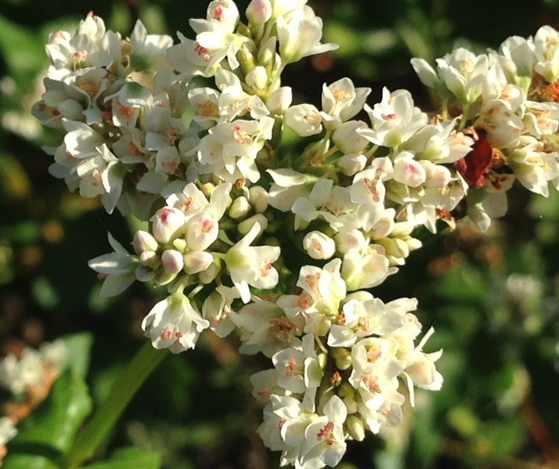

Buckwheat flowers. Pamela Pavek, NRCS.

### Ethnobotany

Buckwheat was one of the first crops domesticated in Asia and was likely used as a food crop in China 5,000 to 6,000 years ago (Meyers and Meinke, 1994). It spread to Europe in the 1400s and was brought to North America by colonists in the 1600s (Berglund, 2003). The plant’s three-sided, angular seed looks like a small beechnut, therefore it was named buckwheat from the Anglo Saxon words *boc* (beech) and *whoet* (wheat) (Berglund, 2003).

### Status

### Please consult the PLANTS Web site (<http://plants.usda.gov/>) and your State Department of Natural Resources for this plant’s current status (e.g., threatened or endangered species, state noxious status, and wetland indicator values).

### Planting Guidelines

Buckwheat should be planted after the risk of frost has passed, and at the appropriate time for its intended purpose. Buckwheat grown for grain harvest should be planted when vegetative growth can occur in warm weather and seed development can occur in cool weather (Berglund, 2003; Bjorkman, 2009). Recommended planting dates vary from late May to mid-June in North Dakota (Berglund, 2003), mid-June to mid-July in New York (Bjorkman, 2009), and mid-July in central Washington (under irrigation). Buckwheat grown as a cover crop can be planted on any date as long as the soil is warm enough for seed germination and there is sufficient time for biomass accumulation.

Buckwheat should be planted with a drill into a firm, weed-free seed bed at a rate of 40 to 60 lb/ac and a depth of 0.5 to 1.5 inches in 6 to 8 inch rows (Clark, 2007; Bjorkman et al., 2008; Bjorkman, 2009). If the seed is broadcast, it should be planted at a rate of 70 to 100 pounds per acre, and the area should be harrowed or culti-packed after broadcasting to attain seed to soil contact. Seeds typically germinate within 3 to 4 days if the soil is warm. Bjorkman et al. (2008) recommend inspecting the field one week after seeding and replanting areas that have gaps more than 1 foot in diameter to minimize weed competition.

### Management

Buckwheat has the potential to fit into many rotations in regions around the country. It can be grown as a cover crop or commercial crop following early-harvested vegetables or grains, and planted for emergency cover if a spring crop fails to establish or if a fall crop planting is delayed. It can also be used as a companion crop or nurse crop of late-fall plantings (Clark, 2007) and for transitioning idle or nutrient-poor fields into production (Bjorkman et al., 2008; O’Meara, 2011).

Buckwheat can be included in cover crop mixes with cow peas, soybeans, sunn hemp, or other warm-season annuals. In trials in the Inland Pacific Northwest, buckwheat grew well when planted in a warm-season cover crop mix with sorghum, sorghum-sudangrass, millet, safflower and sunflower (Pavek, 2014).

The nutrient requirements of buckwheat are low. A crop that yields 960 lb/acre of grain will remove about 25 lb of N, 15 lb of P2O5 and 20 lb of K2O from the soil (Bjorkman, 2009). Excess nitrogen may increase weed pressure, promote vegetative growth, cause lodging, and reduce yields. Fertilizer applications should be based on soil test results. In addition, soil tests should be conducted before the next crop is grown, particularly if buckwheat grain and residue are removed from the field, since buckwheat can remove phosphorus and calcium from the soil.

Buckwheat grown as a cover crop should be mowed no more than 10 days after plants begin to flower (about 4 to 7 weeks after planting) to prevent the plants from reseeding and becoming a weed (Bjorkman et al., 2008; Magdoff and van Es, 2009). Buckwheat grown for beneficial insect habitat should be allowed to flower for at least 20 days, the time needed for minute pirate bugs to produce a new generation (Clark, 2007). Buckwheat can also be grown to maturity and harvested for grain or left to reseed the field.

Buckwheat is easily killed by mowing or frost. Residue breaks down quickly, therefore another crop should be planted as soon as possible to cover the soil (Myers and Meinke, 1994; Clark, 2007).

### Pests and Potential Problems

Few insect or disease pests affect buckwheat (Clark, 2007). Some of the worst pests in the Northeast are deer and turkeys that forage on young buckwheat plants (Bjorkman, 2009). Buckwheat has the potential to attract tarnished plant bugs, lygus bugs and aphids; however, these may serve as a food source for the beneficial insects buckwheat also attracts (Bjorkman and Shail, 2010). Plants may harbor root lesion nematodes (*Pratylynchus penetrans*), andbe susceptible to leaf spot (*Ramularia* sp.), root rot (*Rhizoctonia* sp.) (Clark, 2007), aster yellows (aster yellows phytoplasma (AYT)), powdery mildew (*Erysiphe polygoni*), and sclerotinia stem rot (*Sclerotinia* sp.) diseases (Bjorkman, 2009).

Buckwheat may be negatively affected by residual herbicides from applications to the preceding crop. Bjorkman et al. (2008) recommend not planting buckwheat as a cover crop following crops that had applications of atrazine, imazethapyr, halosulfuron, or fomesafen.

### Environmental Concerns

Buckwheat can become a weed if seeds are allowed to mature in the field.

In states where wheat is produced for export to Japan and other Asian countries, efforts are being made to eliminate buckwheat in and around wheat growing areas due to concerns about buckwheat contamination in wheat shipments. Japan has strict labeling laws that require buckwheat to be listed as an ingredient because some people are susceptible to buckwheat allergies, similar to peanut allergies in the U.S. The NRCS recommends buckwheat should not be planted in rotation with or adjacent to commodity wheat production that will be planted to wheat within 2 calendar years after planting buckwheat in the states of Colorado, Kansas, Minnesota, Montana, Nebraska, North Dakota, Oregon, South Dakota, Washington and Wyoming. Buckwheat can still be planted for commercial and conservation purposes in these states where commodity wheat is not grown.

### Seeds and Plant Production

Buckwheat plants begin to flower within 3 to 6 weeks after planting and flower continuously for several weeks. Flowers are self-sterile and require pollination by insects or wind for fertilization (Myers and Meinke, 1994). Seeds mature 10 days after flowering and shatter (fall off the plant) soon after maturing, which reduces yields and causes potential volunteer problems the following year. Seeds are dark brown, triangular and about the size of a soybean. There are approximately 20,000 seeds per pound.

In addition to indeterminate seed set and shattering, harvest may also be complicated by plant lodging, which happens when the seed heads become heavy or if there are occurrences of wind or stem rot (Bjorkman, 2010).

The best method for harvesting buckwheat is by windrowing or swathing (Bjorkman, 2010). Plants should be cut and windrowed when three fourths of the seed are brown and hard, and laid on 12 inch high stubble for good air circulation. Some of the immature seed will ripen while drying. After 7 to 10 days the windrows can be combined. Buckwheat can also be direct combined if most of the leaves have dropped or have been killed by frost (Bjorkman, 2010).

Seed may be cracked during threshing, therefore Berglund (2003) advises setting the combine cylinder speed at 600 to 800 rpm or lower, and widening the concave clearance if necessary. Buckwheat seed can be stored long-term at 13% moisture (Berglund, 2003).

Typical buckwheat yields range from 720 lb/ac in New York (Bjorkman, 2010) to 1,200 lb/ac in Missouri (Myers and Meinke, 1994), and 1,900 lb/ac in Washington State with irrigation (Risk Management Agency, 2012). Yields are often reported in bushels; buckwheat has 48 lb/bu.

### Cultivars, Improved, and Selected Materials (and area of origin)

The most popular buckwheat varieties in the U.S. differ by region. The variety is usually specified by a processor if the crop is contracted. Buckwheat grown as a cover crop is often planted with common seed (no specified variety).

**‘Horizon’** is a large seeded variety that has produced high yields in trials in North Dakota and Canada.

**‘Koma’** is a large seeded variety that often yields higher than ‘Mancan’.

**‘Koto’** buckwheat was released in 2002 by Cornell University and Kade Research, in a project funded by Birkett Mills. It typically out-yielded ‘Manisoba’ by 13% in New York trials and is more stress tolerant (Bjorkman, 2009).

**‘Kuekett’** is a new variety licensed to Birkett Mills. It is currently being bulked up for commercial trials in the Northeast.

**‘Mancan’** is a large seeded variety that is commonly grown throughout the U.S.

**‘Manisoba’** remains one of the most commonly grown varieties in the Northeast. It out-yielded ‘Manor’ by 10% in New York trials (Bjorkman, 2009).

**‘Manor’** was the dominant variety grown in the Northeast throughout the 1990s. It has a large seed which is required by processors.

**‘Springfield’** is a large-seeded variety that has yielded high in North Dakota trials.

Other buckwheat cultivars include: **‘Pennquad’, ‘Tempest’, ‘Tokyo’,** and **‘Winsor Royal’**.

Cultivars should be selected based on the local climate, resistance to local pests, and intended use. Consult with your local land grant university, local extension or local USDA NRCS office for recommendations on adapted cultivars for use in your area**.**

**Literature Cited**

Berglund, D.R. 2003. Buckwheat Production. North Dakota State University Extension Service Bulletin A687. Available at http://www.ag.ndsu.edu/pubs/plantsci/crops/a687.pdf (accessed 15 Sept 2014). North Dakota State University, Fargo, ND.

Bjorkman, T. 2009. Buckwheat Production Guide for the Northeast. Available at http://www.hort.cornell.edu/bjorkman/lab/buck/guide/main.php (accessed 15 Sept 2014). Cornell University, Ithaca, NY.

Bjorkman, T. 2010. Buckwheat Production: Harvesting. Cornell University Cooperative Extension Agronomy Fact Sheet Series: Fact Sheet 51. Available at http://nmsp.cals.cornell.edu/publications/factsheets/factsheet51.pdf (accessed 4 Sept 2014). Cornell University, Ithaca, NY.

Bjorkman, T., R. Bellinder, R. Hahn, and J.W. Shail, Jr. 2008. Buckwheat Cover Crop Handbook. Available at http://www.hort.cornell.edu/bjorkman/lab/covercrops/pdf/bwbrochure.pdf (accessed 7 Aug 2014). Cornell University Cooperative Extension, Geneva, NY.

Bjorkman, T. and J.W. Shail. 2010. Cover Crop Fact Sheet Series: Buckwheat. Available at http://covercrops.cals.cornell.edu/pdf/buckwheatcc.pdf (accessed 7 Aug 2014). Cornell University Cooperative Extension, Ithaca, NY.

Clark, A. (ed.) 2007. Managing Cover Crops Profitably. 3rd ed. Sustainable Agriculture Research and Education (SARE) Handbook Series, bk 9. Sustainable Agriculture Research and Education, College Park, MD.

Lee-Mader, E., J. Hopwood, L. Morandin, M. Vaughan, and S. H. Black. 2014. Farming with Native Beneficial Insects. Storey Publishing, North Adams, MA.

Mader, E. M. Shepherd, M.Vaughan, S.H. Black, and G. LeBuhn. 2011. Attracting Native Pollinators. Storey Publishing, North Adams, MA.

Magdoff, F. and H. van Es. 2009. Building Soils for Better Crops: Sustainable Soil Management. 3rd ed. Sustainable Agriculture Research and Education (SARE) Handbook Series bk 10. Sustainable Agriculture Publications, Waldorf, MD.

Morrison, F.B. 1936. Feeds and Feeding: A Handbook for the Student and Stockman. 20th ed. The Morrison Publishing Company, Ithaca, NY.

Myers, R.L. and L.J. Meinke. 1994. Buckwheat: A multi-purpose, short-season alternative. University of Missouri Extension Bulletin G4306. Available at: http://extension.missouri.edu/publications/DisplayPub.aspx?P=G4306 (accessed 4 Sept 2014). University of Missouri, Columbia, MO.

National Agricultural Statistics Service. 2012. 2012 Census of Agriculture – State Data. Available at http://www.agcensus.usda.gov/Publications/2012/Full_Report/Volume_1,_Chapter_2_US_State_Level/st99_2_025_025.pdf (accessed 15 Sept 2014). USDA – National Agricultural Statistics Service, Washington, DC.

O’Meara, J. 2011. Buckwheat hay – a quality feed for dairies in the Northeast? 2011 Sustainable Agriculture Research and Education (SARE) Final Report. Project Number FNE10-698. Available at http://mysare.sare.org/mySARE/ProjectReport.aspx?do=viewRept&pn=FNE10-698&y=2011&t=0 (accessed 7 Aug 2014). Sustainable Agriculture Research and Education, College Park, MD.

Oplinger, E.S., E.A. Oelke, M.A. Brinkman and K.A. Kelling. 1989. Alternative Field Crops Manual: Buckwheat. Available at http://www.hort.purdue.edu/newcrop/afcm/buckwheat.html (accessed 15 Sept 2014). Purdue University, West Lafayette, IN.

Pavek, P.L.S. 2014. Evaluation of Cover Crops and Plantings Dates for Dryland Eastern Washington Rotations. Plant Materials Technical Note No. 25. United States Department of Agriculture – Natural Resources Conservation Service. Spokane, WA.

Risk Management Agency. 2012. 2013 Commodity Insurance Fact Sheet: Buckwheat: Washington. Available at http://www.rma.usda.gov/fields/wa_rso/2013/buckwheat.pdf (accessed 4 Sept 2014). United States Department of Agriculture – Risk Management Agency, Spokane Valley, WA.

### Citation

Pavek, P.L.S. 2016. Plant Guide for buckwheat (*Fagopyrum esculentum*). USDA-Natural Resources Conservation Service, Pullman Plant Materials Center. Pullman, WA.

Published September 2014, Revised March 2016

Edited: 18Sept2014 aym; 23Sept2014 rg; 23Sept 2014 plsp; 24Mar2016 plsp; 25Mar2016 je; 28Mar2016 jd

For more information about this and other plants, please contact your local NRCS field office or Conservation District at <http://www.nrcs.usda.gov/> and visit the PLANTS Web site at <http://plants.usda.gov/> or the   
Plant Materials Program Web site:

<http://plant-materials.nrcs.usda.gov>.

PLANTS is not responsible for the content or availability of other Web sites.

The U.S. Department of Agriculture (USDA) prohibits discrimination against its customers, employees, and applicants for employment on the bases of race, color, national origin, age, disability, sex, gender identity, religion, reprisal, and where applicable, political beliefs, marital status, familial or parental status, sexual orientation, or all or part of an individual's income is derived from any public assistance program, or protected genetic information in employment or in any program or activity conducted or funded by the Department. (Not all prohibited bases will apply to all programs and/or employment activities.)

If you wish to file an employment complaint, you must contact your agency's [EEO Counselor](http://www.ascr.usda.gov/doc/EEO_Counselor_List.pdf) (PDF) within 45 days of the date of the alleged discriminatory act, event, or in the case of a personnel action. Additional information can be found online at <http://www.ascr.usda.gov/complaint_filing_file.html>.

If you wish to file a Civil Rights program complaint of discrimination, complete the [USDA Program Discrimination Complaint Form](http://www.ocio.usda.gov/sites/default/files/docs/2012/Complain_combined_6_8_12.pdf) (PDF), found online at <http://www.ascr.usda.gov/complaint_filing_cust.html>, or at any USDA office, or call (866) 632-9992 to request the form. You may also write a letter containing all of the information requested in the form. Send your completed complaint form or letter to us by mail at U.S. Department of Agriculture, Director, Office of Adjudication, 1400 Independence Avenue, S.W., Washington, D.C. 20250-9410, by fax (202) 690-7442 or email at [program.intake@usda.gov](mailto:program.intake@usda.gov).

Individuals who are deaf, hard of hearing or have speech disabilities and you wish to file either an EEO or program complaint please contact USDA through the Federal Relay Service at (800) 877-8339 or (800) 845-6136 (in Spanish).

Persons with disabilities who wish to file a program complaint, please see information above on how to contact us by mail directly or by email. If you require alternative means of communication for program information (e.g., Braille, large print, audiotape, etc.) please contact USDA's TARGET Center at (202) 720-2600 (voice and TDD).

For any other information dealing with Supplemental Nutrition Assistance Program (SNAP) issues, persons should either contact the USDA SNAP Hotline Number at (800) 221-5689, which is also in Spanish or call the [State Information/Hotline Numbers](http://www.fns.usda.gov/snap/contact_info/hotlines.htm).

For any other information not pertaining to civil rights, please refer to the listing of the [USDA Agencies and Offices](http://www.usda.gov/wps/portal/usda/usdahome?navtype=MA&navid=AGENCIES_OFFICES_C) for specific agency information.

***Helping People Help the Land***

**USDA IS AN EQUAL OPPORTUNITY PROVIDER AND EMPLOYER**