

Plant Guide

# mountain Rough fescue

## Festuca campestris Rydb.

Plant Symbol = FECA4

*Contributed by*: USDA NRCS WA PM Program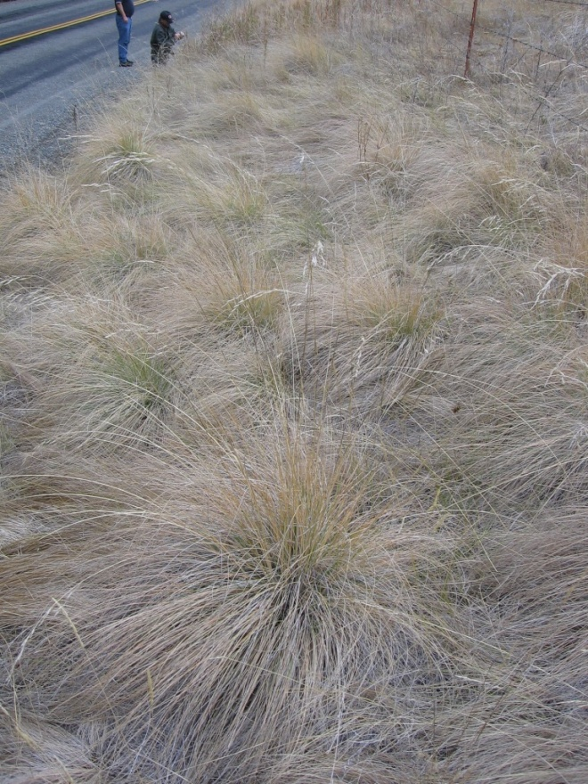

. Mountain Rough Fescue, photo by Francis Njenga

### Alternate Names

Rough Fescue

Buffalo Bunchgrass

Previously known as *Festuca scabrella*, the currently accepted name is *Festuca campestris*

### Uses

Grasslands dominated by rough fescue are some of the most productive grasslands in Canada ( Aiken and Darbyshire 1990, MSU EB69).

*Livestock:* Rough fescue is highly palatable to livestock. It is excellent forage for cattle and horses and good for sheep and wildlife during all growth stages. It produces good hay and is valuable for winter grazing because it retains much of its protein and palatability (Stubbendieck, et.al 2003).

*Wildlife* - Rough fescue is an important source of forage for mule deer and bighorn sheep. It is used by elk on winter ranges (Jourdonnais and Bedunah 1986), although, elk will avoid plants with large amounts of old litter. Sharp-tailed grouse often nest under clumps of rough fescue in northwestern Montana (Giesen and Connelly 1993).

### Status

Please consult the PLANTS Web site and your State Department of Natural Resources for this plant’s current status (e.g., threatened or endangered species, state noxious status, and wetland indicator values).

### Description

*General*: Grass family (Poaceae). Rough fescue is a native, perennial, cool-season bunchgrass. Individual rough fescue plants often form large-diameter bunches averaging 12 – 14 inches in diameter, sometimes as large as 2 feet. *Festuca campestris* culms are erect, 1 to 4.5 ft. tall, glabrous, scabrous, naked below the panicle, and purplish at the base. Leaves are basal 12-30 inches long, 0.03-0.08 inches in diameter, folded, mostly erect, stiff, and pointed. Lower surface of the leaves are often scabrous. Sheaths are closed for less than 1/3 their length and are often persistent. Inflorescences are panicles, generally 3.5-7 inches long, open or loosely contracted, with usually 2 branches per node. The branches are erect to stiffly spreading. Spikelets are 0.3-0.5 inches long and have 3-7 florets. Glumes are exceeded by the upper most florets. Lemmas are 0.25-0.40 inches long with either a sharp point or short awn ( Anderton and Barkworth 2009, Stubbendieck, Hatch, and Landholt 2003). In the fall mountain rough fescue often has a creamy colored appearance when compared with bluebunch wheatgrass (*Pseudoregneria spicata*).

Prior to 1984 *Festuca campestris*, *F. hallii, F. altaica* were often treated collectively as *F. scabrella*. Today *Festuca campestris* is generally regarded as a species separate from *F. hallii* and *F. altaica*. *Festuca campestris* has double the chromosome number of the other two species. (Pavlick and Looman 1984, Aiken and Darbyshire 1990).

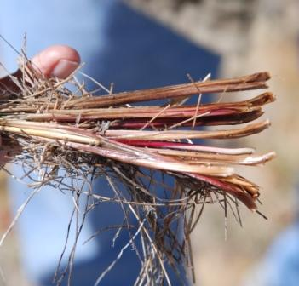

*2*. Clums are often purplish near the base.

*Distribution*: *Festuca campestris’s*  range is from southern British Columbia, Alberta, and southwestern Saskatchewan south through Washington, Oregon, Idaho and Montana. It is more common north of 48 degrees latitude in eastern Washington and north of 46 degrees latitude and west of the continental divide in Montana and northern Idaho (Mueggler, and Stewart 1980). *Festuca campestris* overlaps with plains rough fescue (*Festuca hallii)*  in parts of the Rocky Mountains (Pavlick and Looman 1984).

For current distribution, please consult the Plant Profile page for this species on the PLANTS Web site.

*Habitat*:*Festuca campestris* occurs in grass dominated and shrub dominated plant communities. It also can occur in ponderosa pine woodlands, open ponderosa pine forests, subalpine forests, and in grassy areas within forests. Rough fescue occurs in valleys, on benches, in foothills, and in mountains. When growing in close proximity with bluebunch wheatgrass, mountain rough fescue will usually be on the deeper more fertile soil and bluebunch will be on the more shallow, less fertile soils. On the steppes of Washington, *Festuca campestris* is often associated with Idaho fescue/sulphur flower (*Eriogonum heracleoides*) and Idaho fescue/common snowberry (*Symphoricarpos albus*) habitat types (Daubenmire, R. 1970).

**Adaptation**

*Festuca campestris* is a cool-season grass adapted to mesic cool sites which have a minimum 90 frost –free days during the growing season (USDA NRCS 2005). Coldest month mean temperatures range between -3 and -10 degrees C (14 – 26 degrees F.). Average warmest month temperatures range between 14 and 18 degrees C. (57 – 64 degrees F.) (Anderson. D. G. 2006). *Festuca campestris* occurs in areas receiving 15 inches to 24 inches of precipitation annually. It grows on a wide variety of soil parent materials. Soils are typically loamy and are moderately deep to deep. Rough fescue requires moist soil, therefore, it is most commonly found on north-and east-facing slopes in the foothills region of the northern Rocky Mountains (Stout et al. 1981). *Festuca campestris* occurs on more mesic and cooler sites than the other two subspecies (Aiken and Darbyshire 1990). It occurs at elevations from 2,800 to 9,500 ft.. At lower elevations (< 3,600 ft.) in Washington state *Festuca campestris* tends to remain a minor component in the community. At elevations above 3,600 ft. it may be the dominate grass in the plant community.

### Establishment

Rough fescue typically initiates growth immediately following snowmelt, completes growth before the onset of summer drought, and is dormant by October. Onset of growth in the spring appears to be controlled by soil temperature rather than soil water content or air temperature (Stout et al. 1981). In Alberta Johnston and MacDonald observed that growth began in early May when soil temperatures were 35.6o Fahrenheit (2oC) at 8 inches (20 cm). Flowering occurs from mid-May to mid-June, with seed dispersal in mid to late July. Summer growth cessation is controlled primarily by available water (Stout, McLean, and Quinton 1981). Fall regrowth may occur if significant moisture is present. As with most grasses pollen is dispersed by wind. Seed is dispersed by wind and animals.

Planting methods specifically for *Festuca campestris* have yet to be established. Tried and true methods commonly used for other native, perennial, cool season bunchgrasses with a seed size of 205,000 seeds/lb should work for *Festuca campestris* as well.

Seed with a drill at a depth of ¼ to ½ inch depending on soil texture, coarse soils deeper, fine textured soils shallower. The single species seeding rate recommended would be about 5 pounds Pure Live Seed (PLS) or about 23 PLS per square foot. If used as a component of a mix, adjust to percent of mix desired, for broadcast plantings seed at a rate of 40 to 50 PLS per square foot. A clean, firm, weed free seedbed is required for establishment.

Seed in very early spring on heavy to medium- textured soils and in late fall on medium to light- textured soils. Late summer (August to mid- September) seeding is not recommended unless irrigation is available. Dormant fall seedings will pre-chill seed and may improve germination.

### Management

*Grazing* – Rough fescue is tolerant of winter grazing (Johnston and MacDonald 1967; Willms, Adams, Dormaar 1996). Approximately 80% utilization can occur during dormancy without any appreciable loss in summer vigor (Jourdonnais and Dedunah 1986). Fall or winter grazing is the most sustainable us of rough fescue grasslands (Willms 1991). Plains and mountain rough fescue are described as “sensitive” to summer grazing (King, Hill, Willms 1998). Studies in Canada concluded that heavy grazing (above 2.4 AUM per hectare) jeopardizes fescue grassland ecosystem sustainability by reducing fertility and water-holding capacity. Even light grazing (1.2 AUM per hectare) during the summer causes rough fescue to decline (Dormaar and Willms 1998). Rough fescue is considered an “ice-cream” plant to livestock and, if improperly managed, can easily be grazed out of a community (Tucker, R., personal communication). Soil disturbance by grazing is likely to result in a seral community dominated by annual forbs (Willms and Quinton 1995). Grazing increased the germination of seed and the vegetative expansion of Kentucky bluegrass in rough fescue grassland (Willms and Quinton 1995). Deferred-rotation and rest-rotation systems of grazing are recommended for rough fescue-dominated grasslands in Montana.

### Pests and Potential Problems

Primary pests of *Festuca campestris* are grasshoppers and rodents. Johnston and MacDonald 1967, noted injury to *F. campestris* reproductive culms by eriophyid mites. Feeding by these mites causes a constricted brownish region to develop at the upper node. The condition is called silver top because the inflorescence has a bleached appearance. Also *F. campestris* is likely susceptible to pathogenic or decay fungi that affects other fescues.

### Environmental Concerns

*Fire* –The response of rough fescue to fire is complex, and fire cannot be considered purely beneficial or detrimental to grasslands dominated by this species. The effect of fire on rough fescue varies according to stage of growth and season burned. Most plants survive fires that occur during dormancy or under the high-moisture conditions often associated with spring and fall burning. Timing prescribed burns appears to be critical. Rough fescue production did not change after a spring or fall burn provided the plants were dormant. Spring burning when plants were actively growing caused a decrease in coverage for at least 3 years (Bailey and Anderson 1978).

Rough fescue is vulnerable to altered fire regimes.

Fire damage can be particularly severe and mortality can occur on sites where reduced fire frequencies have produced heavy litter buildups within large-diameter rough fescue crowns (Antos, McCune, and Bara 1983). Fire suppression has been implicated in the spread of woody species in to meadows and prairies. In parts of Montana large areas of grasslands have been invaded by Douglas-fir, causing reductions in rough fescue dominance (Arno and Gruell 1986).

*Weeds* – Grasslands dominated by rough fescue and plains rough fescue can be susceptible to weed invasion. Weeds that have been know n to invade rough fescue grasslands include leafy spurge (*Euphorbia esula*), Dalmatian toadflax (*Linaria dalmatica*), St. Johnswort (*Hypericum perforatum*), and spotted knapweed (*Centaurea maculosa*). Smooth brome (*Bromus inermis*) can be invasive and may invade rough fescue communities as well.

### Seeds and Plant Production

### Rough fescue reproduces primarily by seed (USDA Plants Database) and rarely produces rhizomes (Pavlick and Looman 1984). On average there are 205,300 rough fescue seeds per pound. It produces seed erratically and several years may pass without appreciable seed set. Cultivated seed production has resulted in average production of 100 pounds per acre or less (MSU EB 69). The germination rate of seeds of rough fescue is relatively high, ranging from 86 to 97 percent (Johnston and MacDonald 1967). For plains rough fescue germination is highest at constant temperatures of 15 and 20o C, but seeds germinate over a wide range of temperatures. Osmotic potential accounts for much of the variation in germination and declining osmotic potentials severely restrict germination. Rough fescue (plains) is best planted in the spring when temperatures are rising and soil moisture is highest (Romo, Grilz, Bubar, and Young need year). Bailey and Anderson (1978) observed reductions in seed production following spring burning. Fall burning did not affect seed head development the following year. USDA NRCS 2005 Plants Database) describes seedling vigor as medium. Most fescues are obligate outcrossers. Cold stratification is not required for seed germination.

### Cultivars, Improved, and Selected Materials (and area of origin)

#### These plant materials are not available from commercial sources. Seed is currently available from field collections only (USDA Plants Database).

### References

Aiken, S. G. and S. J. Darbyshire. 1990. Fescue grasses of Canada. Publication 1844/E. Ottawa, ON: Agriculture Canada, Research Branch.

Antos, Joseph A., Bruce McCune, and Cliff Bara. 1983. The Effect of Fire on an ungrazed Western Montana Grassland. American Midland Naturalist 110(2): 354-364.

Arno, Stephen F. and George E. Gruell. 1986. Douglas-fir Encroachment into Mountain Grasslands in Southwestern Montana. Journal of Range Management 39(3): 272-276.

Arno, Stephen F. and George E. Gruell. 1983. Fire History at the Forest-Grassland Ecotone in Southwestern Montana. Journal of Range Management 36(3):332-336.

Bailey, Arthur W., and Murray L. Anderson. 1978. Prescribed Burning of a *Festuca-Stipa* Grassland. Journal of Range Management 31(6) 446-449.

Daubenmire, R. 1970. Steppe vegetation of Washington. Washington Agriculture Experiment Station Technical Bulletin 62. 131 p.

Dormaar, Johan F. and Walter D. Willms. 1998. Effect of forty-four years of grazing on fescue grassland soils. Journal of Range Management 51(1): 122- 126.

Giesen, Kenneth M., and John W. Connelly. 1993. Guidelines for management of Columbian sharp-tailed grouse habitat. Wildlife Society Bulletin. 21: 325-333.

Anderton, Laurel K., and Mary E. Barkworth. 2009. Grasses of the Intermountain Region. Intermountain Herbarium, Utah State University, Logan, Utah.

Hodgkinson, Harmon S., and Alfred E. Young. 1973. Rough Fescue (*Festuca scabrella* Torr.) in Washington. Journal of Range Management 26(1):25-26.

Johnston A. and M.D. MacDonald. 1967. Floral Initiation and Seed Production in *Festuca Scabrella* Torr. Canadian Journal of Plant Science Vol. 47: 577-583.

Jourdonnais, Craig and Don Bedunah. 1986. Burning issues of the Sun. Montana Outdoors 17(6): 15-17.

Kaldy M.S., A. Johnston and S. Smoliak. 1980. Amino Acid Composition of Rough Fescue. Journal of Range Mangement 33(4): 295-296.

King, J.R., M.J. Hill, and W.D. Willms. 1998. Temperature effects on regrowth of 3 rough fescue species. Journal of Range Management 51(4): 463-468.

Montana State University Extension Service. Montana Interagency Plant Materials Handbook EB 69. June 1990.

Mueggler, W.F., and W.L. Stewart. 1981. Forage Production of Important Rangeland Gabitat Types in Western Montana. Journal of Range Management 34(5): 347-353.

Pavlick, Leon E. and J. Looman. 1984. Taxonomy and nomenclature of rough fescues, Festuca altaica, F. campestris (F. scabrella var. major) and F. hallii in Canada and the U.S. Canadian Journal of Botany. 62: 1739-1749.

Romo, J.T., P.L. Grilz, C.J. Bubar, and J.A. Young. 1991. Influences of Temperature and Water Stress on Germination of Plains Rough Fescue. Journal of Range Mangement 44(1):75-81.

Stout, Darryl G., Alastair McLean, and Dee A. Quinton. 1981. Growth and Phenological Development of Rough Fescue in Interior British Columbia. Journal of Range Management 34(6): 455-459.

Stubbendieck, James, Stephan L. Hatch, and L.M. Landholt. 2003. North American Wildland Plants, A Field Guide. University of Nebraska Press.

USDA NRCS. 2005. Plants Database. Available at [www.plants.usda.gov](http://www.plants.usda.gov)

Willms, Walter D. 1991. Cutting frequency and cutting height effects on rough fescue and Parry oat grass yields. Journal of Range Management 44(1):

Willms, Walter D. and David Chanasyk. 2006. Grazing Effects on Snow Accumulation on Rough Fescue Grasslands. Rangeland Ecology & Management 59(4):400-405.

Willms, W.D., and D.A. Quinton. 1995. Grazing effects on germinable seeds on the fescue prairie. Journal of Range Management 48(5):423-430.

**Prepared By**: *Richard Fleenor,* USDA NRCS Plant Materials Program, Spokane WA

### Citation

Fleenor, Richard A. 2011. Plant Guide for mountain rough fescue (*Festuca campestris)*. USDA-Natural Resources Conservation Service, Spokane, WA 99201

Published: July, 2011

For more information about this and other plants, please contact your local NRCS field office or Conservation District at <http://www.nrcs.usda.gov/> and visit the PLANTS Web site at <http://plants.usda.gov/> or the Plant Materials Program Web site <http://plant-materials.nrcs.usda.gov>.

PLANTS is not responsible for the content or availability of other Web sites.

**USDA IS AN EQUAL OPPORTUNITY PROVIDER AND EMPLOYER**