

Plant Guide

# SHEEP FESCUE

## Festuca ovina L.

Plant Symbol = FEOV

Contributed By:USDA, NRCS, Idaho and Washington Plant Materials Staff and the National Plant Data Center

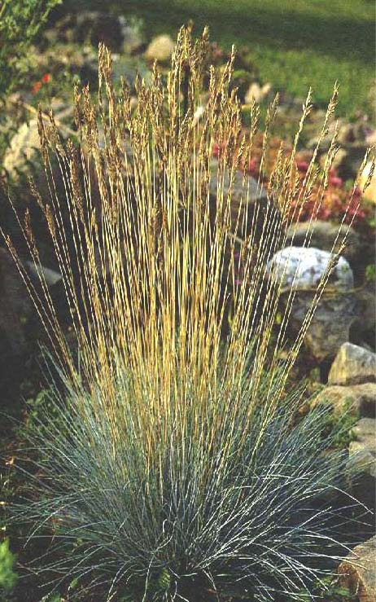

**Figure 1. Sheep fescue in xeriscape garden. D. Ogle, NRCS, ID**

**Alternate names**

Often confused with Idaho fescue in the northwestern U.S. and with Arizona fescue in southwestern U.S.

**Uses**

*Grazing/range/pasture*: In rangeland and pastureland plantings, sheep fescue is a competitive understory grass that controls erosion. Although it is sometimes grazed by sheep, it is seldom utilized by cattle or horses and is not considered to be an important forage species.

*Hay:* Due to its short dense tufts, it is not a good species for hay production.

*Wildlife:* Sheep fescue provides very little cover for hiding or nesting habitat.

*Erosion control/reclamation*: The primary use of sheep fescue is ground cover. It is ideal for stabilization of disturbed soils because of its dense root system. Its low growth form and low maintenance requirements make it ideal for ground cover purposes.

It is commonly used to protect roadsides, airport landing strips, industrial and residential areas, ditch and canal banks, skid trails, clear cuts, ski hills, camp sites and other recreation areas from erosion. It provides excellent cover and erosion control in areas between trees rows of shelterbelts, windbreaks and tree farms.

Sheep fescue withstands moderate equipment traffic and requires minimal maintenance. This makes it useful in vineyards, orchards, and farm equipment yards.

Its good drought tolerance combined with strong bunch type root systems and adaptations to a variety of soils make this species ideal for reclamation in areas receiving 12 to 24 inches annual precipitation. This grass can be used in areas where irrigation water is limited to provide ground cover.

*Weed control:* Sheep fescue is an excellent weed control species because it has an extensive and dense bunch type root system. Once a good stand is established, it excludes the invasion of most weeds.

**Status**

Consult the PLANTS Web site and your State Department of Natural Resources for this plant’s current status such as state noxious status and wetland indicator values.

**Description**

*General*: Grass Family (Poaceae). Sheep fescue *Festuca ovina* L. is an extremely variable cool season grass. It is native to Europe, Asia and North America.

In the western United States, sheep fescue is often confused with Arizona fescue in the southwest and Idaho fescue in the northwest. Historically almost all fine leaved, non rhizomatous fescues were identified as *F. ovina*. Many of these specimens have been re-identified as other species (Barkworth 2007). The PLANTS web site indicates *F. ovina* has been mis-applied to specimens of *F. brachypyhlla* Schult ex Schult. & Schult *F. ssp brachyphylla* and *F. brevipila* Tracy, (*F. trachyphylla* (Barkworth 2007) ), *F. trachyphylla,* like *F. ovina* is native to Europe while *F. brachyphylla ssp. brachyphylla* is circumpolar with North American representatives (Barkworth 2007).

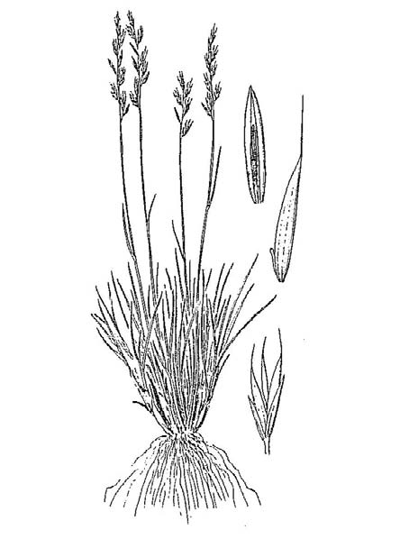

**Figure 2. Sheep Fescue Plant Guide. Idaho, 1982.**

Sheep fescue is a densely tufted, cool season, dwarf bunchgrass. Its numerous basal leaves are narrow, involute, stiff, semi-erect and short, 4 to 8 in (10 to 20 cm) and less than half the culm length. Plants are short, 12 in (less than 30 cm), with numerous fine stiff to semi erect stems.

The panicle is narrow, dense, nearly spike-like in appearance and protrudes well above the basal leaves on stiff naked culms. They are about 4 in (10 cm) long with 4 to 5 flowers per spikelet. The seed is tipped with 1/8 to 1/4 in (3 to 6 mm) awns. The

slightly unequal glumes persist after seed shatter (Cronquist et al., 1977).

**Distribution**

Sheep fescue, *F. ovina*, is a cool season perennial grass native to Europe (Barkworth 2007.) Within North America, sheep fescue can be found in open forests and mountain and foothill slopes from Alaska to North Dakota and south to Arizona and New Mexico. It has also been introduced to many additional locations in eastern North America.

For current distribution, consult the Plant Profile page for this species on the PLANTS Web site.

**Adaptation**

Sheep fescue occupies diverse habitats. Collections show altitudinal variation in habitat extending from 1000 to 13,000 ft (300 to 4,000 m). Although it may be found at any elevation between these extremes, it is most prevalent from about 3,000 to 8,000 ft (915 to 2440 m). It grows on all exposures in a wide variety of soil conditions. It is best adapted to silt loam or sandy loam soils and is occasionally found on loamy sand soils. It also tolerates shallow, dry, gravelly soils. Common habitats are exposed bench lands, hillsides and ridges, parks, meadows, forestlands, and open ponderosa and lodgepole pine stands. It is also tolerant of weakly saline to alkaline and acidic soil conditions.

It has excellent cold tolerance, good drought tolerance, and moderate shade tolerance. It is more drought tolerant than Idaho fescue and hard fescue. Sheep fescue is best adapted to 12 inch plus precipitation zones. It is fairly tolerant of fire in autumn, but requires 2 to 3 years to fully recover after burning. It is not tolerant of high water tables or flooding. It is often found in association with big bluegrass, mountain brome, bluebunch wheatgrass, slender wheatgrass, geranium, western yarrow, mountain big sagebrush, antelope bitterbrush and ponderosa pine.

**Establishment**

*Planting*: Sheep fescue seed should be planted with a drill to a depth of 1/4 inch or less. The single species seeding rate is 4 pounds Pure Live Seed (PLS) or about 60 PLS per square foot (Ogle et al., 2009). If used as a component of a mix, adjust to percent of mix desired. When broadcast planting seed and for harsh critical planting areas, the seeding rate should be increased to 8 pounds PLS or 120 PLS per square foot. Mulching and irrigation during the establishment year are beneficial for stand establishment.

The best seeding results are obtained from seeding in very early spring on heavy to medium textured soils or in late fall on medium to light textured soils. Late summer (August - mid September) seedings are not recommended unless irrigation is available. Seedling vigor is good; stands are generally slow to develop and seedlings may be very hard to find the establishment year.

It should not be planted with aggressive introduced grasses, but is very compatible with slower developing natives such as bluebunch wheatgrass (*Pseudoroegneria spicata*), thickspike wheatgrass (*Elymus lanceolatus* ssp. *lanceolatus*), streambank wheatgrass (*Elymus lanceolatus* ssp. *psammophilus*), big bluegrass (*Poa secunda)* and needlegrass species (*Achnatherum* spp., *Hesperostipa* spp., *Nassella* spp., *Stipa* spp., and *Ptilagrostis* spp.).

Stands may require weed control measures during establishment, but application of broadleaf herbicides such as 2,4-D should not be made until plants have reached the four to six leaf stage. Mow above seedlings when weeds are beginning to bloom to reduce weed seed production. Grasshoppers and other insects may damage new stands and use of insecticides may be required. Be sure to read and follow label directions.

**Management**

Sheep fescue “greens up” in March to early April and matures in late June to mid-July. It is a cool season plant; therefore it produces most of its growth in the spring and again in the fall, if moisture is available. Growth during the summer is minimal and dependant on precipitation or irrigation.

Sheep fescue is a low maintenance plant requiring little additional treatment or care. Its primary pests include grasshoppers. It is resistant to common turf diseases.

**Environmental Concerns**

Sheep fescue hybridizes with Idaho and western fescue resulting in somewhat larger plants. It is long-lived, spreads primarily via seed distribution. It is not considered "weedy", but can spread into adjoining vegetative communities under ideal climatic and environmental conditions.

**Seed Production**

Seed production of sheep fescue has been very successful under cultivated conditions. Row spacing of 24 to 36 inches are recommended and it should be cultivated and maintained in rows.

Seed fields are generally most productive for four to five years. Average production of 300 pounds per acre can be expected under dryland conditions in 16 inch plus rainfall areas. Average production of 700 pounds per acre can be expected under irrigated conditions. Harvesting is best completed by direct combining or swathing in the hard dough stage, followed by combining of the cured windrows. Sheep fescue averages 680,000 seeds/pound (Smith et al., 1998).

**Cultivars, Improved and Selected Materials (and area of origin)**

Foundation and Registered seed is available through the appropriate state Crop Improvement Association or commercial sources to grow certified seed.

**‘Covar’** sheep fescue was released in 1977 by Washington Agricultural Research Center, Washington State University, Agricultural Experiment Stations of Oregon and Idaho in cooperation with the USDA, NRCS, Pullman Plant Materials Center. It originated from Konya, Turkey (Alderson and Sharp, 1994). The name is to identify it as an excellent cover. It is an aggressive competitor that forms an attractive drought tolerant erosion and weed control cover. It is more drought tolerant than other fescues including Idaho, red, western and hard fescue.

**‘Bighorn’** sheep fescue is a PVP turf grass release by Turf-Seed Inc. for improved turf performance, a powder blue color and it has a softer texture. Date of release and nativity is unknown.

**‘MX-86’** sheep fescue is a turf variety developed by Jacklin Seed Company. It was released in 1989. MX-86 is very short and requires very little maintenance. The seed is enhanced with endophyte to improve its insect resistance. Nativity is unknown.

**References**

Alderson, J. & W.C. Sharp 1994. Grass varieties in the United States. Agriculture Handbook No. 170. USDA, SCS, Washington, D.C.

Barkworth Mary E., L.K.; Anderton; K.M. Capels; S. Long; and M.B. Piep (ed.). 2007. Manual of Grasses for North America. Intermountain Herbarium and Utah State University Press. Utah State University, Logan, Utah.

Cronquist, A., A. H. Holmgren, N. H. Holmgren, J. L. Reveal, & P. K. Holmgren 1977. Intermountain flora. Vol. 6. The New York Botanical Garden. Columbia University Press, New York, New York

Hafenrichter, A.L., Mullen, L.A., and R.L. Brown;

1968. Grasses and Legumes for Conservation in the Pacific Northwest and Great basin States. USDA – SCS. Agr. Handbook 339, 69 p.

Hitchcock, A. S. 1950. Manual of the Grasses of the

United States. USDA, Washington, DC.

Ogle, D., L. St John, M. Stannard, L. Holzworth.

2009. Grass, grass-like, forb, legume and woody species for the Intermountain West. USDA-NRCS. ID-TN 24. Boise, ID

Smith, S., S. Smith, R. Haas and L. Holzworth. 1998.

Native Grass Seed production manual. USDA-NRCS, Ducks Unlimited and Manitoba Foage Seed Association.

USDA, Forest Service 1996. *Fire effects information*

*system.* Version: 000413. <http://www.fs.fed.us/database/feis/>. Rocky Mountain Research Station, Fire Sciences Laboratory, Missoula, Montana.

USDA, NRCS 2010. The PLANTS database.

<http://plants.usda.gov>. National Plant Data Center, Baton Rouge, Louisiana.

**Prepared By**

*Daniel G. Ogle*, USDA, NRCS, Boise, ID

*Mark Stannard,* USDA, NRCS, Plant Materials Center, Pullman, WA

*Pamela L. Scheinost,* USDA, NRCS, Plant Materials Center, Pullman, WA

*Loren St John,* USDA, NRCS, Plant Materials Center, Aberdeen, ID

**Citation**

Ogle, D; M. Stannard; P. Scheinost, and L. St John. 2010. Plant guide for sheep fescue (*Festuca ovina*). USDA-Natural Resources Conservation Service, Idaho and Washington Plant Materials Program.

Published May, 2010

Edited ; 01Apr2010sj; ; 01Apr2010pls; 05Apr2010ms; 07Apr2010dgo;07Apr2010jab

For more information about this and other plants, please contact your local NRCS field office or Conservation District at <http://www.nrcs.usda.gov/> and visit the PLANTS Web site at <http://plants.usda.gov/> or the Plant Materials Program Web site <http://plant-materials.nrcs.usda.gov>.

PLANTS is not responsible for the content or availability of other Web sites.

**USDA IS AN EQUAL OPPORTUNITY PROVIDER AND EMPLOYER**