|  |  |
| --- | --- |
| **Natural Resources Conservation Service** | Plant Guide |

# CALIFORNIA COFFEEBERRY

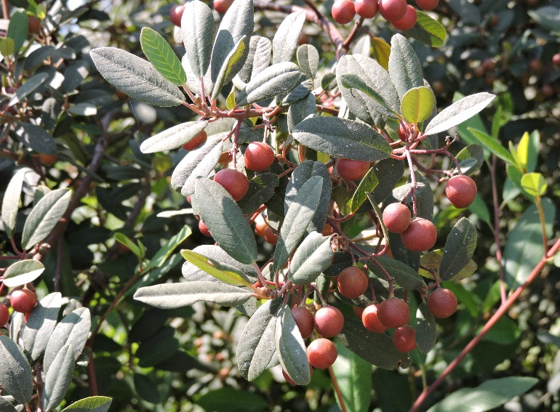

*Figure 1. California coffeeberry with mature fruits. Lockeford Plant Materials Center, 2016.*

## Frangula californica (Eschsch.) A Gray

Plant Symbol = FRCA12

*Common Names:* California buckthorn, California false buckthorn

*Scientific Names: Rhamnus californica* Eschsch

*Subspecies Names: F. californica ssp. Californica, F. californica ssp. crassifolia* (Jeps.) Kartesz & Gandhi, *F. californica ssp. cuspidata* (Greene) Kartesz & Gandhi, *F. californica ssp. occidentalis* (Howell ex Greene) Kartesz & Gandhi, *F. californica ssp. tomentella* (Benth.) Kartesz & Gandhi, *F. californica ssp. ursina* (Greene) Kartesz & Gandhi

### Description

*General*: Coffeeberry is a perennial evergreen or semi-deciduous shrub in the buckthorn family (*Rhamnaceae*) native to the western United States. It grows 6 – 10 ft. tall, under some conditions, it can grow as large as 15 ft. tall. The bark is bright grey-brown, and new growth on twigs is often reddish. Alternately arranged leaves range from ¾ – 4 in. long and are elliptic to ovate in shape. The inflorescence consists of many small, clustered, yellow-green flowers each with 5 petals. It bears 2-stoned fruits that turn from green through red to black and are about ½ inches in diameter (Sawyer, 2012, 2016). The current sub species are described below but the complex needs further study using modern techniques (Sawyer, 2016).

### *F. californica ssp. californica,* the common coffeeberry has leaves ¾ – 3 inches, narrowly to widely elliptic with an acute tip, dark green, lighter underneath. Flowers bloom in May and June (Calflora, 1997; Sawyer, 2012, 2016).

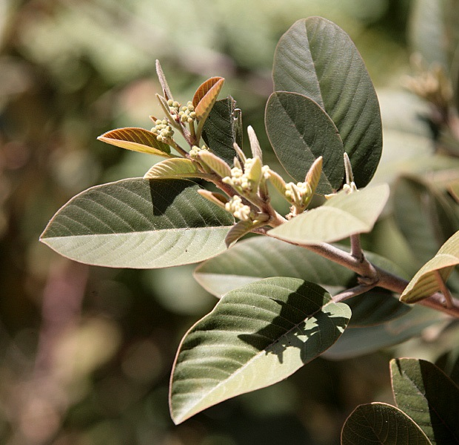

*Figure 2. F. californica ssp. tomentella shoot. © Lynn Watson 2007.*

*F. californica ssp. crassifolia.* The subspecies is similar to *ssp. tomentella*. Twigs are grey and tomentose (woolly with flattened, matted hairs). Leaves are white-tomentose, 1 – 4 inches and widely elliptic with obtuse tips. The margins are entire or blunt-toothed. Flowers bloom in Feb-Apr (Calflora, 1997;Sawyer, 2012, 2016).

*F. californica ssp. cuspidata* is evergreen or semi-deciduous. The twigs are red, leaves are ¾ – 2 ½ inches serrated and are tomentose on the lower surface in two lengths: short hairs mixed with conspicuous long ones. The shrub blooms in April through July (Calflora, 1997;Sawyer, 2012; 2016).

*F. californica ssp. occidentalis* is under 7 ft. tall with brown twigs and leaves that are ¾ – 3 inches ovate to elliptic with acute tips and round bases. Leaf veins are not prominent. It flowers Mar-June and produces 3-stoned fruit (Sawyer, 2012, 2016).

*F. californica ssp. tomentella.* This subspecies is also known as hoary coffeeberry. It grows under 7 ft. tall. Its grey twigs are covered with hairs and leaves are 1 – 2 ¾ inches dull green and elliptic with an acute tip; margins are entire or blunt-toothed. The leaves are smooth but velvety and silvery underneath. It flowers Jan-Apr (Calflora, 1997;Sawyer, 2012, 2016).

*F. californica ssp. ursina* is under 7 ft. tall. Leaves are 1 – 3 ½ inches, green, elliptic or ovate with an acute to rounded tip; the margins may be entire or serrated. They are smooth or covered with minute hairs (Calflora, 1997;Sawyer, 2012, 2016).

*Distribution*: Coffeeberry is widely distributed in the Western US, it is found in CA, OR, NV, AZ, and NM (USDA Plants profile). *F. californica ssp. californica g*rows at elevations under 9,000 ft. (Sawyer, 2016). It is the most coastal of the coffeeberry subspecies growing from southern Oregon to Orange County, California. *F. californica ssp. crassifolia* grows under 4,500 ft. in elevation and occurs in the Klamath Mountains and NW coastal ranges. *F. californica ssp. cuspidata g*rows under 7,500 ft. elevation a in the southern Sierra Nevada mountains, Transverse, and Peninsular ranges. *F. californica ssp. occidentalis* is distributed under 7,500 ft. elevation in southwestern Oregon and northwestern California, where it is characteristic of mafic and ultramafic substrates (Sawyer, 2016). *F. californica ssp. tomentella* grows under 7,500 ft. in elevation is distributed from the Cascades in Oregon to the Sacramento Valley to southwestern and Baja California. All of these subspecies intergrade in intermediate habitats (Sawyer 2016). *F. californica ssp. ursina* is separated geographically from the others as in California it is only encountered in San Bernardino Co. and is otherwise found in AZ and NM (Sawyer, 2016). For current distribution, please consult the Plant Profile page for this species on the PLANTS Web site.

*Habitat*: Coffeeberry occurs in a diversity of habitats including chaparral, coastal sage scrub, northern sage scrub, coastal strand, and mixed-evergreen forest, redwood forest, and central oak woodland plant communities. *F. californica ssp. californica* is associated withcoastal sage scrub, desert scrub, chaparral, forest and woodland, where it is an understory shrub. *F. californica ssp. crassifolia* is primarily found in chaparral and an understory shrub in woodland. *F. californica ssp. cuspidata* inhabits chaparral, desert scrub and montane woodland. *F. californica ssp. occidentalis* is in chaparral and woodland on serpentine soil sites. *F. californica ssp. tomentella* grows in chaparral and woodland sites. *F. californica ssp. ursina* is found in desert scrub and woodland (McMurray, 1990; Sawyer 2016).

**Adaptation**

Coffeeberry generally grows on dry, sandy or rocky slopes in ravines and on hillsides and tolerates sand, clay, and even occasional seasonal flooding. It tolerates sun and light shade, and does well as an understory plant (Theodore Payne Foundation. 2014; Wilson, 2014). *F. californica ssp. occidentalis* characteristically grows on mafic and ultramafic substrates (Sawyer, 2016).

### Uses

### *Erosion Control:* Coffeeberry is useful for erosion control on dry steep hillsides. Best established from transplants, the plants copious seed production distributed by birds can result in formation of good stands (McMurray, 1990). Once established the plants show continuous vegetative regeneration from established root crowns. Regeneration also occurs after fire.

### *Ornamental:* Coffeeberry is often cultivated as an ornamental as the green leaves contrast well with the colored twigs and berries. The plant is drought tolerant, and easy to maintain. It can be used to make an informal hedge and it tolerates pruning well. Deer appear to find it less palatable than many other landscape plants (San Marcos Growers, 1996; Wilson, 2014).

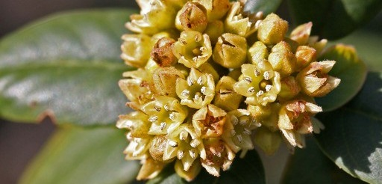

*Figure 3. Coffeeberry inflorescence. © Neal Kramer 2008.*

*Wildlife:* In the fall when more palatable herbaceous plants have dried California coffeeberry is a staple browse of big game and livestock. It is also important browse for mule deer on winter ranges in some areas of California (McMurray, 1990). The fruits are used extensively by many wildlife species including birds, black tailed deer and black bears. Coffeeberry is often included in hedgerow plantings as it supports beneficial insects and the blooms attract native bees (Wilson, 2014).

### Ethnobotany

*Medicinal:* Like other species in the buckthorn family, *F. californica* produces a purgative effect used by native Californians to treat constipation sometimes cause by consumption of acorns, a staple native food (Chestnut 1902).There is historical evidence of widespread use of this plant by groups such as the Chumash and Costanoan who dried and ground the inner bark to create a laxative tea (Bocek 1982; Timbrook 2007).

The leaves were decocted to treat poison oak dermatitis (Bocek 1982) or would be directly rubbed on skin as a remedy for rheumatism (Timbrook 2007). They were also used to heal infected sores and wounds. Carranza et al. (2015) demonstrated the antimicrobial properties of *F. californica* extracts, providing scientific support for this indigenous medicinal use. Other medicinal applications include using the bark to treat influenza and as a kidney remedy (Chestnut 1902), and placing a heated root in the mouth for toothaches (Ladybird Johnson Native Plant Database, 1982.).

### Status

*Threatened or Endangered*: No

*Weedy or Invasive:*

This plant may become weedy or invasive in some regions or habitats and may displace desirable vegetation if not properly managed, it is recognized as invasive in Hawaii.

Please consult the PLANTS Web site (<http://plants.usda.gov/>) and your state’s Department of Natural Resources for this plant’s current status (e.g., threatened or endangered species, state noxious status, and wetland indicator values).

### Planting Guidelines

Establishment of new plantings of coffeeberry are most successful from transplants and nursery stock. Although coffeeberry is drought tolerant, limited irrigation during the summer for the first year or two after transplanting increases survival. Direct seeding may be done in fall or early winter but the seed must be placed at a ¼ or ½ in depth as no germination will occur with deeper planting (ESNERR, 2001).

### Management

Coffeeberry will regenerate from root crowns making pruning or coppicing suitable forms of management (McMurray, 1990).

### Pests and Potential Problems

California coffeeberry is reported to be a secondary host for the rust of velvet grass (*Puccinia* spp. or *Holcus* spp.); there are no other reports of potential pest problems (McMurray, 1990).

### Seeds and Plant Production

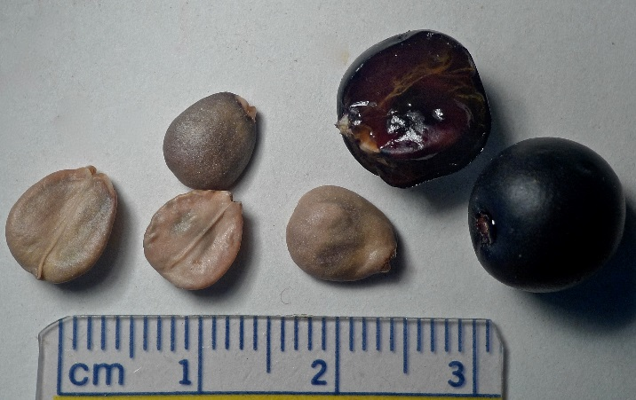*Seed collection and cleaning*: During the fruit ripening period, coffeeberry fruit changes color from green to red to purple-black. Berries should be picked in early fall, before they are fully ripe. If harvesting is delayed, fruit can be lost to foraging birds. Each fruit produces 2 seed, which are hard and brown when mature. To clean the seed crush the fruit by hand and rinse them over a sieve until clean. Let them dry and store in a dry and cool place.

*Pre-plant treatment*: Freshly picked seed may be planted immediately, but stored seed should be cold stratified for 3 months prior to planting (ESNERR, 2001). To cold-stratify, soak seeds in fresh water for 24 hours, place them in a plastic bag with an equal amount of moistened perlite, and place the bag in a refrigerator Monitor the seeds every 2 weeks, checking for moisture and mold (Young, 2001).

*Figure 4. California coffeeberry ripe fruits and seeds. © Jean Pawek 2012.*

*Planting*: Sow one seed into a container filled with standard potting mix. Plant no deeper than ¼ to ½ in. below the soil surface, as the plant is intolerant to deep planting (ESNERR 2001). Cover lightly with soil and place in a greenhouse with an irrigation system to keep them moist. Seed should have a germination success of 85% (Young, 2001).

*Establishment*: Seed germinates after 45 days. Keep seedlings in a greenhouse for 2-3 months before moving them to a shade structure. Maintain the seedlings in a shade structure for at least 2-3 months before planting out in order to harden the plant to outside conditions. The shrub will begin to flower and fruit 3-5 years after establishment (ESNERR, 2001).

### Cultivars, Improved, and Selected Materials (and area of origin)

Some commercially available ornamental cultivars include: *Frangula californica* ‘Bonita Linda’: This cultivar is 8 ft. tall by 10 ft. wide with grey-green foliage and reddish twigs and does well in partial shade (Theodore Payne, 2014). *Frangula californica* ‘Eve case’: This is a compact form growing 5-8 ft. tall with a similar width. The size is maintained by pruning. Introduced by the Saratoga Horticultural Foundation as a result of selection from the “Seaview” parent cultivar. (San Marcos Growers, 1996). *Frangula californica* ‘Leatherleaf’: A compact cultivar growing no more than 8 feet tall and wide, although usually not more that 5 to 6 ft. Darker leaves than other varieties, giving them a leathery appearance. This plant was introduced by the UC Berkeley Botanic Garden from a selection made by Roger Raiche from Montara Mountain on a northern spur of the Santa Cruz Mountains near San Mateo. (San Marcos Growers, 1996). *Frangula californica* ‘Little Sur’: This cultivar is small and compact just 3-4 ft. tall and wide with dark green foliage (Theodore Payne, 2014).

*Frangula californica* ‘Mound San Bruno’: More compact than other varieties and grows only 4-6 ft. tall and twice as wide. This selection was made by Roger Raiche from plants growing on San Bruno Mountain, on the Central California Coast south of San Francisco (San Marcos Growers, 1996).

Cultivars should be selected based on the local climate, resistance to local pests, and intended use. Consult with your local land grant university, local extension or local USDA NRCS office for recommendations on adapted cultivars for use in your area**.**

**Literature Cited**

Bocek B. 1982. Ethnobotany of the Costanoan Indians, California, based on collections by John P. Harrington. Economic Botany. 38(2):240-55.

Calflora, 1997: Consortium of California Herbaria, Berkeley CA http://www.calflora.org/cgi-bin/species_query.cgi?where-calrecnum=10902 (accessed 25 August 2015; verified August 3, 2016).

Carranza M.G., M.B. Sevigny, D. Banerjee, and L. Fox-Cubley. 2015. Antibacterial activity of native California medicinal plant extracts isolated from *Rhamnus californica* and *Umbellularia californica*. Annals of Clinical Microbiology and Antimicrobials. 14:29.

Chestnut V.K. 1902. Plants used by the Indians of Mendocino County, California. US National Herbarium Contributions. 7:295-408.

ESNERR 2001. Native Species Planting Guide for the Elkhorn Slough National Estuarine Research Reserve.

www.elkhornslough.org/habitat-restoration/native_plants.pdf (accessed 25 August 2015, verified 3 August, 2016).

Kramer N. 2008. *Frangula californica ssp. californica*; California coffeeberry http://calphotos.berkeley.edu/cgi/img_query?enlarge=0000+0000+0408+0032 (accessed 1 September 2015).

McMurray, Nancy E. 1990. *Frangula californica*. In: Fire Effects Information System, [Online].U.S. Department of Agriculture, Forest Service, Rocky Mountain Research Station, Fire Sciences Laboratory (Producer). Available: http://www.fs.fed.us/database/feis/plants/shrub/fracal (Accessed: August 2, 2016,).

Ladybird Johnson Native Plant Database, 1982. The Ladybird Johnson Wildflower Center: The University of Texas, Austin, http://www.wildflower.org/plants/result.php?id_plant=EPCAA (Accessed 25 August, 2015; verified 25 July. 2016).

Pawek J. 2012. *Frangula californica*; California coffeeberry. http://calphotos.berkeley.edu/cgi/img_query?enlarge=0000+0000+0912+0516 (accessed 1 September 2015).

Sawyer J.O. Jr. 2012. “*Rhamnaceae*, Buckthorn family”. The Jepson Manual: vascular plants of California, Second Edition. University of California Press. Berkley, CA. Pp. 1163-1164.

Sawyer, J. O. Jr. 2016. *Frangula californica*, in Jepson Flora Project (eds.) Jepson eFlora, http://ucjeps.berkeley.edu/cgi-bin/get_IJM.pl?tid=26041, (accessed on August 03, 2016)

San Marcos Growers, 1996. http://www.smgrowers.com/search/basesearch.asp?strSearchText=Epilobium&x=0&y=0/ Santa Barbara, CA (accessed 25 July. 2016).

Theodore Payne Foundation for Wild Flowers and Native Plants. 2014. Sun Valley, CA http://theodorepayne.org/ (accessed 25 July. 2016).

Timbrook J. 2007. Chumash ethnobotany: plant knowledge among the Chumash people of southern California. Heyday Books, Berkley, CA. p. 164

Tropicos. 2015. *Frangula californica*. Missouri Botanical Garden. http://www.tropicos.org/NameSearch.aspx?name=Frangula+californic (accessed 25 August 2015).

USDA-ARS, National Genetic Resources Program. Germplasm Resources Information Network (GRIN). http://www.ars‑grin.gov/cgi‑bin/npgs/html/taxon.pl?403162 (accessed 25 August 2015).

USDA-NRCS. PLANTS National Database Reports, Plant Profile: *Frangula californica* (Eschsch.) A. Gray, California buckthorn. http://plants.usda.gov/core/profile?symbol=FRCA12 (accessed 25 August 2015).

Watson L. 2007. *Frangula californica ssp. tomentella* http://calphotos.berkeley.edu/cgi/img_query?enlarge=0000+0000+0507+1254 (accessed 1 September 2015).

Wilson B. 2014. *Rhamnus californica*, Coffeeberry. Las Pilitas Nursery. http://www.laspilitas.com/nature-of-california/plants/566--rhamnus-californica (accessed 25 August 2015).

Young B. 2001. Propagation protocol for production of container *Frangula californica* Gray *californica* plants (Deepot 40); San Francisco, California. In: Native Plant Network. http://www.nativeplantnetwork.org (accessed 25 August 2015).

### 

### Citation

Tutka M. 2015. Plant guide for California coffeeberry *(Frangula californica)*. USDA-Natural Resources Conservation Service, Plant Materials Center, Lockeford, CA.

Published: August 2016

Edited:

For more information about this and other plants, please contact your local NRCS field office or Conservation District at <http://www.nrcs.usda.gov/> and visit the PLANTS Web site at <http://plants.usda.gov/> or the   
Plant Materials Program Web site:

<http://plant-materials.nrcs.usda.gov>.

PLANTS is not responsible for the content or availability of other Web sites.

The U.S. Department of Agriculture (USDA) prohibits discrimination against its customers, employees, and applicants for employment on the bases of race, color, national origin, age, disability, sex, gender identity, religion, reprisal, and where applicable, political beliefs, marital status, familial or parental status, sexual orientation, or all or part of an individual's income is derived from any public assistance program, or protected genetic information in employment or in any program or activity conducted or funded by the Department. (Not all prohibited bases will apply to all programs and/or employment activities.)

If you wish to file an employment complaint, you must contact your agency's [EEO Counselor](http://www.ascr.usda.gov/doc/EEO_Counselor_List.pdf) (PDF) within 45 days of the date of the alleged discriminatory act, event, or in the case of a personnel action. Additional information can be found online at <http://www.ascr.usda.gov/complaint_filing_file.html>.

If you wish to file a Civil Rights program complaint of discrimination, complete the [USDA Program Discrimination Complaint Form](http://www.ocio.usda.gov/sites/default/files/docs/2012/Complain_combined_6_8_12.pdf) (PDF), found online at <http://www.ascr.usda.gov/complaint_filing_cust.html>, or at any USDA office, or call (866) 632-9992 to request the form. You may also write a letter containing all of the information requested in the form. Send your completed complaint form or letter to us by mail at U.S. Department of Agriculture, Director, Office of Adjudication, 1400 Independence Avenue, S.W., Washington, D.C. 20250-9410, by fax (202) 690-7442 or email at [program.intake@usda.gov](mailto:program.intake@usda.gov).

Individuals who are deaf, hard of hearing or have speech disabilities and you wish to file either an EEO or program complaint please contact USDA through the Federal Relay Service at (800) 877-8339 or (800) 845-6136 (in Spanish).

Persons with disabilities who wish to file a program complaint, please see information above on how to contact us by mail directly or by email. If you require alternative means of communication for program information (e.g., Braille, large print, audiotape, etc.) please contact USDA's TARGET Center at (202) 720-2600 (voice and TDD).

For any other information dealing with Supplemental Nutrition Assistance Program (SNAP) issues, persons should either contact the USDA SNAP Hotline Number at (800) 221-5689, which is also in Spanish or call the [State Information/Hotline Numbers](http://www.fns.usda.gov/snap/contact_info/hotlines.htm).

For any other information not pertaining to civil rights, please refer to the listing of the [USDA Agencies and Offices](http://www.usda.gov/wps/portal/usda/usdahome?navtype=MA&navid=AGENCIES_OFFICES_C) for specific agency information.

***Helping People Help the Land***

**USDA IS AN EQUAL OPPORTUNITY PROVIDER AND EMPLOYER**