

Plant Guide

# Green ash

## Fraxinus pennsylvanica Marsh.

Plant Symbol = FRPE

*Contributed by*: USDA NRCS East Texas Plant Materials Center

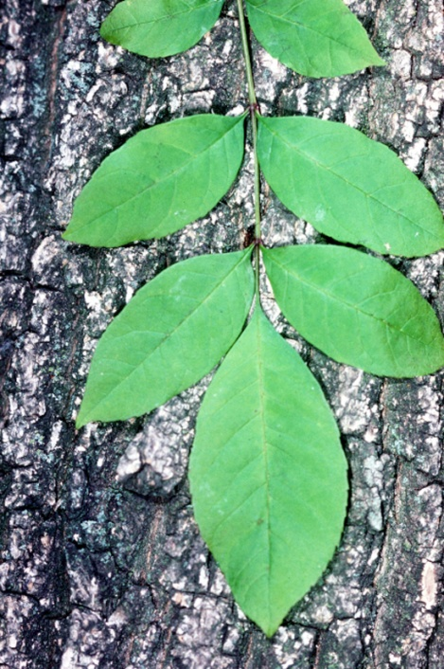

Robert H. Mohlenbrock @ USDA-NRCS PLANTS Database/USDA SCS. 1989. Midwest wetland flora: Field office illustrated guide to plant species. Midwest National Technical Center, Lincoln.

### Alternate Names

Alternate names include: red ash, swamp ash, or water ash (Kennedy, 1990).

### Uses

*Livestock*: Green ash stems are browsed by livestock (Johnson, 1971). Cattle utilize green ash habitats for shade, water, protection, and shelter during calving season (Gucker, 2005).

*Wildlife*: Green ash seeds, stems, and foliage provide cover and food for several small animal species including rabbit. Both game and nongame bird species use this habitat for food, nesting sites and roosts (Gucker, 2005). Black birds, finches, grosbeaks, and cardinal feed on ash fruits (Twedt and Best, 2004). In a study by Hopkins (2004), the Coopers hawk and mountain bluebird nested only in green ash woods.

*Residential*: Green ash is popular as a shade tree in residential areas because of its good form and adaptability to a wide range of sites.

*Windbreak*: Green ash is used frequently in windbreaks and shelterbelt plantings. It is recommended to plant the tree in the central rows of multi-row windbreaks (Dickerson, 2002).

### Status

Please consult the PLANTS Web site and your State Department of Natural Resources for this plant’s current status (e.g., threatened or endangered species, state noxious status, and wetland indicator values).

### Description

*General*: Green ash is a native spreading, round topped tree which grows to a height of 70 feet or more. The deciduous leaves are pinnately compound, 8 to 12 inches long, with 5 to 9 leaflets. The leaflets are oblong, lustrous green on both sides or somewhat paler beneath. The twigs are pale gray along with brown bark. The fruit (samara), usually containing one seed, is light colored, 1 to 2 inches long and ¼ to 1/3 inch wide with a wing (Vines, 1960).

*Distribution*: For current distribution, please consult the Plant Profile page for this species on the PLANTS Web site.

*Habitat*: Green ash is found in areas with 15 to 60 inches of yearly precipitation. It is found growing naturally in bottomlands subject to frequent flooding or overflow (Stewart and Krajicek, 1973). Green ash is moderately tolerant to shade. Some woody species associated with green ash include box elder (*Acer negunda*), red maple (*A. rubrum*), pecan (*Carya illinoensis*), eastern cottonwood (*Populus deltoides*), black willow (*Salix nigra*), and American elm (*Ulmus americana*) (Kennedy, 1990).

**Adaptation**

Green ash grows on clay to sandy or silt soils (Stewart and Krajicek, 1973). It will also perform well when planted on neutral to alkaline medium to coarse textured upland sands and loams with good moisture (Kennedy, 1990). The species has a wide range of adaptation from eastern Montana, Great Plains, and eastern half of the United States (Vines, 1960).

### Establishment

Soil analysis should be performed prior to planting to determine the necessary levels of nitrogen, phosphorus and potassium. Green ash has shown severe chlorosis when grown on a soil with a pH of 8.1 (Wright, 1965). Tests on a riverfront site in Mississippi have shown that green ash grew well on silt loam soils with pH ranging between 7.5 and 8.0 (Kennedy, 1990). Gilmore and Boggess (1963) noted that hardwoods such as green ash need better quality planting sites than pine (*Pinus* sp.).

### Management

Green ash does not grow as fast as red maple (*Acer rubrum*) or elm; therefore it may be crowded out over time. Control the surrounding vegetative competition to maintain green ash (Dickerson, 2002). If this species is being used in a landscape, prune established trees every three to four years to maintain good form and structure (Colorado State University, 2011)

### Pests and Potential Problems

Insects will feed on green ash. Oystershell scale (*Lepidosaphes ulmi*) can cause serious damage to seedlings and small trees in the Northeast. Carpenterworm (*Prionoxystus robiniae*) bores into large branches and trunks, allowing the entrance of fungi. The brown headed ash sawfly (*Tomostethus multicinctus*) and the black headed ash sawfly (*Tethida barda*) also cause damage. The ash borer (*Podesesia syringae*) damages the stems, thereby degrading lumber quality and contributing to decline in shelterbelt plantings (Solomon, 1975 and Wright, 1965).

The emerald ash borer (*Agrilus planipennis*) has been detected in Michigan, Ohio, Pennsylvania and Canada. The beetle is responsible for the loss of millions of ash (*Fraxinus* sp.) trees. The beetle lays eggs between bark layers and crevices. After about one week, larvae hatch and begin to feed on an infected tree’s inner bark and phloem. The larvae change to prepupa and overwinter in the tree. The following spring, after pupation, adults emerge from holes they made in the tree. Symptoms include: branch dieback, branching on the tree trunk and vertical bark slits (USFS, 2004).

A fungus (*Mycosphaerella fraxinocola*) creates a leaf spot which may lead to defoliation of young trees. Rust fungal infections can distort petioles and small twigs. Green ash in Texas and Oklahoma has shown susceptibility to *Phymatrotrichum omnivorum* which causes root rot (Wright, 1965). Older trees may be attacked by a fungus, *Polyporus fraxinophilus*, which attacks wood and turns it into a yellow pulp (Vines, 1960).

### Seeds and Plant Production

Green ash seeds begin to fall as soon as they ripen in the fall (Wright, 1965). Color can be an indicator of maturity. The samaras don’t change color from green to yellow or brown until the embryo is full grown (Bonner, 1974). If picked slightly green, keep the samaras from overheating (Kennedy, 1990). Seed clusters can be collected by hand or with pruners and seed hooks. Another method is to shake the limbs and collect the dried samaras on a sheet beneath the tree. Spread out the samaras for uniform seed drying. After drying, the samara clusters can be broken apart by hand, flailing, or running them through a brush machine (Bonner, 1974).

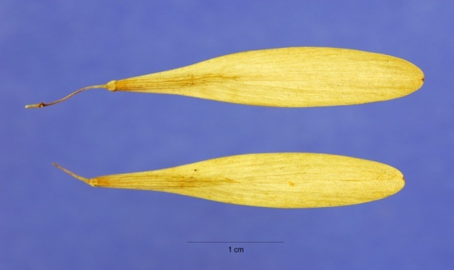

Watch for damage to the samaras by the ash seed weevil. The greatest damage has been reported in seed harvested in the northeast and Great Plains, with less amounts in the south (Bonner, 2008). Remove the stems and trash by fanning or air screen cleaners. Cleaned seed of seed lots collected from the Midwest and Great Lakes region averaged 17,260 seeds per pound. In contrast, cleaned seed collected in Arkansas and Mississippi averaged 20,950 seeds per pound (Bonner, 2008).

Green ash samaras. Steve Hurst @USDA-NRCS PLANTS database

Dry the seeds down to between 7 and 10 percent moisture for storage. Seeds stored in sealed containers at this moisture level at 41° F kept their viability for seven years in a study by Barton (1945). Some green ash seeds may germinate the following spring, while others may be dormant for several years. Dormancy could be a combination of internal factors and seedcoat effects (Bonner, 2008).

Germination of seeds collected from the northern part of the range includes a two-step process of warm stratification for 16 weeks at 68° F and then cold stratification for 16 weeks at 38° F. A one hour resoak in water should be completed weekly in the warm phase and every 2 weeks in the cold phase. Usually only cold stratification is needed for seed collected in the southern part of the range. Seed dormancy may also be affected by seed age. Older stored seeds appear more dormant than those that are freshly collected (Bonner, 1974).

Seeds may be sown in the fall to stratify in the nursery bed. Sow at approximately 80 to 100 seed/m (25 to 30/ft) of row with a row spacing of 15 to 30 cm (6 to 12 in.) apart. Cover the rows with burlap or greenhouse shade cloth until germination begins. Densities of 110 to 130 seed/m2 (10 to 12ft2) are recommended to grow high quality seedlings (Kennedy, 1990). Nursery seedlings normally develop no side branches during the first year of growth. However, by the second year a small number may develop. Some young trees may have a single straight stem until they are 15 ft. (5m) tall (Wright, 1965).

Mature height varies among green ash depending on the location. In the northern part of its range, green ash may reach heights of 50 to 60 feet and breast height diameters of 18 to 24 in. On quality sites in the southern part of its range, trees may grow up to 120 ft. in height and reach a breast height diameter of 24 to 30 in. (Putnam, Furnival, and McKnight, 1960).

### Cultivars, Improved, and Selected Materials (and area of origin)

This is not a complete listing of green ash cultivars and releases. Please consult your local nursery for more information concerning releases adapted to your area. ‘Patmore’ was introduced by the Patmore Nursery, Brandon, Manitoba, Canada. This variety is pyramidal to oval shaped and is a seedless male tree. ‘Summit’ was introduced by the Summit Nursery, Stillwater, Minnesota. This male variety has an upright, narrow growth habit. ‘Marshall’s Seedless’ has a rounded growth form and less cold hardy than ‘Patmore’ or ‘Summit’ (Colorado State University, 2011). Dakota Centennial® Ash (*F. Pennsylvania* ‘Wahpeton’) is an upright, fast growing male tree introduced by North Dakota State University, Fargo, North Dakota.

‘Kindred’ is a male tree introduced by the late Ben Gilbertson, Kindred, North Dakota. ‘Bergeson’ is a patented variety introduced by Bergeson Nursery, Fertile, Minnesota.

‘Cardan’ is a seed strain cultivar released by the USDA-NRCS Plant Materials Center, Bismarck, North Dakota and USDA Northern Great Plains Research Laboratory, Mandan, North Dakota (North Dakota State University, 1999 and Dir, 1990). ‘Oahe’ and Prairie Harvest germplasm are releases by the USDA- NRCS Plant Materials Center, Bismarck, North Dakota.

### References

Barton, L.V. 1945. Viability of seed of *Fraxinus* after storage. Contributions of the Boyce Thompson Institute 13:427-432.

Bonner, F.T. 1974. *Fraxinus* Ash. *In* Seeds of woody plants of the United States. C.S. Schopmeyer, tech coord. P. 411-416. US Department of Agriculture, Agriculture Handbook 450. Washington, DC.

Bonner, F.T. 2008. *Fraxinus* Ash *In* : Woody Plant Seed manual. P. 537-543. US Department of Agriculture, Agriculture Handbook 727. Washington, DC.

Colorado State University Extension. Plantalk. 2011. Available: http://www.ext.colostate.edu/ptlk/1735.html

Dickerson, J. 2002. Plant fact sheet for green ash (*Fraxinus pennsylvanica*). USDA- NRCS New York State Office, Syracuse, New York.

Dir, M. 1990. Manual of Woody Landscape Plants, Their Identification, Ornamental Characteristics, Culture, Propagation and Uses. Stipes Publishing Company, Champaign, IL.

Gilmore, A.R., and W.R. Boggess. 1963. Effects of past agricultural practices on the survival and growth of planted trees. Proceedings, Soil Science Society of America. 27(1):98-102.

Gucker, C.L. 2005. *Fraxinus pennsylvanica*. In: Fire Effects Information System, [Online]. U.S. Department of Agriculture, Forest Service, Rocky Mountain Research Station, Fire Sciences Laboratory (Producer). Available: http://www.fs.fed.us/database/feis/ Accessed [2012, August 8].

Hopkins, R.B. 1984. Avian species associated with prairie woodland types. *In*: Noble, D.L.; R.P. Winokur, eds. Wooded draws: characteristics and values for the northern Great Plains: Proceedings of the symposium; 1984 June 12-13; Rapid City, SD: South Dakota School of Mines and Technology, Biology Department: 27-35.

Johnson, W.C. 1971. The forest understory vegetation on the Missouri River floodplain in North Dakota. Fargo, North Dakota. North Dakota State University. 185. Dissertation.

Kennedy, H.E Jr. 1990. *Fraxinus pennsylvanica* Marsh. Green ash. In: Burns, R.M..; B.H. Honkala technical coordinators. Silvics of North America. Vol.2. Hardwoods. Agriculture Handbook 654. Washington, DC: U.S. Department of Agriculture, Forest Service: 348-354.

North Dakota State University. 1999. Green ash. Available: http://www.ag.ndsu.edu/trees/handbook/th-3-99.pdf Accessed [2012, August 11]

Putnam, J.A., G.M. Furnival, and J.S. McKnight. 1960. Management and inventory of southern hardwoods. US Department of Agriculture, Agricultural Handbook 181. Washington, DC. 102 p.

Solomon, J.D. 1975. Biology of an ash borer, *Podosesia syringae*, in green ash in Mississippi. Annals of the Entomological Society of America. 68(2):325-328.

Stewart, H. A. and J.E. Krajicek. 1973. Ash, an American wood. American Woods Series FS-216. USDA Forest Service. Washington, DC. 7p.

Twedt, D. J.; C. Best. 2004. Restoration of floodplain forests for the conservation of migratory landbirds. Ecological Restoration. 22(3): 194-203.

USDA Forest Service. 2008. What is the emerald ash borer? Bulletin NA-PR-05-04.

Vines, R.A. 1960. Trees, shrubs, and woody vines of the Southwest. Austin, TX: University of Texas Press. 1104 p.

Wright, Jonathan W. 1965. Green ash (*Fraxinus pennsylvanica* Marsh.) *In* Silvics of forest trees of the United States. H.A. Fowells, comp. p.185-190. US Department of Agriculture, Agriculture Handbook 271. Washington, DC.

**Prepared By**: Melinda Brakie, Soil Conservationist

USDA-NRCS East Texas Plant Materials Center, Nacogdoches, Texas

### Citation

Brakie, M., 2013. Plant Guide for green ash (Fraxinus pennsylvanica). USDA-Natural Resources Conservation Service, East Texas Plant Materials Center. Nacogdoches, Texas. 75964.

Published August 2013

Edited:

For more information about this and other plants, please contact your local NRCS field office or Conservation District at <http://www.nrcs.usda.gov/> and visit the PLANTS Web site at <http://plants.usda.gov/> or the Plant Materials Program Web site <http://plant-materials.nrcs.usda.gov>.

PLANTS is not responsible for the content or availability of other Web sites.

**USDA IS AN EQUAL OPPORTUNITY PROVIDER AND EMPLOYER**