

Plant Guide

# BLANKETFLOWER

## Gaillardia aristata Pursh

Plant Symbol = GAAR

*Contributed by*: USDA NRCS Bridger Plant Materials Center, Montana

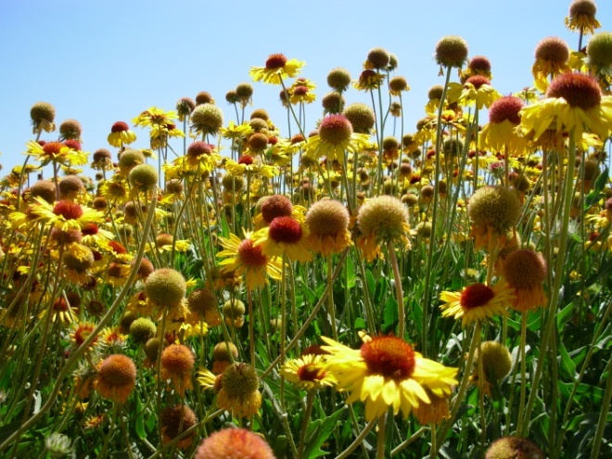

Gaillardia aristata Susan R. Winslow, Bridger Plant Materials Center

### Alternate Names

Indian blanketflower, common gaillardia, gaillardia, brown-eyed Susan

### Uses

Blanketflower is a native perennial wildflower useful for adding species diversity in native plant seed mixes for rehabilitation of disturbed sites. It can be used in producing native wildflower sod for restoration of native plant colonies (Airhart, 1988). Blanketflower is suitable for use as an ornamental wildflower in low maintenance or naturalistic landscapes. It has utility as a cover and food source for pollinators, wildlife, and livestock.

### Status

Please consult the PLANTS Web site (USDA-NRCS, 2011) and your State Department of Natural Resources for this plant’s current status (e.g., threatened or endangered species, state noxious status, and wetland indicator values).

### Description

*General:* Blanketflower *Gaillardia aristata* is a native, herbaceous perennial in the Aster family. *Gaillardia* was named in honor of Gaillard de Marentonneau, an 18th century French patron of botany (Bailey, 1929). The name *aristata* is derived from, *arist*, Latin for bristle, in reference to the hairy stems and leaves, and the awn-like bristles on the single-seeded fruit (achene). The blanketflower inflorescence is said to resemble the colorful, intricate patterns woven into blankets made by Native Americans (Kimball and Lesica, 2005). Blanketflower is found in grasslands, woodlands, and montane meadows. Its natural range extends from southern Canada on both sides of the Rocky Mountains, south to Utah, Colorado, and South Dakota (Strickler, 1993).

*Taxonomy:* Blanketflower is tap rooted, with one or commonly several, erect stems from the base (Hitchcock et al., 1955). The pubescent plant grows to a height of 26 inches with rough-hairy, lance-shaped, alternate leaves, 6 inches long, 1 inch wide, entire to coarsely-toothed, or rarely pinnately divided (Hermann, 1966). The flower heads are radiate, showy, solitary to few, with an outer series of ray flowers and an inner group of disk flowers. There are typically 13, sterile, 0.6 to 1.4 inches long, ligulate (strap-shaped), yellow ray flowers with purple bases (eFloras, 2011). The number and shape of the ray flowers is variable, as is the number of lobes in a ray (Robbins, 1908). A normal flower head has a large number of ligulate and tubular-shaped rays, with the latter shape being four-lobed. A few flower heads have all tubular rays. The purple, perfect (both stamens and pistil) disk flowers are 0.3 to 0.35 inch long, with long hairs at the top (Lesica, 2002). The overall appearance of the central disk flowers are said to resemble big, brown eyes, hence the alternative common name, brown-eyed Susan (Talk About Wildlife, 2011). The receptacle is convex to subglobose, with chaffy or sometimes soft, spine-like bristles that do not individually subtend the disk flowers (Hitchcock and Cronquist, 1973). The fruit is a one-seeded, gray-brown achene, 0.12 to 0.16 inch long, with densely ascending hairs, a short pappus crown 0.3 to 0.4 inch long, and awns approximately two times as long as the fruit body (Jepson Manual, 2011). The chromosome number for blanketflower is 2*n* = 34 (Taylor and Brockman, 1966).

*Distribution:* The native range of blanketflower extends from south-central Canada to southern Colorado, east to the Dakotas and west to the Cascade Mountains of Washington and the Blue Mountains of Oregon (Marlowe and Hufford, 2007).

For current distribution, please consult the Plant Profile page for this species on the PLANTS Web site.

*Habitat:* Blanketflower prefers dry, open spaces in prairies, mountain foothills, and along roadsides and railroad rights-of-way (Vance et al., 1999). It is a mid-successional species capable of growing in dense populations on disturbed sites (Taylor, 1992). Blanketflower is adapted to a wide range of well-drained soils and is drought tolerant. It grows well on dry to mesic, well-drained sites in areas receiving 10 to 30 inches of annual precipitation. Plant growth and development is dependent on site location, with a wide range of dates in emergence and floral initiation.

**Adaptation**

In Montana, presence of blanketflower has been documented in all 56 counties (Booth and Wright, 1959), including nine types of riparian plant communities (Hansen et al., 1995). It is an important component of several habitat types in western Montana (Hermann, 1966). Blanketflower is present in the mountain and foothill environments of more than half of the 23 counties in Wyoming (Rocky Mountain Herbarium, 2011). It does well on a variety of soil types, including loams to rocky to gravelly-sandy textures; and tolerates a soil pH range from slightly acidic to mildly alkaline (USDA-NRCS, 2003). Blanketflower attains optimum growth in full sun, beginning in early spring until seed set in late summer (Mueggler and Stewart, 1980). It occurs at elevations from 1,300 to 9,000 feet.

### Establishment

Blanketflower may be grown from seed or division of vegetative parts. The seed does not require cold stratification treatment to break dormancy. For range plantings, seed should be planted into a firm, weed-free seedbed, preferably with a mechanical drill that will ensure uniform seed placement depth of ¼- to ½- inch. There are approximately 220,700 seeds in one pound of blanketflower. The full seeding rate is 5 pounds pure live seed per acre, but it would seldom be seeded as a pure stand. It is recommended that blanketflower be included as a component of a native seed mixture at a rate not to exceed ½ to 1 pound pure live seed per acre. When used in a mix, adjust the seeding rate to the desired percentage of mix. Spring seeding is preferred over late summer or dormant, fall planting dates.

### Management

Blanketflower is tolerant to drought and requires supplemental moisture only during extended hot, dry conditions. Periodic mowing during the establishment year is one option for weed suppression.

### Pests and Potential Problems

Blanketflower has no serious insect or disease problems. Root rot may be a problem in poorly drained soils, especially during extended periods of heavy rain. Powdery mildew may be present at times of elevated humidity, but usually does not have a long-term negative impact on the plants. The species generally is susceptible to aster yellows and fungal leaf spot disease (Missouri Botanical Garden, 2011). Gaillardia is slightly susceptible to oat blue dwarf virus (Brunt et al., 1996).

### Environmental Concerns

Blanketflower plants tend to be moderately long-lived and may re-seed in abundance. A skin rash or irritation may develop following contact with juice or sap from the foliage (eNature, 2011).

### Ecological Considerations

As global demand increases for drinking and irrigation water, there is concern over the excessive use of high water-consuming plants in residential and commercial landscapes (Proctor, 1996). Blanketflower is an attractive, showy, native wildflower that is tolerant of drought conditions within its range of adaptation (Curtis and Curtis, 1989). It is recommended for use as an ornamental specimen plant or a mass display in low watering zones of Xeriscape™ and waterwise gardens (Knopf, 1991). It may be irrigated using non-potable water with salinity levels up to 5.4 decisiemens per meter with minimal impact to the visual aesthetics of the plant (Niu et al., 2007). Blanketflower is considered deer-resistant due to the mature plant’s unpalatable and rough-textured stems and leaves (Parkinson, 2003). Whitetail deer may lightly browse blanketflower to supplement dietary needs at different times of the year (Atwood, 1941). Low volatility of the leaf chemistry combined with high moisture content suggests blanketflower has low flammability and may be resistant to wildfire (Dennis, 2008). Percentage canopy cover of blanketflower, however, more than doubled following a wildfire (Antos et al., 1983). More than 30 hybrid varieties of several species of blanketflower have been developed for use in the commercial floriculture industry with the majority having landscape application in the southern regions of the United States. (Hammond, 2007).

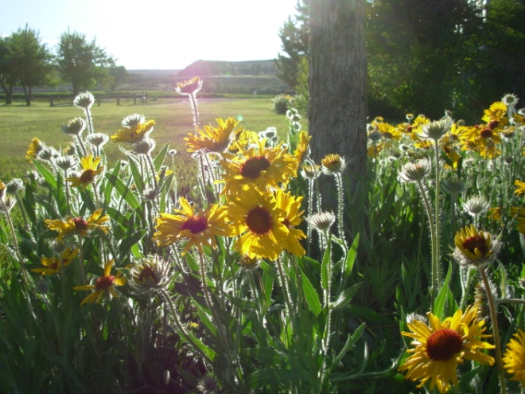

Blanketflower in landscape garden

A wide variety of pollinators and beneficial insects rely on blanketflower as a food source of pollen and nectar, and for resting and cover. It is a common nectar source for the adult stage of the butterfly, Edwards fritillary *Speyeria edwards* (Opler, 2008). A cryptic moth, *Schinia masoni*, is color-camouflaged to mimic the yellow ray flowers and purplish-brown disk flowers of blanketflower as protection against predators (Ferner, 1981). Blanketflower is an indicator plant associated with the upland, dry prairie habitats of the Dakota skipper *Hesperia dacotae* Skinner (Cochrane and Delphey, 2002), a butterfly species petitioned as a candidate for listing under the Endangered Species Act (USDI-USFWS, 2008). In western North America, the widely distributed soft-winged flower beetle *Listrus senilis* is recognized as a crucial pollinator of blanketflower (Mawdsley, 2003). Blanketflower is a component of several northern grassland ecosystems where the breakdown of organic matter by functionally-important insects increased soil fertility and improved soil water-holding capacity and water infiltration (Hewitt and Burleson, 1976).

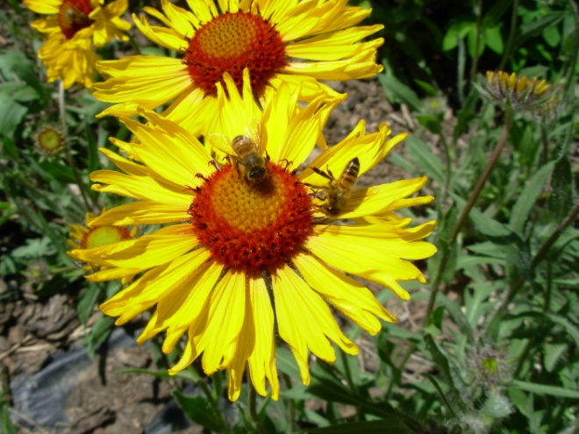

Honey bees visiting blanketflower

Indian tribes of North America long recognized the medicinal qualities of blanketflower and used it to treat many ailments (University of Michigan, 2011). The Blackfeet used infusions of roots and leaves to relieve upset stomachs and to treat saddle sores on horses (Larson and Johnson, 1999). Kiowas picked the flowers for good luck (Johnson and Larson, 1999). Blanketflower was one of the voucher specimens collected by Captain Meriwether Lewis along the Blackfoot River on July 7, 1806 (Phillips, 2003). Cancer studies on major plant groups determined blanketflower contained the sesquiterpene lactone agent, gaillardin, a tumor-killing (antineoplastic) compound (Lewis and Elvin-Lewis, 1977). There is evidence blanketflower contains substances with antibacterial properties (Harris, 1949). A skin rash or irritation may develop following contact with juice or sap from the foliage (Ferner, 1981).

The tender, young plant growth and insect-rich blooms of blanketflower are a potential food source for young and adult upland game birds, such as sage-grouse and sharp-tail grouse. Forage palatability of blanketflower is rated poor to fair for domestic livestock during early stages of growth. It is a mid-summer maturing species in sagebrush plant communities (Pitt and Wikeem, 1990). Blanketflower can be an indicator of range readiness, as it will begin to bloom when more desirable forage plants have reached the stage of growth where they are ready for grazing (WACD, 1987). Blanketflower was a highly selected forb by California bighorn sheep and comprised 2 percent of late-summer diet (Wikeem and Pitt, 1979). Gayton (2003) indicated grazing regime or local site conditions greatly influence re-growth in blanketflower. Its response to grazing and other disturbances can be indicators of successional trend and ecological integrity (Mueggler, 1983). Light grazing by domestic sheep did not noticeably affect the abundance of plants (Daubenmire, 1970). Tyrer et al. (2007) suggest early germination and establishment, and resistance to allelopathic chemicals, give *Gaillardia aristata* seedlings a considerable advantage over later germinating Russian knapweed *Acroptilon repens* (a noxious weed) seedlings. Callaway et al. (2004) found the biomass of spotted knapweed *Centaurea stoebe* ssp. *micranthos* (another noxious weed) was lower when grown in competition with *Gaillardia aristata*. Plant communities rich in perennial forb species such as blanketflower, may be more resistant to noxious weed invasion (Maron and Marler, 2007) and indigenous, deep-rooted, forb functional groups (of which *Gaillardia* is a member) capture soil moisture and nutrients making them less available for weed establishment (Pokorny, 2005).

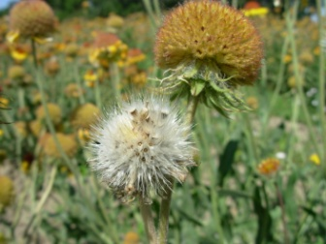Blanketflower seedheads

### Seed and Plant Production

Blanketflower lends itself to agronomic seeding methods when planted at the appropriate time and rate (Norcini, 2006). Seed production fields should be established in rows at 25 pure live seeds per lineal foot of row. Between-row spacing is dependent on the type of planting and cultivation equipment, and ranges from 24 to 36 inches. Adequate between-row space should be provided to perform mechanical cultivation. At 24-inch row spacing, the recommended seeding rate is 2.5 pounds pure live seed per acre, and at 30- and 36-inch row spacing, the seeding rate is 2.2 and 1.9 pounds pure live seed per acre, respectively. There are presently no herbicides specifically labeled to control weeds in seed production fields of this species. Preliminary results in a wildflower seed production herbicide trial indicated effective weed control with the use of pendimethalin and a mix of pendimethalin and trifluralin (Wiese, 2009). Seed harvest can be accomplished by direct combining when the seeds have just begun to shatter from the radiate flowerhead. Immediately after combining, spread out harvested material to dry and prevent mold.

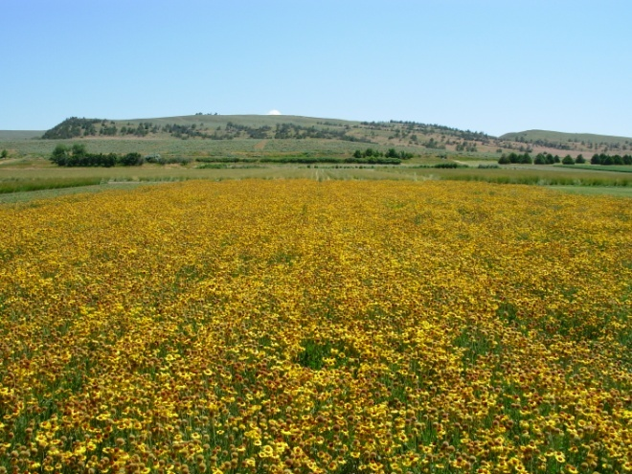

Meriwether Germplasm blanketflower seed production field, at the Bridger Plant Materials Center

Due to the persistent hairy pappus, and poor seed flow, this species is fairly difficult to clean. Seeds are moderately viable and longevity can be expected for several years when stored at favorable temperatures and low humidity. Meriwether Germplasm blanketflower yielded approximately 150 bulk pounds of seed per acre in experimental irrigated plots at the Bridger Plant Materials Center on an average harvest date of July 29. Seed production is expected to be much higher when grown under conventional agronomic conditions.

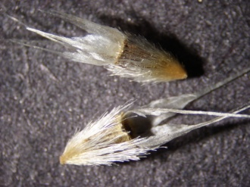

Blanketflower seed with bristly pappus

### Cultivars, Improved, and Selected Materials (and area of origin)

Meriwether Germplasm Selected Class blanketflower was released in 2011 by the Bridger Plant Materials Center in cooperation with the agricultural experiment stations of Montana State University and the University of Wyoming. Meriwether Germplasm is a composite of seed collections from 14 Montana counties and one county in Wyoming.

### References

Airhart, D.L. 1988. Experiments with Seed-Grown Sod as Plant Introduction Technique Described (Massachusetts). Restoration and Management Notes 6(1):51.

Antos, J.A., B. McCune, and C. Bara. 1983. The Effect of Fire on an Ungrazed Western Montana Grassland. American Midland Naturalist 110(2):354-364.

Atwood, E. L. 1941. White-Tailed Deer Foods of the United States. Journal of Wildlife Management 5(3):314-341.

Bailey, L.H. 1929. The Standard Cyclopedia of Horticulture. The MacMillan Company, New York.

Booth, W.E. and J.C. Wright. 1959. Flora of Montana: Part II, Dicotyledons. Montana State College, Bozeman.

Brunt, A.A., Crabtree, K., Dallwitz, M.J., Gibbs, A.J., Watson, L. and Zurcher, E.J., eds. (1996 onwards). Plant Viruses Online: Descriptions and Lists from the VIDE Database. Version: 20th August 1996. Available at www.agls.uidaho.edu/ebi/vdie/descr524.htm (accessed 26 July 2011).

Callaway, R.M., G.C. Thelen, S. Barth, P.W. Ramsey, and J.E. Gannon. 2004. Soil fungi alter interactions between the invader *Centaurea maculosa* and North American natives. Ecology 85(4):1062-1071.

Cochrane, J. F. and P. Delphey. 2002. Status Assessment and Conservation Guidelines for the Dakota Skipper. USDI USFWS, Twin Cities Field Office, Minnesota.

Curtis & Curtis, Inc. 1989. Southwest Plants. Clovis, New Mexico.

Daubenmire, R. 1970. Steppe Vegetation of Washington. Washington Agricultural Experiment Station, Technical Bulletin 62, University of Washington.

Dennis, F.C. 2008. FireWise Plant Materials. (online fact sheet no. 6.305). Available at http://www.ext.colostate.edu/pubs/natres/06305.html (accessed 26 July 2011).

eFloras. 2011. Gaillardia aristata. (Online). Available at http://www.efloras.org/florataxon.aspx?flora_id=1&taxon_id=113131 (accessed 26 July 2011. Missouri Botanical Garden, St. Louis, Missouri, and Harvard University Herbaria, Cambridge, Massachusetts.

eNature. 2011. Great blanketflower *Gaillardia aristata* (Online). Available at http://www.enature.com/fieldguides/detail.asp?recNum=WF0782 (accessed 28 July 2011).

Ferner, J.W. 1981. A cryptic moth, *Schinia masoni* (Noctuidae), on *Gaillardia aristata* (Compositae) in Colorado. The Southwest Naturalist 26(1): 88-90.

Gayton, D. V. 2003. British Columbia Grasslands: Monitoring Vegetation Change. Forest Research Extension Partnership. FORREX Series, Part 2.

Hansen, P.L., R.D. Pfister, K. Boggs, B.J. Cook, J. Joy, and D.K. Hinkley. 1995. Classification and Management of Montana’s Riparian and Wetland Sites. University of Montana, Missoula.

Hammond, H.E., R.K. Schoellhorn, S.B. Wilson, and J.G. Norcini. 2007. Differing Blanketflower Cultivar and Ecotype Responses to Plant Growth Regulators. Hort Technology 17(4):552-556.

Harris, H.A. 1949. Activity of Seedling Extracts of Cultivated Plants. Bulletin of the Torrey Botanical Club 76(4):244-254.

Hermann, F.J. 1966. Notes on Western Forbs. United States Department of Agriculture-Forest Service. Agriculture Handbook No. 293. U.S. Government Printing Office, Washington D.C

Hewitt, G.B. and W.H. Burleson. 1976. An Inventory of Arthropods from Three Rangeland Sites in Central Montana. Journal of Range Management 26(3):232-237.

Hitchcock, C.L., A. Cronquist, M. Ownbey, and J.W. Thompson. 1955. Vascular Plants of the Pacific Northwest. University of Washington Press, Seattle.

Hitchcock, C.L. and A. Cronquist. 1973. Flora of the Pacific Northwest: An Illustrated Manual. University of Washington Press, Seattle and London.

Jepson Manual, Second Edition. 2011. (Online). Available at http://ucjeps.berkeley.edu/interchange/I_treat_indexes.html (accessed 26 July 2011). University of California, Davis.

Johnson, J.R. and G.E. Larson. 1999. Grassland Plants of South Dakota and the Northern Great Plains. B566--South Dakota State Agricultural Experiment Station, Brookings.

Kimball, S.F. and P. Lesica. 2005. Wildflowers of Glacier National Park and Surrounding Areas. Trillium Press, Kalispell, Montana.

Knopf, J. 1991. The Xeriscape Flower Garden--A Waterwise Guide for the Rocky Mountain Region. Johnson Books. Boulder, Colorado.

Larson, G.E. and J.R. Johson. 1999. Plants of the Black Hills and Bear Lodge Mountains. B732--South Dakota State Agricultural Experiment Station, Brookings.

Lesica, P. 2002. A Flora of Glacier National Park, Montana. Oregon State University Press, Corvallis.

Lewis, W.H. and P.F. Elvin-Lewis. 1977. Medical Botany: Plants Affecting Man’s Health. John Wiley & Sons, New York.

Marlowe, K. and L. Hufford. 2007. Taxonomy and Biogeography of *Gaillardia* (Asteraceae): A Phylogenetic Analysis. System Botany 32(1):208-226.

Maron, J. and M. Marler. 2007. Native Plant Diversity Resists Invasion at both Low and High Resource Levels. Ecology 88(10): 2651–2661.

Mawdsley, J. R. 2003. The Importance of Species of Dasytinae (Coleptera: Melryridae) as Pollinators in Western North America. The Coleopterists Bulletin 57(2):154-160.

Missouri Botanical Garden. 2011. Kemper for Home Gardening (Online). Available at www.mobot.org/gardinghelp/plantfinder/plant.asp?code=A723 (accessed 26 July 2011).

Mueggler, W.F. 1983. Variation in Production and Seasonal Development of Mountain Grasslands in Montana. United States Department of Agriculture-Forest Service. Research Paper INT-316. Intermountain Forest and Range Experiment Station. Ogden, Utah.

Mueggler, W. F. and W.L. Stewart. 1980. Grassland and Shrubland Habitat Types of Western Montana. United States Department of Agriculture-Forest Service. General Technical Report INT-66. Intermountain Forest and Range Experiment Station. Ogden, Utah.

Niu, G., D.S. Rodriguez, and L. Aguiniga. 2007. Growth and Landscape Performance of Ten Herbaceous Species in Response to Saline Water Irrigation. Journal of Environmental Horticulture 25(4):204-210.

Norcini, J.G. 2006. Seed Production of Blanketflower. University of Florida Cooperative Extension IFAS Bulletin ENH 987.

Opler, P.A. and W.S. Cranshaw. 2008. Attracting Butterflies to the Garden. (online fact sheet no. 5.504). Available at http://www.ext.colostate.edu/pubs/insect/05504.html.

Parkinson, H. 2003. Landscaping with Native Plants of the Intermountain Region. Technical Reference No. 1730-3. USDI Bureau of Land Management, Boise, Idaho.

Phillips, H.W. 2003. Plants of the Lewis and Clark Expedition. Mountain Press Publishing Company, Missoula, Montana.

Pitt, M.D. and B.M. Wikeem. 1990. Phenological Patterns and Adaptations in an Artemisia/Agropyron Plant Community. Journal of Range Management 43(4):350-358.

Pokorny, M.L., R.L. Sheley, C.A. Zabinski, R.E. Engel, T.J. Svejcar, and J.J. Borkowski. 2005. Plant functional group diversity as a mechanism for invasion resistance. Restoration Ecology 13(3): 448-459.

Proctor, R. 1996. Xeriscape Plant Guide. Fulcrum Publishing. Golden, Colorado.

Robbins, W.W. 1908. Variation in Flower-Heads of *Gaillardia aristata*. Biometrika 6(1):106-108

Rocky Mountain Herbarium. 2011. Atlas of the Vascular Plants of Wyoming. University of Wyoming, Laramie. (Online). Available at http://www.sbs.utexas.edu/tchumley/wyomap/list.htm#gaillard (accessed 26 July 2011).

Strickler, D. 1993. Wayside Wildflowers of the Pacific Northwest. The Flower Press, Columbia Falls, Montana.

Talk About Wildlife. 2011. Newsletter of the Weaselhead Society (Online species profile). Available at http://talkaboutwildlife.ca/profile/index.php?s=11128. (accessed 26 July 2011). Alberta, Canada.

Taylor, R.L. and R.P. Brockman. 1966. Chromosome Numbers of Some Western Canadian Plants. Canadian Journal of Botany, Vol. 44, pg. 1,093-1,103.

Taylor, R.J. 1992. Sagebrush Country: A Wildlife Sanctuary. Mountain Press Publishing Company, Missoula, Montana.

Tyrer, S.J., A.L. Hild, B.A. Mealor, and L.C. Munn. 2007. Establishment of Native Species in Soils from Russian Knapweed (*Acroptilon repens*) Invasions. Rangeland Ecology and Management 60(6):604-612.

USDA-NRCS. 2003. Field Office Technical Guide Section II, Ecological Site Descriptions--Montana, North Dakota, and South Dakota.

USDA, NRCS. 2011. The PLANTS Database ([http://plants.usda.gov](http://plants.usda.gov/), 26 July 2011). National Plant Data Team, Greensboro, NC 27401-4901 USA.

USDI-USFWS. 2008. Findings for Petitioned Candidate Species. Federal Register, Vol. 73, No. 238, Wed., Dec. 10, 2008. pg 36-37.

University of Michigan. 2011. *Gaillardia aristata*. Native American Ethnobotany--A Database of Food, Drugs, Dyes, and Fibers of North American Peoples, Derived from Plants (Online). Dearborn, Michigan. Available at http://herb.umd.umich.edu. (accessed 27 July 2011).

Vance, F.R., J.R. Jowsey, J.S. McLean, and F.A. Switzer. 1999. Wildflowers of the Northern Great Plains, Third Edition. University of Minnesota Press, Minneapolis.

Wiese, J.L. 2009. Establishment and seed production of native forbs used in restoration. M.S. Thesis. Montana State University, Bozeman, Montana.

Wikeem, B.M. and M.D. Pitt. 1979. Interpreting Diet Preference of California Bighorn Sheep on Native Rangeland in South-central British Columbia. Rangelands 1(15):200-202.

Wyoming Association of Conservation Districts. 1987. Wyoming Range and Land Management. Cheyenne.

**Prepared By**

*Susan R. Winslow*

USDA-NRCS Plant Materials Center

Bridger, Montana

### Citation

Winslow, S., 2011. Plant Guide for blanketflower (*Gaillardia aristata)*. USDA-Natural Resources Conservation Service, Plant Materials Center. Bridger, Montana 59014.

Published August, 2011

Edited: [26July2011 srw; 26July2011jds; 28July2011 jsj; 01August2011 jab; 01September2011 hh; 13September2011 rmg].

For more information about this and other plants, please contact your local NRCS field office or Conservation District at <http://www.nrcs.usda.gov/> and visit the PLANTS Web site at <http://plants.usda.gov/> or the Plant Materials Program Web site <http://plant-materials.nrcs.usda.gov>.

PLANTS is not responsible for the content or availability of other Web sites.

**USDA IS AN EQUAL OPPORTUNITY PROVIDER AND EMPLOYER**