

Plant Guide

# Uinta Basin waxfruit

***Glaucocarpum suffrutescens* (Rollins) Rollins**

Plant Symbol = GLSU

*Contributed by*: USDA NRCS Idaho and Utah Plant Materials Program

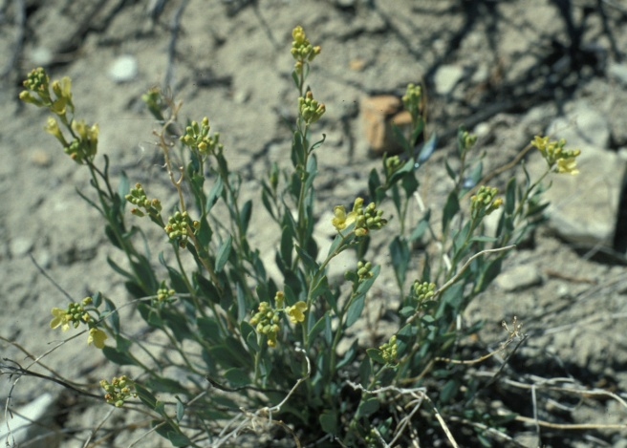

**Uinta Basin waxfruit (Glaucocarpum suffrutescens). Photo by V. Tepedino**

### Alternate Names

Shrubby glaucocarpum

Shrubby reed-mustard

Toad-flax cress

*Hesperidanthus suffrutescens*

*Schoenocrambe suffrutescens*

*Thelypodium suffrutescens*

### Uses

Uinta Basin waxfruit is grazed by rabbits, horses, sheep and cattle (USDI-FWS, 1987). There are no known human uses of this species.

### Status

Uinta Basin waxfruit was listed as an endangered species in 1987 due to its restricted range and number of individuals, and its vulnerability to habitat disturbance (USDI-FWS, 1987). At that time, it was proposed to designate critical habitat for the species. The proposal was however withdrawn, because it was believed that designated critical habitat would expose the population to a significant risk of vandalism (USDI-FWS, 1987).

This species has also been treated historically as a member of the genera *Schoenocrambe* and *Thelypodium*; however, Al-Shehbaz (2005), and subsequently, the Flora of North America,combined *Glaucocarpum,* and *much of Schoenocrambe* into the larger genus *Hesperidanthus.* This change has not yet been adopted by the PLANTS database or USDI Fish and Wildlife Service.

Consult the PLANTS Web site and your State Department of Natural Resources for this plant’s current status (e.g., threatened or endangered species, state noxious status, and wetland indicator values).

### Description

*General*: Mustard family (Brassicaceae). Uinta Basin waxfruit is a perennial subshrub with multiple stems arising from a woody caudex. The plants grow to a height of 10 to 35 cm (4 to 14 in). It has sessile or petiolate leaves with a smooth margin, 10 to 25 mm (0.39 to 1.0 in) long and 3 to 10 mm (0.12 to 0.39 in) wide. The inflorescence is a raceme with 5 to 20 yellow four-petaled flowers, with petals 7 to 11 mm (0.28 to 0.43 in) long. The fruit is a silique (a lengthened pod), 10 to 20 mm (0.39 to 0.79 in) long by 1.2 to 2.5 mm (0.05 to 0.10 in) thick. The seeds are 1.5 to 1.9 mm (0.06 to 0.07 in) long by 0.9 to 1.3 mm (0.4 to 0.5 in) thick.

*Distribution*:

There are three known populations of Uinta Basin waxfruit. The Gray Knolls population sits between the Green River and Hill Creek in Uintah County, Utah, and contains approximately 1,000 plants in three stands. The second population is on Little Pack Mountain and Big Pack Mountain between Hill Creek and Willow Creek in Uintah County, Utah and is comprised of approximately 3,000 plants in six stands. The third population is in Duchesne County, Utah at the base of the Bad Lands Cliff with approximately 1,000 scattered plants. The lands occupied by Uinta Basin waxfruit are managed by the USID-BLM, the Uintah and Ouray Reservation of the Ute Indian Tribe, and the Naval Oil Shale Reserve No. 2 administered by the Department of Energy (USDI-FWS, 1994).

For current distribution, consult the Plant Profile page for this species on the PLANTS Web site.

*Habitat*:

Uinta Basin waxfruit occurs in desert shrub communities with interspersed pinyon (*Pinus edulis*) and juniper (*Juniperus osteosperma*). The dominant species of the habitat include shadscale (*Atriplex confertifolia*), pygmy sagebrush (*Artemisia* *pygmaea*), mountain mahogany (*Cercocarpus* *montanus*), Salina widlrye (*Elymus salina*) and jointfir (*Ephedra* spp.). Several local endemics grow in this unique habitat (USDI-FWS, 1994; Welsh et al., 2003).

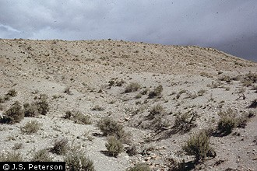

**Uinta Basin waxfruit habitat. Photo by J.S. Peterson, USDA-PLANTS database**

**Adaptation**

Uinta Basin waxfruit is endemic to the Green River Formation, a highly erodible calcareous shale stratum (USDI-FWS, 1994). This species occurs from 1,645 to 1,830 m (5,400 to 6,000 ft) in a 15 to 23 cm (6 to 9 in) precipitation zone (WRCC, 2011).

### Management

Existing threats to Uinta Basin waxfruit include oil and gas exploration, oil-shale mining, stone quarrying, and off-road vehicle (ORV) use. All known populations are found on Federal lands leased for oil and gas energy reserves. Additionally, this species’ range is underlain by oil shale, which may be mined when economic conditions for oil extractions become favorable (USID-FWS, 1994).

Due to its extreme rarity and its long-term decline, downlisting or delisting of Uinta Basin waxfruit is unlikely in the near future. Management goals include the establishment of a minimum of 5 separate populations consisting of 2,000 or more individuals per population. This is to be accomplished by controlling the habitat threatening activities listed above, and by identifying suitable habitat for additional populations and introducing propagated materials (USDI-FWS, 1994).

### Pests and Potential Problems

Historical sheep and cattle grazing use may have impacted Uinta Basin waxfruit on USDI-BLM lands. However current grazing levels are not believed to pose a serious threat (USDI-FWS, 1994).

### Environmental Concerns

### There are no known environmental concerns associated with Uinta Basin waxfruit.

### Seed and Plant Production

Flowering occurs from April to May with fruit ripening in May to June. Individual flowers bloom for 3 to 5 days. Uinta Basin waxfruit is capable of self-pollination, but significantly more seed is produced via cross-pollination. Numerous native, solitary, ground nesting bees have been identified foraging in Uinta Basin waxfruit including *Dialictus* *perdifficilis, D. sedi, Evylaeus pulveris*, and *Andrena* *walleyi* (USDI-FWS, 1994). There has been limited success with propagation attempts (CPC, 2011).

### References

Al-Shehbaz, I. A. 2005. *Hesperidanthus* (Brassicaceae) revisited. Harvard Pap. Bot. 10: 47-51.

Center for Plant Conservation. 2011. Plant profile for *Glaucocarpum suffrutescens*. Online at: http://www.centerforplantconservation.org. Accessed January 13, 2011.

USDI-fish and Wildlife Service. 1987. Endangered and threatened wildlife and plants; final rule to determine *Glaucocarpum suffrutescens* (Toad-flax cress) to be an endangered species. In: Federal Register. 52(193): 37416-37420.

USDI-Fish and Wildlife Service. 1994. Utah reed-mustards; clay reed-mustard (*Schoenocrambe* *argillacea*), Barneby reed-mustard (*Schoenocrambe barnebyi*), shrubby reed-mustard (*Schoenocrambe suffrutescens*) recovery plan. Denver, Colorado. 22p.

Welsh, S.L., N.D. Atwood, S. Goodrich, and L.C. Higgins. 2003. A Utah Flora. Third Edition, revised. Brigham Young University, Provo, UT.

Western Regional Climate Center. 2011. Online. http://www.wrcc.dri.edu/index.html. Accessed January 13, 2011.

**Prepared By**:

*Derek Tilley*; USDA NRCS Plant Materials Center, Aberdeen, Idaho.

*Loren St. John*, USDA NRCS Plant Materials Center, Aberdeen, Idaho.

*Dan Ogle*, USDA NRCS, Boise, Idaho.

### Citation

Tilley, D., L. St. John and D. Ogle. 2011. Plant guide for Uinta basin waxfruit (*Glaucocarpum suffrutescens*). USDA-Natural Resources Conservation Service, Idaho Plant Materials Center. Aberdeen, ID.

Published Jan 2011

Edited: 14Jan2011djt; 14jan2011ls; 14jan2011dgo;

For more information about this and other plants, please contact your local NRCS field office or Conservation District at http://www.nrcs.usda.gov/ and visit the PLANTS Web site at http://plants.usda.gov/ or the Plant Materials Program Web site http://plant-materials.nrcs.usda.gov.

PLANTS is not responsible for the content or availability of other Web sites.

**USDA IS AN EQUAL OPPORTUNITY PROVIDER AND EMPLOYER**