

Plant Guide

# Great Valley Gumweed

## Grindelia camporum Greene

Plant Symbol = GRCA

## Contributed by: USDA NRCS Lockeford Plant Materials Center, California

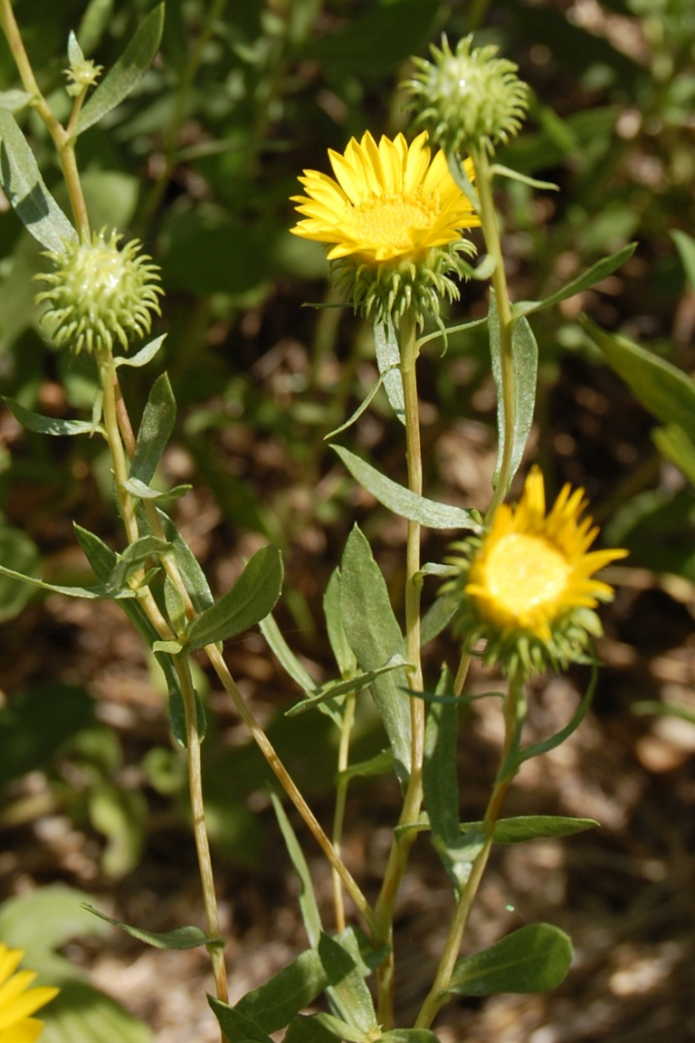

Figure 1: Great Valley gumweed in bloom, with immature flower buds and open flowers. Photo M. Bliss, NRCS Lockeford Plant Materials Center, 2012.

### Alternate Names

*Common Alternate Names:*

common gumplant

Great Valley gumplant

resinweed

boton de oro (golden button)

*Scientific Alternate Names*:

*Grindelia bracteosa* J.T. Howell

*Grindelia camporum* Greene var. *camporum*

*Grindelia camporum* Greene var. *parviflora*

*Grindelia* *hirsutula* Hook. & Arn. var. *davyi* (Jepson) M.A. Lane

*Grindelia* *paludosa* Greene

*Grindelia* *procera* Greene

*Grindelia* *robusta* Nutt.

**Please Note:** The *Grindelia* genusrepresents a highly variable array of ecological forms occurring over a large area of North America in diverse habitats. Some sources have grouped *G. camporum* into a much larger complex under the species name *Grindelia hirsutula*, combining 25 previously separate taxa (Strother, 2006). This genus is currently the subject of extensive genetic research to determine which morphologies represent true phylogenetic differences and how much variability is phenotypic or the result of hybridization (Bartoli, 2012; Moore, 2012; USDA ARS, 2012). Therefore, this plant guide applies best only to *G. camporum* as it was initially described and not under the umbrella grouping of *G. hirsutula*.

**Uses**

*Horticulture:*Great Valley gumweed is an attractive ornamental for use in wildflower meadows and butterfly gardens. It flowers from May to late October or early November, providing color through the summer and autumn months (Munz, 1968; Moore, 2012).

*Wetland Restoration:* This species thrives in disturbed areas, along stream banks, and in alluvial soils (Timmerman, 1987), which makes Great Valley gumweed a good candidate for riparian and wetland restoration projects. Wetland plants have enormous ecosystem importance and help to balance water salinity, prevent soil erosion, and may reduce runoff pollution into waterways.

*Pollinators and Beneficial Insects:* High drought and salt tolerance allows this plant to persist throughout the late summer months when other plants wither, (Hoffman 1986; Timmerman, 1987)making it an important late-season source of pollen and nectar for native bees, honey bees, syrphid flies, and butterflies. For this reason, it is often planted in pollinator meadows and hedgerows. Great Valley gumweed is an obligate out-crosser, meaning it cannot self-fertilize and relies entirely upon the pollination services of insects for reproductive success (Dunford, 1964; Schuck, 1988).

*Medicinal:* Historically, Great Valley gumweed has been used in herbal remedies to treat respiratory maladies, dermatological conditions, blood disorders, and minor injuries (See Ethnobotany below). *Grindelia* is presently available from herbal supplement stores and is touted for its anti-inflammatory, expectorant, and pain relieving properties.

**Warning:** Great Valley gumweed may contain high levels of selenium, which is toxic when ingested in large amounts.

*Resin Production:* Great Valley gumweed is so-named for the tacky residue produced in multicellular glands and ducts coating the plants’ flower heads and leaves. For many years, the value of gumweed “gum” has been known to chemists who have sought turn the plant into a valuable cash crop in arid regions. The resins produced by *Grindelia* are not true polysaccharide gums, but diterpene acids that serve an important use in the naval stores industry (Hoffman, 1986; Timmerman, 1987). These specialty chemicals are used in a variety of industrial applications such as soil amendments, rubber production, animal feed supplements, paper sizing, fermentation products, synthetic fuels, paints, varnishes, and lacquers (Hoffman, 1986). *Grindelia camporum* is an excellent candidate for producing these chemicals; labdene-type acids account for approximately 10% of the plant’s dry weight. This substance is hydrophobic, non-volatile, and virtually identical to rosins found in pine and other woods traditionally used in naval stores production, but is less labor-intensive to extract, and ideal for growing in the American southwest, where water is a limiting factor (Hoffman, 1986). Gumweed trials for resin production have occurred in Tucson, Arizona and Lahore, Pakistan (Zafar, 1994).

### Status

Great Valley gumweed is classified as a facultative upland plant; it usually occurs in non-wetland areas, but is occasionally found in wetlands. Please consult the PLANTS Web site and your State Department of Natural Resources for this plant’s current status (e.g., threatened or endangered species, state noxious status, and wetland indicator values).

### Weediness

This plant may become weedy in orchards if not properly managed. Please consult with your local NRCS Field Office, Cooperative Extension Service office, state natural resource, or state agriculture department regarding its status and use. Weed information is also available from the PLANTS Web site at <http://plants.usda.gov/>. Please consult the Related Web Sites on the Plant Profile for this species for further information.

### Description

*General:* Great Valley gumweed, a member of the sunflower family (Asteraceae), is a perennial, semi-woody subshrub native to central California. There are approximately 60 species within the genus *Grindelia* distributed between North and South America. Intermediate forms are common where species ranges overlap (Dunford, 1964; Moore; 2012).

Great Valley gumweed grows 2–8 feet tall but dies back in the winter to a basal rosette of leaves before bolting again from the perennial rootstock (Hoffman, 1986). The gangly, branched stems appear white-varnished and are generally leafy and upright with tips ascending. Leaves are lance-shaped (lanceolate) to ovate, alternate, and stalkless, often with clasping bases. They have entire or serrate margins, grow up to 2½ inches long and ½ inch wide, are slightly wider near the tip, and are dotted with stalked glands that produce a sticky resin (Moore, 2012).

Plants flower from May to November. Immature flower heads are spheroid and ooze sticky, white latex that gives them a milky appearance. When open, the daisy-like flower heads are 1 to 2 inches across and are composed of 25–39 yellow petal-like ray flowers 1/3 to 4/5 inch long surrounding the yellow disk flowers in the center. Below the flower heads is the involcre, a whorled cup of sticky-glandular, green bracts (phyllaries) with long, thin tips that are spreading or sometimes curved back from the flower head. Fruits are small, wind-borne, dandelion-like achenes with featherlike tufts of two to several firm, but deciduous, awns. The seeds themselves are somewhat flattened, 3/8 inch long, and 1/16 inch wide (Moore, 2012)..

The specific taxonomy of this plant is very complex, making identification a difficult task best suited for trained botanists.

*Distribution*: Great Valley gumweed is native to central California. It is found primarily in the Sacramento and San Joaquin Valleys. However, the plant may also be found to the east, across the North Coast Ranges and around the San Francisco Bay, north to the Cascade Range foothills, west along the Sierra Nevadas, and south along the outer Southern Coast Ranges into Baja California (Moore, 2012). There are historical records of introductions to Pennsylvania (Steyermark, 1934) and Massachusetts (Robinson, 1924). For updated distribution, please consult the Plant Profile page for this species on the PLANTS Web site.

*Habitat*: This plant may be found in sandy or saline bottomlands, dry banks, rocky fields, plains, and roadsides (Munz, 1968; Moore, 2012).

**Ethnobotany**

Native Americans regarded Great Valley gumweed as a useful medicinal plant for a variety of treatments, including respiratory and dermatological afflictions.

The Costanoan Indians boiled leaves and flower heads of gumweed for healing dermatitis caused by poison oak, and for wounds, burns, boils, and sores (Bocek, 1984; Foster, 2002). The Kawaiisu people used a similar decoction as a general analgesic and orthopedic aid, applying the plant material to their sore muscles (Zigmond, 198; Foster 2002), and Miwok Indians used fresh, resinous buds as a treatment for blood disorders (Merriam, 1966). These Native American remedies were so effective that many were adopted by early physicians of Western medicine in California (Foster, 2002).

**Adaptation**

Within its historical range, Great Valley gumweed occurs across a wide variety of habitats, often eking out a niche where other plants are not adapted to survive. It can grow in highly alkaline soils, and is one of few actively growing plants during the dry central Californian summers (Hoffman, 1986; Timmerman, 1987). Great Valley gumweed is hardy to zone 9 and grows below 4600 feet (Moore, 2012).

### Establishment

Propagation is easiest from seed, and germination rates are generally high. Achenes placed under a thin layer of soil on wet filter paper at ambient temperature and diffuse light germinate at around 70%, but an 8-day cool pretreatment at 46°F can raise these rates slightly (McLaughlin, 1987; Zafar, 1994). Germination usually occurs at 2 to 3 weeks at 50–60°F. Seed can be propagated in containers and transplanted, or sown directly on-site in the fall or spring, though October plantings tend to produce higher yields with lower irrigation requirements (McLaughlin, 1987). There are approximately 229,600 seeds per pound. The recommended single-species seeding rate is about 1 pound per acre at a depth of ¼ to ½ inch, or about 0.5 lb/acre in a mix. Plants may also be propagated vegetatively by root or stem cuttings, but these methods are very labor-intensive and result in fairly low establishment rates. Plants do best in full sun on well drained soil. In winter, the plant dies back, but rebolts from perennial rootstock in the spring (Hoffman, 1986). Seed collection is easiest by hand. Inflorescences are thoroughly dried and crushed. Achene awns separate easily and may be screened and sorted by weight.

### Management

Once established, plants require little management. The will tolerate high mowing during spring and summer and a low mow in fall that breaks up dead vegetation.

### Pests and Potential Problems

Although Great Valley gumweed attracts many pollinators, no insects are known to cause damage to the plant. The highly resinous nature of gumweed defends against herbivory from insects (Severns, 2009) and possibly larger herbivores such as deer. There are no known diseases of this plant.

### Environmental Concerns

There are no known environmental concerns associated with Great Valley gumweed.

### Control

Please contact your local agricultural extension specialist or county weed specialist to learn what works best in your area and how to use it safely. Always read label and safety instructions for each control method.

### Seeds and Plant Production

### Stands of Great Valley gumweed have been raised in many arid regions of the world, but the planting for each stand depends on climate. For commercial plantings, fluid-drilling of pretreated seeds has been used (Zafar, 1994) with an optimum density of 32,400 plants per acre (McLaughlin, 1987). Pretreated seeds were soaked under continuous light for optimum germination at 50-68°F, but this pretreatment could be substituted for a two-stage cold stratification at 32°F followed by 59°F in the dark (McLaughlin, 1987; Zafar, 1994). Since the plant is salt and drought tolerant, very little irrigation or soil treatments are needed. In successful commercial plantings the soil was classified as poor to low-fertile (Zafar, 1994). Plants may be harvested twice in a growing season, first in June and then in October by hand-cutting the stems 2 – 4 inches above ground. Harvested plants may then be air dried in an oven at 203°F, and resin extracted by milling each part of the plant and using dichloromethane in a Soxhelt extractor (Zafar, 1994).

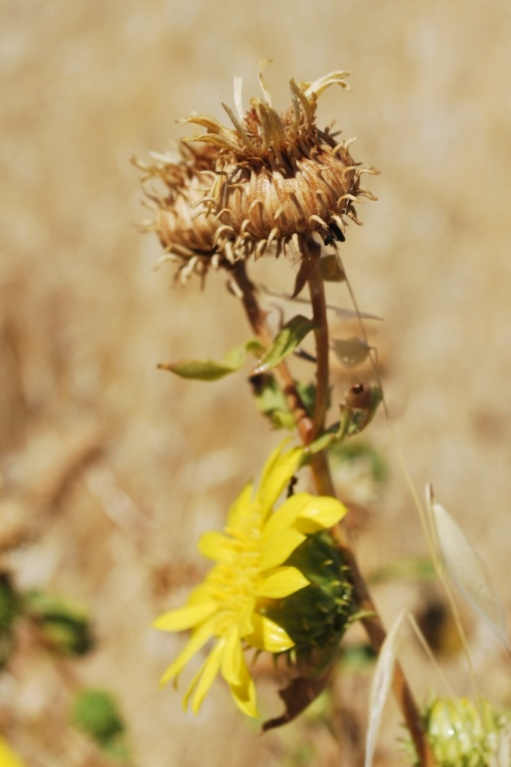

Figure 2: Mature Great Valley gumweed flower heads in seed. Photo M. Bliss, NRCS Lockeford Plant Materials Center, 2012

### Cultivars, Improved, and Selected Materials (and area of origin)

There are no developed cultivars of Great Valley gumweed, but seed is generally available from commercial sources both individually and in pollinator mixes. Container plants are also sometimes available from native plant nurseries in the Central Valley and surrounding foothills.

### References

Bartoli, A., and R.D. Tortosa. 2012. Revision of the North American species of *Grindelia* (Asteraceae). Annals of the Missouri Botanical Garden. 98(4):447-513.

Bocek, B.R. 1984. Ethnobotany of Costanoan Indians, California, based on collections by John P. Harrington. Economic Botany 38(2):240-255 (p. 26).

Dunford, M.P. 1964. A cytogenetic analysis of certain polyploids in *Grindelia* (Compositae). Amer. J. Bot. 51(1): 49-56.

Foster, S, and C. Hobbs. 2002. A field guide to western medicinal plants and herbs. Houghton Mifflin Company, New York. (p.132).

Hoffmann, J. J., and S. P. McLaughlin. 1986. *Grindelia camporum*: potential cash crop for the arid southwest. Economic Botany 40: 162-169.

McLaughlin, S. P., and J. D. Linker. 1987. Agronomic studies on gumweed: seed germination, planting density, planting dates, and biomass and resin production. Field Crops Research 15: 357-367.

Merriam, C.H. 1966. Ethnographic notes on California Indian tribes. University of California Archaeological Research Facility, Berkeley (p. 338).

Moore, A. 2012. Treatment of *Grindelia*. 2012. The Jepson Manual: Vascular Plants of California. 2nd ed. University of California Press, Berkeley.

Munz, P.A. and D.D. Keck. 1968. A California flora with supplement. Univ. of California Press, Berkeley.

Robinson, B.L., editor. 1924. Reports on the flora of the Boston district XLVI. Rhodera 26:108.

Schuck, S. M., and S. P. McLaughlin. 1988. Flowering phenology and outcrossing in tetraploid *Grindelia camporum* Greene. Desert Plants 9: 7-16.

Severns, P.M and E. Karacetin. 2009. Sex bias adult feeding for gumweed (Asteraceae) flower nectar and extrafloral resin by a wetland population of *Lycaena xanthoides* (Boisduval) (Lycaenidae). Journal of the Lepidopterists’ Society 63(2): 83-86.

Steyermark, J. A. 1934. Studies in *Grindelia* II: a monograph of the North American species of the genus *Grindelia*. Annals of the Missouri Botanical Garden 21: 433-608.

Strother, J.L. and M.A. Wetter. 2006. Treatment of *Grindelia*. Flora of North America 20: 424-425.

Timmermann, B. N., S. P. McLaughlin, and J. J. Hoffmann. 1987. Quantitative variation of grindelane diterpene acids in 20 species of North American *Grindelia*. Biochemical Systematics and Ecology 15:401-410.

USDA, ARS, National Genetic Resources Program. *Germplasm Resources Information Network - (GRIN)* [Online Database: http://www.ars-grin.gov/cgi-bin/npgs/html/paper.pl?language=en&chapter=scient 27 March 2012)]. Natl. Germplasm Resources Laboratory, Beltsville, Maryland.

Zafar, S. I., W. H. Shah, and Z. U. Rehman. 1994. Studies on achene germination, transplantability, saltinity tolerance, and cultivation of gumweed (*Grindelia camporum*) in hot and semi-arid conditions. Field Crops Research 37:77-84.

Zigmond, Maurice L. 1981. Kawaiisu ethnobotany. Salt Lake City. University of Utah Press (p. 33)

**Prepared By**: Marc Bliss, USDA-NRCS Lockeford Plant Materials Center, California

### Citation

Bliss, M. 2012. Plant guide for Great Valley gumweed (*Grindelia camporum)*. USDA-Natural Resources Conservation Service, Plant Materials Center, Lockeford, CA.

Published *August, 2013*

Edited: 02oct2012 pbnj, 10Dec2012 msk, 7Jun2013 jb

For more information about this and other plants, please contact your local NRCS field office or Conservation District at <http://www.nrcs.usda.gov/> and visit the PLANTS Web site at <http://plants.usda.gov/> or the Plant Materials Program Web site <http://plant-materials.nrcs.usda.gov>.

PLANTS is not responsible for the content or availability of other Web sites.

**USDA IS AN EQUAL OPPORTUNITY PROVIDER AND EMPLOYER**