|  |
| --- |
| NEEDLE-And-Thread |
| Hesperostipa comata  (Trin. & Rupr.) Barkworth |
| Plant Symbol = HECO26 |

Contributed by: USDA NRCS Idaho State Office

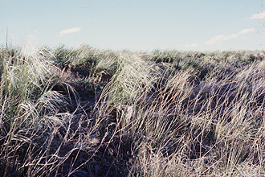

©W.L. Wagner. Courtesy of [Smithsonian Institution, Dept. of Systematic Biology, Botany](http://www.nmnh.si.edu/botany/).

Alternate Names

*Stipa comata;* spear-grass

Uses

Grazing/Livestock- Needle-and-Thread begins growth early in the spring, goes dormant in early to mid-summer and may green-up in fall if soil moisture is adequate. It is considered good forage in spring prior to awn development and again in fall after seed is dropped. When grazed while awned seeds are present, the sharp-pointed seed may injure livestock by working into tongue, throat, eyes and ears.

Wildlife- It is desirable forage for elk in winter and spring and considered desirable forage for deer in spring.

Erosion Control/Reclamation- It is a very effective grass in preventing wind erosion on sandy soils. It is one of the first grasses to naturally establish in disturbed sandy sites. It can be used in seeding mixtures for revegetation of sandy sites and sites disturbed by mining activities.

Status

Consult the PLANTS Web site and your State Department of Natural Resources for this plant’s current status (e.g. threatened or endangered species).

Description

Genera*l*: Needle-and-Thread is a native, tufted, cool-season grass common to the prairies, plains and foothills of the western United States. It is a perennial bunchgrass, 1- 4 feet tall with erect, smooth culms and long, flat leaves 8- 12 inches long. The inflorescence is a contracted panicle that remains partially in the sheath. The source of its name is the 4- 5 inch long twisted awn which arises from the lemma. It detaches from the inflorescence with the seed and gives the appearance of a short needle and long thread. The ligule, an identifying characteristic, is membranous and split.

Distribution: This grass is found from British Columbia and the Yukon to Ontario, south to California, New Mexico and Texas.

Habitat: Needle-and-Thread is an important plant in a wide variety of plant communities throughout western Canada and the United States. It can be found in the Palouse region of Idaho, Oregon and Washington and mountain foothills of British Columbia, Alberta, Idaho, Montana, Oregon and Washington associated with bluebunch wheatgrass, Idaho fescue, and bluegrass plant communities. In the northern Great Plains it is found in association with western wheatgrass, blue grama and bluebunch wheatgrass plant communities. In the central Great Plains it can be found in bluestem, gramagrass and prairie sandreed plant communities. In the arid regions of Idaho, Nevada, Oregon, Utah, and Wyoming it is found in association with sagebrush, saltbush, horsebrush, bitterbrush, winterfat, Sandberg bluegrass, Indian ricegrass, and thickspike wheatgrass plant communities. This species is a fairly early vegetative component on sand dunes in the intermountain region. On sand dune soils in southern Idaho, it follows the establishment of yellow wildrye and scurf pea and establishes before Indian ricegrass and thickspike wheatgrass.

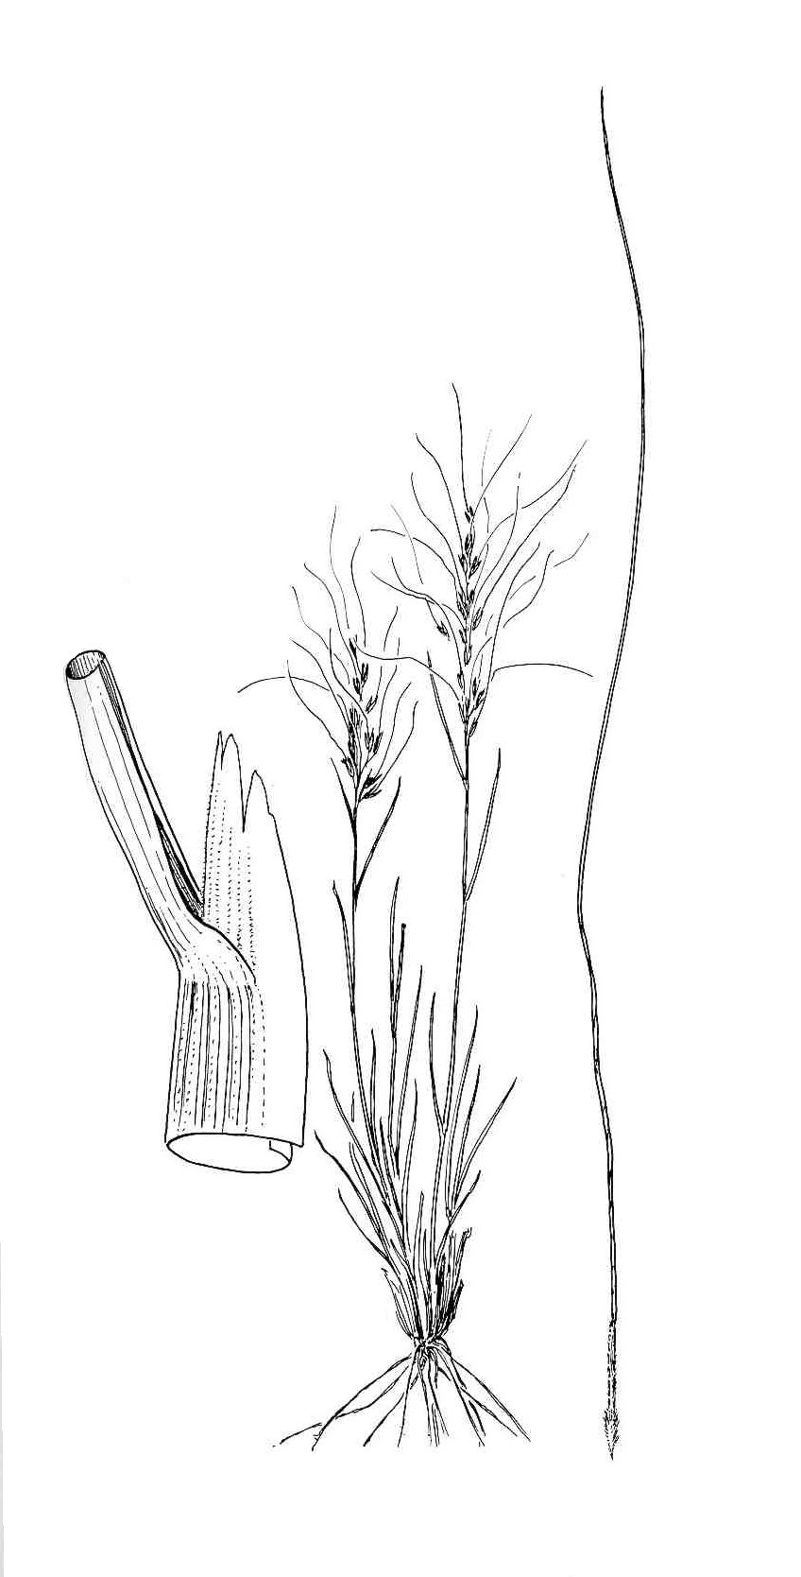

Intermountain Flora - drawn by Jeanne R. Janish.

University of Washington Press.

Adaptation

Needle-and-Thread is very drought tolerant and prefers excessively drained sands to fine sandy loams to coarse gravelly loam soils, but is also found on loam to clay loam soils in some habitats. It is most commonly found in 7- 16 inch precipitation zones, but occasionally is found in areas receiving as low as 5- inches to as much as 24- inches mean annual precipitation.

Its elevation range is most common from 3500 to 8500 feet, but it has been found at elevations as low as 1000 feet.

Establishment

This species has fairly high levels of seed dormancy. If seed is less than 2- years old, it should be planted in late fall as a dormant planting to assist with breaking the seed dormancy. Older seed can be planted in early spring. Seed should be planted about ¾- inch deep on loamy soils, about ½- inch deep on clay soils and up to 1- inch deep on sandy soils.

Short prechill treatments (30 to 60 days) can induce a secondary dormancy, reducing seed germination (Scianna 2005). Tests show that seed with no prechill or 120 days prechill readily germinate, but seed prechilled 30 to 60 days had reduced germination of 37 and 68% respectively. Based on this study dormant fall planting or late spring planting will produce the best stands.

Because of its broad range of adaptation, native seed mixtures should specify "Source Identified" seed from locations within 500 miles of the planting site. Great Plains collections and Intermountain West collections do best within their own ecoregions.

There is an average of 115,000 seeds per pound. The recommend full seeding rate is 6 pounds PLS per acre. Seeding mixtures should specify a percentage of this rate.

Management

Needle-and-Thread begins growth in early spring, flowers in June and matures seed in July, goes dormant in early to mid-summer and may green-up in fall if soil moisture is adequate.

It is considered good forage in spring prior to awn development and again in fall after seed is dropped. When grazed while awned seeds are present, the sharp-pointed seed may injure livestock by working into tongue, throat, eyes, ears and hide. It cures well and provides fair to good winter forage.

It generally increases under grazing except in sandy soils and the central Great Plains where it decreases under grazing pressure. It needs to set seed in order to establish new plants, thus deferred rotation grazing systems are recommended.

Pests and Potential Problems

It is not known to be vulnerable to insects or other pests.

Environmental Concerns

Needle-and-Thread is a native species which spreads via seed. It is not considered to be "weedy" or an invasive species, but it can spread into adjoining vegetative communities under ideal climatic and environmental conditions. Its rate of spread is slow.

Needle-and-Thread is known to hybridize with closely related species, Indian ricegrass. These hybrids are sterile.

Seed Production

Seed production of Needle-and-Thread has been somewhat successful under cultivated conditions.

Row spacing of 24- 36 inches under irrigation or high precipitation (>16 inches annual precipitation) to 36- 48 inches under dryland conditions are recommended. Seeding rates for seed production range from 2.9- 4.3 (48- 36 inch rows) pound PLS per acre on dryland to 4.3- 5.7 (36- 24 inch rows) pound PLS per acre under irrigated conditions.

It should be seeded in locations where weeds are well controlled. Needle-and-Thread seedlings are slow to establish and are therefore vulnerable to mechanical (wheel and foot traffic) and chemical damage. Wait until the 3- 5 leaf stage before applying herbicides at a low rate (bromoxynil according to label) or clipping for weed control. Cultivation between rows will be needed for weed control and to maintain row culture.

Seed fields are productive for about 3- 4 years. Field moisture during the fall, soil fertility, and plant re-growth determine the yield the succeeding year.

Average production of 100 pounds per acre can be expected under dryland conditions in 16- inch plus rainfall areas. Average production of 150 pounds per acre can be expected under irrigated conditions.

Harvesting can be completed by direct combining in the hard-dough stage (seed turning brown) or by windrowing followed by combining. Windrowing may help ensure a more complete threshing. Windrowing also reduces the risk of loss of seed from wind. Seed is generally harvested from late July to late August. Seed must be dried immediately after combining (moisture content should be 12 percent in bins/15 percent in sacks). Brush-type seed strippers work well in harvesting seed of this species, as the long twisted awns of the mature seed are readily pulled into the hopper, leaving the immature straight awned seed in the inflorescence. Stripping seed must be immediately dried.

Seed should be stored in plastic woven sacks – not cotton or burlap sacks. Sharp seeds will become caught in cotton and burlap fabric. Awn should be removed as soon after harvest as possible or it becomes intertwined with other seed making seed processing very difficult.

Because of the difficulty in harvesting and conditioning, the forage can be harvested at time of seed maturity and the baled forage used as mulch on planting sites. Shattered seed will naturally plant itself when changes in relative humidity cause the awn to twist, driving the seed into the soil surface.

Cultivars, Improved, and Selected Materials

No releases are presently available.Contact your local Natural Resources Conservation Service (formerly Soil Conservation Service) office for more information. Look in the phone book under ”United States Government.” The Natural Resources Conservation Service will be listed under the subheading “Department of Agriculture.”

References

Alderson, J. and W. C. Sharp. 1994. *Grass varieties in the United States.* Agriculture Handbook No. 170. USDA, SCS, Washington, DC.

Cronquist, A., A.H. Holmgren, N.H. Holmgren and J.L. Reveal. 1977. *Intermountain Flora: Vascular Plants of the Intermountain West*, U.S.A. The New York Botanical Garden.

Hitchcock, A.S. (rev. A. Chase). 1950. Manual of the grasses of the United States. USDA Misc. Publ. No. 200. Washington, DC. 1950.

Ogle, D. G., L. St. John, M. Stannard and L. Holzworth. 2006. Technical Note 24: *Grass, grass-like, forb, legume, and woody species for the intermountain west*. USDA-NRCS, Boise, ID. 42p.

Scianna, J.S. 2005. Needlegrass Dormancy Study. In USDA-NRCS Bridger PMC Annual Technical report 2004-2005. Bridger, MT.

Smith, R., S. Smith, R. Haas, and L. Holzworth. 1998. *Native Grass Seed Production Manual,* USDA-NRCS, Bismarck, ND and Ducks Unlimited Canada. 155 p.

USDA, NRCS. 2006. The PLANTS Database, Version 061010. [(http://plants.usda.gov)](http://plants.usda.gov/). [National Plant Data Center](http://npdc.usda.gov/npdc/index.html), Baton Rouge, LA 70874-4490 USA.

Prepared By

*Daniel G. Ogle*

USDA-NRCS, Idaho State Office, Boise, ID

*Mark Majerus*

USDA-NRCS, Plant Materials Center, Bridger, MT

*Loren St. John*

USDA-NRCS, Plant Materials Center, Aberdeen, ID

*Derek Tilley*

USDA-NRCS, Plant Materials Center, Aberdeen, ID

*Dr. Thomas A. Jones*

USDA-ARS, Forage & Range Research Laboratory, Logan, UT

Species Coordinator

*Daniel G. Ogle*

USDA-NRCS, Idaho State Office, Boise, ID

Edited: 05oct06dgo; 09maydjt; 11may06ls; 05june06mm; 05june06taj; 10oct06jsp

For more information about this and other plants, please contact your local NRCS field office or Conservation District, and visit the PLANTS Web site<<http://plants.usda.gov>> or the Plant Materials Program Web site <<http://Plant-Materials.nrcs.usda.gov>>

*The U.S. Department of Agriculture (USDA) prohibits discrimination in all its programs and activities on the basis of race, color, national origin, sex, religion, age, disability, political beliefs, sexual orientation, and marital or family status. (Not all prohibited bases apply to all programs.) Persons with disabilities who require alternative means for communication of program information (Braille, large print, audiotape, etc.) should contact USDA's* [*TARGET Center*](http://www.usda.gov/oo/target.htm) *at 202-720-2600 (voice and TDD).*

*To file a complaint of discrimination write USDA, Director, Office of Civil Rights, Room 326-W, Whitten Building, 14th and Independence Avenue, SW, Washington, DC 20250-9410 or call 202-720-5964 (voice or TDD). USDA is an equal opportunity provider and employer.*

*Read about* [*Civil Rights at the Natural Resources Convervation Service*](http://www.nrcs.usda.gov/about/civilrights/)*.*