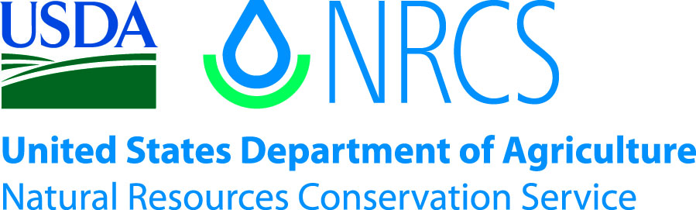

Plant Guide

# Ashy sunflower

## Helianthus mollis Lam.

Plant Symbol = HEMO2

*Contributed by*: USDA NRCS Golden Meadow and East Texas Plant Materials Centers

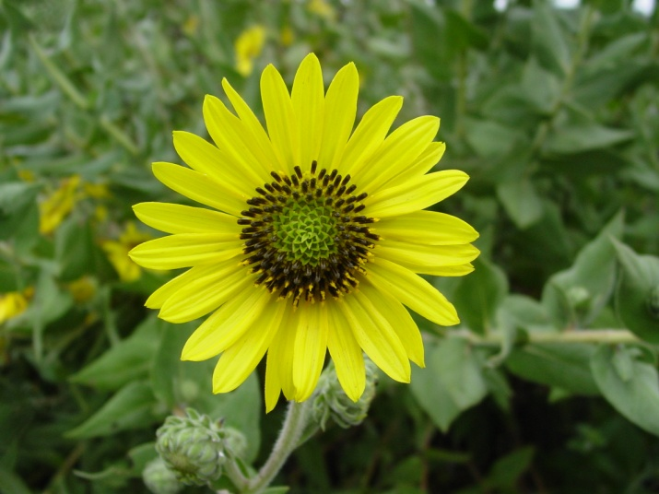

*Ashy sunflower. Photo taken by Gary Fine, Bayou Land RC&D*

### Alternate Names

Downy sunflower, Hairy wild sunflower

### Uses

*Conservation/Restoration*: Ashy sunflower can be used to increase forb diversity in conservation and restoration plantings. It has potential for use in soil erosion prevention with its perennial root crowns and rhizomatous root system. Annual stems are produced from underground rhizomes, allowing ashy sunflower to spread and form dense plant clusters, reinforcing soil and preventing erosion.

*Livestock*: Similar to other sunflower species, ashy sunflower is palatable and nutritious to all classes of livestock, and is readily utilized.

*Wildlife*: Ashy sunflower is attractive to a wide array of pollinating insects. Bumblebees, Miner bees, large Leaf-Cutting bees, Cuckoo bees, Green Metallic bees, and other Halictid bees visit the flowers along with several species of butterflies and bee flies. The foliage is an important food source for the caterpillars of the butterflies *Chlosyne nycteis* (Silvery Checkerspot) and *Chlosyne gorgone* (Gorgone Checkerspot). The seed is utilized by many species of game and non game bird species, including but not limited to mourning dove, greater prairie chicken, ringed-neck pheasant, bobwhite, goldfinch, horned lark, eastern meadowlark, lark sparrow, savannah sparrow and cardinal. Seeds and young foliage is consumed by small rodents, deer, rabbits, and livestock (Hilty, 2012). Habitat and cover are provided to birds and small mammals by individual plant clusters and dense colonies formed with other shrub like plants.

*Ornamental*: The bright yellow flowers and unique grayish-green, neatly shaped, densely hairy leaves of ashy sunflower make it an excellent candidate for use in native gardens.

### Status

Please consult the PLANTS Web site and your State Department of Natural Resources for this plant’s status (e.g., threatened or endangered species, state noxious status, and wetland indicator values).

### Description

Ashy sunflower is a native, warm-season; perennial forb typically found growing in well-drained soils and full sun. Stems are erect, solitary or clustered, densely pubescent gray, growing from rhizomes to 1.2 m tall. Leaves are opposite, stiff, ascending, sessile and clasping with a rough-hairy grayish-green surface to 12 cm long and 8 cm wide. Leaf margins are entire to shallowly toothed with a pointed tip. Inflorescence consists of single flower heads positioned on terminal stems. Flowers exhibit 15-30 yellow petals (sterile ray florets), 2.5-3 cm long encompassing fertile yellow disk florets compressed to 2.5 cm in diameter. Each disk floret has a glabrous corolla tube to 6 mm long, and five stamens with whitish filaments and dark-brown anthers. Fruits are achenes that are wedge shaped, dark-brown or black, and tipped by two scales with pointed tips each enclosing a small single seed 3-6 mm in length.

**Ethnobotany**

It is reported that this species was used as a fever reducer. Strong teas were made from the leaves to reduce fever. Honey was added to teas to loosen phlegm, and the stems were used as a treatment for malaria (Styles, 2000).

*Distribution*:

Ashy sunflower is found throughout the eastern half the United States, as far west as Nebraska and northward into Canada. It has not been reported in Florida, which may be the extent of its southern range. For current distribution, please consult the Plant Profile page for this species on the PLANTS Web site.

*Habitat:*

Ashy sunflower is historically a species of the prairies and open grasslands. It may also occur on dry, sandy soils along roadsides, savannas, woodland edges and openings, and old fields (Taylor, 2012).

**Adaptation**

Ashy sunflower prefers full sun and mesic to dry conditions. It will tolerate poor soil conditions and low pH, and will grow aggressively in fertile soils with good moisture. It will tolerate harsh winter conditions growing as far north as Maine, Wisconsin, and Michigan. Ashy sunflower was introduced into Ontario, Canada where it continues to persist along roadsides and protect areas (eFloras, 2008).

### Establishment

### Begin seedbed preparation in advance of spring planting. Prepare a clean, weed free seedbed by either tillage or herbicides. The use of herbicide and a no-till drill is an effective way to obtain stands with minimal weed pressure. Tillage often increases weed pressure and should be avoided unless there are no other means to plant. Broadcast seeding onto a prepared seedbed may be used, but additional coverage such as cultipacking or light dragging should used to ensure good seed to soil contact. Number of seed/lb is reported to range from 112,000 - 2.5 million (USDA-NRCS, 2011, Steffen, 1997) resulting in an average seeding rate of 1.0 to 8.0 pounds of pure live seed (PLS) per acre when based on planting 20 live seed per square foot.

Seed should be planted approximately ¼-inch deep. Timing plantings to rainfall events will help to insure good stands. In planting mixtures, reduce the rate according to the percent of ashy sunflower desired.

### Management

Ashy sunflower, once established, requires little maintenance. Irrigation should be used, if available to help plants establish until they are mature. Weeds may be controlled via selective herbicide or cultivation as necessary. Allow ashy sunflower colonies to occasionally produce seed to aid in stand renewal and longevity. Mowing may also be used to control annual weeds until the sunflower seedlings can compete or out compete weed species.

### Pests and Potential Problems

Ashy sunflower is easy to grow and not subject to serious problems with foliar disease. Longhorn beetle (*Dectes texanus*)*,* a stem boring insect can damage plants in some areas of the country but has not drastically affected seed production (Patrick, 1998). Other insects known to bore stems and feed on foliage include; Rigid Sunflower Borer Moth (*Papaipoma rigida*)*,* Sunflower Borer Moth (*Papaipoma necopina*), Burdock Borer Moth (*Papaipoma cataphracta*), Blackberry Looper Moth (*Chlorochlamys chloroencaria*), Common Looper Moth (*Autographa precautionis*), Sunflower Gall Moth (*Gnorimoschema sp.*), Frothy Moth (*Stibadium spumosum*), Spur-Throated Grasshopper (*Melanoplus angustipennis*), Leaf Beetle (*Trirhabda and Ophraella* spp*.*), Leaf Miner Beetle (Microorhapala cyanea), and Four-Lined Plant Bug (*Poecilocapsus lineatus*) (Hilty, 2012).

### Environmental Concerns

In a study by Anderson et. al (1978), ashy sunflower seemed to have an allelopathic affect on radish and wheat root and shoot development, and inhibited radical development of little bluestem. It can become aggressive under ideal conditions forming dense stands.

### Seeds and Plant Production

### At the East Texas Plant Materials Center (ETPMC), seed production fields are drilled in early spring after the last freeze date on 40” rows. Baskin (2002) noted that ashy sunflower seeds exhibited physiological dormancy and recommended cold moist stratification for 60 days before germination testing. Germination tests at the ETPMC comparing stratified to non-stratified seed revealed that stratification did not appear to improve seed germination with all samples averaging between 61% to 86% germination. Planting in early spring when soil temperatures are still cool will help with the stratification if seed dormancy is suspected.

Fields should be irrigated to aid seedling establishment. Fertilization is not recommended during establishment years as it promotes competition from warm season, annual weed species. Irrigation should be used sparingly on mature stands as it can lead to lodging due to excessive and rapid growth. Fertilization of established stands should follow soil test recommendations and should be applied in late spring. Seed is harvested by direct combine in late October. Seed from the combine is scalped to remove excess vegetative matter, and air-dried in a forced air-drying bin with no heat. Seed may also be dried by spreading on a concrete floor in a thin layer and allowing a fan to circulate air over the seed. Turn the seed daily or until sufficiently dried. This will prevent molding and mildew. Seed may then be cleaned using a multi-screen seed cleaner and bagged for storage. Cleaned seed yields at the ETPMC average approximately 100 pounds per acre.

### Cultivars, Improved, and Selected Materials (and area of origin)

Cajun Sunrise Germplasm ashy sunflower was released cooperatively in 2012 by the USDA-Natural Resources Conservation Service (NRCS) Golden Meadow Plant Materials Center, the USDA-NRCS East Texas Plant Materials Center, and the Louisiana Native Plant Initiative partners. This plant release is a composite selection of ten seed collections from Jefferson Davis Parish near the town of Fenton in southwestern Louisiana. Cajun Sunrise Germplasm ashy sunflower was selected based on superior plant vigor, seed germination, and seed production. The primary uses for this release are coastal prairie revegetation/restoration, wildlife habitat improvement, and enhancing pollinator habitat. Breeder seed (G0) is maintained at the USDA-NRCS East Texas Plant Materials Center, Nicholls State University Farm, University of Louisiana Lafayette-Center for Ecology and Environmental Technology, and McNeese State University Agriculture Farm. Seed for commercial production will be distributed through the Louisiana Native Plant Initiative partnerships by contacting the Golden Meadow Plant materials Center.

### References

Anderson, R.C., Katz, A.J., and Anderson, M.R. 1978. Allelopathy as a factor in the success of Helianthus mollis Lam. J. Chem. Ecol., vol.4, No.1, pp. 9-16.

Baskin, C.C. and J.M. 2002. Propagation protocol for production of container *Helianthus mollis* Lam. plants; University of Kentucky, Lexington, Kentucky. In: native Plant Network. URL: http://www.native plant network.org (accessed 3 July 2012). Moscow (ID): University of Idaho, College of Natural Resources, Forest Research Nursery.

Taylor, D. 2012. Celebrating Wildflowers. 2012. Accessed 23 July 2012. USDA Forest Service, Rangeland Management Botany Program, Washington D.C.  
<http://www.fs.fed.us/wildflowers/plant-of-the-week/helianthus_mollis.shtml>

eFloras. 2008. Accessed 22 July 2012. Missouri Botanical Garden, St. Louis, MO & Harvard University Herbaria, Cambridge, MA. <http://www.efloras.org/florataxon.aspx?flora_id=1&taxon_id=242416635>

Hilty, J. 2012. Illinois Wildflowers. Accessed 23 July 2012 <http://www.illinoiswildflowers.info/prairie/plantx/dwn_sunflowerx.htm>

Patrick, C. D. 1998. Managing Insect Pest of Texas Sunflowers, Texas Agricultural Extension Service Bulletin No. 1488, p3.

Styles, B. 2000. Prairie Plants Field Guides. Illinois State Museum. Accessed 23 July 2012. <http://www.museum.state.il.us/muslink/prairie/htmls/plants/H-mollis.html>

Steffen, J.F. 1997. Seed treatment and propagation methods, in Packard, S., and Mutel, C.F., eds., The Tallgrass Restoration Handbook for prairies, Savannas, and Woodlands: Washington, D.C., Island Press, 463 pages.

USDA-NRCS. 2011. Illinois Conservation Practice Standard, CP 327 Conservation Cover. Accessed 20 June 2012. <http://efotg.sc.egov.usda.gov/references/public/IL/IL327.pdf>.

**Prepared By**:

*Garret Thomassie, Manager*

*USDA-NRCS Golden Meadow Plant Materials Center, Galliano, Louisiana*

*Alan Shadow, Manager*

*USDA-NRCS East Texas Plant Materials Center,*

*Nacogdoches, Texas*

*Melinda Brakie, Soil Conservationist*

*USDA-NRCS East Texas Plant Materials Center, Nacogdoches, Texas*

### Citation

Thomassie, G., Shadow, A., and Brakie, M. 2012. Plant Guide for ashy sunflower (*Helianthus mollis* Lam.). USDA-Natural Resources Conservation Service, Golden Meadow Plant Materials Center. Galliano, LA 70354.

Published August, 2012

Edited:

For more information about this and other plants, please contact your local NRCS field office or Conservation District at <http://www.nrcs.usda.gov/> and visit the PLANTS Web site at <http://plants.usda.gov/> or the Plant Materials Program Web site <http://plant-materials.nrcs.usda.gov>.

PLANTS is not responsible for the content or availability of other Web sites.

**USDA IS AN EQUAL OPPORTUNITY PROVIDER AND EMPLOYER**