

Plant Guide

# PALEyellow iris

## Iris pseudacorus L.

Plant Symbol = IRPS

*Contributed by*: USDA NRCS Montana State Office

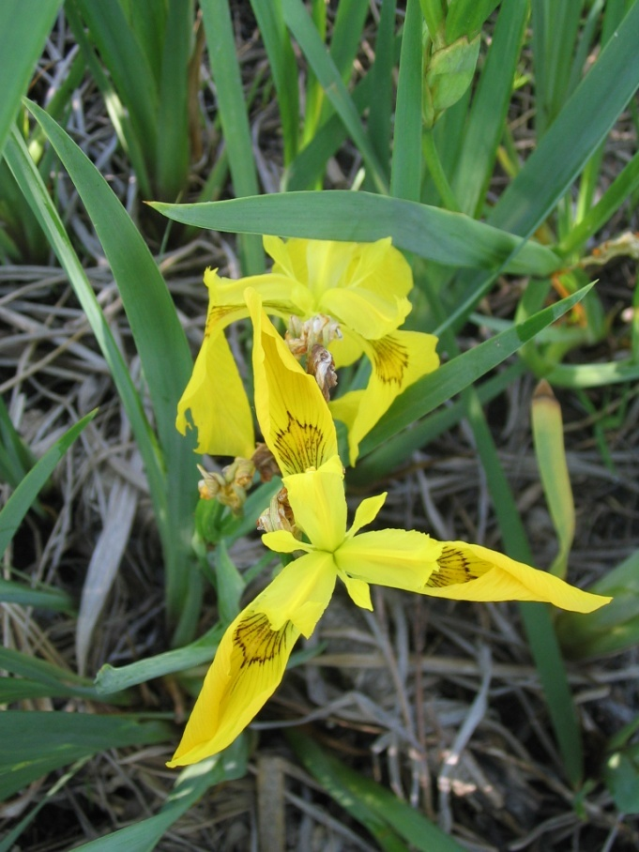 Figure 1. Paleyellow iris flowers. Photo by Jane Mangold, Montana State University, Bozeman, Montana

#### **Alternate Names**

Yellowflag iris

#### **Uses**

Paleyellow iris has been used as a horticultural plant. Because paleyellow iris tolerates low oxygen, it lives in areas with high levels of soluble organics and it may reduce the organic load by 25% over one year. Within a 24-hour period, rhizome reductions of *Escherichia coli* were 50 percent, *Salmonella* 70 percent, and *Enterocoli* 60 percent. It has been suggested that paleyellow iris can remove heavy metals efficiently and economically from wastewater because of its ability to absorb the metals and survive in unfavorable conditions.

#### **Status**

Please consult the PLANTS Web site and your State Department of Natural Resources for this plant’s current status (e.g., threatened or endangered species, state noxious status, and wetland indicator values). Paleyellow iris is listed as an invasive, banned, prohibited, designated, or noxious weed in Connecticut, Massachusetts, Montana, New Hampshire, Oregon, and Washington.

#### **Weediness**

This plant may become weedy or invasive in some regions or habitats and may displace desirable vegetation if not properly managed. Please consult with your local NRCS Field Office, Cooperative Extension Service office, state natural resource, or state agriculture department regarding its status and use. Weed information is also available from the PLANTS Web site at <http://plants.usda.gov>. Please consult the Related Web Sites on the Plant Profile for this species for further information. This species is weedy in many riparian habitats.

#### **Description**

*General:* Paleyellow iris is perennial and grows from a stout rhizome ranging in diameter from 0.4 to 1.6 inches (1-4 centimeters). The sap of the rhizome is black. Roots are normally four to eight inches (10-20 centimeters) long, but may reach lengths of 12 inches (30 centimeters). The hairless (glabrous) plants form clones when rhizomes separate. Each individual (ramet) produces 10 leaves covered with a fine waxy powder giving the leaves a whitish or bluish (glaucous) cast. The sword-shaped leaves have a raised midrib and are about 0.4 to 1.2 inches (10-30 centimeters) wide. Leaves range from 20 to 40 inches (50-100 centimeters) in length, or about as long as the flowering stem. Typical of iris, flowers form on a leafless stalk (peduncle) that is round in cross-section and is often branched. Beneath each flower is a large solitary bract (spathe), with thin, dry, margins that lack green color (scarious). Flower pedicels are about 1.5 to three inches (4-8 centimeters) long, about the length of the ovary. Flowers are about three to four inches (8-10 centimeters) in diameter, and vary in color from pale yellow to nearly orange, pale yellow being the most common color (see Figure 1). There are six perianth segments (sepals and petals) fused at their bases to form a tube and situated on top of the ovary. The sepals are variable in form but generally curve outward, have short claws, are commonly purple-veined, and have an orange spot near the base. The petals are smaller than the sepals and curve upward. The style has three petal-like yellow branches, and on the underside near the tip, is a small lip-like stigma. The three stamens are hidden beneath the three style branches. The elliptic capsules are 1.5 to three inches (4-8 centimeters) long and have three chambers each with two rows of seeds. The seeds are smooth, disc-shaped, and variable in size, turning dark brown when mature.

*Distribution:* In its native range, paleyellow iris occurs in North Africa and all European countries except Iceland. It occurs in the Caucasus, Western Asia, and New Zealand. In North America it has been reported in all but 13 states and provinces. For current distribution, please consult the Plant Profile page for this species on the PLANTS Web site.

*Habitat:* Paleyellow iris forms dense clumps in shallow water and wet places around lakes and ponds, and along streambanks.

#### **Adaptation**

Paleyellow iris grows in a wide variety of soil types ranging from gravel beds on beaches (shingle) where rhizomes grow over bare rock with roots penetrating into underlying soil, to waterlogged clay soils (gleys). It usually grows on sites with continuously high soil-water content, but not necessarily submerged soil, and it can grow on dry sandy soil. Rhizome clumps can form mats floating in water. Paleyellow iris grows on peats and permanently submerged organic and inorganic soils at water’s edge. In Europe, it persists in the higher zones of salt marshes and in estuarine water with 24‰ salinity. It is less common on chalk (CaCO3), but is found in fens and in fen woodland. It tolerates soil pH ranging from 3.6 to 7.7. It requires high levels of soil nitrogen. It is associated with depressions within terrestrial habitats and groundwater seepages. It tolerates high levels of organics and low levels of oxygen.

#### **Establishment**

Paleyellow iris grows from both rhizomes and seeds. Rhizomes increase in size from year to year unless flowering occurs or the rhizomes branch, which typically occurs after flowering. The seasonal accumulation of storage materials in the rhizomes results in annual segments that can be counted to determine their age. Rhizomes have air spaces in the cellular tissues (lacunae) that facilitate survival in low oxygen conditions characteristic of flooding. Carbohydrates are stored in rhizomes, roots, leaf bases, and developing flower shoots. Excavated rhizomes of paleyellow iris continued growing for three months indoors without water indicating they can tolerate extensive drought.

Most flowers bloom between May and July, but flowering can persist into November. Flowers are pollinated when insects pass between the stamens and the outer perianth segments to obtain nectar, brushing pollen from their backs between the two lips of the stigma. Two flower forms are reported with differences in the distance between the style branches and the outer perianth segments, and thus the flower forms differ in the insect species that are effective pollinators. In Europe, insect species visiting flowers include the bumblebees (*Bombus pascuorum*, the most common visitor, *B. hortum*, *B. ruderarius*, *B. vestalis* Hymenoptera), honey bees (*Apis mellifera*, Hymenoptera), solitary bee (*Osmia rufa*, Hymenoptera) and the hoverfly (*Rhingia rostrata*, Diptera). Seeds are produced between July and November. European studies found an average of 5.6 seed pods per plant; however the number of seeds per pod varied from 32 to 120 with many seeds undeveloped and not viable.

The percentage of seed that germinate is variable. Laboratory studies found germination of freshly collected seeds was 48 percent at 41 degrees Fahrenheit (five degrees Centigrade). Scarification increased germination to 70 percent and washing seeds with xylene to remove a fat-like substance from the seed coat increased germination to over 80 percent. Most seeds germinate in the spring, but some germinate in the summer. Seeds rarely germinate in autumn. In field situations, 20 percent of the seeds dispersed in October germinated the spring of the next year, with an additional 20 percent germinating the following year.

At germination under normal conditions, the root radical emerges and grows for about five days. The shoot cotyledon sheath emerges on the seventh day, and the first leaf appears on the tenth day. After one month, seedlings can have three leaves, lateral roots, and adventitious roots. The proportion of roots relative to shoots is high during early seedling development, which is believed to prevent the seedling from being washed out of muddy substrates and improves survival.

#### **Management**

See Control below.

#### **Pests and Potential Problems**

Paleyellow iris can be invasive. See Environmental Concerns below.

#### **Environmental Concerns**

Paleyellow iris forms dense colonies in riparian areas where it crowds-out native species, thus reducing plant community diversity. This may result in altered riparian area function and reduced habitat for wildlife and pollinators. In eastern states, reduced native sedges and rushes that support waterfowl is associated with paleyellow iris populations. Clumps of paleyellow iris may restrict water flow in irrigation and flood control ditches. The glycoside levels in leaves make the plant unpalatable to livestock and wildlife. Not only do grazers avoid eating the plant, but they avoid grazing palatable plants growing next to dense clumps of paleyellow iris. Animals eating hay containing paleyellow iris commonly experience gastroenteritis. Cattle in Scotland suffered acute diarrhea after eating rhizomes. Paleyellow iris is a skin irritant.

#### **Control**

Please contact your local agricultural extension specialist or county weed specialist to learn what works best in your area, how to use it safely, and for regulatory information about herbicide application in riparian areas. Always read label and safety instructions for each control method. Trade names and control measures appear in this document only to provide specific information. USDA NRCS does not guarantee or warranty the products and control methods named, and other products may be equally effective.

Glyphosate is the most widely used chemical for paleyellow iris management. A five percent solution of an aquatic label glyphosate applied to actively growing foliage in late spring or early summer has been most effective. Glyphosate is a non-selective herbicide and revegetation to provide competition to re-establishing paleyellow iris may be necessary.

Digging or grubbing rhizomes may be effective if all rhizomes are removed. Retreatment to remove missed rhizomes will most likely be necessary. Removed rhizomes should be disposed of in a landfill away from riparian areas. Gloves and skin protection are recommended to prevent skin irritation. Repeated mowing or clipping may prevent seed production or reduce spread by rhizomes by depleting energy reserves. Using mowing equipment that simultaneously applies herbicide (wet blade) may be a way to target paleyellow iris for herbicide control while reducing non-target impacts. Prescribed burning, fertilization or irrigation do not effectively control paleyellow iris. However, flooding may reduce populations if water levels are maintained for over 65 days.

Grazing management is not recommended for paleyellow iris because it is usually avoided by cattle, sheep, goats, horses, and rabbits because of glycosides in the leaves. Unpublished reports indicate sheep try early season leaves, and cattle eat leaves down to the rhizomes if leaves are present and short in the autumn.

There are no biological control agents developed or approved for the management of paleyellow iris in the United States. A list of species that feed on paleyellow iris is provided by Sutherland (1990).

#### **Seeds and Plant Production**

Not applicable.

#### **Cultivars, Improved, and Selected Materials (and area of origin)**

None available.

#### **References**

Bussuyt, B., B. DeFré and M. Hoffmann. 2005. Abundance and flowering success patterns in a short-term grazed grassland: early evidence of facilitation. Journal of Ecology 93: 1104-1114.

Schlüter, U. and R.M.M. Crawford. 2001. Long-term anoxia tolerance in leaves of *Acorus calamus* L. and *Iris pseudacorus* L. Journal of Experimental Botany. 52:2213-2225.

Sutherland, W.J. 1990. Biological flora of the British Isles. No. 169 *Iris pseudacorus* L. Journal of Ecology 78: 833-848.

#### **Prepared By**

*Jim Jacobs*

USDA, NRCS, Montana State Office, Bozeman, Montana

*Melissa Graves*

Extension Weeds and IPM Specialist, Montana State University, Bozeman, Montana

*Jane Mangold*

Extension Invasive Plant Specialist, Montana State University, Bozeman, Montana

#### **Citation**

Jacobs, J., M. Graves, and J. Mangold. 2010 Plant guide for paleyellow iris (*Iris pseudacorus)*. USDA-Natural Resources Conservation Service, Montana State Office. Bozeman, Montana 59715.

Published September, 2010

Edited: 11Aug2010 jsj, 12Augjm, 13Augkb

For more information about this and other plants, please contact your local NRCS field office or Conservation District at <http://www.nrcs.usda.gov/> and visit the PLANTS Web site at <http://plants.usda.gov/> or the Plant Materials Program Web site <http://plant-materials.nrcs.usda.gov>.

PLANTS is not responsible for the content or availability of other Web sites.

**USDA IS AN EQUAL OPPORTUNITY PROVIDER AND EMPLOYER**