|  |
| --- |
| Prairie junegrass |
| Koeleria macrantha  (Ledeb.) J.A. Schultes |
| Plant Symbol = KOMA |

Contributed by: USDA NRCS Idaho State Office

[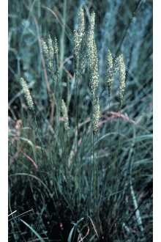](http://plants.usda.gov/java/largeImage?imageID=kocr_003_avp.tif)

©Larry Allain. [USGS NWRC](http://www.nwrc.usgs.gov/)

Alternate Names

*Koeleria cristata*; Mountain junegrass, junegrass,

Uses

Grazing/Livestock – Prairie junegrass is a component of many native plant communities. It commonly represents up to 5 percent of the community. It greens up early in the spring and provides good early spring forage and fair late spring forage for livestock.

Wildlife – Prairie junegrass is considered a fair to good forage for elk throughout the year and is desirable forage for deer and antelope in the spring and early summer.

Reclamation – Prairie junegrass is used as a component of native seed mixtures in revegetation of mined lands, heavy use areas and other surface disturbed lands.

Status

Consult the PLANTS Web site and your State Department of Natural Resources for this plant’s current status (e.g. threatened or endangered species).

Description

General: Prairie junegrass is a native, perennial, cool season tufted bunchgrass found on rangelands, plains and open forestlands. It is commonly 0.5- 2 feet tall. The narrow leaves form small basal clusters from which arise several seedheads. Leaves are basal, flat to in-rolled and sharply pointed. The seedheads are narrow contracted panicles and have the appearance of dense spikes, one per stem. The spikelets are normally pale green to purplish in color. Fine hairs are found on the reproductive stem just below the seedhead. The glumes are sharp and shiny. This is one of the first grasses to green-up in the early spring. Prairie junegrass is a perennial grass of medium longevity found in a wide variety of native plant communities.

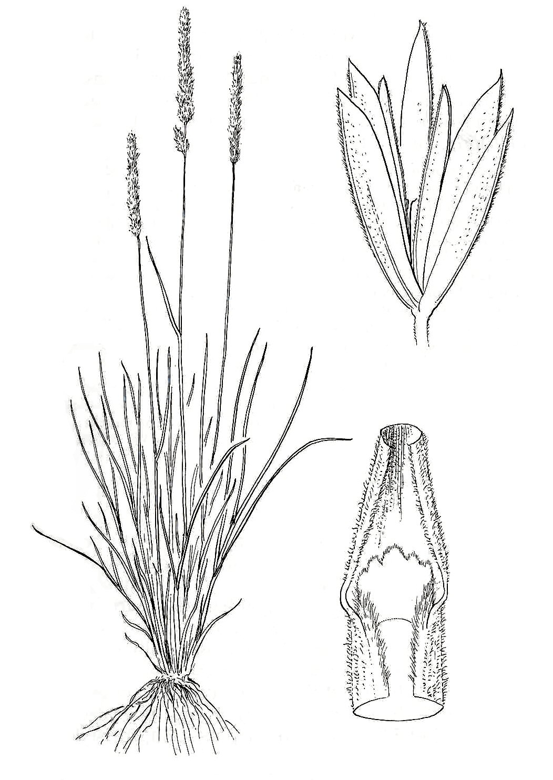

Intermountain Flora - drawn by Jeanne R. Janish.

University of Washington Press.

This species is often mistaken for muttongrass (*Poa fendleriana)* and spike trisetum (*Trisetum wolfii)*, but can be distinguished by the hairy panicles and smaller spikelets.

Distribution: The range of prairie junegrass extends from Ontario to British Columbia, south to Delaware, California and Mexico. For additional information on distribution, consult the Plant Profile page for this species on the PLANTS Web site.

**Adaptation**

Prairie junegrass is cold, heat and drought tolerant and grows on rangeland meadows, plains, mountain foothills and open forestlands. It does best at 12- 20 inches annual precipitation. It is most commonly found at elevations from 4,000- 8,000 feet, but occurs up to 11,500 feet in the central Rocky Mountains.

It is found primarily as a component of native plant communities in open and rocky areas. It is best adapted to well-drained soils such as silts to loams to sandy loams. It prefers 6.5- 8.0 pH soils. It has good tolerance to fire.

Establishment

Prairie junegrass is not recommended for fall or dormant fall seedings. It does best when seeded in the spring. Young plants are subject to thinning by frost heaving and soil cracking during winter and very early spring.

The native accessions of this species have an average of 2,300,000 seeds per pound. The full monoculture seeding rate for drill application is 1 PLS pound per acre. Use the appropriate percentage of this rate when planting native seed mixtures. The seed should be planted into a clean, weed-free, firm seedbed at soil surface to 1/8-inch depth because seed requires light to achieve maximum germination.

The exclusion of grazing animals until plants become well established is recommended. This may require up to 2- 3 growing seasons.

Management

During the second to third growing season, seedheads will flower in mid-April to mid-June. Seed reaches maturity in July through August depending on latitude and elevation. Fall regrowth can occur if soil moisture conditions are favorable.

Prairie junegrass greens up early in the spring. Grazing deferment until plants are 4- 6 inches tall is recommended to ensure the health of the plant and to reduce over-grazing. It is considered good forage in early spring, but as it matures in later spring, it becomes tough and less palatable. This grass has moderate to high tolerance to grazing.

Prairie junegrass tends to increase in percent cover following fire events and is very resistant to fire.

Pests and Potential Problems

Prairie junegrass may be vulnerable to some insects such as the striped flea beetle which will cause the leaf tips to wilt.

Environmental Concerns

Prairie junegrass is medium-lived native species, spreading primarily via seed. It is not considered to be "weedy" or an invasive species, but it can spread into adjoining vegetative communities under ideal climatic and environmental conditions. It does not generally spread from original stands, or if it does spread, the rate of spread is slow.

Seed Production

Seed production of prairie junegrass has been successful under cultivated conditions. Row spacing of 24 inches under irrigation or high precipitation (> 16 inches annual precipitation) to 36 inches under dryland conditions is recommended. Seeding rates for seed production range from 0.75 pound PLS per acre on dryland to 1.0 pound PLS per acre under irrigated conditions.

It should be seeded in locations where weeds are well controlled. Prairie junegrass seedlings are not vigorous, are slow to establish and are therefore vulnerable to mechanical (wheel and foot traffic) and chemical damage. Wait until the 3- 5 leaf stage before applying herbicides at a low rate (bromoxynil according to label) or clipping for weed control. Cultivation between rows will be needed for weed control and to maintain row culture.

Seed fields are productive for about 4- 5 years. Field moisture during the fall, soil fertility, and plant re-growth determine the yield the succeeding year.

Average production of 75 pounds per acre can be expected under dryland conditions in 16- inch plus rainfall areas. Average production of 100- 150 pounds per acre can be expected under irrigated conditions.

Harvesting can be completed by direct combining in the hard-dough stage or by windrowing followed by combining. Windrowing may help ensure a more complete threshing and more uniform in ripening. Windrowing also reduces the risk of loss of seed from wind. Seed is generally harvested from early July to late August. Seed must be dried immediately after combining (moisture content should be 12 percent in bins/15 percent in sacks).

Not all native ecotypes readily produce viable seed. Many ecotypes generally go through anthesis, but not all will produce viable seed at an economically acceptable level.

Cultivars, Improved, and Selected Materials

‘Barkoel’prairie junegrass is the only release of this species. It originates from Barenbrug, Holland, Oosterhout, The Netherlands. It is a selection of clones after three years of testing under turf conditions. The clones were chosen on basis of good winter color and good seed yield. Barkoel is intended for use as a cool-season turfgrass and not intended for native plantings. Seed is available through Barenbrug USA, PO Box 239, Tangent, OR 97389, (503) 926-5801.

A native selection that has been tested since 1986 is nearing release by the Upper Colorado Environmental Plant Center in Meeker, CO. No other releases are presently available.

Contact your local Natural Resources Conservation Service (formerly Soil Conservation Service) office for more information. Look in the phone book under ”United States Government.” The Natural Resources Conservation Service will be listed under the subheading “Department of Agriculture.”

References

Alderson, J. and W. C. Sharp. 1994. *Grass varieties in the United States.* Agriculture Handbook No. 170. USDA, SCS, Washington, DC.

Cornforth, B., L. St. John and D. G. Ogle. 2001. Technical Note 14: *Seed production standards for conservation plants in the Intermountain West.* USDA-NRCS, Boise, ID. 15p.

Cronquist, A., A.H. Holmgren, N.H. Holmgren and J.L. Reveal. 1977. *Intermountain Flora: Vascular Plants of the Intermountain West*, U.S.A. The New York Botanical Garden.

Hitchcock, A.S. (rev. A. Chase). 1950. Manual of the grasses of the United States. USDA Misc. Publ. No. 200. Washington, DC. 1950.

Ogle, D. G., L. St. John, M. Stannard and L. Holzworth. 2006. Technical Note 24: *Grass, grass-like, forb, legume, and woody species for the intermountain west*. USDA-NRCS, Boise, ID. 42p.

Smith, R., S. Smith, R. Haas, and L. Holzworth. 1998. *Native Grass Seed Production Manual,* USDA-NRCS, Bismarck, ND and Ducks Unlimited Canada. 155 p.

USDA, NRCS. 2006. The PLANTS Database, Version 061010. [(http://plants.usda.gov)](http://plants.usda.gov/). [National Plant Data Center](http://npdc.usda.gov/npdc/index.html), Baton Rouge, LA USA.

Prepared By

*Daniel G. Ogle*

USDA-NRCS, Idaho State Office, Boise, ID

*Loren St. John*

USDA-NRCS, Plant Materials Center, Aberdeen, ID

*Mark Majerus*

USDA-NRCS, Plant Materials Center, Bridger, MT

*Derek Tilley*

USDA-NRCS, Plant Materials Center, Aberdeen, ID

*Dr. Thomas A. Jones*

USDA-ARS, Forage & Range Research Laboratory, Logan, UT

*Steve Parr*

Upper CO Environmental Plant Center, Meeker, CO

Species Coordinator

*Daniel G. Ogle*

USDA-NRCS, Idaho State Office, Boise, ID

Edited: 10oct06dgo; 05may06taj; 09may06djt; 11may06ls; 05june05mm, 06oct06sp; 10oct06jsp

For more information about this and other plants, please contact your local NRCS field office or Conservation District, and visit the PLANTS Web site<<http://plants.usda.gov>> or the Plant Materials Program Web site <<http://Plant-Materials.nrcs.usda.gov>>

*The U.S. Department of Agriculture (USDA) prohibits discrimination in all its programs and activities on the basis of race, color, national origin, sex, religion, age, disability, political beliefs, sexual orientation, and marital or family status. (Not all prohibited bases apply to all programs.) Persons with disabilities who require alternative means for communication of program information (Braille, large print, audiotape, etc.) should contact USDA's* [*TARGET Center*](http://www.usda.gov/oo/target.htm) *at 202-720-2600 (voice and TDD).*

*To file a complaint of discrimination write USDA, Director, Office of Civil Rights, Room 326-W, Whitten Building, 14th and Independence Avenue, SW, Washington, DC 20250-9410 or call 202-720-5964 (voice or TDD). USDA is an equal opportunity provider and employer.*

*Read about* [*Civil Rights at the Natural Resources Convervation Service*](http://www.nrcs.usda.gov/about/civilrights/)*.*