

Plant Guide

# winterfat

## Krascheninnikovia lanata (Pursh) A.D.J. Meeuse & Smit

Plant Symbol = KRLA2

*Contributed by*: USDA NRCS Idaho Plant Materials Program

### Large Photo of Krascheninnikovia lanata

### Mature winterfat. Photo by Gary A. Monroe @ USDA-NRCS PLANTS Database.

### Alternate Names

*Common Alternate Names:*

White sage, winter-sage, feather-sage, sweet sage, lambstail

*Scientific Alternate Names:*

*Ceratoides lanata, Eurotia lanata*

### Uses

*Rangeland/Grazing* – Winterfat is superior winter browse for livestock and wildlife. It is rated as excellent to good browse for cattle, sheep, and goats and fair browse for horses (Ogle and Brazee). It is one of the most valuable rangeland browse plants for maintaining weight of adult animals on winter grazing range because of the high (>10 percent) crude protein content in winter. Welch (1989) reported winterfat nutrition values at 43.5% in vitro digestibility and 21.0 and 12.2% crude protein in spring and summer respectively.

*Wildlife* – Winterfat is considered very good browse for wildlife and is extensively utilized by rodents, rabbits, antelope, deer, elk, and bighorn sheep (Keating, 1985;McArthur et al., 1978).

*Erosion Control* – Winterfat is a good erosion control plant when planted in a mixture to provide greater plant density. It has a deep taproot and an extensive fibrous root system near the soil surface, which helps stabilize soils. It germinates readily and provides fairly rapid growth under favorable growing conditions.

### *Reclamation*: Winterfat is an important pioneer species which can be established on drastically disturbed sites or poorly developed soils such as those commonly found on mine lands (Stevens et al., 1977).

*Ethnobotany*

Winterfat was used by the Goshute, Hopi, and Tewa tribes for treating fever and sore muscles (Chamberlin, 1911; Colton, 1974; Whiting, 1939). Powdered root or poultice of winterfat was used by Navajo, Hopi, Tewa and Zuni to treat skin conditions such as poison ivy, burns, sores and boils (Colton, 1974; Hocking, 1956; Vestal, 1952; Stevenson, 1915). Winterfat was also used by the Havasupai and Navajo as winter forage for horses and sheep (Weber and Seaman, 1985; Elmore, 1944).

### Status

Please consult the PLANTS Web site and your State Department of Natural Resources for this plant’s current status (e.g., threatened or endangered species, state noxious status, and wetland indicator values).

### Description

*General*: Winterfat is an erect to spreading, low-growing, long-lived half-shrub native to the western United States. It is a cool season plant, typically with a central woody stem arising from a woody crown. Annual secondary stems are 20 to 122 cm (8 to 48 in) and sometimes taller. The stems are herbaceous on dwarf forms and herbaceous to woody throughout on taller forms. Winterfat has an extensive fibrous root system and a deep penetrating taproot.

Leaves are simple, alternate, mostly linear, and revolutely margined (rolled back from the margin). The inflorescence is a spike. Plants are monoecious with staminate flowers above the pistillate ones or occasionally they are dioecious. Pollination usually occurs between plants, but self-pollination may occur on monoecious plants. Wind is the principal mode of pollination. The seed is a utricle and the seed coat is thin and covered with fine white, silky pilose hairs to 13 mm (0.5 in) long (Welsh et al., 2003). There are approximately 123,000 seeds per pound (Ogle et al., 2012).

*Distribution*:

This plant is widely distributed in arid plant communities of western North America from Saskatchewan and Manitoba, Canada to western Nebraska, Colorado, west Texas, California and Washington. For current distribution, please consult the Plant Profile page for this species on the PLANTS Web site.

*Habitat*: Winterfat is found from near sea level to 10,000 feet elevation in salt desert shrub, pinyon juniper, sagebrush grass and near the edges of some forested plant communities in the Intermountain West (Hickman, 1993; Welsh et al., 2003). In the Southwest it can be found growing in Joshua tree communities (MacMahon, 1988).

**Adaptation**

Winterfat is most common in the 180 to 400 mm (7 to 16 in) annual precipitation zones, but has been found in areas with less than 150 mm (6 in) of annual precipitation and in areas with greater than 500 (20 in) annual precipitation.

Winterfat grows well on a wide range of soil textures, although it prefers more basic or limy soils. It tolerates moderate to highly saline conditions, but is not tolerant of acidic soils. It does not tolerate flooding or extended wet conditions. Refer to soil surveys and ecological site descriptions for additional guidance. It generally has good cold tolerance with some accessions being more tolerant.

Active growth begins in early to mid spring, flowering occurs from mid spring to early summer, and seed maturity is reached by mid to late fall.

### Establishment

*Planting:* Winterfat seed does not remain viable for extended periods and use of seed no older than two years is recommended. Winterfat seed may lose as much as 50 percent or more viability during the first year of storage. It is very important to have current germination test results for seed that is to be planted.

Dormant fall - winter or very early spring plantings result in the best stands. Studies indicate that winterfat seedlings can survive freezing temperatures and do well at cool temperatures, but growth is very slow during hot summer periods.

Winterfat utricles are covered with fine silky hairs that will not flow through a drill. Debearded seed flows readily through a drill, but this seed (with hairs removed) may be viable for a shorter period of time than non-debearded seed.

Winterfat should be seeded on the soil surface to no deeper than ¼ inch. Broadcasting seed on snow or broadcasting on a moist firm soil surface followed by a packing operation results in the best stands. Drilling seed from 1.5 to 6 mm (1/16 to 1/4 in) deep using a drill with good depth control and packer wheels into firm soil also results in satisfactory stands.

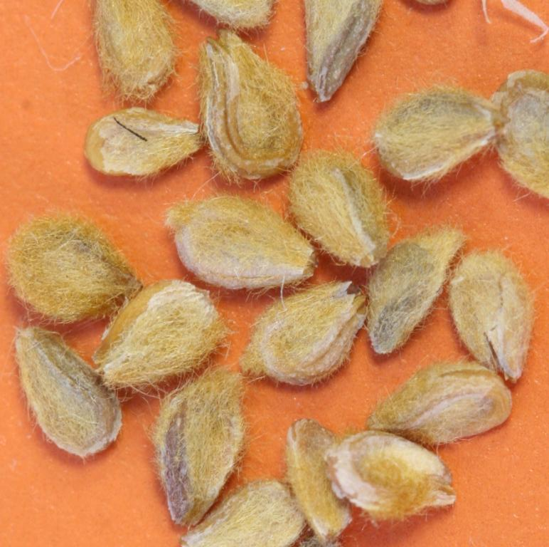

**Winterfat seed that has been processed to remove hairs. Photo by Derek Tilley.**

When drill seeded alone to reclaim winterfat monoculture plant communities, 15 Pure Live seeds (PLS) per square foot (5.0 pounds PLS per acre) is recommended. If broadcast seeded, the seeding rate should be increased by 1.5 to 2 times the standard rate.

When seeded as a component of a mix, 0.025 to 0.5 pound PLS per acre drilled or 0.05 to 1.0 pound PLS per acre broadcast is recommended. Seeding in alternate or cross rows promotes optimum establishment of winterfat. A seeding rate of 1/40 (0.025) pound PLS per acre will result in approximately 400 plants per acre under favorable establishment and growing conditions (Ogle et al., 2012).

### If winterfat is seeded in areas where annual weeds such as cheatgrass, medusahead rye, and/or tumble mustard are prevalent, it should be seeded in a mixture of adapted, vigorous native grasses following control practices such as tillage or herbicide treatment for the annual weeds.

### Management

Winterfat has excellent tolerance to browsing during the winter. However, over-browsing has greatly reduced or eliminated it in some areas. No more than 25 percent of the annual season growth should be removed during the active growing period (less during active spring growth period) and no more than 50 percent of the annual season growth should be removed during dormant periods. Late winter grazing can reduce the vigor of winterfat stands allowing undesirable species to increase (Rasmussen and Brotherson, 1986).

### New plantings should be excluded from browsing by livestock and wildlife until plants are well established and producing seed.

### Pests and Potential Problems

There are no known potential problems or pests associated with winterfat.

### Environmental Concerns

Winterfat is native, long-lived, and spreads by seed distribution. It is not considered "weedy", but could slowly spread into adjoining vegetative communities under ideal climatic and environmental conditions. This species is well documented as having beneficial qualities and no negative impacts on wild or domestic animals.

### Seeds and Plant Production

Seed production fields can be established from transplants or by direct seeding. Establishing plants in a greenhouse and transplanting to the field will result in satisfactory stands for seed production. Plant spacing under transplant conditions should be 1.2 to 1.5 m (4 to 5 ft) within row and a minimum of 1.5 m (5 ft) between rows. Transplanting into weed barrier fabric can also improve plant establishment and seed production, weed control, and moisture conservation. Transplanting is recommended in the spring prior to hot summer temperatures. . Full seed production is usually reached the second to third year following transplanting.

Plantings can also be established by direct seeding. A minimum of 15 to 20 PLS seeds per linear foot of drill row should be planted. Hand seeding in late fall or very early spring may also be an option. Plant 5 to 10 seeds in a close group at desired spacing and thin to 1 or 2 plants after emergence. Full seed production may be reached the third to fourth year following direct seeding.

Winterfat requires an equivalent of 10 to 12 inches annual precipitation for seed production. Irrigation may only be needed for establishment. Expected seed yields may range from 200 to 400 pounds per acre. Fertilization is not generally recommended unless soil tests indicate severe nutrient deficiencies. Rabbits and rodents can damage stands and may destroy seedlings. Insects such as grasshoppers and Mormon crickets infrequently damage stands beyond recovery.

Harvesting seed is best accomplished by hand stripping. Swathing and combining the cured windrow, or direct-combining are options, but the processed material requires additional drying to prevent the seed from molding. Harvested seed is usually threshed by debearding or run through a hammermill or brush machine to remove the fine silky hairs that cover the seed followed by screening. This process greatly enhances the ability of the seed to flow through planting equipment. Removing the white hairs that surround the seed can injure the seed resulting in reduced viability, seedling vigor, and stand establishment. One must be extremely careful when threshing seed to limit the amount of mechanical action on the seed to minimize seed damage. Unthreshed seed is recommended for stand establishment if hand seeding directly or for transplants (McArthur and Monsen, 2004).

Viability of winterfat seed rapidly decreases after storage for 1 to 2 years even under the best storage conditions (Stevenson et al., 1977). Germination of fresh seed can be as high as 85 to 95 percent. Germination of seed 3 years or older is commonly below 25 percent. It is extremely important to have a current germination test for seed that will be planted. Seeds per pound will vary by accession, but averages 125,000 with bracts intact. Seed conditioned with a hammer-mill to remove bracts averages 200,000 seeds per pound.

### Cultivars, Improved, and Selected Materials (and area of origin)

There are no cultivars, improved, or selected materials of winterfat currently available. Common wildland collected seed is available from commercial sources (Native Seed Network).

### References

Chamberlin, R.V. 1911. The Ethno-botany of the Gosiute Indians of Utah. Memoirs of the American Anthropological Association. 2(5); 331-405.

Colton, H.S. 1974. Hopi History and Ethnobotany. In: A.A. Horr (ed.) Hopi Indians. Garland. New York. 317p.

Elmore, F.H. 1944. Ethnobotany of the Navajo. School of American Research. Sante Fe, NM. 44p.

Hickman, J.C. ed. 1993. The Jepson Manual: Higher Plants of California. University of California Press. Berkeley, CA. 1400p.

Hocking. G.M. 1956. Some plant materials used medicinally and otherwise by the Navaho Indians in the Chaco Canyon, New Mexico. El Palacio. 56: 146-165.

Keating, K.A., Irby, L.R., and W.F. Kasworm. 1985. Mountain sheep winter food habits in the upper Yellowstone Valley. Journal of Wildlife Management. 49(1): 156-161.

MacMahon, J.A. 1988. Warm deserts. In: Barbour, M.G., and D.W. Billings (eds.). North American Terrestrial Vegetation. Cambridge University Press. Cambridge, NY. 724p.

McArthur, E.D. and S.B. Monsen. 2004. Chenopod Shrubs. In: S.B. Monsen, R. Stevens, and N.L. Shaw [compilers]. Restoring western ranges and wildlands. Fort Collins, CO: USDA Forest Service, Rocky Mountain Research Station. General Technical Report RMRS-GTR-136-vol-2. p. 467-491.

McArthur, E.D., Plummer, A.P., and J.N. Davis. 1978. Rehabilitation of game range in the salt desert. In: Johnson, L.L., ed. Wyoming shrublands: proceedings 7th Wyoming shrub ecology workshop; 1978 May 31-June 1; Rock Springs, WY. Laramie: university of Wyoming, Division of Range Management: 23-50.

Native Seed Network. http://www.nativeseednetwork.org (Accessed September 15, 2012)

Ogle, D. G., L. St. John, M. Stannard and L. Holzworth. 2006. Technical Note 24: Conservation plant species for the intermountain west. USDA-NRCS, Boise, ID. 57p.

Rasmussen, L.L., and J.D. Brotherson. 1986. Response of winterfat (*Ceratoides lanata*) communities to release from grazing pressure. Great Basin Naturalist. 46: 148-156.

Stevens, R., B. Giunta, K. Jorgensen, & A. Plummer 1977. Winterfat (*Ceratoides lanata*). Publication No. 77-2 Utah Division of Wildlife Resources. Federal Project W-82-R 1977. 41pp.

Stevens, R., K. Jorgensen, S. Young, & S. Monsen, 1996. Forb and shrub seed production guide for Utah. Utah State University Extension AG 501. 51pp.

Stevenson, M.C. 1915. Ethnobotany of the Zuni Indians. SI-BAE. Annual Report No. 30. 51p.

Vestal, P.A. 1952. The ethnobotany of the Ramah Navaho. Papers of the Peabody Museum of American Archaeology and Ethnology. 40(4): 1-94.

Wasser, C. 1982. Ecology and culture of selected species useful in revegetating disturbed lands in the West. USDI Fish & Wildl. Serv. FWS/OBS-82/56. 347p.

Weber, S.A. and P.D. Seaman. 1985. Havasupai Habitat: A.F. Whiting’s Ethnography of a Traditional Indian Culture. The University of Arizona Press. Tucson, AZ.

Welch, B.L. 1989. Nutritive value of shrubs. In: McKell, C.M., ed. The Biology and Utilization of Shrubs. Academic Press, Inc. San Diego, CA. 656p.

Welsh, S.L., Atwood, N.D., Goodrich, S. and L.C. Higgins. 2003. A Utah Flora. Brigham Young University. Provo, UT. 912p.

Whiting, A.F. 1939. Ethnobotany of the Hopi. Museum of Northern Arizona. Bulletin No. 15.

**Prepared By**:

Daniel G. Ogle, USDA NRCS Idaho State Office, Boise, Idaho

Loren St. John, USDA NRCS Plant Materials Center, Aberdeen, ID

Susan R. Winslow, USDA NRCS Plant Materials Center, Bridger, Montana

Derek Tilley, USDA NRCS Plant Materials Center, Aberdeen, ID

### Citation

Ogle, D.G., St. John, L., Holzworth, L., Winslow, S.R., and D. Tilley. 2012. Plant Guide for winterfat (*Krascheninnikovia lanata*). USDA-Natural Resources Conservation Service, Aberdeen, ID Plant Materials Center. 83210-0296.

Published August, 2012

Edited: 05dec00 jsp; 16aug02 srw; 16aug02 lkh; 24sept02 lsj; 24sept02 dgo; 11feb03 jsp; 060802 jsp; 10aug2012djt; 15aug2012ls

For more information about this and other plants, please contact your local NRCS field office or Conservation District at <http://www.nrcs.usda.gov/> and visit the PLANTS Web site at <http://plants.usda.gov/> or the Plant Materials Program Web site <http://plant-materials.nrcs.usda.gov>.

PLANTS is not responsible for the content or availability of other Web sites.

**USDA IS AN EQUAL OPPORTUNITY PROVIDER AND EMPLOYER**