

Plant Guide

# altai wildrye

## Leymus angustus (Trin.) Pilg.

### Plant Symbol = LEAN3

#### Contributed by USDA NRCS Idaho and North Dakota Plant Materials Program

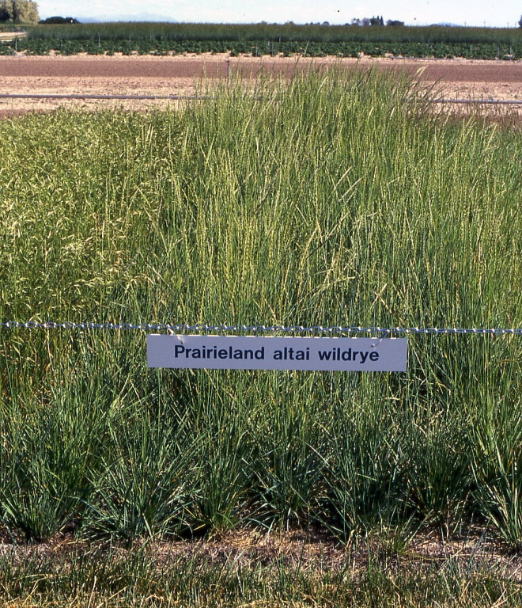 'Prairieland’ Altai wildrye. Loren St. John, USDA-NRCS, Aberdeen, ID PMC.

#### **Alternate Names**

*Aneurolepidium angustum* (Trin.) Nevski, *Elymus angustus* Trin. (PLANTS Database).

#### **Uses**

*Grazing:* Altai wildrye is well suited for pasture forage production. It has a long period of growth that begins early in the spring and continues into late fall. The mostly basal leaves make the forage difficult to harvest as hay (Smoliak, et. al, 1990).

*Wildlife:* Altai wildrye provides good wildlife cover because of its tall stature and standing residue but is not readily used by foraging wildlife. It has limited value as a seed source for wildlife and birds or use by native pollinators (Sedivec, et. al, 2007).

#### **Status**

Consult the PLANTS Web site and your State Department of Natural Resources for this plant’s current status (e.g., threatened or endangered species, state noxious status, and wetland indicator values).

#### **Description**

*General*: Grass Family (Poaceae). Altai wildrye is an introduced, drought resistant, perennial grass that can grow to approximately 40 inches tall. The coarse, wide, erect, basal leaves vary from light green to blue. The plant is generally a bunch type but has short rhizomes. The root system can penetrate 10-13 feet deep and can use soil moisture to that depth more efficiently than most other grasses.

Culms are solitary or tufted, 60-100 cm (24-40 in) tall, glabrous, or pubescent below nodes and the seedhead. Leaf sheath is grayish green, usually shorter than the internodes, smooth or slightly scabrous. The ligule is 0.5-1 mm (0.02-0.04 in) long, membranous with and an obtuse apex. Leaf blade is glaucous, rolled, 15-25 cm (6-10 in) long and 0.5-0.7 cm (0.20-0.28 in) wide, stiff and mostly smooth on both sides. The spike is erect, 15-20 cm (6-10 in) long by 0.7-1 cm (0.28-0.39 in) diameter. There are 2-3 spikelets per node with 2 or 3 florets per spikelet. Glumes cover the base of the first lemma, 10-13 mm (0.39-0.51 in) long, linear-lanceolate and 1-veined. Lemma is lanceolate, with 5-7 faint veins. The first lemma is 10-14 mm (0.39-0.55 in) long including an awn. The palea is slightly shorter than the lemma and is ciliate along the keels (Flora of China). The seed is very large, three times the size of Russian wildrye (Kruger).

*Distribution*:

Altai wildrye is native to China, Kazakhstan, Kyrgyzstan, Mongolia, Russia, Turkmenistan, Uzbekistan, southwest Asia and Europe (Flora of China). For current distribution in North America, consult the Plant Profile page for this species on the PLANTS Web site.

#### **Adaptation**

Altai wildrye is well adapted to loam to clay-loam soils receiving 14-18 inches or greater mean annual precipitation (or irrigated). It has comparable seedling emergence and tolerance to salinity as Russian wildrye (Kruger), (McElgunn and Lawrence, 1973) and can be utilized to reclaim saline sites.

#### **Establishment**

Altai wildrye seedlings grow and establish slowly and as compared to many other grasses and are poor competitors with weeds. Good seedbed preparation is critical to stand establishment. It is important to have a clean, firm seedbed. Weeds should be destroyed by cultivation or with herbicides before seeding. After emergence, weed control will need to continue to ensure plant establishment. Once Altai wildrye is established, it is very competitive with most weeds (Smoliak, et. al, 1990).

Even though seed of Altai wildrye is large and can emerge better from deeper depths than many other grasses, shallow seeding is recommended because of its reduced competitive ability (Smoliak, et. al, 1990), (Kruger). Altai wildrye should be seeded with a drill at a depth of ¼-½ inch. There are approximately 68,000 seeds per pound (PLANTS Database). The recommended full seeding rate is 12 pounds Pure Live Seed (PLS) per acre (Ogle, et. al, 2010). If used as a component of a seeding mix, adjust to percent of mix desired. For critical area stabilization or broadcast planting, double the drill seeding rate to 24 pounds PLS per acre.

#### **Management**

New stands of Altai wildrye should not be grazed until they are well established and have started to produce seed heads. Eight inches of new growth should be attained in spring before grazing is allowed in established stands. Grazing cycles with 35 days or more rest are recommended. Six inches of stubble should remain at the end of the grazing season to maintain the long-term health of the stand (Ogle, et al., 2009).

Altai wildrye establishes slowly as compared to many other grasses and is a poor competitor with weeds. However, once established, it is a very competitive grass. Altai wildrye produces about 20 percent of its total growth by mid-May and 30 percent by early June and reaches peak forage production by late July. It provides good quality forage in spring and early summer based on its growth patterns. It also provides excellent quality forage in the fall and early winter (Sedivec, et al, 2007). In northern regions, it is commonly swathed into windrows and utilized for winter forage (Ogle, et al., 2010).

#### **Pests and Potential Problems**

Altai wildrye is susceptible to leaf spot diseases. Resistance to leaf spot has been a factor in the selection of released varieties (Sedivec, et al. 2007).

#### **Environmental Concerns**

Altai wildrye is a bunchgrass that develops short rhizomes. It generally does not move from its planting location except under ideal climatic and environmental conditions.

#### **Seed Production**

Plant Altai wildrye seed at 6-7 pounds PLS per acre in 30-36 inch rows to a seeding depth of ¼ to½ inch in a clean, firm seedbed. This seeding rate is equivalent to approximately 30 seeds per linear foot of row. Seeding in April and May is recommended to maximize stand establishment and seed yield (Kruger). To facilitate seed production and weed control, it is desirable to plant in spaced rows instead of a solid stand. Between-row cultivation is required to maximize seed yield, and to maintain rows and weed-free conditions.

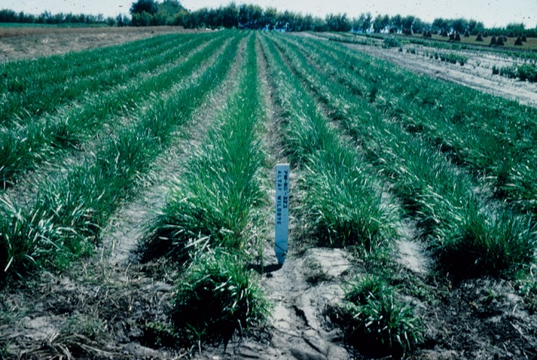

Altai wildrye seed production field in North Dakota. USDA-NRCS, Bismarck, ND PMC.

Fertilizer is generally not recommended during establishment. If soil nitrogen and phosphorus are low, an application of 10-15 pounds per acre of nitrogen and 20-30 pounds per acre of phosphorus may be applied and incorporated into the soil prior to planting. Fertilize for full seed production following the establishment year in the early fall or if on sandy soils, use split applications in early fall and again in early spring.

Clipping or mowing annual weeds is an effective strategy for control during the establishment year. Weeds should be mowed as needed to prevent them from setting seed. Once Altai wildrye becomes established, there will be fewer weeds. Hand rouging and herbicides labeled for grass seed production will also be required. The most difficult weeds to control include quackgrass, cheatgrass (downy brome), green foxtail and Persian darnel. (Kruger).

Seed is usually harvested mid to late July. Swathing to allow the seed to complete maturity followed by combining is recommended. Direct combining is also an option but harvest timing and seed drying are critical elements that must be dealt with. Altai wildrye readily shatters when mature and seed must be dried to 10-12 percent moisture content before storage (Kruger). Seed yields range from 50 to 150 pounds per acre on dryland and 75 to 200 pounds per acre under irrigation. The removal of residue and stubble from seed production fields is critical to maintaining the seed productivity of a stand. Plots remaining unclipped in the fall show elevation of the growing points above the ground level predisposing primordial seed heads to winter injury (Kruger).

#### **Cultivars, Improved, and Selected Materials (and area of origin)**

**‘Eejay’** was selected and released by Agriculture Canada (Swift Current, Saskatchewan) in 1989. It was selected for higher seed and forage yield compared to Prairieland and is also resistant to leaf spot diseases (Sedivec, et al. 2007).

**‘Mustang’** was released in 2004 by the USDA-Agricultural Research Service, Forage and Range Laboratory in Logan, Utah. It is significantly taller than Prairieland, Pearl and Eejay. It has higher forage production than Prairieland or Pearl and superior seedling establishment compared to Prairieland and Pearl (Sedivec, et al. 2007).

**‘Pearl’** was selected and released by Agriculture Canada (Swift Current, Saskatchewan) in 1989. It was selected for higher seed production than Prairieland. It has lower forage yield than Prairieland and is also resistant to leaf spot diseases (Sedivec, et al. 2007).

**‘Prairieland’** was selected and released by Agriculture Canada (Swift Current, Saskatchewan) in 1976. It was selected for high seed yield, high forage yield and is resistant to leaf spot diseases (Sedivec, et al. 2007).

#### **References**

Flora of China. *Leymus angustus*. [Online] Available at http://www.efloras.org (accessed 26 October 2010).

Kruger G., no date. Altai wildrye: A Seed Production Review. [Online] Available at www1.agric.gov.ab.ca (accessed 27 October 2010).

McElgunn, J. D. and Lawrence, T. 1973. Salinity Tolerance of Altai Wild Ryegrass and Other Forage Grasses. Can. J. Plant Sci. 53: 303-307.

Ogle, D.G., St. John, L., Stannard, M. 2010. Grass, Grass-like, Forb, Legume and Woody species for the Intermountain West. USDA-NRCS. ID-TN24. Boise, ID.

Ogle, D.G.., St. John, L., Cornwell, J., Stannard, M. and Holzworth, L. 2009. Pasture and Range Seedings: Planning – Installation – Evaluation – Management. USDA-NRCS. ID-TN10. Boise, ID.

Ogle, D.G., St. John, L., and Stannard, M. 2009. Pasture – Species Selection and Grazing Management Guidelines. USDA-NRCS. ID-TN11. Boise, ID

PLANTS Database. Conservation plant characteristics for *Leymus angustus*. [Online] Available at http://plants.usda.gov (accessed 26 October 2010).

Sedivec, K. K., Tober, D.A., Duckwitz, W.L., Dewald, D. D., and Printz, J. L. 2007. Grasses for the Northern Plains. Volume 1 – Cool Season. North Dakota State University Extension Service R-1323. 89 p.

Smoliak, S., Ditterline, R.L., Scheetz, J.D., Holzworth, L. K., Sims, J.R., Wiesner, D.E., Baldrige, D.E. and Tibke, G.L. 1990. Montana Interagency Plant Materials Handbook for Forage Production, Conservation, Reclamation and Wildlife. Montana State University, Extension Service. EB 69. 337 p.

#### **Prepared By**

Loren St. John, Team Leader, USDA, NRCS Plant Materials Center, Aberdeen, ID

Daniel G. Ogle, Plant Materials Specialist, USDA, NRCS, Boise, ID

Wayne Duckwitz, Manager, USDA, Plant Materials Center, Bismarck, ND

Dwight Tober, Plant Materials Specialist, USDA, NRCS, Bismarck, ND

#### **Citation**

St. John, L., D.G. Ogle, W. Duckwitz, D. Tober. 2010. Plant Guide for Altai wildrye (*Leymus angustus*). USDA-Natural Resources Conservation Service, Aberdeen, ID Plant Materials Center

Published January, 2011

Edited: ls 19Nov2010;dgo 14Dec2010;wd13Dec2010;ls 14 Dec2010;wd17Dec2010; jab 20Dec2010; ls 5jan2011

For more information about this and other plants, please contact your local NRCS field office or Conservation District at <http://www.nrcs.usda.gov/> and visit the PLANTS Web site at <http://plants.usda.gov/> or the Plant Materials Program Web site <http://plant-materials.nrcs.usda.gov>.

PLANTS is not responsible for the content or availability of other Web sites.

**USDA IS AN EQUAL OPPORTUNITY PROVIDER AND EMPLOYER**