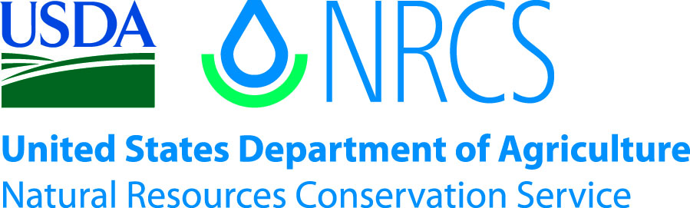

Plant Guide

# basin wildrye

## Leymus cinereus (Scribn. & Merr.) Á. Löve

Plant Symbol = LECI4

*Contributed by*: USDA NRCS Plant Materials Center, Aberdeen, Idaho

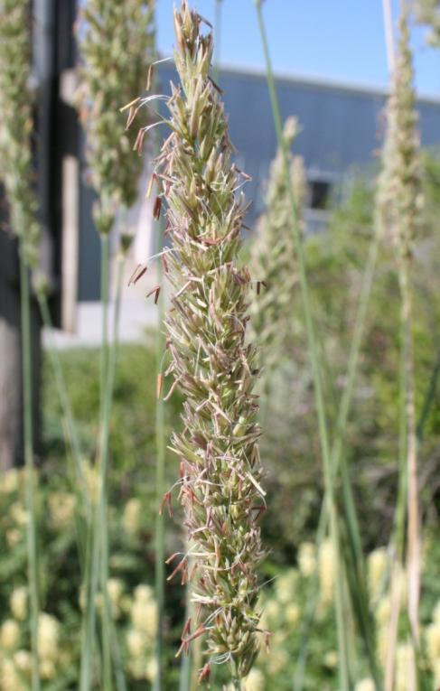

**Basin wildrye inflorescence. Photo by Derek Tilley, USDA-NRCS**.

### Alternate Names

*Alternate Common Names:*

Great Basin wildrye

Giant wildrye

*Alternate Scientific Names:*

*Elymus cinereus*

**Uses**

*Grazing/rangeland/hayland*: Basin wildrye is generally not recommended for spring or summer forage production, because it has an elevated growing point and is easily damaged by overgrazing.

Basin wildrye is palatable to all classes of livestock and wildlife. It is a preferred feed for horses in spring and is considered a desirable feed for cattle, sheep, elk, deer, and antelope in the spring. It is considered a desirable feed for cattle and horses in early summer, late fall, and winter. It reaches its peak production in protein per acre from mid-June through August. Protein levels can be as high as 20 percent and decrease to about 7 to 8 percent protein as it matures and cures out.

This species produces large quantities of forage and can be used as winter forage when found in large stands. It is generally not recommended for haying, because it is difficult to harvest above its natural growing point. Removal of the growing point during the growing season is detrimental to the plant and will eventually kill the grass. Leaving 10 to 12 inches of stubble height will help reduce grazing damage. Once harvested, basin wildrye produces little re-growth.

Basin wildrye is ideal for providing wind protection in winter calving pastures. It holds its nutrient value well at maturity (7-8% protein) and can withstand heavy grazing and trampling in its dormant state. Its tall stature and stiff stems makes this forage accessible in areas of deep snow.

*Erosion control/reclamation*: Basin wildrye is well adapted to stabilizing disturbed soils and has been used for disturbed area stabilization, mine reclamation and fire rehabilitation. It has a deep fibrous root system extending to depths of 200 cm (63 in) in undisturbed soils with a lateral root spread of up to 100 cm (39 in) (Reynolds and Fraley 1989).

It does not compete well with aggressive introduced grasses during the establishment period, but it is very compatible with slower developing natives such as Snake River wheatgrass (*Elymus wawawaiensis*), bluebunch wheatgrass (*Pseudoroegneria spicata*), thickspike wheatgrass (*Elymus lanceolatus* ssp. *lanceolatus*), streambank wheatgrass (*Elymus lanceolatus* ssp. *psammophilus*), western wheatgrass (*Pascopyrum smithii*), and needlegrass species (*Stipa* spp., *Nasella* spp., & *Ptilagrostis* spp.).

The drought tolerance of basin wildrye, combined with fibrous root system and fair seedling vigor, make it desirable for reclamation in areas receiving 8 to 20 inches annual precipitation. It is commonly used as a grass barrier for wind erosion or controlling blowing snow. It has also been planted on hilly cropland as a vegetative terrace for water erosion control.

*Wildlife*: Because basin wildrye is a tall upright bunchgrass, it is considered excellent cover habitat for small animals and birds, excellent nesting cover for upland birds, and excellent standing winter feed and cover for big game animals. It is less palatable in winter yet may be grazed by livestock, deer and elk when other food sources are covered in snow.

### Status

Please consult the PLANTS Web site and your State Department of Natural Resources for this plant’s current status (e.g., threatened or endangered species, state noxious status, and wetland indicator values).

### Description

*General*: Grass Family (Poaceae). Basin wildrye is a large, coarse, robust, perennial bunchgrass. Basin wildrye clumps may reach 3 feet in diameter and 3 to 6 feet tall (10 feet under excellent soil and climate conditions). The growing points are 10 to 12 inches above the crown. It is a long-lived cool season native with an extensive deep coarse fibrous root system (Reynolds and Fraley 1989). Basin wildrye has long leaf blades (15 to 25 inches) and flat wide (up to 3/4 inch) leaves with long pointed auricles. The reproductive stems are dense, stout, and strongly erect. Seed heads are 6 to 10 inches long. There are approximately 130,000 seeds per pound (Ogle et al. 2011).

Basin wildrye consists of two chromosome races, a tetraploid (2n=28) race and an octoploid (2n=56) race. The tetraploid race occurs in southern Idaho, Utah, Colorado, Wyoming, Montana, Alberta, and Saskatchewan, while the octoploid race is primarily found west of the Continental Divide in British Columbia and Washington (Jones et al. 2009). Tetraploid plants are generally non-glaucus with green foliage. Octoploid types are typically glaucus and appear more bluish.

Basin wildrye is known to produce hybrids with Salina wildrye (*L. salinus*), beardless wildrye (*L*. *triticoides*), and bottlebrush squirreltail (*Elymus* *elymoides*) (Welsh et al. 2003).

Basin wildrye has fair seedling vigor. It is one of the first grasses to initiate spring growth and produces an abundance of basal leaf growth until the development of seed heads in mid-June to mid-July. Following the development of seed heads, basin wildrye produces very little additional basal leaf growth and rapidly becomes coarse and mostly stems.

**Ethnobotany**

Basin wildrye has been used for a variety of purposes by Native Americans. The roots were used to create a decoction to treat internal hemorrhaging and other maladies by the Okanagan-Colville (Turner et al. 1980). The stems and leaves were used for bedding by many tribes (Hart 1981; Johnston 1987; Turner et al. 1980). The stems were used as arrow shafts (Tuner et al. 1980).

*Distribution*: Basin wildrye is native to the Great Plains and Intermountain regions of the western United States.

For current distribution, please consult the Plant Profile page for this species on the PLANTS Web site.

*Habitat*: Basin wildrye occurs in moist to dry sites including wet meadows, valley bottoms, flood plains and hillsides from 600 to 3,000 m (1,970 to 9,800 ft) elevation. It often occupies bottomlands and drainage areas with high soil moisture. Species often associated with basin wildrye include the big sagebrush complex (*Artemisia tridentata*), juniper species (*Juniperus* spp.), needlegrass species (*Stipa* spp.), bluebunch wheatgrass, Snake River wheatgrass, thickspike wheatgrass, Indian ricegrass (*Achnatherum hymenoides*), and Idaho fescue (*Festuca idahoensis*).

**Adaptation**

Basin wildrye is very winter hardy and has a rather broad climatic adaptation. It grows best in areas with average annual precipitation of 8 inches to above 20 inches. ‘Trailhead’ has been seeded in areas with as low as 5 inches of rainfall and reproduced to populate areas around original plots. In lower rainfall areas, it grows in drainage areas, along gullies or watercourses, or near sites with high seasonal water tables. It does not tolerate areas with extended periods of inundation. It will tolerate short-term winter flooding. It is susceptible to leaf and stem rust in wetter climatic areas.

Basin wildrye has a broad soil texture adaptation, but it is not adapted to shallow soils. It is most common on deep soils with high water holding capacities. Optimal growth has been observed on silty and clayey soils.

It is tolerant of low to moderate levels (< 10 mmhos/cm3) of saline and sodic soil conditions and some low pH soils. It has a pH range of 5.6 to 9.0 (USDA-NRCS 2012). Established stands of basin wildrye can tolerate long periods of drought, and it prefers cycles of wet winters and dry summers. It tolerates partial shading and wildfire if soil moisture is not too dry.

It does well as a pioneer plant and establishes seedlings in disturbed areas, such as recent road fills and areas disturbed by wildlife (ex. rodent diggings).

### Establishment

This species should be seeded with a disc or deep furrow drill at a depth of 1/4 to 3/4 inch on medium to fine textured soils and 1 inch or less on coarse textured soils. Single species seeding rate recommended for basin wildrye is 8 pounds Pure Live Seed (PLS) per acre or 24 PLS per square foot or 24 PLS seeds per linear row foot at 12 inch row spacing. If used as a component of a mix, adjust to percent of mix desired. For rangeland mixtures, approximately 10 to 20 percent of mix or 1 to 2 pounds PLS should be considered.

For mined lands and other harsh critical areas, the seeding rate should be doubled. When seeding is for a vegetative windbreak, vegetative terrace, or wildlife cover, it is recommended that 3.0 to 3.5 pounds PLS be seeded in rows spaced 36 to 48 inches s.

The best seeding results are obtained from seeding in very early spring on heavy to medium textured soils and in late fall on medium to light textured soils. Summer and late summer (July to mid September) seedings are not recommended. Seedling vigor is fair, and stands may take 2 to 5 years to fully establish.

Stands may require weed control measures during establishment. Bromoxynil has shown to be effective when applied applied at the 3-4-leaf stage of grass for early suppression of young broadleaf weeds. Application of 2,4-D should not be made until plants have reached the 4-6-leaf stage. Mow when weeds are beginning to bloom to reduce seed development. Grasshoppers and other insects may also damage new stands. Use of insecticides may be required. All and pesticides should be applied according to the label.

### Management

Basin wildrye establishes slowly and new seedings should not be grazed or hayed until at least late summer or fall of the second growing season. Basin wildrye makes its initial growth in early spring and matures seed by late summer. It reproduces primarily by seed and tillers.

Basin wildrye is palatable to all classes of livestock and wildlife. New stands should not be grazed until plants are at least 10 inches tall. Overgrazing, especially in spring, easily damages basin wildrye, and stubble of at least 10 inches should remain following grazing. Basin wildrye is ideal for providing wind protection in winter calving pastures. It holds approximately twice the nutrient value (7-8% protein) of wheatgrasses (3-4% protein) at maturity and can withstand heavy grazing and trampling in its dormant state.

Established stands can be grazed in late spring or fall (leave about 10 inches of stubble to protect plant health). Following grazing, little re-growth can be expected, even when the stand is irrigated. Basin wildrye is a low maintenance plant requiring little additional treatment or care. However, it may benefit from low levels of fertilization (60 to 80 pounds per acre on irrigated plantings for optimum forage production).

*Environmental Concerns*: Basin wildrye is long-lived and spreads primarily via seed. It is not considered "weedy" or an invasive species, but can spread into adjoining vegetative communities under ideal climatic and environmental conditions. Most seedings do not spread from original plantings. If they do spread, the rate is not alarming. Basin wildrye accessions with the same chromosome number (2n=28 or 56) will cross with each other but are not noted for crossing with those of a different chromosome number.

### Pests and Potential Problems

Wheat stem sawfly (*Cephus cinctus*) is known to infect basin wildrye. The larvae eat the tissues within the culms, cut the stems and overwinter in the remaining stubble (Youtie and Johnson 1988).

### Environmental Concerns

Basin wildrye is native to western North America and is a natural component of the native flora. It poses no known environmental concerns.

**Seed Production**

Seed production of basin wildrye has been very successful under cultivated conditions. Row spacing of 36 inches (3.5 pounds PLS per acre) to 48 inches (3.0 pounds PLS per acre) is recommended. Cultivation will be needed for weed control and to maintain row culture.

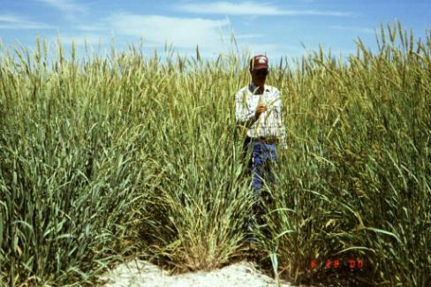

**Seed production field of basin wildrye. Dan Ogle, USDA-NRCS.**

Seed fields are productive for five to seven years. Average production of 150 to 200 pounds seed per acre can be expected under dryland conditions in 14 inch plus rainfall areas. Average yields of 300 to 400 pounds seed per acre can be expected under irrigated conditions using direct combining. The seed heads have moderate rates of shatter and require close scrutiny of maturing stands. Seed is generally harvested in mid-August to September. Seed must be dried immediately after combining (12 percent bins/15 percent sacks moisture content).

### Cultivars, Improved, and Selected Materials (and area of origin)

Several varieties of basin wildrye are commercially available.

‘Continental’ is an octoploid cultivar developed from the hybridization of the cultivars Trailhead and Magnar (Jones et al. 2009). It has shown similar or superior stand establishment to Trailhead and Magnar in trial plantings in Utah, southwestern Wyoming and northwestern Colorado. It has improved seedling vigor and has potential for use in restoration, reclamation and rehabilitation of rangelands where traditional cultivars are expected to fail. It is expected to be adapted to the Intermountain West and northern Great Plains. Breeder seed is maintained by the USDA ARS Forage and Range Research Laboratory, Logan, Utah. Seed is available to commercial growers through the Utah Crop Improvement Association.

‘Magnar’ was originally collected by the Pullman, Washington, Plant Materials Center (PMC). It was developed by the Aberdeen, Idaho, PMC and released in 1979. It is a selection of vigorous plant types over several generations. It is adapted to the Northwest and Intermountain Regions of the Western United States where precipitation averages 8 inches or above. It has survived in plantings with 7 inches annual rainfall. It prefers deep clayey to loamy to sandy soils and can be found in weakly saline conditions. Magnar is an octoploid cultivar and is noted for bluish foliage, fair seedling vigor and establishment, high forage production, good winter cover, fair winter forage, and ability to survive and thrive under very dry conditions. Certified seed is available, and breeder seed is maintained by the Aberdeen PMC.

Tetra Germplasm basin wildrye is a composite of 31 tetraploid accessions from the Great Basin developed by The Utah Division of Wildlife Resources. Tetra Germplasm is intended for rehabilitation of cheatgrass-infested sites and for improving sage-grouse habitat.

'Trailhead' was selected by the Bridger, Montana, PMC and released in 1991. The original collection site was near Roundup, Montana, in a sub-irrigated range site. It is adapted to the Northern Great Plains and Intermountain Regions of the Western United States where precipitation averages 8 inches or above. It has survived in plantings with 5 inches annual rainfall. It was selected for its stand longevity and drought tolerance as compared to other basin wildrye accessions. It prefers deep clayey to loamy to sandy soils and tolerates weakly saline conditions. It is noted for green foliage, fair seedling vigor and establishment, high forage production, good winter cover, fair winter forage, and ability to survive and thrive under very dry conditions. ‘Trailhead’ is a 28-chromosome tetraploid cultivar. Certified seed is available, and the Bridger PMC maintains breeder seed.

Washoe Germplasm basin wildrye, NRCS accession number 9081627, is a Selected-Class pre-varietal selection released in 2002. It was selected primarily for use in the Anaconda-Butte, Montana, area for sites contaminated with acid and heavy metal fallout resulting from years of historic smelting operations in the area. The original collection was made in Deer Lodge County, Montana, from a population of plants found growing on a severely impacted site approximately 1.5 miles southwest of the Washoe smelter stack. This selection demonstrated superior vigor and seedling survival than ‘Trailhead’ and ‘Magnar’ when grown on contaminated soil amended with lime in a replicated study north of Anaconda, Montana. It has the same general botanical and phenological attributes as the species. Washoe is a tetraploid germplasm.

### References

Alderson, J. & W.C. Sharp 1994. *Grass varieties in the United States*. Agriculture Handbook No. 170. USDA, SCS, Washington, D.C.

Cronquist, A., A. H. Holmgren, N. H. Holmgren, J. L. Reveal, & P. K. Holmgren 1977. *Intermountain flora*. Vol. 6. The New York Botanical Garden. Columbia University Press, New York, New York.Hitchcock, A. S. 1950. *Manual of the grasses of the United States*. USDA, Washington, DC.

Hart, J.A. 1981. The ethnobotany of the northern Cheyenne Indians of Montana. Journal of Ethnopharmacology 4: 1-55.

Johnston, A. 1987. Plants and the Blackfoot. Lethbridge, Alberta. Lethbridge Historical Society.

Jones, T.A., Parr, S.D., Winslow, S.R., and M.A. Rosales. 2009. Notice of release of ‘Continental’ basin wildrye. Native Plants Journal 10(1): 57-61.

Ogle, D., St. John, L., Stannard, M., and L. Holzworth. 2011. Technical Note 24: Conservation plant species for the Intermountain West. USDA-NRCS, Boise, ID-Salt Lake City, UT-Spokane, WA. ID-TN 24. 57p.

Powell, A.M. 1994*. Grasses of the Trans-Pecos and adjacent areas. University* of Texas Press, Austin, Texas.

Reynolds, T.D., and L. Fraley Jr. 1989. Root profiles of some native and exotic plant species in southeastern Idaho. Environmental and Experimental Botany. 29(2): 241-248.

Turner, N.J., R. Bouchard, and D. Kennedy. 1980. Ethnobotany of the Okanagan-Colville Indians of British Columbia and Washington. Victoria. British Columbia Provincial Museum.

USDA, Forest Service 1996. Fire effects information system. Version: 000417. <http://www.fs.fed.us/database/feis/>. Rocky Mountain Research Station, Fire Sciences Laboratory, Missoula, Montana.

[USDA NRCS] USDA Natural Resources Conservation Service. 2011. The PLANTS Database, version 3.5. URL: http://plants.usda.gov (accessed 7 Mar 2012). Baton Rouge (LA): National Plant Data Center.

Welsh, S.L., Atwood, N.D., Goodrich, S., and L.C. Higgins. 2003. A Utah Flora. Third Edition, revised. Brigham Young University, Provo, UT.

**Prepared By**:

Daniel G. Ogle, USDA NRCS, Boise, ID

Derek Tilley, USDA NRCS Plant Materials Center, Aberdeen, ID

Loren St. John, USDA NRCS Plant Materials Center, Aberdeen, ID

### Citation

Ogle, D.G., Tilley, D., and L. St. John. 2012. Plant Guide for basin wildrye (*Leymus cinereus)*. USDA-Natural Resources Conservation Service, Aberdeen Plant Materials Center. Aberdeen, Idaho 83210.

Published: November 2012

Edited: 19sep00 jsp; 03feb03ahv; 060802 jsp; 8Mar2012djt; 19oct2012s; 01Nov2012jab

For more information about this and other plants, please contact your local NRCS field office or Conservation District at <http://www.nrcs.usda.gov/> and visit the PLANTS Web site at <http://plants.usda.gov/> or the Plant Materials Program Web site <http://plant-materials.nrcs.usda.gov>.

PLANTS is not responsible for the content or availability of other Web sites.

**USDA IS AN EQUAL OPPORTUNITY PROVIDER AND EMPLOYER**