|  |  |
| --- | --- |
| **Natural Resources Conservation Service** | Plant Guide |

# LENTIL

## Lens culinaris Medik.

Plant Symbol = LECU2

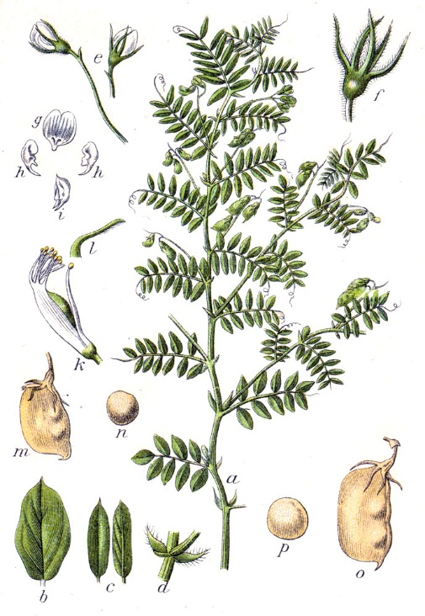

Drawing of lentil in Flora von Deutschland, Österreich und der Schweiz 1885 by Prof. Dr. Otto Wilhelm Thomé, Gera, Germany; www.biolib.de.

### Alternate Names

*Common Names:* none

*Scientific Names: Cicer lens* (L.) Willd.; *Ervum lens* L.; *Lens esculenta* Meunch

### Description

*General*: Legume family (Fabaceae). Lentils are 12 to 30 inches tall, slender, semi-erect annuals. Plants can have a single stem or branched, bushy form. Leaves are pinnate and have up to 14 sessile, ovate to lanceolate leaflets, each about 0.5 to 1.5 inches long. Leaves have two small stipules at the base and may terminate in a tendril. Flowers are usually double, or sometimes one to four on racemes, small (less than 0.5 inch long) and white to pale purple or dark purple. They bloom in sequence from the lower braches upwards (Cash et al., 2001). Flowers are self-pollinated and usually pollinate before opening. Occasionally cross-pollination can occur by thrips or other small insects. Flowers fade within 3 days of opening, and seed pods form 3 to 4 days later. Seed pods are flat, smooth, 0.5 to 0.75 inch long and contain 1 or 2 seeds (Muehlbauer et al., 2002). Seeds are lens shaped, and have a seed coat which ranges in color from clear to green, pale tan, brown and black. Seed coats of some cultivars have purple or black mottles or speckles.

Lentils are divided into two major types: macrosperma (large-seeded, or Chilean types) and microsperma (small-seeded, or Persian types) (Zohary, 1995; Cash et al., 2001). Large-seeded lentils have seeds up to 0.5 inch diameter with yellow cotyledons and little pigmentation in the flowers or vegetative structures. Small-seeded lentils have seeds up to 0.25 inch diameter with red, orange or yellow cotyledons and more pigmentation in the plant tissue. Small-seeded lentils are generally shorter and have smaller leaves and pods (Muehlbauer et al., 2002).

*Distribution*: Lentils are currently cultivated in 53 countries around the world (Food and Agriculture Organization, 2015). Major producers are Canada, India, Turkey, Australia and the United States (Food and Agriculture Organization, 2015). In the United States, Montana, North Dakota, Washington and Idaho lead production (USDA-National Agricultural Statistics Service, 2012). For current distribution, please consult the Plant Profile page for this species on the PLANTS Web site.

***Adaptation***

Lentils are a drought-tolerant, cool-season crop. They are usually grown in semi-arid climates without irrigation. A minimum of 10 inches of annual rainfall is required for lentil production (Cash et al., 2001). Lentils can tolerate low rainfall and high temperatures, however these stresses may negatively impact yield if they occur during flowering and seed set (Muehlbauer et al., 2002). Lentils are often planted in the spring in cool climates and in the fall or winter in warm climates. A few varieties are tolerant of extreme cold temperatures and can be planted in the winter in cool climates.

Lentils grow best in deep, sandy loam soils, however they will grow in all soil types with good drainage (Oplinger et al., 1990; Elzebrok and Wind, 2008). They can tolerate moderate alkaline or saline conditions (Muehlbauer et al., 2002) and grow in soils with pH of 4.4 to 8.2, but are best adapted to soils with pH of 5.5 to 7 (Elzebrok and Wind, 2008).

### Uses

*Commercial crop:* Lentils are considered a “pulse” or “grain legume” because they are grown for their edible seed, which is consumed primarily by humans. Some lentils are sold and consumed with seed coats intact, and others with seed coats removed. Seeds are often consumed whole or split in soups, stews and salads, and can be ground into flour and used in cakes or infant food (Elzebrok and Wind, 2008). Canada, Australia, and the United States export most of their lentil crop to Asian countries which have high levels of consumption (Cash et al., 2001).

Lentils are an excellent source of fiber, protein, the amino acid lysine and the nutrients folate, thiamin, phosphorus and iron (USDA-Agricultural Research Service, 2015). They are low in the amino acids methionine and cysteine, however when consumed with cereals, form a complete protein (Cash et al., 2001).

*Livestock feed:* Lentils that do not meet food grade standards (#3 or below) are used for livestock feed (Oplinger et al., 1990). Plant residues are also sometimes fed to livestock.

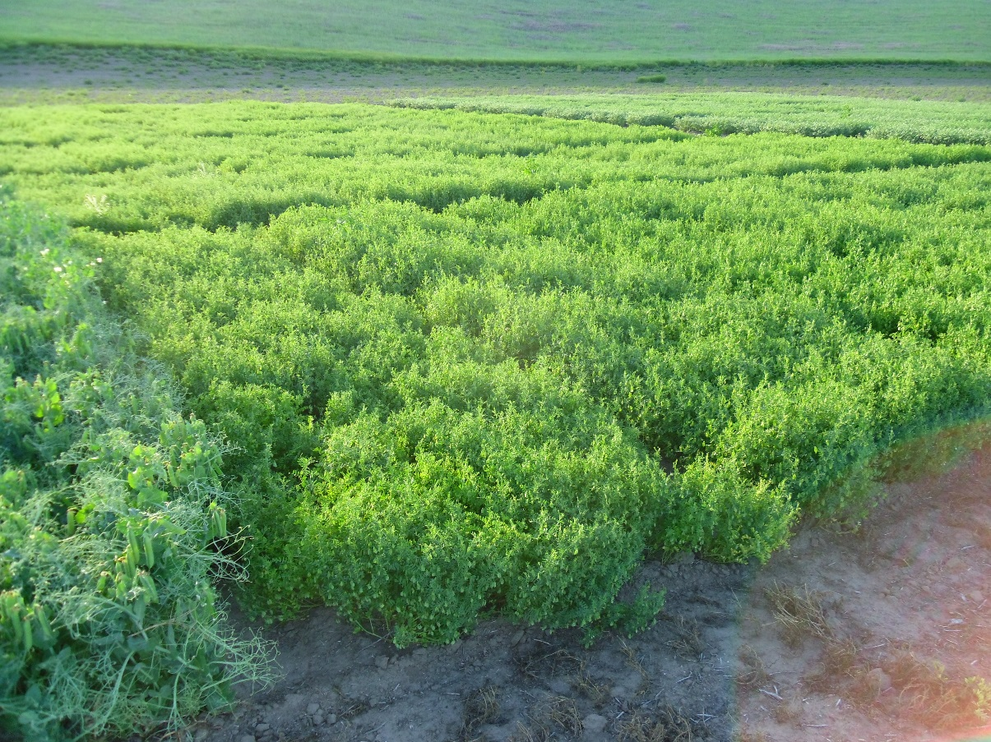

Lentils in a variety trial near Dusty, WA in early July at the end of flowering during pod filling. Stephen Guy, Washington State University

*Rotational crop:* Lentils provide many agronomic benefits when grown in rotation with cereals and other crops. They help reduce cereal disease severity because they are not an alternate host for cereal disease pathogens (Muehlbauer et al., 2002). Being a broadleaf crop, they allow an opportunity to control grass weeds. They also provide nitrogen to the subsequent crop through biological nitrogen fixation in association with symbiotic *Rhizobium* bacteria. Depending on environmental conditions, lentils may provide 30 to 100 pounds of nitrogen per acre (Muehlbauer et al., 2002). In addition, lentil residue decomposes quickly due to its low carbon to nitrogen ratio, minimizing operations necessary to prepare a seedbed for the following crop.

*Green manure and cover crop:* Lentils are a potential cover crop or green manure in semi-arid areas and are an option for replacement of fallow in the northern Great Plains (Allen et al., 2011). Research demonstrates, however, growers should approach this practice with caution and good management. If lentils are grown as a green manure and not terminated before pod set, they can have negative impacts on soil moisture and wheat yield compared to fallow (Zentner et al., 1996; Brandt, 1999; Allen et al., 2011). Early lentil termination (at flower stage) may reduce effects on soil moisture (Pikul et al., 1997; Allen et al., 2011) but also reduce the amount of nitrogen produced (McCauley et al., 2012).

Allen et al. (2011) determined several years may be required before experiencing benefits from growing a lentil green manure. In their long term study in Montana, wheat yield was significantly lower when grown in rotation with lentil green manure compared to fallow during the first five years, but after six years (three rotation cycles), differences in wheat yield were negligible. They discovered after six years, lentil green manure improved soil nitrogen cycling, maintained water productivity and offset wheat fertilizer requirements.

The Lockeford Plant Materials Center (CAPMC) in California’s Central Valley demonstrated lentils grown as a cover crop outperformed several other legumes in winter trials under drought conditions (Smither-Kopperl, personal communication, 2015). The CAPMC is conducting advanced trials to evaluate differences among lentil cultivars.

### Ethnobotany

The centers of origin of lentil are the Mediterranean and southwest Asia (Vavilov, 1949; Zohary, 1995). Lentils have been cultivated for as long as humans have planted crops (Zohary and Hopf, 1973). They were domesticated approximately 8,500 years ago, around the same time as wheat, barley and pea (Zohary and Hopf, 1973). Lentils were cultivated in Spain and Germany 7,000 years ago, and in India 4,500 years ago (Hancock, 2004; Elzebrok and Wind, 2008). They were brought to the United States in 1916 and grown near Farmington, Washington, then grown on a larger commercial scale beginning in 1937 (Youngman, 1967).

Lentils are a significant component of Mediterranean, Middle Eastern, Indian, Ethiopian, and western Asian diets. Popular lentil dishes are *dhal* in India, *mujaddara* in Arab countries, *kik wot* in Ethiopia, and *kushari* in Egypt. Lentils are an important food in Jewish mourning ceremonies because their round shape symbolizes the cycle of life, and in Italy and Hungary, people consume lentils on New Year’s Eve to bring about wealth and prosperity since lentils are shaped like coins (USA Dry Pea and Lentil Council, 2015). The lentil is celebrated every year in Pullman, Washington, at The National Lentil Festival with a parade and the “world’s largest bowl” of lentil chili.

### Status

Please consult the PLANTS Web site (<http://plants.usda.gov/>) and your State Department of Natural Resources for this plant’s current status (e.g., threatened or endangered species, state noxious status, and wetland indicator values).

### Planting Guidelines

Spring varieties of lentils should be planted when the soil has warmed to 40°F. Timely spring planting results in taller plants, which may improve ease of harvest and yield (Oplinger et al., 1990; Cash et al., 2001). Lentil seedlings can generally withstand frost and temperatures as low as 21°F (Cash et al., 2001). Lentils are more tolerant of frost than other crops because their cotyledons remain below the soil surface during germination (Cash et al., 2001).

Winter-tolerant varieties of lentils should be planted in the late summer or early autumn. The timing of planting is dictated by soil moisture conditions. In regions utilizing summer fallow, lentils can be planted into moisture in late August. In other regions, autumn-sown lentils are typically planted in September or October just before or after autumn precipitation.

Lentil seed should be inoculated with *Rhizobium leguminosarum* bacteria when planting in fields where lentils, peas or vetch have not been recently grown to ensure root nodule formation and the fixation of atmospheric nitrogen. In fields where residual nitrate levels exceed 44 pounds per acre, lentils may not nodulate and produce nitrogen (Cash et al., 2001). If soil nitrate levels are extremely low, a small amount of nitrogen (10 to 30 pounds per acre) applied prior to planting may be beneficial for establishment (Oplinger et al., 1990).

Lentils require high levels of phosphorus for optimum seed yields and nitrogen fixation (Cash et al., 2001). Phosphorus and potassium fertilization rates should be based on soil test results and recommendations for your area. See local extension bulletins for this information. The fertilizer should be worked into the soil or deep-banded in the fall prior to spring planting or during spring field preparation to avoid direct contact with seedlings (Oplinger et al., 1990; Cash et al, 2001).

Seeding rates range from 40 to 70 pounds per acre, depending on variety (Cash et al., 2001; Muehlbauer et al., 2002). Typical grain drills with 6 to 12-inch row spacing can be used for seeding and should be calibrated to plant about 10 seeds per square foot (Cash et al., 2001). The ideal seeding depth is 1 to 2 inches.

### Management

Weed management prior to lentil establishment is critical since lentils do not compete well with weeds (Cash et al., 2001) and plants are easily damaged by post-planting cultivation (Oplinger et al., 1990). Applications of pre-emergent herbicides such as linuron and metribuzin (applied post-planting) are common. A few post-emergence herbicides are labeled for lentils, however they are not typically used since they may cause damage to the crop. These include sethoxydim and trilliate for grass weeds, and imazethapyr and metribuzin for broadleaf weeds (Cash et al., 2001). Contact your local agricultural extension specialist or county weed specialist to learn what works best in your area and how to use it safely. Always read label and safety instructions for each control method. Trade names and control measures appear in this document only to provide specific information. USDA NRCS does not guarantee or warranty the products and control methods named, and other products may be equally effective.

A growing season of 80 to 100 days is required for growing a lentil crop, depending on seeding date, precipitation and heat units (Cash et al., 2001). Lentil seed pods mature from the bottom up, with the lower pods maturing before the upper pods. The crop should be swathed or desiccated with chemical desiccants when the lower pods mature to prevent seed shattering (Cash et al., 2001). The crop can also be direct combined, which reduces losses due to shattering and weather delays. Combine headers with automatic height adjustment (“flex” headers) and “pick up” reel attachments are helpful. Low cylinder speeds (less than 500 rpm) should be used to minimize damage to the seed. Lentils should have about 18 to 20% moisture at the time of harvest to prevent seed damage (Oplinger et al., 1990), then dried to 14 to 15% moisture for long-term storage (Oplinger et al., 1990; Cash et al., 2001).

### *single row of lentils at physiological maturity*

Single row planting of a lentil accession in the lentil core collection from the Washington State University germplasm repository at Pullman, WA. Plants are at physiological maturity. Stephen Guy, Washington State University

### Pests and Potential Problems

Lentils are attacked by insects at all stages of plant growth. Seeds and seedlings are eaten by seedcorn maggots (*Delia platura*), wireworms (*Limonius* spp. and *Ctenicera* spp.), cutworms (*Agrotis* spp.), and weevil larvae (*Sitona* spp.). Lentil leaves, stems and flowers are eaten by thrips (*Frankliniella* spp.), leaf weavils (*Sitona lineatus*), lepidopterous larvae (*Helicoverpa* spp. and *Spodoptera* spp.), lygus bugs (*Lygus* spp.) and grasshoppers (multiple spp.) (Muehlbauer et al., 2002). Aphids (*Aphis craccivora*  and *Acyrthosiphon pisum*) can cause damage by drinking sap from plant parts.

Common lentil diseases include aphid-vectored viruses (alfalfa mosaic, bean/pea leaf roll, bean yellow mosaic, pea enation mosaic, pea streak, and seedborne mosaic), root rots or wilts (*Rhizoctonia, Pythium, Sclerotium, Aphanomyces* and *Fusarium* spp.), rust (*Uromyces viciae-fabae*), Ascocyta blight (*Acochyta fabae*), Stemphylium blight (*Stemphylium* spp.), anthracnose (*Colletotrichum truncatum*) and seedborne fungi (Muehlbauer et al., 2002).

Lentil disease severity can be reduced by planting disease-free seed, eliminating plant residue, and lengthening crop rotation cycles so the same crop is not planted in the same field more than once every three years (Cash et al., 2001).

### Environmental Concerns

None.

### Control

Lentils can shatter from the pods before or during harvest and become weeds in the following crop. They can typically be controlled with herbicides labeled for cereal crops.

### Seeds and Plant Production

Lentil seed size varies with seed type and cultivar. Large-seeded cultivars ‘Laird’ and ‘Merrit’ have approximately 6,500 seeds per pound, and small-seeded varieties ‘Eston’ and ‘Pardina’ have about 12,600 to 19,700 seeds per pound. Average yields in the U.S. during the years 2002 to 2012 ranged from 1,000 to 1,400 pounds per acre (USDA-National Agricultural Statistics Service, 2012).

### Cultivars, Improved, and Selected Materials (and area of origin)

Numerous lentil cultivars are available for commercial production. A few of the most common cultivars for each market class are listed below. Cultivars preceded by CDC were developed by the Crop Development Centre at the University of Saskatchewan.

Small Reds: CDC Rosetown, Crimson, CDC Rouleau, CDC Redcoat, CDC Redberry

Small Green: CDC LeMay, CDC Viceroy

Medium Green: CDC Richlea, Avondale

Large Green: CDC Greenland, Pennell, Merrit, Riveland

Spanish Brown: Pardina

Zero Tannin: Shasta, Cedar

Cultivars should be selected based on the local climate, resistance to local pests, and intended use. Consult with your local land grant university, extension or local USDA NRCS office for recommendations on adapted cultivars for use in your area**.**

**Literature Cited**

Allen, B.L., J.L. Pikul Jr, J.T. Waddell, and V.L. Cochran. 2011. Long-term lentil green-manure replacement for fallow in the semiarid northern Great Plains. Agronomy J. 103:1292-1298.

Brandt., S.A. 1999. Management practices for black lentil green manure for the semi-arid Canadian prairies. Canadian J. of Plant Sci. 79:11-17.

Cash, D., R. Lockerman, H. Bowman and L. Welty. 2001. Growing Lentils in Montana. Montana State University Extension Guide MT199615. Montana State University, Bozeman, MT.

Elzebroek, T., and K. Wind. 2008. Guide to cultivated plants. CAB International, Oxfordshire, UK.

Food and Agriculture Organization. 2015. [Online] Available at: http://faostat3.fao.org/download/Q/QC/E (Accessed 24 August 2015). FAO, Rome.

Hancock, J.F. 2004. Plant Evolution and the Origin of Crop Species. CAB International, Oxon, UK and Cambridge, MA.

McCauley, A.M., C.A. Jones, P.R. Miller, M.H. Burgess, and C.A. Zabinski. 2012. Nitrogen fixation by pea and lentil green manures in a semi-arid agroecoregion: effect of planting and termination timing. Nurtient Cycling in Agroecosystems 92:305-314.

Muehlbauer, F.J., R.J. Summerfield, W.J. Kaiser, S.L. Clement, C.M. Boerboom, M.M. Welsh-Maddux,   
and R.W. Short. 2002. Principles and Practice of Lentil Production. Available at: http://www.ars.usda.gov/is/np/lentils/lentils.htm (Accessed 17 August 2015). USDA-Agricultural Research Service, Pullman, WA.

Oplinger, E.S., L.L. Hardman, A.R. Kaminski, K.A. Kelling and J.D. Doll. 1990. Lentil. Alternative Field Crops Manual. [Online] Available at: https://hort.purdue.edu/newcrop/afcm/lentil.html. University of Wisconsin Cooperative Extension and University of Minnesota Extension Service, Madison, WI and St. Paul, MN.

Pikul, J.L. Jr., V.L. Cochran, and J.K. Aase. 1997. Lentil green manure as fallow replacement in the semiarid northern Great Plains. Agronomy J. 89:867-874.

USA Dry Pea and Lentil Council. 2015. Processing Information and Technical Manual. [Online] Available at: http://www.pea-lentil.com/ (Accessed 19 Aug 2015). USA Dry Pea and Lentil Council, Moscow, ID.

USDA-National Agricultural Statistics Service. 2012. Press release. [Online] Available at: http://www.nass.usda.gov/Statistics_by_State/Washington/Publications/Current_News_Release/pealent11.pdf. (Accessed 14 August 2015). USDA-NASS, Washington, DC.

USDA-Agricultural Research Service. 2015. National Nutrient Database Standard Release. [Online] Available at: http://ndb.nal.usda.gov/ndb/foods/show/4782?fgcd=&manu=&lfacet=&format=&count=&max=35&offset=&sort=&qlookup=lentil (Accessed 24 August 2015). USDA-ARS, Washington, DC.

Vavilov, N.I. 1949. The origin, variation, immunity and

breeding of cultivated plants. Chron. Bot. 13:1-54.

Youngman, V.E. 1967. Lentils – a pulse for the Palouse. Economic Botany 22:135–139.

Zentner, R.P., R. Selles, V.O. Biederbeck, and C.A. Campbell. 1996. Indianhead black lentil as green manure for wheat rotations in the Brown soil zone. Canadian J. of Plant Sci. 76:417-422.

Zohary, D. and M. Hopf. 1973. Domestication of pulses in the Old World. Science 182:887-894.

Zohary, D. 1995. Lentil: *Lens culinaris* (Leguminoseae – Papilionoideae). In: Smartt, J. and N.W. Simmonds (eds) Evolution of Crop Plants. Longman Scientific & Technical, Harlow, UK.

### Citation

Pavek, P.L.S. and R. McGee. 2016. Plant Guide for lentil (*Lens culinaris* Medik.). USDA-Natural Resources Conservation Service, Pullman Plant Materials Center. Pullman, WA.

Published January 2016

[Edited:](#edited" \o "[e.g., 08Sep2009 rg, 08Sep2009 jfh; 17Sep2009 mws]  NOTE:  Please remove the brackets if no editing data exists (new document).1) The author is the person(s) who did the majority of the work and should not exceed 2 people. Names should not be added to updated PGs unless significant rewrites are done. If a substantial rewrite is done the citation should be adjusted as follows:Original authors name, title, [add ed. (rev) Editor name. new pub date], remainder of citation remains the same.Example:  Pavek, P.L.S. 2012. Plant guide for pea (Pisum sativum L.). ed. (rev) E.R. Garner. 2014. USDA-Natural Resources Conservation Service, Pullman, WA.2) If minor updates or revisions are made it is only in the edited by section. Retain the most recent 5-10 edits.3) Names should not be removed regardless of death or retirement.) 22Dec2015 aym

For more information about this and other plants, please contact your local NRCS field office or Conservation District at <http://www.nrcs.usda.gov/> and visit the PLANTS Web site at <http://plants.usda.gov/> or the   
Plant Materials Program Web site:

<http://plant-materials.nrcs.usda.gov>.

***Helping People Help the Land***

**USDA IS AN EQUAL OPPORTUNITY PROVIDER AND EMPLOYER**