

Plant Guide

# manystem wildrye

## Leymus multicaulis (Kar. & Kir.) Tzvelev

### Plant Symbol = LEMU11

#### Contributed by: USDA NRCS Lockeford Plant Materials Center, California & Bridger Plant Materials Center, Montana

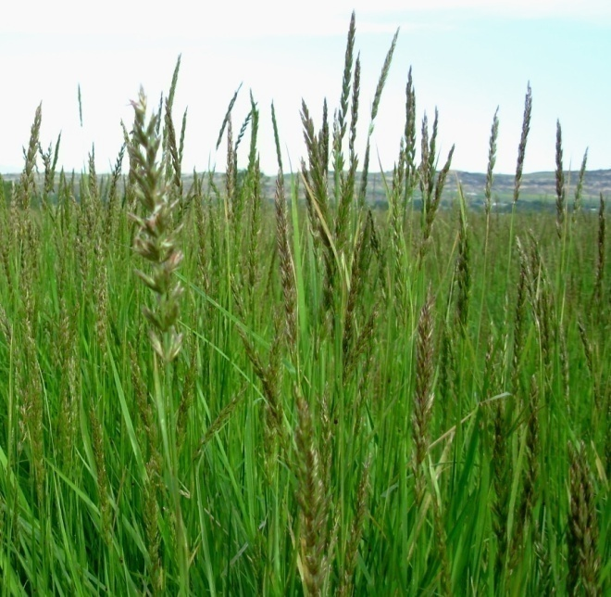

Leymus multicaulis, Susan R. Winslow, Bridger PMC

#### **Alternate Names**

Many-stem lyme grass, *Elymus multicaulis*

#### **Uses**

Manystem wildrye is primarily used for reclamation of wet, saline soils. It can be used effectively on saline-affected, irrigated cropland and pastureland, and on land where the water table is within 3 ft (0.9 m) of the soil surface. Manystem wildrye is also used for reclamation of saline seep discharge areas on dry cropland, where water tables are typically deeper than 3 ft (0.9 m) and annual precipitation may range from 12 to 18 inches (30-45 cm).

This grass is recommended for use as forage, soil stabilization for prevention of wind and water erosion, and in wildlife cover plantings. It is moderately palatable to all livestock, especially in the early spring before it becomes coarse. It is compatible with creeping meadow foxtail (Alopecurus arundinaceus) and slender wheatgrass (Elymus trachycaulus) for cattle grazing (Baldridge and Lohmiller 1990).

#### **Status**

Please consult the PLANTS Web site and your State Department of Natural Resources for this plant’s current status (e.g., threatened or endangered species, state noxious status, and wetland indicator values).

#### **Description**

*General*: Grass Family (Poaceae). Manystem wildrye is an introduced, perennial, cool-season, sod-forming grass. Plants are somewhat cespitose and rhizomatous, growing 19 to 32 inches tall (50-80 cm) (Barkworth 2009). Stems are usually smooth, but are occasionally hairy. Leaf blades are grayish green, sometimes glaucous, stiff and flat early in the growth season, becoming rolled later in the year, and are 0.1 to 0.3 inch wide (3-8 mm). The spike is narrow and 2 to 5.5 inches long (5-14 cm), with typically two or more spikelets (up to 6) occurring per node. Glumes and lemmas are sharp pointed, and lemmas are generally tipped with an awn approximately 0.1 inch (2-3 mm) in length.

*Taxonomy*: After its release, ‘Shoshone’ beardless wildrye (*Leymus triticoides*) was determined to be *Leymus multicaulis* (Asay and Jensen 1996). *L. multicaulis* is very similar to *L. triticoides*; it differs primarily in having both primary and secondary veins in its blades (usually widely spaced) and small hairs on its calluses (about 0.2 mm long), while *L. triticoides* has closely spaced, prominently ribbed subequal veins and calluses without hairs, or with a few short (0.1 mm) hairs (Barkworth 2009). Hybrids between the two species are highly fertile.

*Distribution*: The native distribution of manystem wildrye in Eurasia extends from the Volga River delta to Xinjiang, China (Barkworth 2009). Because of the recent recognition of Shoshone as manystem wildrye, its distribution in North America is unknown, but it is likely found throughout the western US. For current distribution, please consult the Plant Profile page for this species on the PLANTS Web site.

#### **Adaptation**

Manystem wildrye is adapted to wet, saline meadows, where rainfall exceeds 9 to 14 inches (23-35 cm), or where wet, saline-alkaline sub-irrigated sites exist (Ogle et al. 2008). Manystem wildrye does well on moderately-coarse/sandy to poorly-drained soils, and ranges from uplands and slopes to bottomlands (Baldridge and Lohmiller 1990).

This species tolerates neutral to strongly alkaline soils (pH 6.6 to 9.0) and soils classified as strongly saline (greater than 16 dS/m) (Baldridge and Lohmiller 1990; Ogle and St. John 2008). Winter hardiness and frost tolerance are good, though variable among seed lots. Manystem wildrye is moderately shade tolerant (Baldridge and Lohmiller 1990).

#### **Establishment**

Fall dormant plantings are recommended for northern regions to increase seed coat permeability by overwintering in the soil (Gutormson 1984). Mechanical seed scarification enhances seedling growth and improves establishment of spring planted manystem wildrye (Baldridge and Lohmiller 1990). Seedlings have poor vigor, develop slowly, and compete poorly with weeds and other forage grasses in the first year of establishment. It is thus very important to minimize weed competition with properly prepared seedbeds and adequate weed management prior to seeding.

For range and pasture seedings, seeds should be drilled into a well-disked seedbed in late fall just prior to freeze up at a depth of 0 to ¼ inch (6 mm) and a rate of 6 to 9 lbs pure live seed (PLS) per acre (7-10 kg/ha) for full-rate, monotypic seedings (Ogle and St. John 2008; Ogle et al. 2008). For restoration plantings where drilling is not possible, seeds can be broadcast at a rate of 10 to 20 PLS lbs/acre (11-22 kg/ha) (Baldridge and Lohmiller 1990).

Vegetative planting of rhizomes (‘sprigging’) in mid-September to November is recommended for establishment on sites typically saturated or under standing water in the spring or early summer, or where rapid cover is needed. Stand establishment from sprigs is slow during the first year, but once established rhizomes spread rapidly to produce better coverage and more forage than stands originating from seed. In Montana, sprigging at a rate of 40 bu/acre (100 bu/ha) is recommended for streambank protection plantings (Baldridge and Lohmiller 1990).

#### **Management**

Once established, stands of manystem wildrye survive for many years. Manystem wildrye has been found to be compatible with many other species because it does not form a dense, restrictive sod. It is highly productive for hay when planted at a rate of 6 PLS lbs/acre (7 kg/ha) on irrigated or sub-irrigated sites. Best yields are attained on fields with adequate levels of fertility, especially available nitrogen. Forage yields depend on the level of salts and moisture in the soil. High concentrations of salts and/or low levels of moisture result in poorer stand establishment, lower yields, and slower growth rates. Forage trials conducted on Shoshone manystem wildrye over a 4-year period, on fields with moderate fertility, yielded an average of 1,750 lbs/acre in Bridger, MT (Majerus 1979).

#### **Pests and Potential Problems**

Manystem wildrye has been found to be susceptible to a soil-borne pathogen, “take-all” disease, caused by the root-inhabiting fungus *Ophiobolus graminis* (Stroh 1968).A temporary solution to arrest the disease may be achieved with an application of P2O5 at a rate of100 lb/acre (112 kg/ha). More drastic follow-up measures to renovate the site include plowing to a 6-inch (15-cm) depth, harrowing, and irrigating to promote rhizome emergence.

Manystem wildrye varies in resistance to leaf rust, stripe rust, and ergot. No ill effects are known from livestock consumption of the infected material.

#### **Environmental Concerns**

Manystem wildrye is known to produce fertile hybrids with beardless wildrye(*Leymus triticoides*). Seed production in these species is poor so hybrid offspring should not have a competitive advantage in native plant communities.

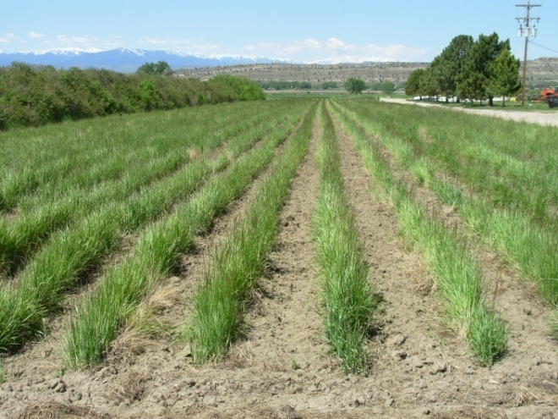

Shoshone foundation seed field at Bridger PMC, 2010.

#### **Seeds and Plant Production**

There are approximately 150,000 to 175,000 seeds per pound (331,000-386,000 seeds/kg) (Ogle et al. 2008). The recommended seeding rate for seed production under irrigation is 3.7 PLS lbs/acre (4.1 kg/ha) at 24-inch (60-cm) row spacing, or 24 seeds/ft (79 seeds/m) (Smith and Smith 1997). Susceptibility to seed shatter is low, but it is still recommended that the crop be combined from the windrow (Baldridge and Lohmiller 1990). No special problems are presented in cleaning the seed.

In Montana, Shoshone is commonly cultivated the first two to three years and then allowed to spread into solid stands. Seed yields and stand longevity are reduced when between-row cultivation is not practiced. Seed yields of Shoshone average 200 lbs/acre (224 kg/ha) (Baldridge and Lohmiller 1990).

#### **Cultivars, Improved, and Selected Materials (and area of origin)**

**‘Shoshone’** was released in 1980 as beardless wildrye (*Leymus triticoides*) through a cooperative agreement between the Bridger PMC and the agricultural experiment stations of Montana and Wyoming. After its release, however, Shoshone was determined to be the Eurasian species *Leymus multicaulis* (Asay and Jensen 1996). The original collection was made in 1958 from the Riverton, WY fairgrounds, possibly from a seeded stand established in the 1940s from an unknown source. The collection site is at an elevation of 4,950 ft (1,509 m), in a 5 to 9-inch (12-23 cm) precipitation zone in the Wind River Basin. Shoshone is adapted to a wide range of soil textures on sub-irrigated sites in most areas of Montana and Wyoming, as well as northwestern Colorado and southern Idaho. It is a cool-season, moderately tight sod-forming cultivar selected primarily for forage, stabilization, or cover on wet or moist-saline-alkaline soils. This includes pastureland, saline-affected irrigated cropland, dryland saline-seep-discharge areas, highly erodible areas along waterways, and sites that are periodically flooded.

#### **References**

Asay, K.H., and K.B. Jensen. 1996. Wildryes. p. 725-748. In L.E. Moser, D.R. Buxton, and M.D. Casler (eds.) Cool-season forage grasses. Agron. 34. Amer. Soc. of Agron., Madison, WI.

Baldridge, D.E., and R.G. Lohmiller (eds.) 1990. Montana Interagency Plant Materials Handbook. Extension Bulletin 69. Montana State University Extension Service, Bozeman.

Barkworth, M.E. 2009. Leymus Hochst. In Grass Manual on the Web [Online]. Available at http://herbarium.usu.edu/webmanual/info2.asp?name=Leymus_triticoides&type=treatment (accessed 13 Jan. 2010). Utah State University, Logan.

Gutormson, T.J. 1984. Field establishment and germination of beardless wildrye (*Elymus triticoides* Buckl.) Thesis for Master of Science in Agronomy. Montana State University, Bozeman.

Majerus, M.E. 1979. Saline seep program - Beardless wildrye trials. *In* USDA SCS Annual Technical Report. Bridger Plant Materials Center, Bridger, MT.

Ogle, D., and L. St. John. 2008. Plants for saline to sodic soil conditions. Technical Note PM-9. USDA-NRCS, Boise, ID.

Ogle, D., L. St. John, M. Stannard, and L. Holzworth. 2008. Grass, grass-like, forb, legume, and woody species for the Intermountain West. Technical Note PM-24. USDA-NRCS, Boise, ID.

Smith, S.R., and S. Smith (eds.) 1997. Native Grass Seed Production Manual. Cooperative publication of the USDA NRCS Plant Materials Program, Ducks Unlimited Canada, the Manitoba Forage Seed Association, and the University of Manitoba.

Stroh, J.R. 1968. Cultural methods for the establishment of *Elymus triticoides* on saline-sodic soils. *In* USDA-SCS Annual Technical Report, Bridger Plant Materials Center, Bridger, MT.

#### **Prepared By**

*Anna Young-Mathews*

USDA-NRCS Plant Materials Center

Lockeford, California

*Susan R. Winslow*

USDA-NRCS Plant Materials Center

Bridger, Montana

#### **Citation**

Young-Mathews, A. and S. R. Winslow. Plant guide for manystem wildrye (*Leymus multicaulis)*. USDA-Natural Resources Conservation Service, Plant Materials Center. Lockeford, California 95237.

Published October, 2010

Edited: 17Aug2010 aym, 18Aug2010 kdl, 19Aug2010 cjs, 20Aug2010 msk, 23Aug2010 srw, 31Aug2010 jds, 1Sep2010 aym

For more information about this and other plants, please contact your local NRCS field office or Conservation District at <http://www.nrcs.usda.gov/> and visit the PLANTS Web site at <http://plants.usda.gov/> or the Plant Materials Program Web site <http://plant-materials.nrcs.usda.gov>.

PLANTS is not responsible for the content or availability of other Web sites.

**USDA IS AN EQUAL OPPORTUNITY PROVIDER AND EMPLOYER**