

Plant Guide

# mammoth wildrye

## Leymus racemosus (Lam.) Tzvelev

### Plant Symbol = LERA5

#### **Contributed by:** USDA NRCS Idaho and Washington Plant Materials Program

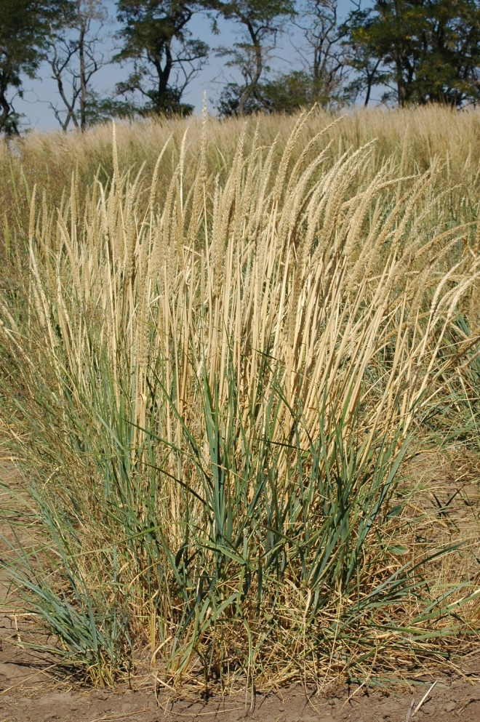

Mammoth Wildrye. Pamela Pavek, USDA-NRCS, Pullman, WAPMC

#### **Alternate Names**

*Elymus arenarius var. giganteus, Elymus giganteus, Elymus racemosus, Leymus giganteus* (PLANTS Database).

#### **Uses**

Mammoth wildrye is used primarily for stabilization of inland sand dunes and for wind erosion control on sand to fine sandy loam soils. It is also used in wildlife plantings to provide cover and nesting sites for upland birds. It can also be used for revegetation of mine tailings and in fire breaks or greenstrips. Mammoth wildrye has also been used to incorporate genes from *Leymus* into wheat to improve resistance to barley yellow dwarf virus (Qi, et.al 1997). Mammoth wildrye is generally not suitable for grazing and has poor to fair palatability during the spring and summer (Monsen et.al 2004).

#### **Status**

Consult the PLANTS Web site and your State Department of Natural Resources for this plant’s current status (e.g., threatened or endangered species, state noxious status, and wetland indicator values). An environmental evaluation of ‘Volga’ mammoth wildrye conducted by the Plant Materials Program in 2002 indicated that the cultivar had a low chance of negatively affecting the environment, and is relatively easy to control.

#### **Weediness**

This plant may become weedy or invasive in some regions or habitats and may displace other vegetation if not properly managed. Consult with your local NRCS Field Office, Cooperative Extension Service office, state natural resource, or state agriculture department regarding its status and use. Weed information is available from the PLANTS Web site at <http://plants.usda.gov>. Consult the Related Web Sites on the Plant Profile for this species for additional information.

#### **Description**

*General*: Grass Family (Poaceae). Mammoth wildrye is an introduced, long-lived, rhizomatous perennial grass that grows to approximately 3 feet in height. It is coarse stemmed with large, long, flat, and tough leaves.

Culms to 100 cm (39 in) tall, 10 mm (0.04 in) diameter and scaberulous pubescent below raceme. Leaf sheath is membranous at the margin and ligule is approximately 2 mm (0.008 in) long, membranous with a truncate apex. The leaf blade is glaucous green 20-40 cm (8-16 in) long and 1.5 cm (0.6 in) wide, the lower surface smooth and the upper surface and margin scabrous. The spike is 15-30 cm (6-12 in) long, 1-2 cm (0.39-0.79 in) diameter and is stout and glabrous. There are 4-6 spikelets per node with 3-5 florets. Glumes are linear-lanceolate with a robust midvein and 2 faint lateral veins. The lemma is lanceolate, 7-veined, softly hairy and awnless. The palea is slightly shorter than the lemma.

Chromosome number is 2n=28 (Flora of China, 2006). Zhipeng Liu et.al (2008) reported that *Leymus racemosus* is a tetraploid (4x).

*Distribution*:

Mammoth wildrye is native to China, Kazakhstan, Kyrgyzstan, Mongolia, Russia, Turkmenistan and Uzbekistan (Flora of China, 2006). For current distribution in North America, consult the Plant Profile page for this species on the PLANTS Web site.

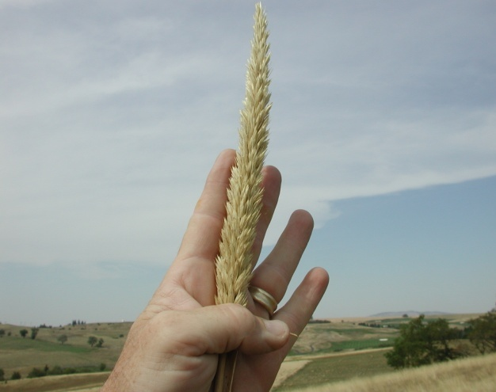

Mammoth wildrye spike. Mark Stannard, USDA-NRCS Pullman WAPMC

#### **Adaptation**

Mammoth wildrye is adapted to areas that receive at least 7 inches of mean annual precipitation throughout most of the western United States. It performs best on well drained neutral to somewhat alkaline soils. Mammoth wildrye thrives in sandy soils and is very tolerant of sand deposition. It can be grown on loam, silt loam and clay loam soils but vegetative spread by rhizomes diminishes on heavier soils. It is not adapted to coastal areas. Mammoth wildrye tolerates fire fairly well because the leaves and stems remain green during the summer fire season and it does not combust as readily as most other plants (Pullman Plant Materials Center). Stevens et.al (2004) indicated that mammoth wildrye is suitable for riparian restoration and rated tolerant of salinity and flooding.

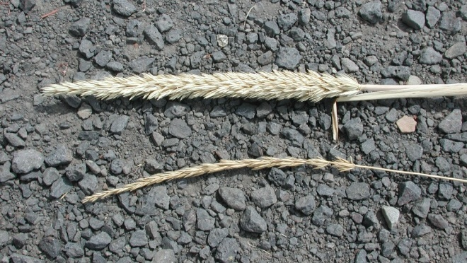

Mammoth wildrye spike top, basin wildrye spike bottom. Mark Stannard, USDA-NRCS, Pullman WAPMC.

#### **Establishment**

Proper seedbed preparation, irrigation scheduling and weed management are required to establish mammoth wildrye. Kochia and Russian thistle can be troublesome during establishment of mammoth wildrye. Broadleaf herbicides effectively control both weeds. Mowing mammoth wildrye is not recommended for controlling weeds.

Use sprigs and rhizome sections to plant and stabilize active sand dunes. Plant sprigs and rhizomes are planted only during cool weather while they are dormant and the site is moist to 18 inch soil depth, usually mid-November to mid-March.

Mammoth wildrye can also be seeded. There are approximately 55,000 seeds per pound (PLANTS database) and the recommended full seeding rate is 15 pounds Pure Live Seed (PLS) per acre to a seeding depth of ½ to ¾inch (Ogle, et. al 2010). If used as a component of a seeding mix, adjust to percent of mix desired. For critical area stabilization or broadcast planting, double the drill seeding rate to 30 pounds PLS per acre. Seeding should be completed in late fall as a dormant seeding on course textured soils.

It has been determined that mammoth wildrye has developed an important seedling desiccation strategy to survive harsh conditions, most notably erosion of sand. Seedlings have the ability to survive and develop even after the whole seedling has been under desiccation for a long period (approximately 20-40 days), if the root is <15mm long prior to dehydration. If roots are longer than 15 mm, the seedling will not survive (Huang and Gutterman, 2004).

#### **Management**

Mammoth wildrye is not generally considered a forage plant. The leaves and stems are very coarse, have low palatability, and are high in indigestible structural carbohydrates (Pullman Plant Materials Center), (Jefferson, et.al, 2004). However, grazing animals will eat mammoth wildrye if no other forage is available. Jack rabbits will consume new growth of mammoth wildrye and often pull young plants out of the ground. Monsen et.al (2004) indicated that mammoth wildrye has fair palatability during the spring and summer. Grazing should be excluded from erosion control plantings (Hafenrichter, et.al, 1968).

#### **Pests and Potential Problems**

Mammoth wildrye is susceptible to infection of ergot from the fungus *Claviceps purpurea*. Ergot infection can significantly reduce seed yields and the fungal sclerotia contain a variety of alkaloids. Consumption of the alkaloids can result in reproductive failure, gangrene and other serious maladies in grazing animals (Mihail, 1993).

#### **Environmental Concerns**

Mammoth wildrye spreads primarily by rhizomes and to a much lesser degree by seed into adjoining vegetative communities under ideal climatic and environmental conditions.

For control, contact your local extension specialist or county weed specialist to learn what works best in your area and how to use it safely. Always read label and safety instructions for each control method.

#### **Plant Production**

Proper seedbed preparation (weed-free and firm), irrigation scheduling and weed management are required to establish mammoth wildrye. On moving sand dunes and non-stabilized areas, use sprigs and rhizomes for stand establishment. For maximum sprig and rhizome production, plants should be grown under cultivation on irrigated sites. Two years are required to grow suitable sized sprigs and rhizomes for harvest.

**Handling Harvested Plant Materials**

All of the old growth, coarse roots and stems with seedheads are removed. Leafy tops are cut to leave a 16 inch stem and are tied in bundles, heeled in, or kept cool and moist until planting time. Plants are dug (harvested), processed and planted only during cool weather while sprigs and rhizomes are dormant and the site to be planted is moist to 18 inch soil depth, usually mid-November to mid-March.

**Seed Production**

Plant mammoth wildrye seed at 8-10 pounds PLS per acre in 30-36 inch rows, to a seeding depth of ½ to ¾ inch. This seeding rate is equivalent to approximately 30 seeds per linear foot of row. To facilitate seed production and between-row weed control, it is desirable to plant in spaced rows instead of a solid stand. Cultivation is required to maintain rows and weed-free conditions.

Seed is usually harvested in August by swathing to allow the seed to complete maturity followed by combining. Mammoth wildrye seed requires a brief after-ripening (one month) and stratification (1-2 weeks at 40 degrees F.). Seed can be stored under cool and dry conditions for 11-15 years without serious loss of germination or vigor (Jorgenson, 2004).

#### **Cultivars, Improved, and Selected Materials (and area of origin)**

**‘Volga’** was selected and released from the Pullman, Washington Plant Materials Center in 1949. The original seed collection was made in the lower Volga region of the former USSR by the Westover-Enlow expedition in 1934. The most vigorous plants from the original collection were selected during several generations followed by vegetative reproduction for the most desirable type. Volga was initially released as vegetative material for inland dune control and in 1986 the release was modified to include seed propagation. The Upper Colorado Environmental Plant Center at Meeker, Colorado produces and distributes Foundation seed (Alderson and Sharp, 1994).

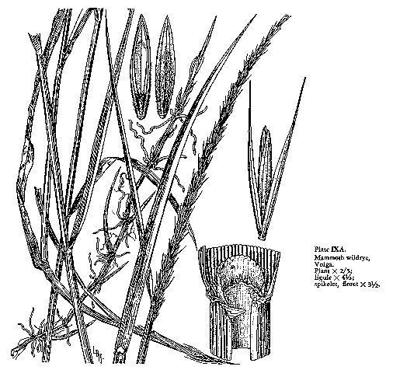

Agriculture Handbook No. 339 USDA-SCS 1979.

#### **References**

Alderson, J., Sharp, W.C. 1994. Grass Varieties in the United States. Agriculture Handbook No. 170. USDA-SCS. Washington, D.C.

Flora of China. 2006. 22:387-394.

Hafenrichter, A.L., J.L. Schwendiman, H.L. Harris, R.S. MacLauchlan, H. W. Miller. 1968. Grasses and Legumes for Soil Conservation in the Pacific Northwest and Great Basin States. Agriculture Handbook No. 339. USDA-SCS. Washington, D.C.

Huang, Z, and Y. Gutterman. 2004. Seedling desiccation tolerance of *Leymus racemosus* (Poaceae) (wildrye), a perennial sand-dune grass inhabiting the Junggar Basin of Xinjian, China. Seed Science Research 14:233-239.

Jefferson, P.G., W.P. McCaughey, K. May, J. Woosaree and L. McFarlane. 2004. Forage Quality of seeded native grasses in the fall season on the Canadian Prairie Provinces. Can. J. Plant Sci. 84:503-509.

Jorgenson, K. and R. Stevens. 2004. Seed Collection, Cleaning, and Storage. USDA Forest Service Gen. Tech. Rep. RMRS – GTR-136. P. 699-716.

Liu, Zhipeng, Z. Chen, J. Pan, X. Li, M. Su, L. Wang, Li and G. Liu. 2008. Phylogenetic relationships in *Leymus* (Poaceae: Triticeae) revealed by nuclear ribosomal internal transcribed spacer and chloroplast *trn*L-F sequences. Molecular Phylogenetics and Evolution 46(2008) 278-289. Science Direct. www.sciencedirect.com

Mihail, J.D. 1993. Diseases of alternative crops in Missouri. Can. J. Plant Pathol. 15:119-122.

Monsen, S., R. Stevens, and N. Shaw. 2004. Grasses. USDA Forest Service Gen. Tech Rep. RMRS-GTR-136. P. 199-294.

PLANTS Database. Conservation plant characteristics for *Leymus* *racemosus*. [Online] Available at http://plants.usda.gov (accessed 25 August 2010.

Pullman Plant Material Center. Release brochure for Volga Mammoth wildrye.

Ogle, D.G., L. St. John, M. Stannard, and L. Holzworth 2010. Grass, Grass-like, Forb, Legume and Woody species for the Intermountain West. USDA-NRCS. ID-TN24. Boise, ID

Qi, L.L., Wang, S.L., Chen, P.D., Liu, D.J., Friebe, B. and Gill, B.S. 1997. Molecular cytogenetic analysis of Leymus racemosus chromosomes added to wheat. Theor Appl Genet.95:1084-1091.

Stevens, R. and S. Monsen. 2004. Guidelines for Restoration and Rehabilitation of Principal Plant Communities. USDA Forest Service Gen. Tech. Rep. RMRS-GTR-136. P. 309.

#### **Prepared By**

Loren St. John, Team Leader, USDA, NRCS Plant Materials Center, Aberdeen, ID

Daniel G. Ogle, Plant Materials Specialist, USDA, NRCS, Boise, ID

Mark Stannard, Manager, USDA, NRCS Plant Materials Center, Pullman, WA

Pamela Pavek, Agronomist, USDA, NRCS Plant Materials Center, Pullman, WA

#### **Citation**

St. John, L., D.G. Ogle, M. Stannard, P. Pavek. 2010. Plant Guide for Mammoth Wildrye (*Leymus racemosus*). USDA-Natural Resources Conservation Service, Aberdeen, ID Plant Materials Center.

Published October 2010

Edited: ls 26Oct2010; plsp 26Oct2010; dgo01Nov10; jab02Nov2010; ls08Nov2010; plsp 08Nov10; dgo 08Nov10; jab 09Nov10; ms 09Nov10

For more information about this and other plants, please contact your local NRCS field office or Conservation District <<http://www.nrcs.usda.gov/>>, and visit the PLANTS Web site <[http://plants.usda.gov](http://plants.usda.gov/)> or the Plant Materials Program Web site <[http://Plant-Materials.nrcs.usda.gov](http://plant-materials.nrcs.usda.gov/)>

PLANTS is not responsible for the content or availability of other Web sites.

**USDA IS AN EQUAL OPPORTUNITY PROVIDER AND EMPLOYER**