|  |
| --- |
| Dotted Gayfeather |
| *Liatris punctata* Hook. |
| Plant Symbol = LIPU |

Contributed by: USDA NRCS Plant Materials Center Manhattan, Kansas

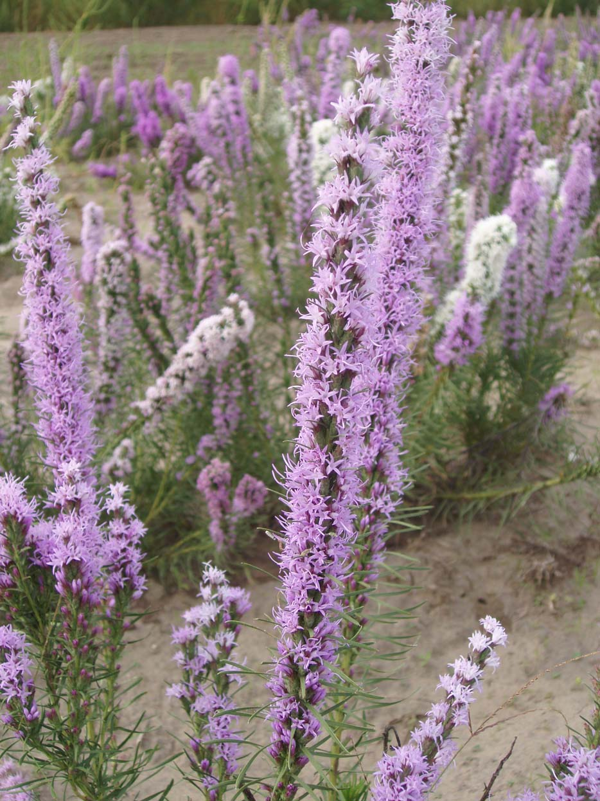

R. Alan Shadow, East Texas PMC, Nacogdoches, Texas

Alternate Names

Dotted blazing star, Nebraska blazing star, blazing star, button snakeroot, starwort

Uses

Dotted gayfeather is a forage or browse species that is eaten by deer, antelope, and domestic livestock, especially sheep. The forage quality is rated as fair to good. This plant will decrease under continuous heavy grazing. Many species of butterflies, bees and other native pollinators visit the flowers in full bloom. American Indians used the dotted gayfeather for food and medicinal purposes. Kindscher (1987) indicated that the root was used for food and was either baked or boiled before being consumed by Native American tribes. Kindscher (1992) listed a host of medicinal uses that the Plains Indian tribes had for dotted gayfeather. The Blackfeet used boiled root to reduce swelling, the Omaha’s powdered the root and applied it as a poultice for external inflammation. They also made a tea from the plant to treat abdominal troubles. The Pawnees boiled the leaves and roots together and fed the tea to children with diarrhea. The root was also used as an antidote for snake bites. Gayfeathers are becoming more popular for ornamental use, especially fresh floral arrangements and winter bouquets (Stubbendieck et al. 1989). If picked at their prime and allowed to dry out of the sunlight then spikes will retain their color and can be used in dry plant arrangements. This species also offers much promise for roadside plantings in the Great Plains region (Salac 1978).

Status

Please consult the PLANTS Web site and your State Department of Natural Resources for this plant’s current status (e.g. threatened or endangered species, state noxious status, and wetland indicator values).

Description

*General*: Dotted gayfeather belongs to the composite or sunflower family (Asteraceae). Dotted gayfeather is a native long lived herbaceous forb that is 20 to 80 cm tall, with stems single or in clusters from a woody rootstock. This species taproot system is remarkably extensive; its lateral branches spread 1.0 to 1.5 meters. Weaver (1954) found that the generalized root system more or less thoroughly occupied the first 2.5 meters of soil, absorbing little in the first 30 cm, but sometimes reaching a depth of 5 meters. Its leaves have an alternate arrangement on the stem, are closely spaced and linear, being up to 15 cm long and 1.5 to 5 mm wide. The leaves arch upward, have ciliate margins, and have dotted glands on the surface, thus the common name dotted gayfeather. Flowering heads as tufts arranged in spike like groups at the end of stems. Flowering occurs from August to October. A spike blooms for a long time as flower heads bloom successively from the top down. Flower corollas are small, tubular, 9 to 12 mm long and rose-purple with five pointed lobes and strap like styles protruding. The collection of dotted gayfeather at the Manhattan PMC has the traditional corolla color of rose-purple as well as a percentage of individuals with white corollas. The fruits are 10 ribbed dry achenes, measuring 6 to 7 mm long and each containing a tuft of feathery bristles.

*Distribution*: For current distribution, please consult the Plant Profile page for this species on the PLANTS Web site. Dotted gayfeather is found through much of the plains region from southern Manitoba to Alberta and from western Missouri to New Mexico and into northern Mexico.

*Habitat*: It grows on many types of upland, rocky prairie sites in the open where it will receive full sunlight. Weaver (1954) found this species on 58 percent of the upland prairie sites he visited and in 10 percent of those sites it ranked as the most common forb.

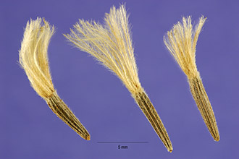

Photo byline: Steve Hurst @ USAD-NRCS PLANTS Database.

Dotted gayfeather achenes with tufts of feathery bristles.

Adaptation

Seedlings grow slowly above ground, but with marked rapidity below ground. By mid-summer a seedling may be only 12 cm tall and have but two narrow, long, erect leaves, while its taproot may be a meter long already. It is extremely tolerant of shade and can grow under light intensities of 5 to 10 percent of normal. Carbohydrates are being stored in the plants fleshy taproot at only a few weeks following germination. Dotted gayfeather is indeed ideally suited to grow in dry, coarse soils with its extensive root system and limited foliage of linear, narrow leaves.

Establishment

*Liatris punctata* can be established using seed. Stratified seed can be planted in the field in spring or non-stratified seed can be planted in the fall. The typical seedbed preparations should be followed in order to optimize the seedlings success. Prepare a firm, weed free seedbed by disking, harrowing and cultipacking the site. Chemical weed control can be used prior to planting to minimize the weed competition. Plant the seed units of *Liatris punctata* utilizing a drill with a legume or forb box and depth bands to ensure correct depth of planting (6 mm) and good seed to soil contact. If establishing this species for seed production purposes planting in rows is desirable with a planting rate of 30 Pure Live Seed (PLS) per 30 cm of row. For prairie restoration or diverse plantings intended for wildlife, add 60 grams of PLS seed per ha into the seeding mixture. Apply no fertilizer the year of establishment unless there is a severe deficiency of potassium or phosphorus indicated by the soil test. No nitrogen should be used the year of establishment to reduce the weed competition. Seedling vigor of this species is good, but first years growth is prioritized to the root system. Establishment is comparatively easy when weed competition can be successfully controlled.

Management

Barr (1983) indicated that *Liatris punctata* often seemed to need lime or potash to strengthen its stems in moist environments. He stated that in its native, drier climate the stems were naturally erect.

Pests and Potential Problems

Menhusen (1973) indicated that rodents will eat the flower buds, seedlings, new leaves and roots of this species. A medium amount of lodging can be a problem during seed maturity in a field monoculture situation.

Environmental Concerns

There are no environmental concerns with dotted gayfeather. This species will reproduce by volunteer seedlings, but will not do so aggressively (Platt and Harder 1991).

Seeds and Plant Production

Seed units can be sown in pots or flats in a greenhouse setting. The seedlings can be transplanted to pots when the first true leaves develop. Moist stratification is necessary for consistent germination of dotted gayfeather. Salac et al. (1978) reported 96 percent germination of *Liatris punctata* seeds after two weeks of moist stratification. They reported that the optimum temperature for germination was 26 degrees centigrade. Sorensen and Holden (1974) found that a seed lot of *Liatris punctata* collected in the wild contained 76.5 percent mature embryos and had a germination percentage of 47 over an 8 to 22 day period. Salac et al. (1978) reported that this species can be propagated vegetatively by root cuttings taken during the dormant season or by soft stem cuttings during the growing season. Seed units of this species are quite small with 305,800 seeds per kg or about 139,000 seeds per pound. Dotted gayfeather can be hand stripped or harvested with a conventional combine. Seed units are usually processed by running through a hammer mill to remove the tuft of feathery bristles attached to the end of the achene. The seed units can be processed further using a two screen fanning mill with a low air setting.

Cultivars, Improved, and Selected Materials (and area of origin)

Contact your local Natural Resources Conservation Service office for more information. Look in the phone book under “United States Government.” The Natural Resources Conservation Service will be listed under the subheading “Department of Agriculture.”

There are currently no released varieties or germplasm lines of *Liatris punctata* from the NRCS Plant Materials Program.

References

Barr, C.A. 1983. *Jewels of the plains*. University of Minnesota Press, Minneapolis, Minnesota.

Kindscher, K. 1992. *Medicinal Wild Plants of the Prairie: An Ethnobotanical Guide*. University Press of Kansas, Lawrence, Kansas.

Kindscher, K. 1987. *Edible Wild Plants of the Prairie: An Ethnobotanical Guide.* University Press of Kansas, Lawrence, Kansas.

Menhusen, B.R. 1973. Ecology of the Prairie Species *Liatris*. Pp 60-62. In Hulbert (ed.) *Third Midwest* *Prairie Conference Proceedings.*  Division of Biology, Kansas State University, Manhattan, Kansas.

Platt, D.R. and L.H. Harder. 1991. Growing native wildflowers. *The Kansas Wildflower Society Handbook.* Kauffman Museum, Bethel College. Newton, Kansas.

Salac, S. S., P.N. Jensen, J.A. Dickerson, and R.W. Gray, Jr. 1978. *Wildflowers for Nebraska Landscapes.* Nebraska Agriculture Experiment Station. MP 35.

Sorensen, J.T., and D.J. Holden. 1974. Germination of native prairie forb seed. *J. of Range Man*. 27: 123-126.

Stubbendieck, J., J.T. Nichols, and C.H. Butterfield. 1989. *Nebraska Range and Pasture Forbs and Shrubs.* University of Nebraska Cooperative Extension Bulletin EC 89-118-S.

Weaver, J.E. 1954. *North American Prairie*. Johnsen Publishing Co., Lincoln, Nebraska.

Prepared By and Species Coordinator

Richard Wynia, USDA NRCS Manhattan Plant Materials Center

Edited: 080229 jsp

For more information about this and other plants, please contact your local NRCS field office or Conservation District, and visit the PLANTS Web site<<http://plants.usda.gov>> or the Plant Materials Program Web site <<http://Plant-Materials.nrcs.usda.gov>>

*The U.S. Department of Agriculture (USDA) prohibits discrimination in all its programs and activities on the basis of race, color, national origin, sex, religion, age, disability, political beliefs, sexual orientation, and marital or family status. (Not all prohibited bases apply to all programs.) Persons with disabilities who require alternative means for communication of program information (Braille, large print, audiotape, etc.) should contact USDA's* [*TARGET Center*](http://www.usda.gov/oo/target.htm) *at 202-720-2600 (voice and TDD).*

*To file a complaint of discrimination write USDA, Director, Office of Civil Rights, Room 326-W, Whitten Building, 14th and Independence Avenue, SW, Washington, DC 20250-9410 or call 202-720-5964 (voice or TDD). USDA is an equal opportunity provider and employer.*

*Read about* [*Civil Rights at the Natural Resources Conservation Service*](http://www.nrcs.usda.gov/about/civilrights/)*.*