

Plant Guide

# big deervetch

## Lotus crassifolius (Benth.) Greene

Plant Symbol = LOCR

*Contributed by*: USDA NRCS Corvallis Plant Materials Center

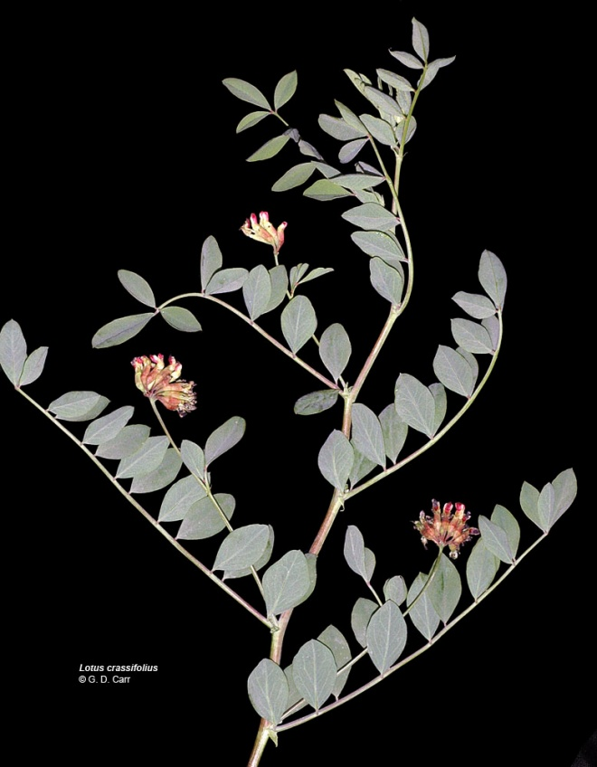

Figure 1. Big deervetch in flower, © 2006 G. D. Carr

### Alternate Names

Buck lotus, broad leaved lotus, thick-leaved lotus, thickleaf trefoil, thickleaf bird's-foot trefoil, Otay Mountain lotus[*L. crassifolius* var*. otayensis*]

Taxonomic Synonyms: *Hosackia crassifolia* Benth*.*; *Lotus aboriginus* Jeps. previously called *Lotus crassifolius* (Benth.) Greenevar*. subglaber* (Ottley) C.L. Hitchc.

### Uses

*Wildlife/livestock forage:* The seed and foliage of big deervetch are eaten by elk, quail and other game birds, nongame birds and small mammals (Martin et al., 1951). It is sometimes browsed by black-tailed deer, though it’s usually not a principal component of their diet (Miller, 1968). Plants are palatable to livestock and withstand grazing because of their perennial roots and rhizomes (USDA-Forest Service, 1966). Crude protein content in Oregon clear-cut test plots ranged from 12-18% on sheep-grazed plots to 8–10% on ungrazed plots (Sharrow and Rhodes, 1981).

*Pollinators*: The flowers attract hummingbirds, butterflies, honeybees and native bees, and can be incorporated into hedgerow or pollinator plantings. The plant also serves as a larval food source for the silver-spotted skipper butterfly (Las Pilitas Nursery, 2011).

*Restoration/erosion control*: Big deervetch is an early colonizer of disturbed areas, and because it is a rhizomatous legume, it stabilizes soil while adding essential nitrogen and organic carbon to these depleted soils. Plants often volunteer on bare road cuts (Graham, 1941), and can be direct-seeded or established from root cuttings onto disturbed sites such as old roadbeds, road cuts, clear-cuts, fire-damaged land, stream banks and pastures for erosion control cover and critical area plantings.

### Status

Otay Mountain lotus [*L. c.* var*. otayensis*] is ranked as 1B by the California Native Plant Society (Plants Rare, Threatened, or Endangered in California and Elsewhere) because its occurrence is limited to a few highly restricted populations in the state (Reiser, 1994). Variety *crassifolius* is common and widespread. Please consult the PLANTS Web site and your State Department of Natural Resources for this plant’s current status (e.g., threatened or endangered species, state noxious status, and wetland indicator values).

### Description

*General*: Fabaceae (Pea family). Big deervetch is a robust, native, herbaceous, rhizomatous perennial legume. Plants are sprawling to erect, 1–5 feet tall, and stems have a hollow base. Compound leaves have (7) 9–15 (23) leaflets that are about 1 inch long, elliptic to obovate, with length generally 1–2.5 times the width, bright green on the upper surface and paler below. Flowers are arranged in umbels of (7) 12–20 small (about ½ inch), yellow-green flowers that are often dark red or purple-blotched, especially with age. A tubular, lobed calyx half encloses the petals and gives the inflorescences a pink to deep red color. Fruits are oblong (1.4–2.8 inches long by 0.1–0.2 inch wide) and hairless, with several dark brown seeds per pod. Bloom period extends from May to August depending on latitude and elevation, with seeds generally ripening late June to September (Gilkey and Dennis, 2001; Hickman, 1993; Hitchcock et al., 1961; Kozloff, 2005; Rosatti and Wojciechowski, 2011).

Plants are winter dormant, even in mild growing regions. They can easily regenerate from lateral roots and rhizomes, as well as deep taproots that may later become exposed near the soil surface following disturbance (Darris, personal observations, 2001).

There are two currently recognized varieties of big deervetch, *otayensis* and *crassifolius* (Rosatti and Wojciechowski, 2011; USDA-NRCS, 2011). Var. *otayensis* is covered in long, soft, wavy hairs and is found only in southern San Diego County, CA, while var. *crassifolius* is hairless(glabrous) or covered in straight, stiff, sharp hairs that lay flat against the stem (strigose).

There was formerly another recognized variety of big deervetch, *L. crassifolius* var. *subglaber* (Hitchcock et al., 1961), but this is now generally considered a separate species, either *L. aboriginus* (rosy bird’s-foot trefoil; USDA-NRCS, 2011) or *Hosackia rosea* (Rosatti and Wojciechowski, 2011). Rosy bird’s-foot trefoil can be distinguished from *L. crassifolius* by its lower elevation Coast Range distribution (below 2600 ft), more diminutive stature (0.3–2.3 ft), leaflet length 2–3 times width, fewer flowers per inflorescence (6–10), and white flowers tinged with red or purple.

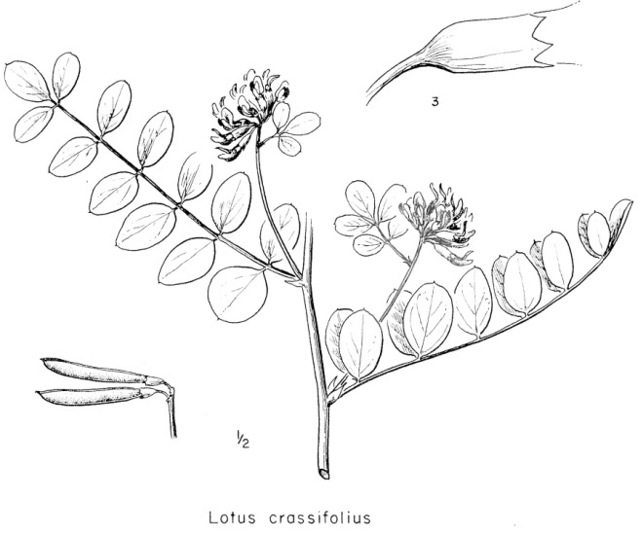

Figure 2. Drawing of big deervetch seed pods, plant in flower, and calyx, reprinted with permission of Univ. of Washington Press.

*Distribution*: Big deervetch is native from southern Washington and Oregon, mostly west of the Cascades, through California and Baja California, Mexico at elevations up to 8000 feet (Hitchcock et al., 1961; Rosatti and Wojciechowski, 2011). Variety *otayensis* is found only on Otay Mountain, San Diego County, CA and into Baja California. For current distribution, please consult the Plant Profile page for this species on the PLANTS Web site.

*Habitat*: Big deervetch is common in openings in chaparral, pine or mixed woodlands as well as on stream banks, disturbed areas and roadsides (Gilkey and Dennis, 2001; Rosatti and Wojciechowski, 2011). It often grows in association with Douglas-fir (*Pseudotsuga menziesii*), fescues (*Festuca* spp.), oatgrass (*Danthonia* spp.), perennial pea (*Lathyrus latifolia*), pearly everlasting (*Anaphalis margaritacea*), blackberry (*Rubus* spp.), elk sedge (*Carex garberi*), bentgrass (*Agrostis* spp.), velvetgrass (*Holcus lanatus*), vine maple (*Acer circinatum*), bluehead gilia (*Gilia capitata*) and figwort (*Scrophularea* spp.) (USDA-SCS, 1983).

**Adaptation**

Big deervetch is a fast grower that does best in full sun on fine- to medium-textured, well-drained soils. It grows in areas receiving 14–80 inches mean annual precipitation, and tolerates temperatures down to -3°F (USDA-NRCS, 2011). It is drought tolerant and fire-stimulated, germinating readily from the seed bank, even after intense fires (Rocca, 2009).

A common garden study of 141 collections of big deervetch and rosy bird’s-foot trefoil from Oregon found little differentiation within ‘varieties’ (species), suggesting one large seed transfer zone should suffice for each species within the area of collection (Doede, 2006). The var. *crassifolius* zone encompassed the entire range of the collections within the central Oregon Cascades (Willamette National Forest) and part of the Willamette Valley, while the var. *subglaber* (*L. aboriginus*) zone covered the Willamette Valley and north-central coastal range (Siuslaw National Forest) up to an elevation of 2000 ft. Because the adaptive variation of accessions from above about 2000 ft. elevation was not tested in this study, higher elevation coast range seed collections should be used for treatments in those areas. In the Willamette Valley overlap area, no reason was found to favor one species over the other, so seed source selection is left to the discretion of local knowledge or preference for certain plant characteristics.

### Establishment

Big deervetch seed has combined dormancy, meaning it has both physical and physiological inhibitions to germination, so seed should be scarified and stratified prior to sowing. Seed can be scarified in a Forsberg seed scarifier with 220 grit sandpaper for 10 to 15 seconds in order to overcome physical seed coat dormancy, followed by cold-moist stratification for at least 60–90 days to overcome the physiological dormancy (Darris, unpublished data, 2000-2001). With these treatments, germination rates can reach 80-85% for good seed lots. Treatment with boiling water has been proposed as an alternative to mechanical scarification in some *Lotus* species, but further testing is required to evaluate the success of these treatments on big deervetch germination.

Scarified seed can be direct-seeded in the fall to stratify *in situ*, germinating in the spring when the soil begins to warm. Like most legumes, establishment success, plant vigor and nodulation will be improved by inoculating seed prior to sowing. This can be accomplished by making a slurry from soil and/or root nodules of existing big deervetch (or co-occurring legumes), or purchasing rhizobium inoculants from a commercial source. Seedlings are often slow to establish initially, so a good weed management plan should be in effect prior to planting in order to minimize competition. There are about 48,600 seeds per pound. Sown alone, the suggested seeding rate is 4–8 pure live seed (PLS) pounds per acre, or 4–8 seeds per square foot.

### Management

Plants require little management once established; they are long-lived, drought-tolerant, and re-sprout or germinate readily after fire and other major disturbances.

### Pests and Potential Problems

Pocket gophers can do significant damage to plantings of big deervetch (Doede, 2006). There are no other records of specific pest or disease problems, but plants may be expected to be susceptible to insect pests and diseases similar to those found on other native *Lotus* species.

### Environmental Concerns

There are no known environmental concerns associated with big deervetch.

### Seeds and Plant Production

Seed production fields can be established in the spring with transplants on 2-foot centers, or direct-seeded in the fall on 2-foot rows at a rate of about 4–6 pure live seed (PLS) pounds per acre. Because of its ability to spread widely from rhizomes, in-row cultivation is difficult once stands establish. Therefore, weed management may be mostly limited to hand weeding, very shallow surface cultivation, or dormant spraying with non-selective herbicides such as glyphosate in the spring before shoots begin to emerge. Please contact your local agricultural extension specialist or county weed specialist to learn what works best in your area and how to use it safely. Always read label and safety instructions for each control method. Trade names and control measures appear in this document only to provide specific information. USDA, NRCS does not guarantee or warranty the products and control methods named, and other products may be equally effective.

Seed can be direct-combined if ripening is fairly uniform (this can be managed to a certain extent with soil moisture management as pods begin to ripen), or swathed and immediately moved onto rolled out paper or tarp to dry before combining.

For plant production, seed is scarified, sowed in 7-cubic-inch cone-tainers or plug trays, and moist stratified in a cooler at 35–38°F for 60 to 90 days (Darris and Doede, 2000). Vegetative propagation is also possible from rhizome segments or root cuttings containing at least one shoot bud, although further testing is required to determine the best practices.

### Lotus crassifolius seed pods. Photo copyright G. D. Carr, 2006.

Figure . Big deervetch seed pods, © 2006 G. D. Carr

### Cultivars, Improved, and Selected Materials (and area of origin)

There are no improved or selected materials of big deervetch, but container plants and/or seed are sometimes available from commercial sources on the West coast.

### References

Darris, D., and D.L. Doede. 2000. Adaptive genetic variation in big deervetch, study no. ORPMC-T-9901-CR. p. 22-25. In Corvallis Plant Materials Center annual technical report: 2000. USDA-NRCS, Corvallis, OR.

Doede, D.L. 2006. *Lotus crassifolius* (big deer vetch) common garden study. Unpublished report. USDA- Forest Service, Gifford Pinchot N.F., Mt. Adams Ranger Dist., Trout Lake, WA.

Gilkey, H.M., and L.R.J. Dennis. 2001. Handbook of northwestern plants. Rev. ed. Oregon State Univ. Press, Corvallis.

Graham, E.H. 1941. Legumes for erosion control and wildlife. USDA Misc. Publ. No. 412. U.S. Gov. Print. Office, Washington, DC.

Hickman, J.C. (ed.) 1993. The Jepson manual: higher plants of California. Univ. of California Press, Berkeley.

Hitchcock, C.L., A. Cronquist, M. Ownbey, and J.W. Thompson. 1961. Vascular plants of the Pacific Northwest. Part 3: saxifragaceae to ericaceae. Univ. of Washington Press, Seattle.

Kozloff, E.N. 2005. Plants of western Oregon, Washington & British Columbia. Timber Press, Portland, OR.

Las Pilitas Nursery. 2011. Plants for a California or western butterfly garden [Online]. Available at http://www.laspilitas.com/butterfl.htm (accessed 15 Aug. 2011). Las Pilitas Nursery, Santa Margarita, CA.

Martin, A.C., H.S. Zim, and A.L. Nelson. 1951. American wildlife & plants: a guide to wildlife food habits. Dover Publications, Inc., New York.

Miller, F.L. 1968. Observed use of forage and plant communities by black-tailed deer. J Wildl Manage 32(1):142-148.

Reiser, C.H. 1994. Rare plants of San Diego County [Online]. Available at http://sandiego.sierraclub. org/rareplants/ (accessed 15 Aug. 2011). Aquafir Press, Imperial Beach, CA.

Rocca, M.E. 2009. Fine-scale patchiness in fuel load can influence initial post-fire understory composition in a mixed conifer forest, Sequoia National Park, California. Nat Areas J 29(2):126-132.

Rosatti, T.J., and M. Wojciechowski (ed.) 2011. Fabaceae (Leguminosae). In The Jepson manual: vascular plants of California. 2nd ed. Available at http://ucjeps.berkeley.edu/tjm2/review/treatments/fabaceae_all.html (accessed 17 Aug. 2011). Jepson Flora Project, Berkeley, CA.

Sharrow, S.H., and B. Rhodes. 1981. The effect of grazing sheep on clearcuts in Oregon’s coast range and its impact on big game habitat. Progress Report 1981-1982. Project No. 0066. Oregon Agric. Exp. Stn., Corvallis.

USDA-Forest Service. 1966. Notes on western range forbs. Agric. Handb. 293. U.S. Gov. Print. Office, Washington, DC.

USDA-NRCS. 2011. Conservation plant characteristics of big deervetch (*Lotus crassifolius* [Benth.] Greene). In The PLANTS database [Online]. Available at http://plants.usda.gov/ (accessed 16 Aug. 2011). National Plant Data Team, Greensboro, NC.

USDA-SCS. 1983. Plant materials center project plan: big deervetch initial evaluation project (IEP), no. 411037T. USDA-SCS Corvallis Plant Materials Center, Corvallis, OR.

**Prepared By**:

*Anna Young-Mathews and Dale Darris*

USDA-NRCS Plant Materials Center

Corvallis, Oregon

### Citation

Young-Mathews, A., and D. Darris. 2011. Plant guide for big deervetch (*Lotus crassifolius)*. USDA-Natural Resources Conservation Service Plant Materials Center, Corvallis, OR.

Published September 2011

Edited: [30Aug2011 klp; 06Sep2011 jab]

For more information about this and other plants, please contact your local NRCS field office or Conservation District at <http://www.nrcs.usda.gov/> and visit the PLANTS Web site at <http://plants.usda.gov/> or the Plant Materials Program Web site <http://plant-materials.nrcs.usda.gov>.

PLANTS is not responsible for the content or availability of other Web sites.

**USDA IS AN EQUAL OPPORTUNITY PROVIDER AND EMPLOYER**