

Plant Guide

# fernleaf biscuitroot

## Lomatium dissectum (Nutt.) Mathias & Constance

### Plant Symbol = LODI

#### Contributed by: USDA NRCS Idaho Plant Materials Program, USDA-FS Rocky Mountain Research Station, and USDA-ARS Bee Biology and Systematics Laboratory

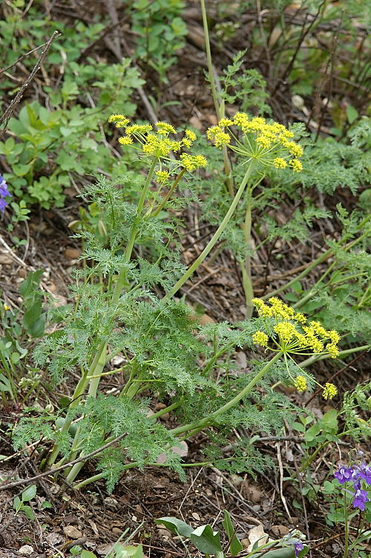 **Fernleaf biscuitroot. Photo courtesy of USDI-NPS**

#### **Alternate Names**

#### Desert parsley

#### Ferula dissoluta

#### Giant lomatium

Giant parsley

Indian parsley

*Leptotaenia dissecta*

Toza

Wild carrot

#### **Uses**

*Wildlife*

Established plants of fernleaf biscuitroot, like other members of the *Lomatium* genus, begins growth very early in the spring, often just following snow melt, providing crucial early forage for many wildlife and domestic animals. It is considered a very valuable forage species due to its large stature and high biomass production levels. Ogle and Brazee (2009) rate members of the genus as desirable spring and summer forage for cattle, sheep, horses, elk, deer and antelope.

Early green-up and flowering make this an important species for early spring pollinators and other insects. It is highly attractive to some bees. Pollinator surveys at native stands of fernleaf biscuitroot showed frequent visitation by several species of *Andrena* and *Micrandrena* that are oligolectic (pollen specialists) for this genus. In cultivated stands, honeybees and overwintering queens of *Halictus* and *Lasioglossum* bee species are sometimes frequent.

Micrandrena spp. on fernleaf biscuitroot. Jim Cane, ARS Bee Biology Lab, Logan, UT

***Micrandrena* spp. on fernleaf biscuitroot. Jim Cane, ARS Bee Biology and Systematics Lab, Logan, UT**

Fernleaf biscuitroot has been identified as an important plant species in sage-grouse habitat. Pre-laying sage-grouse hens eat the foliage (Barnett and Crawford, 1994). Sage-grouse chicks consume the plants, as well as associated insects (Drut et al., 1994).

*Ethnobotanic*

#### Fernleaf biscuitroot, known as Toza by the Numic speaking tribes of the Great Basin, was commonly used for food, medicine, and ceremonial purposes (Meilleur et al., 1990). It is one of the most widely used plant species in native North American culture (Moerman, 1998).

#### Food

Many western Native American tribes used fernleaf biscuitroot as a food source. Gosiute Indians, Great Basin Indians, and Montana Indians used tender young shoots as cooked greens (Blankenship, 1905; Chamberlin, 1911; Nickerson, 1966). Members of the Nez Perce, Okanagon, and Thompson tribes cooked and ate the thick fleshy taproots (Perry, 1952; Hart, 1992). The seeds were used as food by the Gosiute tribe (Chamberlin, 1911), and Great Basin Indians made a beverage from boiled roots (Nickerson, 1966).

#### Medicinal

#### Fernleaf biscuitroot was commonly used by Native Americans for a wide variety of ailments. Below is a partial list of medicinal applications of fernleaf biscuitroot by various Native American Tribes compiled from Chamberlin (1911), Park and Fowler (1989), Grinnell and Fitzgerald (2008), Hart (1992), McClintock (1909), Nickerson (1966), Steedman (1928). Train et al., (1941), Turner et al., (1980), and Zigmond (1981).

|  |  |  |
| --- | --- | --- |
| Native American medicinal uses of fernleaf biscuitroot | | |
| Ailment or use | **Part used** | **Tribe** |
|  |  |  |
| Dietary tonic | Root | BF, C, GB, NP; OC |
| Stomach or internal disorders | Infusion of dried roots | C |
| Wounds, cuts, or bruises | Poultice of roots | G, GB, K, P, NP, S, U, W |
| Cold and flu | Decoction of roots | GB, P; NP, T, S, W |
| Respiratory aid | Inhaled root smoke or herbal steam | GB, NP, P, S, W |
| Sores | Root oil | NP |
| Sore eyes | Root oil | NP |
| Arthritis | Infusion or decoction of root | OC |
| Tuberculosis | Infusion or decoction of root | OC, NP, P, S, W |
| Rheumatism | Poultice of root | P; NP; S |
| Sore throat | Chewed raw root | P, S, W |
| Burns | Root powder mixed with grease | T |

**BF=Blackfoot, CH=Cheyenne, G=Gosiute, GB=Great Basin, K=Kawaiisu, NP=Nez Perce, OC=Okanagan-Coleville, P=Paiute, S=Shoshoni, T=Thompson, U=Ute, W=Washoe**

#### Fernleaf biscuitroot is still popular as a natural herbal medicine, and has been shown to possess antiviral and antibiotic properties (McCutcheon et al., 1992; 1995). It is available in the commercial health market as whole root or as a tincture.

#### Veterinary

#### Paiute, Shoshoni and Ute Indians caused their horses to inhale smoke of burning roots to treat distemper (Train et al., 1941; Chamberlin, 1911). Nevada Indians administered a poultice of ground fernleaf biscuitroot chips for head troubles and sores (Murphey, 1990)

*Fishing*

Okanagan-Colville and Northern Paiute Indians pounded roots and soaked them in water to poison and catch fish (Turner et al., 1980; Park and Fowler, 1989).

*Ceremony*

Blackfeet Indians burned smashed root as incense (McClintock, 1909). Navajo Indians administered an infusion of dried and ground fernleaf biscuitroot mixed with other plants to patients as part of their Mountain Top Chant ceremony (Elmore, 1944).

#### **Status**

Consult the PLANTS Web site and your State Department of Natural Resources for this plant’s current status (e.g., threatened or endangered species, state noxious status, and wetland indicator values).

#### **Description**

*General*: Carrot family (Apiaceae). Fernleaf biscuitroot is the largest member of the *Lomatium* genus. It is a perennial, herbaceous forb arising from a thickened woody taproot or caudex. Mature plants can be up to 1.3 m (51 in) tall. The leaves are ternate and pinnately compound. Blades of the larger mature leaves are 15 to 30 cm (6 to 12 in) long and the larger ultimate segments are 2 to 3 mm (0.08 to 0.12 in) wide.

Flowering occurs from April through May. The flowers are yellow to purple, and born in umbels with 10 to 30 rays; each ray is 4 to 10 cm (1.6 to 3.9 in) long. Each umbel is composed of a combination of 50 to 200 male and hermaphroditic flowers (Thompson, 1998). Occasionally, all-male umbels are found, but the species is clearly hermaphroditic with both stamens and pistils in the same flower.

The seeds are elliptical; 8 to 15 mm (0.6 in) long and 5 to 10 mm (0.4 in) wide with a thickened wing about 1 mm (0.04 in) wide. There are approximately 99,000 seeds per kg (45,000 seeds per lb) (USDA-NRCS, 2010).

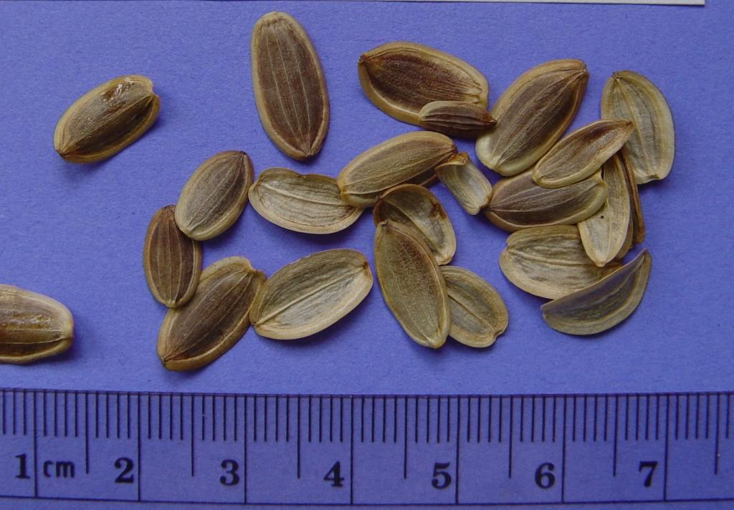

**Fernleaf biscuitroot seed. Nancy Shaw, USDA-FS RMRS, Boise, ID**

The root is a large, sometimes branching, taproot reaching approximately 30 cm (1 ft) long and 5 cm (2 in) thick.

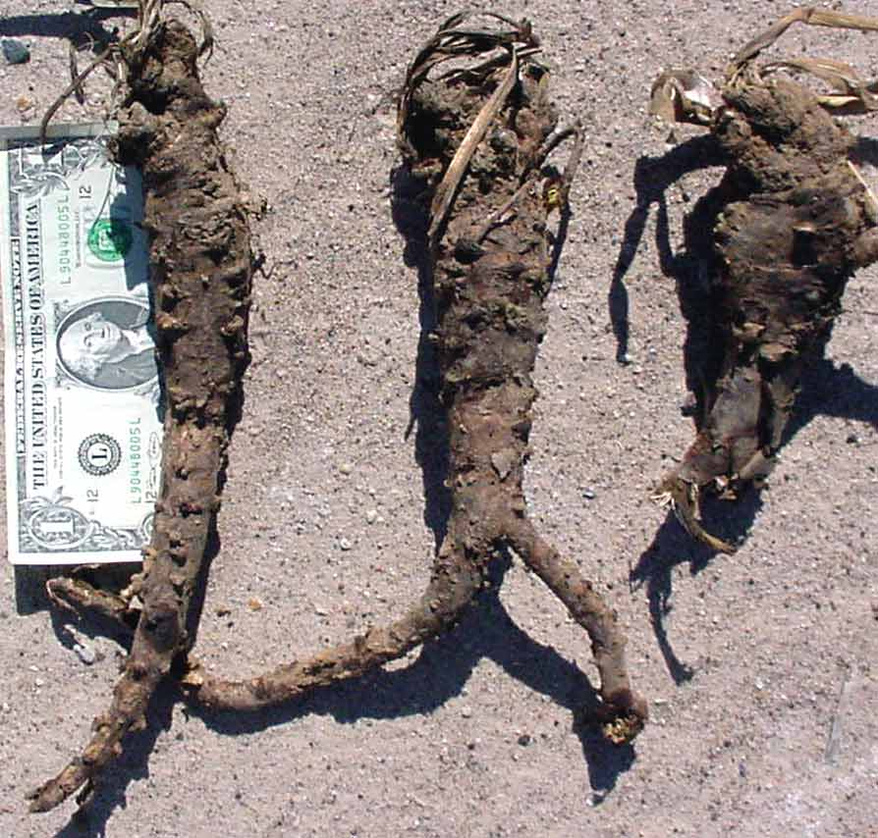

**Fernleaf biscuitroot taproots. Jim Cane, USDA-ARS Bee Biology Lab, Logan, Utah**

**\*NOTE:** Fernleaf biscuit root foliage bears a strong resemblance to poison hemlock (*Conium maculatum*). The two can be distinguished vegetatively by the small purple spots found on hemlock stems and petioles. Hemlock also has white flowers instead of yellow or purple.

*Distribution*:

Fernleaf biscuitroot naturally occurs from British Columbia and Saskatchewan south to California and New Mexico and extends eastward to Wyoming and Colorado. For current distribution in North America, consult the Plant Profile page for this species on the PLANTS website.

*Habitat*:

#### This species is common in mountain and Wyoming big sagebrush, pinyon-juniper, and mountain shrub communities from 150 to 3,000 m (500 to 10,000 ft) throughout its range (Welsh et al., 2003; Hickman, 1993).

#### **Adaptation**

Fernleaf biscuitroot is adapted to coarse- to fine-textured soils with pH of 6.5 to 7.5. It can be found in a variety of plant communities in areas receiving 360 to 760 mm (14 to 30 in) or more mean annual precipitation (USDA-NRCS, 2010).

#### **Establishment**

Seed can be broadcast or drilled to 0.3 to 0.6 cm (1/8 to 1/4 in) into a well prepared, weed-free seedbed. This species should be seeded in late fall as a dormant planting to allow for natural stratification of the seed over winter.

#### **Management**

Once established, fernleaf biscuitroot is very competitive against weeds due to its long taproot; however additional measures to control weeds are necessary for seed production.

#### **Pests and Potential Problems**

Thompson (1998) conducted plant pest surveys at a natural stand of fernleaf biscuitroot near Pullman, Washington over a 10 year period. He found that the greatest threat to fernleaf biscuitroot was pocket gophers, which accounted for 43% of the plant mortality observed in his study. Plants were grazed by rabbits and deer. They were also attacked by leaf miners, gall causing flies and *Puccinia* rust. Additionally, fernleaf biscuitroot can be a host to ant-tended aphids, and the seeds are consumed by *Smicronyx* seed weevils (Cane, unpubl.). Colonization by the basidiomycete fungus *Rhizoctonia solani* has been observed following wet spring conditions (Tisserat, unpubl.).

#### **Environmental Concerns**

There are no known environmental concerns regarding fernleaf biscuitroot.

#### **Seed and Plant Production**

*Small scale production*

Seed matures in July into August. Wildland seed disarticulates readily and is easily hand collected. Very clean collections can be made by shaking ripened inflorescences over a bag or tarp. Minor screening to remove sticks provides excellent purity.

Extended seed stratification is required for successful propagation of fernleaf biscuitroot. At the time of dispersal, the seeds have underdeveloped embryos which require a trigger for growth prior to germination. Scholten et al. (2009) observed that greatest embryo elongation occurred at temperatures of 3.4 to 5.5° C (38 to 42° F). The best germination percentages occurred at 3.4 C (38° F) with approximately 16 weeks of cold/moist stratification. Baskin and Baskin (2002) recommend a cold moist stratification for 330 days followed by 18° C germination conditions. In Pullman, Washington, best results were obtained when seed was sown into containers in the fall that were left outside to overwinter. Germination begins in March and growth continues for 3 to 4 months until the plants go dormant in late July or August. Containerized plants should be left outside in a lath house for an additional winter before transplanting the following spring. Flowering and seed production typically begins 3 years after transplanting (Skinner, 2004).

*Large scale production*

Seed can be drilled in rows at 82 to 98 PLS/m (25- 30 PLS/ft) or into weed barrier fabric at 45 to 60 cm (18 to 24 in) spacing. Dormant fall seedings are recommended to permit over-winter stratification.

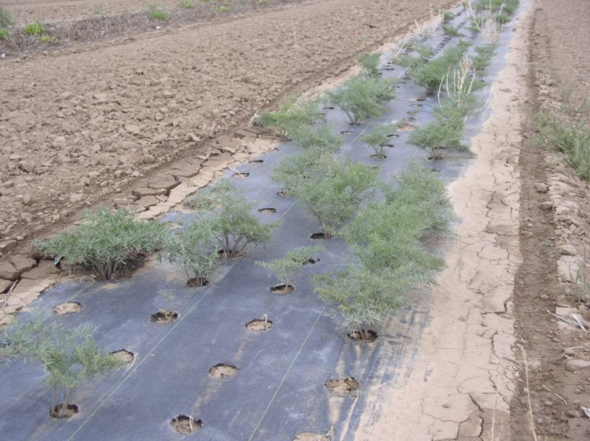

**Three year old plants grown in weed barrier fabric. Loren St. John, USDA-NRCS, Aberdeen, ID PMC**

Above ground growth is slow as young plants invest significant resources to produce a substantial taproot. Plants grow in early spring into summer and go dormant in mid-summer, giving the appearance of mortality. During the first year of establishment, most plants will only produce a few leaves. Seed production fields at Aberdeen, Idaho did not produce flowers or seed until the fourth year of production. Similarly, organic herb growers report 4 year old plants which are still not ready for harvest, but it was not indicated if these plants were from seed or transplants (Lomatium.com, 2010). Experimental plots at Ontario, Oregon, using supplemental irrigation produced seed in the fourth season with peak yields of 482 kg/ha (430 lb/ac) (Shock et al. 2010).

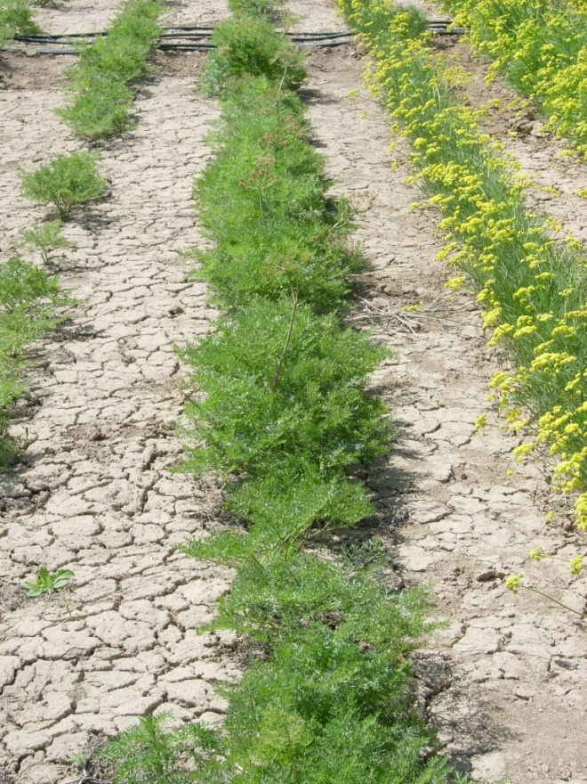

**Fernleaf biscuitroot production field. Nancy Shaw, USDA-FS RMRS, Boise, Idaho**

Good weed control can be achieved through the use of weed barrier fabric and hand roguing. Because fernleaf biscuitroot enters dormancy in early summer, foliar herbicide applications of glyphosate to surrounding weeds are possible after senescence.

Always read and follow label and safety instructions for each control method. USDA-NRCS does not guarantee or warranty any products or control methods named, and other products may be equally effective.

New techniques are being investigated regarding the feasibility of growing fernleaf biscuitroot densely in rooting beds prior to field establishment. This method would allow a grower to sacrifice a much smaller area in the first 1 to 2 years of plant development while the plants are not producing seed. Trials indicate that taproots transplanted in autumn establish well (Jensen, 2010).

Shock et al. (2010) at Ontario, Oregon showed a significant positive response to irrigation with 10 and 20 cm (4 and 8 in) additional water. Ontario has a mean annual precipitation of 24 cm (9.5 in) (U.S. Climate Data, 2010), bringing the total received water to approximately 46 cm (18 in) for optimum seed production.

Though fernleaf biscuitroot flowers are self-fertile, they still require visitation by pollinators for fertilization to occur. Cane (2007) showed a 60X increase in seed set in the presence of pollinators. Fernleaf biscuitroot has a very restricted range of natural pollinators; primarily the oligolectic *Andrena* and *Micrandrena* spp., thus developing a manageable pollinator for seed production is unlikely. In cultivation, honey bees and sweat bees may suffice, but a planting trial is recommended.

Seed can be harvested in production fields via a vacuum type harvester or flail vac (Bair and Tilley, 2010). Seed can be cleaned using an air screen cleaner. Purities approximating 100% are achievable with minimal effort.

**Cultivars, Improved and Selected Materials (and area of origin)**

Common wildland collected seed is available from commercial sources. There are currently no commercial releases of fernleaf biscuitroot. Commercial growers are producing pooled Source Identified seed representative of Omernik Ecoregion 12 (Snake River Plain) and 80 (Northern Basin and Range).

#### **References**

Bair, C. and D. Tilley. 2010. The jet harvester: a shop built tool for harvesting forb and shrub seed. USDA-NRCS Technical Note 55. Boise, Idaho.

Barnett, J.K. and J.A. Crawford. 1994. Pre-laying nutrition of sagegrouse hens in Oregon. Journal of Range Management. 47 (2): 114-118.

Baskin, Carol C.; Baskin, Jerry M. 2002. Propagation protocol for production of container *Lomatium dissectum* (Nutt.) Math.&Const. plants; University of Kentucky, Lexington, Kentucky. In: Native Plant Network. URL: http://www.nativeplantnetwork.org (accessed 7 December 2010). Moscow (ID): University of Idaho, College of Natural Resources, Forest Research Nursery.

Blankinship, J. W. 1905. Native economic plants of Montana. Bozeman. Montana Agricultural College Experimental Station, Bulletin 56.

Cane, J. 2007. Pollinating bees crucial to farming wildflower seed for U.S. habitat restoration. In: Bees in Agricultural Ecosystems. James, R.R. and T. Pitts-Singer (eds.). Oxford university Press.

Chamberlin, R.V. 1911. The Ethno-botany of the Gosiute Indians of Utah. Memoirs of the American Anthropological Association 2(5):331-405.

Drut, M.S., Pyle, W.H. and J.A. Crawford. 1994. Technical Note: Diets and food selection of sage grouse chicks in Oregon. Journal of Range Management. 47(1): 90-93.

Elmore, Francis H. 1944. Ethnobotany of the Navajo. Sante Fe, NM. School of American Research.

Grinnell, G, and J. Fitzgerald. 2008. The Cheyenne Indians - their history and lifeways. World Wisdom Press. 240 p.

Hart, Jeff. 1992. Montana native plants and early peoples. Helena. Montana Historical Society Press. 168 p.

Hickman, J.C. ed. 1993. The Jepson manual: higher plants of California. University of California Press. Berkeley and Los Angeles, CA. 1400 p.

Jensen, S. and M. Anderson. 2010. The quest for natives: cultural practices, species screening and private growers. In: Great Basin native plant selection and increase project, FY2009 progress report. USDA-FS-RMRS. Boise, Idaho.

Lomatium.com. 2010. URL: http://www.lomatium.com/index.htm (accessed 7 December 7, 2010).

McClintock, W. 1909. Medizinal und Nutzpflanzen der Schwarzfuss Indianer. Zeitschriff fur Ethnologie 41:273-9.

McCutcheon, E., Ellis, L.A., Hancock, R.E.W., and G.H.N. Towers. 1992. Antibiotic screening of medicinal plants of the British Columbian native peoples. Journal of ethno-pharmacology. 37 (3): 213-223.

McCutcheon, A.R., Roberts, T.E., Gibbons, E., Ellis, S.M., Babiuk, L.A., Hancock, R.E.W., and G.H.N. Towers. 1995. Antiviral screening of British Columbian medicinal plants. Journal of ethno-pharmacology 49: 101-110.

Meilleur, B.A., Hunn, E.S., and R.L. Cox. 1990. *Lomatium dissectum* (Apiaceae): multi-purpose plant of the Pacific Northwest. Journal of Ethnobiology. 10(1): 1-20.

Moerman, D.E. 1998. Native American Ethnobotany. Timber Press. 927 p.

Murphey, E. 1990. Indian Uses of Native Plants. Glenwood, Ill. Meyerbooks. Originally published in 1959.

Nickerson, G.S. 1966. Some Data on Plains and Great Basin Indian Uses of Certain Native Plants. Tebiwa. 9(1):45-51.

Ogle, D., and B. Brazee. 2009. Estimating initial stocking rates. USDA-NRCS, ID-TN 3. Boise, ID.

Park, W.Z. and C. Fowler. 1989. Willards Z. Park's Ethnographic Notes on the Northern Paiute of Western Nevada, 1933-1940. Salt Lake City. University of Utah Press. 160 p.

Perry, F. 1952. Ethno-Botany of the Indians in the interior of British Columbia. Museum and Art Notes 2(2):36-43.

Scholten, M., Donahue, J., Shaw, N., and M. Serpe. 2009. Environmental regulation of dormancy loss in seeds of *Lomatium dissectum* (Apiaceae). Annals of Botany. 103 (7): 1091-1101.

Shock, C.C., Feibert, E., Saunders, L., and N. Shaw. 2010. Native wildflower seed production with limited subsurface drip irrigation. Oregon State University Agricultural Experiment Station, 2009 Annual Report: 193-209.

Skinner, David M. 2004. Propagation protocol for production of container *Lomatium dissectum* (Nutt.) Mathias & Constance *multifidum* (Nutt.) Mathias & Constance plants; USDA NRCS - Pullman Plant Materials Center, Pullman, Washington. In: Native Plant Network. URL: http://www.nativeplantnetwork.org (accessed 7 December 2010). Moscow (ID): University of Idaho, College of Natural Resources, Forest Research Nursery.

Steedman, E.V. 1928. The Ethnobotany of the Thompson Indians of British Columbia. SI-BAE Annual Report No. 45:441-522.

Thompson, J.N. 1998. Coping with multiple enemies: 10 years of attack on *Lomatium dissectum* plants. Ecology 79(7): 2550-2554.

Train, P., J.R. Henrichs, and W.A. Archer 1941. Medicinal uses of plants by Indian tribes of Nevada. Washington DC. U.S. Department of Agriculture. 199 p.

Turner, N., Bouchard , J.R., and D.I.D. Kennedy 1980. Ethnobotany of the Okanagan-Colville Indians of British Columbia and Washington. Victoria. British Columbia Provincial Museum. 179 p.

U.S. Climate Data. 2010. URL: http://www.usclimatedata.com (accessed 6 December 2010). Summerweb. Belgium, Europe.

USDA, NRCS. 2010. The PLANTS Database (http://plants.usda.gov, 7 December 2010). National Plant Data Center, Baton Rouge, LA 70874-4490 USA.

Welsh, S.L., N.D. Atwood, S. Goodrich, and L.C. Higgins. 2003. A Utah Flora. Third Edition, revised. Brigham Young University, Provo, UT.

Zigmond, M.L. 1981. Kawaiisu Ethnobotany. Salt Lake City. University of Utah Press. 102 p.

#### **Prepared By**

*Derek Tilley*; USDA NRCS Plant Materials Center, Aberdeen, Idaho.

*Loren St. John*, USDA NRCS Plant Materials Center, Aberdeen, Idaho.

*Dan Ogle*, USDA NRCS State Office, Boise, Idaho.

*Nancy Shaw*. USDA-FS. Rocky Mountain Research Station. Boise, Idaho.

*Jim Cane*. USDA-ARS. Bee Biology and Systematics Laboratory. Logan, Utah.

#### **Citation**

Tilley, D., St. John, L. Ogle, D., Shaw, N., and J. Cane. 2010. Plant guide for fernleaf biscuitroot (*Lomatium dissectum*). USDA-Natural Resources Conservation Service, Idaho Plant Materials Center. Aberdeen, ID.

Published January, 2011

Edited: 28Jan2011dt; 03Jan2011dgo; 03Jan2011lsj; 21Dec2010ns; 21Dec2010jc

For more information about this and other plants, please contact your local NRCS field office or Conservation District at <http://www.nrcs.usda.gov/> and visit the PLANTS Web site at <http://plants.usda.gov/> or the Plant Materials Program Web site <http://plant-materials.nrcs.usda.gov>.

PLANTS is not responsible for the content or availability of other Web sites.

**USDA IS AN EQUAL OPPORTUNITY PROVIDER AND EMPLOYER**