

Plant Guide

# nineleaf biscuitroot

## Lomatium triternatum (Pursh) Coulter & Rose

### Plant Symbol = LOTR2

#### Contributed by: USDA NRCS Idaho Plant Materials Program and USDA-FS Rocky Mountain Research Station

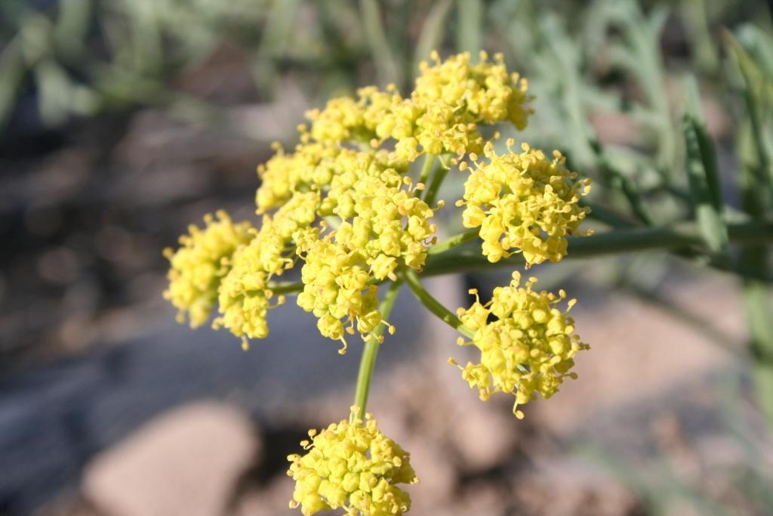

**Nineleaf biscuitroot inflorescence. Derek Tilley, USDA-NRCS, Aberdeen, ID PMC**

#### **Alternate Names**

#### Cogswellia triternata

#### Ternate lomatium

#### **Uses**

*Wildlife*

Nineleaf biscuitroot begins growth very early in the spring, often just following snow melt, providing crucial early forage for many wildlife and domestic animals. It is considered one of the most valuable forage species of the genus due to its large stature and high production levels. It is rated as having fair to very good forage for sheep and poor to good forage for cattle (USDA-FS, 1937). Ogle and Brazee (2009) rate it as desirable spring and summer forage for cattle, sheep, horses, elk, deer and antelope.

Early green-up and flowering make this an important species for early spring pollinators and other insects. It is highly attractive to bees.

This species has been identified as an important plant species in sage- grouse habitat because of its early

growth habit and the associated insects that provide a critical food source for sage-grouse chicks.

*Ethnobotanic*

Nineleaf biscuitroot was used by Blackfeet Indians for healing various ailments. An infusion of roots was taken for chest troubles, and the seed was chewed by long distance runners to avoid side aches (Moerman, 1993). The seeds were also stuffed into a porcupine’s foot and tied on a young girl’s hair as a good luck charm (Moerman, 1998).

The roots of nineleaf and other biscuitroot species are edible and were used as an important food source by Native Americans. Roots could be eaten raw, cooked as a vegetable, or ground into flour for bread meal (USDA-FS, 1937).

#### **Status**

Consult the PLANTS Web site and your State Department of Natural Resources for this plant’s current status (e.g., threatened or endangered species, state noxious status, and wetland indicator values).

#### **Description**

*General*: Carrot family (Apiaceae). Nineleaf biscuitroot is an herbaceous forb that grows from a large taproot. Mature plants reach 70 cm (28 in) tall. Leaves are ternate-pinnately compound with 9 to 21 leaflets or segments and petioles up to 20 cm (8 in) long (Welsh et al., 2003). The petiole has a dilated base which forms a sheath around the stem. Leaflets range from 1 to 13 cm (0.4 to 5 in) long and 1 to 1.5 cm (0.4 to 0.6 in) wide. The inflorescence is an umbel with 4 to 20 rays ending in bright yellow flowers. The fruit is 8 to 15 mm (0.6 in) long and 4 to 11 mm (0.16 to 0.43 in) wide with lateral wings from 1 to 3 mm (0.04 to 0.12 in) wide.

The root is a long, narrow taproot which can extend several feet into the soil. Five-year old nineleaf biscuitroot grown at Aberdeen, Idaho had taproots of up to 28 cm (11 in) long and weighing up to 125 g (0.27 lb). The taproot makes nineleaf biscuitroot extremely tolerant to grazing, trampling and drought, and fire (Monsen et al., 2004).

Flowering takes place from late spring through mid-summer with seed ripening in July and August. There are approximately 42,000 seeds/lb (Monsen et al., 2004).

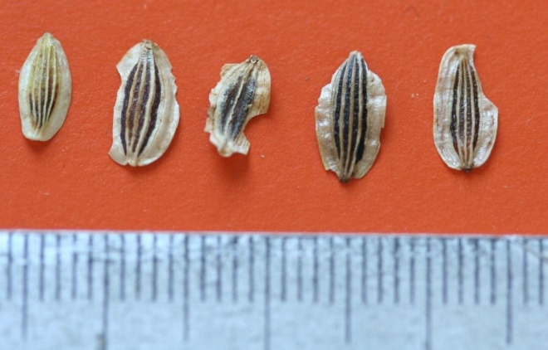

**Nineleaf biscuitroot seed. Derek Tilley, USDA-NRCS, Aberdeen, ID PMC**

Plants are known to live more than 20 years (Garden guides, 2010).

*Distribution*:

Nineleaf biscuit is native to western North America, occurring from northeastern California to British Columbia and east to Alberta and Colorado. For current distribution in North America, consult the Plant Profile page for this species on the PLANTS website.

*Habitat*:

This species is common on sunny valley bottoms, open ridges and slopes of foothills and lower mountains. It is also sometimes found at higher elevations. It can be found in association with mountain shrub, mountain big sagebrush, pinyon-juniper and alpine plant communities at elevations from 1,300 to 2,900 m (4,200 to 9,500 ft) (Welsh et al., 2003).

#### **Adaptation**

Nineleaf biscuitroot is adapted to well drained, dry rocky soils in areas receiving 20 to 50 cm (8 to 20 in) of annual precipitation (Walker and Shaw, 2005). It is reported to grow in soils with a pH of 6.5 to 8.8 and minimum of 120 frost free days. (Garden Guides, 2010); however, the authors have seen the species growing in areas with an average of 90 frost free days.

#### **Establishment**

The seed can be broadcast or drilled to 0.3 to 0.6 cm (1/8 to 1/4 in) into a well prepared, weed-free seed bed. This species should be seeded in late fall as a dormant planting to allow natural stratification. Nineleaf biscuitroot does well in seed mixtures (Monsen et al., 2004).

#### **Management**

Once established, nineleaf biscuitroot is very competitive against weeds due to its long taproot; however additional measures to control weeds are necessary for seed production.

#### **Pests and Potential Problems**

There are no known pests associated with nineleaf biscuitroot.

#### **Environmental Concerns**

There are no known environmental concerns regarding nineleaf biscuitroot.

#### **Plant Production**

Seed matures in July or August. Wildland seed is easily hand collected. The seed disarticulates readily from the stems, and very clean, small collections can be made by shaking ripened inflorescences over a bag or tarp. Minor screening to remove sticks provides excellent purity. Seed viability in proper storage conditions remains high for 3 to 4 years (Monsen et al., 2004).

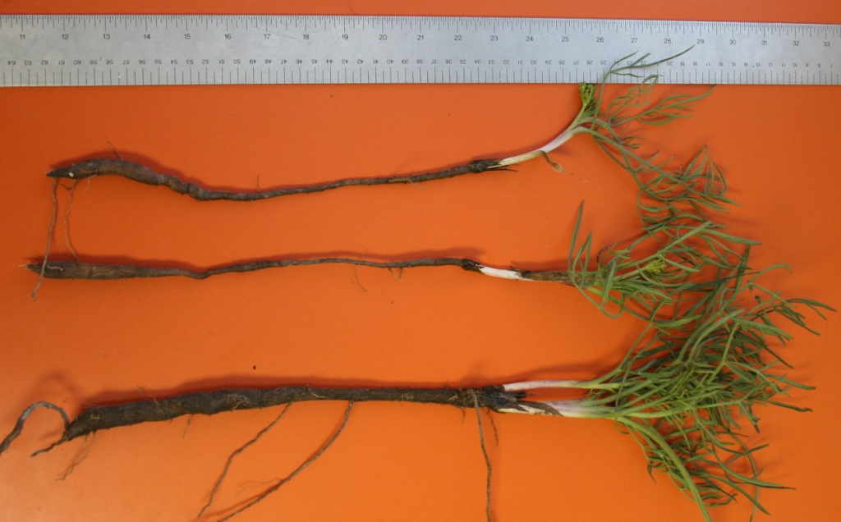 **Five year old nineleaf biscuitroot taken from a seed production field at Aberdeen, Idaho. Derek Tilley, USDA-NRCS, Aberdeen, ID PMC**

For greenhouse plant production, a long stratification period is required. Parkinson and DeBolt and Parkinson (2005) achieved over 90% germination after a 60 day cold/moist stratification. Skinner (2007) saw no germination with a non-stratified or 30 day cold/moist stratification treatment. Similar results were observed at by St. John and Ogle (2005). Best results are obtained when seed is sown in late fall or early winter and left outside to stratify naturally. Containerized plants should be grown for a full season and overwintered before transplanting the following spring. Transplants are very hardy, and if weeds are controlled, 100% establishment can be accomplished (Skinner, 2007).

**Large Scale Seed Production**

Seed can be sown in rows at 82 pure live seeds (PLS)/m (25 PLS/ft) or into weed barrier fabric at 40 to 60 cm (18 to 24 in) spacing. All seeding should be completed as dormant fall seeding to allow natural stratification to occur.

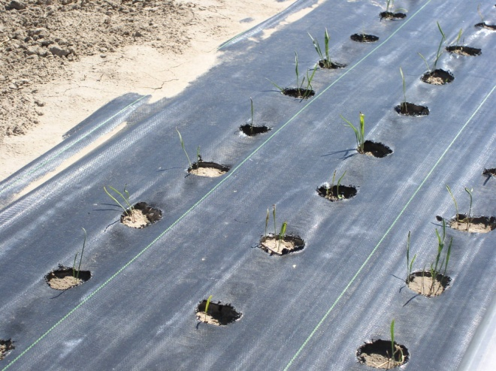

Nineleaf biscuitroot seedlings grown in weed barrier fabric for seed production. Loren St. John, USDA-NRCS, Aberdeen, ID PMC

Above ground growth is slow as the plants expend energy developing a substantial taproot. Plants grow in early spring and go dormant in mid-summer, giving the appearance of mortality. In the first year, most plants will only produce a few leaves. Seed production fields at Aberdeen, Idaho did not produce flowers or seed until the fourth year of establishment. Experimental plots at Ontario, Oregon; using supplemental irrigation, however, produced seed in the second season with peak yields in the third and fourth years of over 1,120 kg/ha (1,000 lb/ac) (Shock et al. 2010a).

Good weed control can be achieved through the use of weed barrier fabric and hand rouging. Because nineleaf biscuitroot goes into dormancy in early summer, foliar herbicide applications of glyphosate to surrounding weeds are possible after senescense. In preliminary herbicide tolerance trials, seed yields were reduced by early spring bromoxynil applications (Shock et al., 2010b).

Always read and follow label and safety instructions for each control method. USDA-NRCS does not guarantee or warranty any products or control methods named, and other products may be equally effective.

New techniques are being investigated regarding the feasibility of growing nineleaf biscuitroot in rooting beds at high densities prior to field establishment. This method would allow a grower to sacrifice a much smaller area in the first 1 to 2 years of plant development while the plants are not producing seed.

Shock et al. (2010a) at Ontario, Oregon showed a positive response to irrigation with up to 10 cm (4 in) additional water. Ontario has a mean annual precipitation of 24 cm (9.5 in) (U.S. Climate Data, 2010), bringing the total water received to approximately 36 cm (14 in) for optimum seed production.

Seed can be harvested in production fields via a vacuum type harvester or flail vac.

**Cultivars, Improved and Selected Materials (and area of origin)**

Common wildland collected seed is available from commercial sources. There are currently no commercial releases of nineleaf biscuitroot. Growers are producing pooled sources of Source Identified germplasms for the Snake River Plain and Northern Great Basin Ecoregions.

#### **References**

Garden Guides. 2010. URL: http://www.gardenguides.com (accessed 6 December 2010). Santa Monica, California.

Moerman, D.E. 1998. Native American Ethnobotany. Timber Press. 927 p.

Monsen, S.B., Stevens, R. and N. Shaw. 2004. Grasses. In: S.B. Monsen, R. Stevens, and N.L. Shaw [compilers]. Restoring western ranges and wildlands. Fort Collins, CO: USDA Forest Service, Rocky Mountain Research Station. General Technical Report RMRS-GTR-136-vol-2. p. 295-424.

Ogle, D., and B. Brazee. 2009. Estimating initial stocking rates. USDA-NRCS, ID-TN 3. Boise, ID.

Parkinson, Hilary; DeBolt, Ann. 2005. Propagation protocol for production of container *Lomatium triternatum* (Pursh.) Coult. & Rose. In: Native Plant Network. URL: http://www.nativeplantnetwork.org (accessed 6 December 2010). Moscow (ID): University of Idaho, College of Natural Resources, Forest Research Nursery.

Shock, C.C., Feibert, E., Saunders, L., and N. Shaw. 2010. Native wildflower seed production with limited subsurface drip irrigation. Oregon State University Agricultural Experiment Station, 2009 Annual Report: 193-209.

Shock, C.C., J. Ishida, E.B.G. Feibert, and N. Shaw. 2010. Native perennial forb tolerance to repeated annual applications of postemergence herbicides. Oregon State University Agricultural Experiment Station, 2009 Annual Report:213-217.

Skinner, David M. 2007. Propagation protocol for production of container *Lomatium triternatum* (Pursh.) Coult. & Rose; In: Native Plant Network. URL: http://www.nativeplantnetwork.org (accessed 3 December 2010). Moscow (ID): University of Idaho, College of Natural Resources, Forest Research Nursery.

St. John, L. and D. Ogle. 2005. Establishment and maintenance of certified generation 1 (G1) seed; propagation of native forbs and native plant display nursery; develop technology to improve the diversity of introduced grass stands. In: Great Basin native plant selection and increase project USDI-BLM and other cooperators . http://www.fs.fed.us/rm/boise/research/shrub/greatbasin.shtml (accessed 1 December 2010). Boise, Idaho.

U.S. Climate Data. 2010. URL: http://www.usclimatedata.com (accessed 6 December 2010). Summerweb. Belgium, Europe.

USDA-FS. 1937. Range Plant Handbook. Washington, DC.

USDA, NRCS. 2010. The PLANTS Database (http://plants.usda.gov, 7 December 2010). National Plant Data Center, Baton Rouge, LA 70874-4490 USA.

Walker, S. and N. Shaw. 2005. Current and potential use of broadleaf herbs for reestablishing native communities. USDA-FS Proceedings RMRS-P-38. pp. 56-61.

Welsh, S.L., N.D. Atwood, S. Goodrich, and L.C. Higgins. 2003. A Utah Flora. Third Edition, revised. Brigham Young University, Provo, UT.

#### **Prepared By**

*Derek Tilley*; USDA NRCS Plant Materials Center, Aberdeen, Idaho.

*Loren St. John*, USDA NRCS Plant Materials Center, Aberdeen, Idaho.

*Dan Ogle*, USDA NRCS State Office, Boise, Idaho.

*Nancy Shaw*. USDA-FS. Rocky Mountain Research Station. Boise, Idaho.

#### **Citation**

Tilley, D., St. John, L. Ogle, D. and N. Shaw. 2010. Plant guide for nineleaf biscuitroot (*Lomatium triternatum*). USDA-Natural Resources Conservation Service, Idaho Plant Materials Center. Aberdeen, ID. 4 p.

Published January 2011

Edited: 07Dec2010dt; 07Dec2010dgo; 07Dec2010lsj10Dec2010ns

For more information about this and other plants, please contact your local NRCS field office or Conservation District at <http://www.nrcs.usda.gov/> and visit the PLANTS Web site at <http://plants.usda.gov/> or the Plant Materials Program Web site <http://plant-materials.nrcs.usda.gov>.

PLANTS is not responsible for the content or availability of other Web sites.

**USDA IS AN EQUAL OPPORTUNITY PROVIDER AND EMPLOYER**