

Plant Guide

# Mountain tarweed

## Madia glomerata Hook.

Plant Symbol = MAGL2

Contributed by: USDA NRCS Corvallis Plant Materials Center, Oregon

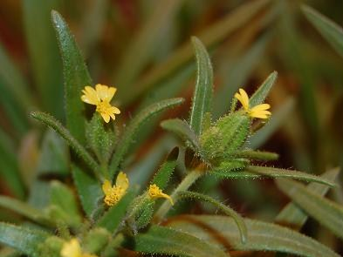Mountain tarweed in flower at the Corvallis Plant Materials Center. Photo by Tyler Ross, 2012.

### Alternate Names

*Alternate Common Names:* cluster tarweed, mountain tarplant, California dwarf-sunflower

*Alternate Scientific Names:* none

### Uses

*Pollinator habitat:* Mountain tarweed attracts many native pollinators and other beneficial insects. It may be included in roadside revegetation mixes and pollinator hedgerows along farm edges. It is particularly useful as a late season pollen source for native bees.

*Wildlife:* The seeds (achenes) are used as food by birds and small mammals.

*Restoration:* Mountain tarweed can be planted on restoration sites that contain upland areas such as meadows, oak savannas, or shrublands. This species is used for NRCS Conservation Reserve Program (CRP) and Wildlife Habitat Incentives Program (WHIP) plantings.

### Status

Throughout its native range in the West, mountain tarweed is considered a facultative upland plant (FACU), meaning it occasionally occurs in wetlands but is usually found in uplands. Where it has become naturalized in Alaska, it is considered an obligate upland plant (UPL), meaning it almost always occurs in uplands. Please consult the PLANTS Web site and your State Department of Natural Resources for this plant’s current status (e.g., threatened or endangered species, state noxious status, and wetland indicator values).

### Weediness

Mountain tarweed often becomes weedy in overgrazed pastures and on disturbed sites such as roadsides and trails (Lass, 2007). It may displace desirable vegetation if not properly managed. Please consult with your local NRCS Field Office, Cooperative Extension Service office, state natural resource, or state agriculture department regarding its status and use. Weed information is also available from the PLANTS Web site at <http://plants.usda.gov/>. Please consult the Related Web Sites on the Plant Profile for this species for further information.

### Description

*General*: Mountain tarweed is a strongly scented annual herb that may be 6 to 40 inches tall. The plants may be simple or with stiff ascending branches. Leaves are 1 to 4 inches in length and are densely pubescent (hairy) on the underside and sparsely covered with glandular hairs on top. Inflorescences are clusters of glandular flower heads comprised of 0–3 yellow ray flowers and 1–5 disk flowers. The seed is a flat, black achene (Hickman, 1993).

*Distribution:* Mountain tarweed is the most widely distributed of all of the *Madia* species, with a native range covering much of the western and northern parts of North America from British Columbia to the Southwestern United States, across southwestern Canada and into the Rocky Mountains region. It has become naturalized in Alaska and across eastern Canada and the north-central and northeastern U.S. For current distribution, please consult the Plant Profile page for this species on the PLANTS Web site.

*Habitat:* Mountain tarweed grows mostly on disturbed sites including openings in grasslands, meadows, swales, shrublands, woodlands, forests, edges of marshes, lakes, and roadsides at elevations of 0–12,000 ft (Hickman, 1993).

**Ethnobotany**

First nation people harvested the seeds to use as a food source and used other parts of the plant for medications, cures, and rituals (Moerman, 2003).

**Adaptation**

Mountain tarweed is adapted to quickly cover recently disturbed land. It often becomes dominant on overgrazed rangelands because it is avoided by cattle and wildlife due to its odor. It often grows in coarse, sandy or gravelly soils. It is also found growing in silty/clayey soils, usually in full sun.

### This photo of a mountain tarweed seed increase plot was taken by Amy Bartow at the Corvallis Plant Materials Center in 2008. MAGL2.jpg *Photo by Amy Bartow, NRCS Corvallis Plant Materials Center, 2008.*

### Establishment

### In trials done at the Corvallis Plant Materials Center, mountain tarweed seeds sown in the fall germinated in late winter to early spring, just as temperatures start to increase slightly. Seeds sown in early spring also germinated well, suggesting that cold stratification is not required. Seed can be broadcast onto sites or planted with a seed drill at a depth of ¼ inch. Use a rate of 10 pounds per acre to produce a dense, single species stand. For best results, seeding should be done in early spring to allow seedlings to become established while soil moisture is plentiful. There are 150,000 to 200,000 seeds per pound. If one pound of seed is sown on one acre of land, there will be between 3 and 5 seeds per square foot.

### Management

Control of weedy perennial species that may out-compete mountain tarweed over time may be necessary. Encroachment of trees and shrubs will shade out this species. Grazing and periodic burning or mowing will help to maintain the habitat. Although this species is an annual herb, it readily self-sows and persists.

### Pests and Potential Problems

There is no current information on pests or diseases of this species.

### Environmental Concerns

This species readily self-sows and may spread and become weedy in pastures/rangeland or other neighboring habitat.

### Control

Please contact your local agricultural extension specialist or county weed specialist to learn what works best in your area and how to use it safely. Always read label and safety instructions for each control method.

### Seeds and Plant Production

*Field establishment:* For best establishment, grow plugs in a greenhouse in late winter and transplant out in spring. Transplant into a field covered with weed fabric containing holes on 1ft by 1 ft spacing. Seeds can also be sown directly into holes in the weed fabric in early spring. Place 10 seeds per hole (2 pounds per acre) and cover them lightly with soil or vermiculite.

For direct seeding fields (without weed fabric) use a rate of 50 seeds per square foot or 10 pounds per acre. Sow in spring at a depth of ¼ inch or less into rows 12 to 24 inches apart. Weed fabric is highly recommended because seeds shatter as they ripen and the fabric catches the seed so it can be collected after the plants are removed. For agronomic seed increase, hand weeding and fertilization may be necessary. This species may become weedy in production areas, but does not become a persistent weed.

*Harvesting techniques:* Seeds fall from the plant as they mature and can shatter over a period of weeks. When seed production has commenced, cut plants at the base and place on tarps to dry, and then vacuum remaining seed off of the fabric and from the holes in the fabric. Large fields, with or without weed fabric, can be directly combined. This method will result in much lower yields than fields with weed fabric due to high amount of shattering that occurs prior to and during harvest. Plants can be very sticky when green and should not be combined until sufficiently dried and less sticky.

*Seed Cleaning Techniques:* Use a thresher, combine, or hammer mill to break seeds loose from plant material. Use an air screen machine to remove stems, chaff and unfilled seeds to reach desired purity standards. Distinguishing filled seed from non-filled seeds can be challenging with this species. Yields can vary widely based on field conditions and harvest methods, averaging between 400-1200 pounds per acres.

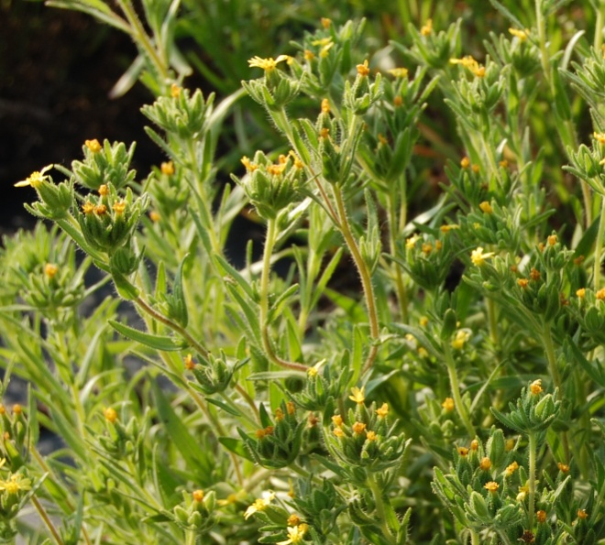

Photo by Amy Bartow, NRCS Corvallis Plant Materials Center, 2012.

### Cultivars, Improved, and Selected Materials (and area of origin)

Seed of this species may be available from native plant nurseries from within its range. Contact your local Natural Resource Conservation Service office for more information on availability.

### References

Hickman, J.C. (ed.) 1993. The Jepson manual: higher plants of California. Univ. of California Press, Berkeley.

Lass, L., and T. Prather. 2007. Cluster tarweed / *Madia glomerata* Hook.and Coast tarweed / *Madia sativa* Molina. In: A scientific evaluation for noxious and invasive weeds of the Highway 95 construction project between the Uniontown Cutoff and Moscow. AquilaVision Inc, Missoula, MT. p. 27–28. www.northwestmedia.net/us95/pdf-final/Final-Weed-Report.pdf (accessed 14 Mar. 2012).

Moerman, D. 2003. Native American ethnobotany database. Univ. of Michigan, Dearborn. http://herb.umd.umich.edu/herb/search.pl?searchstring=Madia+glomerata (accessed 24 Aug. 2012).

### Prepared By

*Tyler C. Ross and Amy Bartow,* USDA-NRCSCorvallis Plant Materials Center, Oregon

### Citation

Ross, T.C. 2012. Plant guide for mountain tarweed (*Madia glomerata)*. USDA-Natural Resources Conservation Service, Plant Materials Center, Corvallis, OR.

Published December, 2012.

Edited: 13Dec2012 aym; 16Jan2013 jab

For more information about this and other plants, please contact your local NRCS field office or Conservation District at <http://www.nrcs.usda.gov/> and visit the PLANTS Web site at <http://plants.usda.gov/> or the Plant Materials Program Web site <http://plant-materials.nrcs.usda.gov>.

PLANTS is not responsible for the content or availability of other Web sites.

**USDA IS AN EQUAL OPPORTUNITY PROVIDER AND EMPLOYER**